
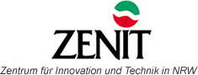
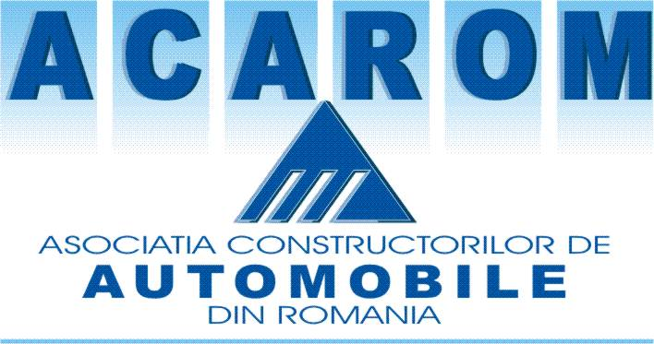

PUBLISHABLE EXECUTIVE SUMMARY

Project Title: Suppliers Portal to Research and Innovation in Transport
Acronym: SPRINT

Coordinator : ACAROM
Address: Banu Maracine Str. , Bl. D5, Pitesti, 110194, Arges, ROMANIA

Consortium

PARTNERS |  | MAIN CONTACT
Association of Automotive Manufacturers in Romania (ACAROM)  Banu Maracine Str. , Bl. D5, Pitesti, 110194, Arges, ROMANIA  Project Manager:Prof. Dr. Eng. Ion Ungureanu  E-mail:ion.ugureanu@upit.ro |  | Mr. Constantin STROE  Phone: +40-248-211657  Fax: +40-248-211657  E-mail: constantin.stroe@acarom.ro
University of Pitesti (UPIT)  Targul din Vale Str. Nr.1, Pitesti, Arges, ROMANIA  Project Manager: Prof. Dr. Eng. Viorel Nicolae  E-mail:viorel.nicolae@upit.ro |  | Mr. Viorel Nicolae  Phone: +40-0727-848112  Fax: +40-248-217736  E-mail: viorel.nicolae@upit.ro
SC INNO CONSULT SRL (INNO)  Aleea Valea Florilor 8, RO-011465, Bucharest, Romania  Project Manager: Mr. Daniel Cosnita  E-mail: daniel.cosnita@gtz.ro |  | Mr. Daniel Cosnita  Phone: +40-21-3190176  Fax: +40-21-3190181  E-mail: daniel.cosnita@gtz.ro
Zentrum für Inovation und Technik in NRW GmbH (ZENIT)  Dohne 54, 45468, Mulheim and der Ruhr, Germany  Project Manager: Mr. Stefan Braun  E-mail: br@zenit.de | 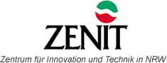 | Mr.Stefan Braun  Phone: +(49208)30004.57  Fax: +(49208)30.004.68  E-mail: br@zenit.de

Project Objectives:
The automotive sector is one of the most important industries in the Romanian Economy. Established in the years of communism, this huge manufacturing sector needed an appropriate supplying industry which was also created under the planned system. After 1989, the Romanian automotive manufacturing sector was faced with the realities of the market economy.

Against this background, SPRINT has been undertaken the following mission:

- to help Romanian automotive suppliers enhance their research activities in order to develop new products in accordance to the demand of the manufacturers and of the European standards regarding environment, quality and safety;
- to link the Romanian automotive suppliers to the state of art regarding research results achieved at EU level;
- to raise the degree of awareness and knowledge regarding FP6, and to help Romanian automotive suppliers (mostly SMEs) better participate to European research projects;
- to facilitate the collaboration in research between ACC countries in order to reduce the costs of implementing EU standards regarding quality, safety and environment protection in the transport field.

Concrete objectives of the SPRINT are:

- the creation of a high quality innovative network of suppliers for the automotive industry;
- the creation of several research nuclei, which would approach current hot research issues in the automotive field, as defined within the 6th thematic priority ;
- the organisation of a series of regional workshops in order to raise awareness about already achieved research results on European level and of the FP6 Programme in general;
- the organisation of a South East European Conference in order to enhance international research cooperation of the suppliers.

State of the project after the first 24 months:

In order to establish a high quality innovative network of automotive suppliers, a very thorough preparation work had to be done. 191 entities representing automotive suppliers (115), research laboratories (26), universities and departments in universities (46) and research institutes (4) have been asked to fill in a very comprehensive questionnaire regarding their products, technologies used, quality systems implemented R&D capacities, R&D expenditures, human ressources etc. To give only a few examples of the results only 18% of the suppliers in question allocate more than 2% of the turnover for R&D, but all suppliers have an ISO 9001 system implemented. 63% of the suppliers have recently developed new products for Dacia-Renault, 37% for Daewoo and 26% for other car manufacturers. As a response, 50 organisations entered as founding members of the SPRINT network: 30 suppliers - members of ACAROM, 5 suplliers - non-members of ACAROM, 2 research institutes, 11 testing laboratories and 12 universities or university departments. By the end of the project the network number as many as 80 members i.e. an increase of 60%.
A fine tunning questionnaire followed the launching workshop (March 2006) in order to better establish the wishes and needs the members expect the SPRINT network to fulfill. Accordingly, a network concept was developed. The network would mainly have three functions: information regarding offer and demand of products, technologies, partners, available production capacities and equipment; collaboration in the field of R&D mainly by means of the research nuclei; builduing up of consortia for common projects.
Regarding the research nuclei, 6 such informal association have already been established on topics like: New materials, Experimental studies for the improvement of the automotive components, Design of new cars/car components, Fabrication support, New technologies, Fabrication systems. The Nuclei have already started to function. As a result we can account for 3 successful projects submitted, approved and under finance within the frame of the Romanian National Program for Excellence in Research with a total value of over 1 Mil. EUR as well as other over 20 project ideas waiting in pipeline for the appropriate financing opportunity.
After the kick off meeting of the network (June 2006) and based on the members’ profiles followed the designing of the web portal, the major tool of the SPRINT network. The actual designing of the web portal was outsourced to a specialised company. The portal www.sprintnetwork.ro was offically launched on the 1st of September 2006. The portal contains a public area where general information about the SPRINT project, events and useful links are available as well as a member area where members’ profiles are available. Offer and demand of products, technologies, and partnership requests can be found and used by the members. The SPRINT network is open for new members and the registration is free of charge.
The networking effort was ensured not only by means of the portal but also through a number of visits done by the SPRINT team to selected enterprises in regions as well as via a series of workshops held in cities like Bucharest (Open Forum for Technology Transfer and Innovation) Pitesti, Timisoara and Cluj, each of them placing a strong emphasis on the opportunities offered by FP7.
The integration of the network from a broader European perspective was endured by the participation to several automotive conferences in Prague, Brussels, and Dresden as well as by the organisation in June 2007 of the South East European Conference in Pitesti. Representative of the automotive sector from Bulgaria, Serbia, Croatia, Slovenia, and Romania as well as the big car manufacturer Renault discussed together on actions to be undertaken in order to assure a better cooperation between emerging automotive clusters in SEE in order to avoid fragmentation in research and better integrate into the European market.

The results achieved so far can be better visualised in the following table:

Objectives | Identified results | How to exploit the results
The creation of a high quality innovative network of suppliers for the automotive industry | A deep analysis of the Romanian automotive supplying system has been performed  The SPRINT network was officially founded on the 12th of July 2006 with 50 founding members. Until the 31stof August 2007 the number of members has already reached 80.  The SPRINT portal was launched on the 1st of September 2006 | The network is open for new members  Continuous adapting and improvement of the services provided by the network to the members’ needs  Linking the SPRINT network to other Romanian and international excellence networks  PR activities on various conferences and events
The creation of several research nuclei, which would approach current hot research issues in the automotive field | 6 research nuclei have been established | Further development of the research nuclei to autonomous entities  Coaching of the research nuclei  Match making events
the organisation of a series of regional workshops in order to raise awareness about already achieved research results on European level and of the FP6 Programme in general | Several regional workshops in Pitesti (9), Timisoara(2), Cluj (1), Bucharest (6)  Visits to enterprises in Timisoara, Cluj, Bucharest  Partner mediation event in Sibiu and Timisoara | Further regional workshops  Linking workshops to other Romanian and international scientific events
Linking the SPRINT network to other European automotive networks and initiatives | Participation to several automotive conferences in Prague, Brussels, Dresden,  Participation to ZMesse Fair in Leipzig  Organization of the SEE Conference in Pitesti, June 2007 | Future joint projects within FP7, INTERREG

The flowchart of the activities run within the project looks as follows:

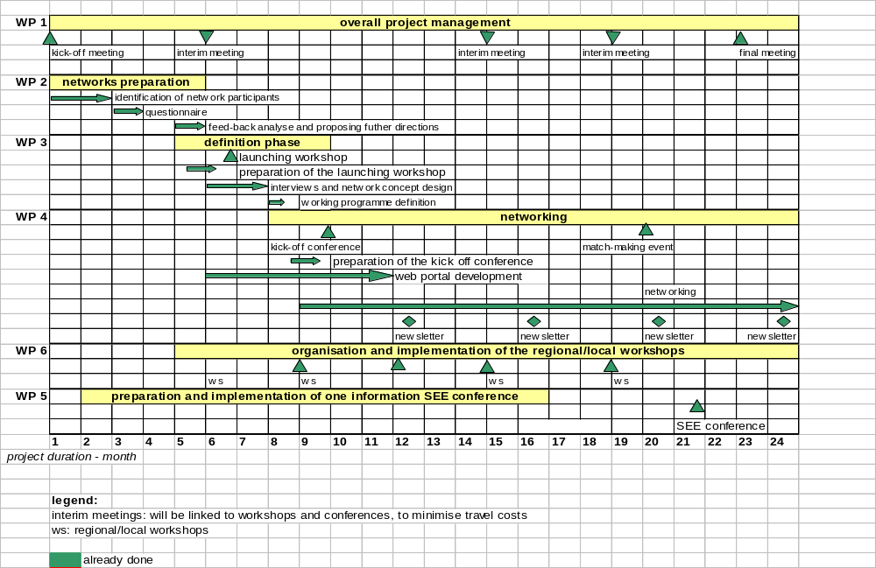
:

Account details WWW.SPRINTNETWORK.RO

The account details for accesing the portal as a member of the SPRINT network are:
- username: acarom;
- password: ac1arom
In order to acces the management area of the portal please use the following password:
- password: acup01inze

Below a snapshot of the portal:



