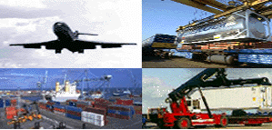
EUTP II Final report - Public

CONTRACT N°: 2000-TN.10081

ACRONYM: EUTP II

TITLE: Thematic Network on Freight Transfer Points and Terminals

PROJECT CO-ORDINATOR: Regional Development Company Ringkøbing County (EURA A/S), DK

PARTNER: VTT FI

MEMBERS: EDI Management FI
Combiconcept FR
EFIP BE
FEPORT BE
UIRR BE
Interporto Bologna IT
ISL DE
PTV DE
SGKV DE
Web House DK
CDV CZ
MAHART HU

REPORTING PERIOD: FROM 1 April 2000 (T1) TO 31 March 2004 (T48)

PROJECT START DATE: 1 April, 2000 DURATION: 48 months

Date of issue of this report: May 31, 2004

 |   Project funded by the European Community under the ‘Competitive and Sustainable Growth’ Programme (1998–2002)

1 Table of Contents
2 Executive Summary 3
3 Objectives of the project 4
3.1 Objective of EUTP 4
3.2 Tasks of EUTP 4
3.3 Member profiles 5
3.4 Aim and Structure of the Report 7
4 Scientific and technical description of the results 8
4.1 Steering Committee 8
4.11 Introduction 8
4.12 1st Steering Committee Meeting 2001 8
4.13 2nd Steering Committee Meeting 2002 8
4.14 3rd Steering Committee Meeting 2003 10
4.15 4th Steering Committee Meeting 2004 11
4.16 Participation in the Steering Committee 12
4.17 SC conclusions - Different national policies to support intermodal transport and terminals 12
4.2 Country reports (EUTP Deliverable 2.1) 13
4.3 Clustering 14
4.31 Introduction 14
4.32 1st Clustering in Brussels 2000 15
4.33 2nd Clustering seminar in Prague 2001 15
4.34 3 Clustering in Rotterdam 2002 16
4.35 4 Clustering in Bologna 2003 17
4.36 Participation in Clustering Activities 18
4.37 Clustering review report (EUTP Deliverable 3.1) 18
4.4 EUTP Seminars on new development in intermodal terminals 22
4.41 Intermodal demonstration in Pasila intermodal terminal, Helsinki 2001 22
4.42 1st EUTP seminar in Ludvigshafen 2003 23
4.43 2nd EUTP seminar in Bologna 2003 25
4. 5 Recommendations for policy and research activities (EUTP Deliverable 4.1) 26
4.51 Top priorities 26
4.52 Future priorities and outlook 27
4.6 Other findings of EUTP 29
4.61 The evolution of combined transport 29
4.62 Mega-Hub Project in Germany 30
4.63 TEN - Where are the nodes? 31
4.64 Terminal developments 32
4.7 Website and database 32
4.8 Dissemination and exploitation 33
5 List of deliverables 34
6 Results and conclusions 35

Annexes

2 Executive Summary

The main objectives of EUTP are to run a dynamic network, to enhance exchange of information, and to create synergy in the European research effort related to intermodal freight transfer points. The aim is to form a European RTD strategy to enhance and develop the intermodal transport sector through a more efficient use of intermodal transfer points. The network comprises researchers, industry representatives, policy makers, transport operators, and transport consultants.

EUTP deliverable 3.1 presents the main conclusions from the clustering meetings held. The cluster approach is employed to enhance the co-operation between national and European RTD on freight transfer points and to discuss research and policy issues with all relevant stakeholders.

EUTP Deliverable 4.1 provides a concise summary and analysis of the work established in WP2 Inventory and carried out in WP3 Clustering Activities. The goal is to identify interrelated RTD activities with a view to presenting future policy and research requirements. In this respect, bottlenecks in the field of intermodal freight transport and in particular those related to intermodal terminals are identified. Recommendations are then made to industry, transport operators, terminal owners, and policy makers with regard to the following general top priority themes:
- European intermodal terminal network
- Quality of services
- Security
- Organisation between actors
- Intelligence (IT and architectures).

EUTP has produced country reports for Austria, Belgium, Czech Republic, Denmark, Finland, France, Germany, Greece, Ireland, Italy, Lithuania, Poland, Sweden, Switzerland, The Republic of Slovenia, Romania, The Netherlands, and The United Kingdom (Deliverable 2.1).

This final report summarises the results of all EUTP activities.

Project Reference: 2000–TN.10081
Contract type: Thematic network
Duration: 48 months
Project Acronym: EUTP
Update date: 10. December 2003
Co-ordinator: EURA A/S

Contacts:
Flemming Fisker Antti Permala
EURA A/S VTT Building and Transport
Tel: +459 7325 000 Tel +358 9 456 4535
ffp@eura.dk antti.permala@vtt.fi

3 Objectives of the project

3.1 Objective of EUTP

The main objectives of EUTP are to run a permanent and dynamic network, to enhance exchange of data and information, and to create synergy in the European research effort related to intermodal freight transfer points. The aim is to form a European RTD strategy to enhance and develop the intermodal transport sector through a more efficient use of intermodal transfer points. The network comprises researchers, industry representatives, policy makers, transport operators, and transport consultants.

3.2 Tasks of EUTP

The EUTP II project has as its aim the creation of a comprehensive database of information relating to intermodal freight transport research and for this to be accessible to the entire European transport fraternity through Internet services. Ongoing and completed national, European or international RTD projects are analysed with a view to contribute to the development of a future policy and research approach. The outcome, in terms of expanding the inventory of the state of the art and best practice developed in EUTP, is used for policy-making purposes and to identify shortcomings in the current national and European research efforts. This will have an effect on research activities in future RTD, TEN-T, ERDF and PACT / Marco Polo programmes, to mention but a few of the EU financed programmes/funds where transfer points constitute an integral part today. The work is separated into the following main categories:

- Steering Committee consisting of national representatives
The Steering Committee that has been created comprises representatives from 14 member states, OECD, European Parliament and EU. The members are representing ministries as well as the research and private sectors.

- The clustering activities. Three clusters are defined:
- Policy, organisational aspects and network integration
- Infrastructure, transport equipment and transfer means
- Information and communication systems

The cluster approach is employed to enhance the co-operation between national and European RTD on freight transfer points and to discuss research and policy issues with all relevant stakeholders. Each cluster consists of members from the consortium and 6–8 experts selected from the research sector, public authorities and the transport industry. The goal of each cluster has been to define results and recommendations from research projects and from pilot and demonstration activities. Furthermore, each cluster makes recommendations for policy initiatives.

- A comprehensive dissemination of results including information brochures, CD-ROM, and seminars. The EUTP website (www.eutp.org) is used to disseminate activities and findings, and an Internet search tool and RTD database have been created to assist in locating European intermodal research data. All of the papers produced as well as a large number of related projects have been entered into the website. Links to other relevant websites have also been established. Updates have been made on a continuous basis.

Two EUTP seminars have been arranged.

The database
The database contains current and past projects (both EU and national) dealing with intermodal transfer points, related papers and country reports. All database related issues were completed within the first project year and are continuously revised during the project to obtain even better functionality and usability.

Country reports
EUTP II has produced country reports for Austria, Belgium, Denmark, Finland, France, Germany, Greece, Ireland, Italy, Sweden, Switzerland, The Netherlands and United Kingdom. Information from the following candidate countries has been added to the website: Czech Republic, Poland, Lithuania, Hungary and the Republic of Slovenia.

NAS countries.
EUTP II has expanded to include two new members from NAS countries. The value added from NAS participants is in the coverage of the eastern parts of the European transport area. East–West transport has a growing importance and one success factor is the interoperability of transfer points in intermodal transport chains.

Innovative Technologies in Intermodal Transport
Innovative Technologies in Intermodal Transport project (ITIP) is a related activity dealing with the development and integration of new technologies to improve intermodal transport. The ITIP project aims to analyse the development and integration of new technologies for the improvement of intermodal transport operations. ITIP reports can be found on the EUTP website.

3.3 Member profiles

EURA
EURA A/S, established in 1993, is a regional business development company with Ringkøbing County Council as main shareholder. EURA A/S main purpose is to create further regional development based on international business co-operation and innovation. Our role should be seen as of an intermediary and developer of new business concepts - often with international partners and dimensions.

VTT
VTT, the Technical Research Centre of Finland is an impartial expert organisation that carries out technical and techno-economic research and development work. VTT Communities and Infrastructure is one of the seven research institutes of VTT. The business idea of VTT Communities and Infrastructure is to provide information on communities, transport and physical infrastructures for the needs of industry and commerce as well as public authorities.

ISL
The Institute of Shipping Economics and Logistics (ISL) is a non-profit making independent foundation with more than 40 years of experience in applied research and development in the field of transport economics, logistics and telematics. The scope covers the elaboration of studies, innovative software development, consulting as well as training and coaching.

PTV
PTV AG, a group independent enterprise, was founded in 1979. PTV offers a complete and integrated set of services covering all important problems for today's and the future's traffic and transport. The interdisciplinary working teams of PTV deal with complex planning tasks related to all transport systems, integrating information technology (IT), communication technology and geographical information systems (GIS).
Oy EDI Management Finland
EDI Management is a provider of consulting services in the areas of logistics, e-business and supply chain management. Our mission is to increase the logistics performance of our clients by developing their business processes and by utilising modern e-business and information technologies.

UIRR
The International Union of Combined Road-Rail Transport Companies (UIRR) and their member companies are privately oriented combined transport operators. Its central objective is to ensure a more sustained development of rail transport of swap bodies and containers as well as of semi-trailers and lorries by private transport hauliers and logistics companies. Today 17 combined transport companies are members of the UIRR.

WebHouse
WebHouse ApS is developing and maintaining standard Web based software tools for making specialised Content Management Systems and Corporate Portals. The tools are often used for building large websites and/or Extranet/Intranet solutions for SME's. WebHouse is specialised in Open Source and Web based Information- and Exchange platforms using XML and other standards.
SGKV
SGKV (research association for Intermodal Transport) is a non-profit organisation, which has the purpose to improve the efficiency of the freight traffic by promoting and developing the intermodal transport. The SGKV is supported together by the German industry and the transport companies and by the German ministry of transport.

EFIP
The European Federation of Inland Ports (EFIP) was created in Brussels in 1994. Today, it counts some 200 inland ports in 18 countries covering the EU, Switzerland and central and eastern Europe.

FEPORT
As a result of European developments, it was found essential to create an organisation representing the interests of private port operators, i.e. stevedores and terminal operators, on a European level. This resulted in the foundation of FEPORT on January 13 1993, uniting national and regional representative associations of private port operators in the EU. In this way about 800 individual port operating companies are currently represented.
CombiConcept
A consultancy specializing in intermodal transport, including intermodal terminals design and operation. CombiConcept serves the global market. CombiConcept is part of the CNC Group, the European leader of door-to-door and port-to-door intermodal services.
Interporto Bologna
The Bologna Freight Village consists of an integrated system of logistics, rail and road infrastructures designed for the transport of freight and directly connected to the national railway line and motorway system. The freight village accommodates more than 81 national and international transport companies, the Customs offices, the public warehouses etc.

MAHART
The MAHART has been since 1895 the first and dominant company of Hungarian shipping industry. In the more than one century that passed since its formation, the company and its legal predecessors carried on the rivers more than 110 million tons of cargoes and 230 million passengers, and the port transhipped 60 million tons of cargoes. The seagoing ships called at 160 countries worldwide.
CDV
CDV (Transport Research Centre) has more than forty years long tradition of research and development. CDV has been appointed since 1 July, 1996 by the decision of the Minister of Transport of the Czech Republic as the only research institute on transport issues under the responsibility of the Ministry of Transport.

3.4 Aim and Structure of the Report

This deliverable presents the main findings and conclusions from the EUTP project. The report is put together by Antti Permala from the Technical Research Centre of Finland (VTT).

4 Scientific and technical description of the results

4.1 Steering Committee

4.11 Introduction

The members of the Steering Committee have been nominated in co-operation with the Member States and the European Commission. All 15 Member States were contacted by the Commission and asked to delegate a representative to participate in the Steering Committee. 1–2 members from 14 EU countries (except Luxembourg) were invited in the Steering Committee. NAS Countries, OECD, ECMT, European transport organisations, transport operators and selected co-ordinators of RTD projects have been invited in the meetings and some have participated.

Some members represent the ministries, some the research sector, and a few members have been appointed from the private sector. It has been clearly mentioned to all Member States that the representatives should have a close insight into national research and policy on intermodality and terminals.

Changes have been made in the composition of the Steering Committee from the start of EUTP till today, as members have changed position or as new representatives have been appointed by former representatives.

The Steering Committee members have received all relevant material for comments. Four meetings were organised in the lifetime of the project. Furthermore, the members have been invited to participate in the clustering activities and in other related activities.

4.12 1st Steering Committee Meeting 2001

The first EUTP II Steering Committee was arranged 8.–9. March 2001 in Stockholm/Helsinki. Mark Major (EU) presented EU intermodal policy and research initiatives and Fabrizio Minarini (EU) E-commerce and distribution. National presentations were received from Italy, The Netherlands, Germany, Sweden and Finland.

Karin De Schepper from EFIP talked about the role of the terminals in the integration of inland waterways and Short Sea Shipping in the transport chain and finally the results from clustering activities were discussed, based on presentations by Antti Permala (VTT), Dieter Wild (PTV) and Frank Arendt (ISL).

4.13 2nd Steering Committee Meeting 2002

The second Steering Committee meeting took place in Brussels 9 July 2002. EUTP project and the web-site were presented by Antti Permala and Christian Broberg (Webhouse) as well as EU policy priorities, past, current and future research and related matters by Stefan Tostmann (EU) and Mark Major.

National presentations from Austria, Denmark, Finland, Germany, Greece, Ireland, Italy the Netherlands, Portugal, Czech and Hungary were given. The topics dealt with inland waterway transport, low priority for transport research in some countries, reflections on the White Paper, development of national intermodal transport, national RTD programmes, national subsidy programmes, aims to shift freight transport from road to intermodal transport, intermodal in urban areas and national policy papers.

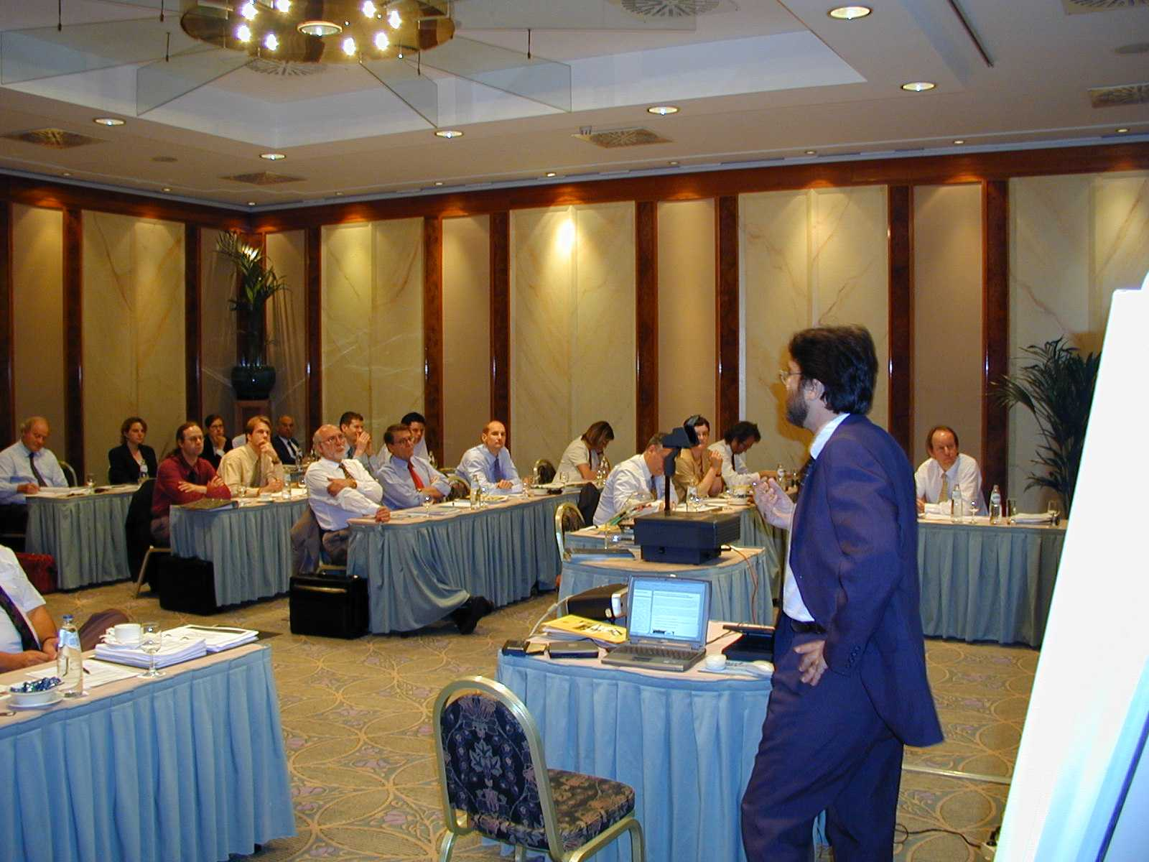
Figure 1. Mr Ballis in the 2nd Steering Committee Meeting 2002.

Results from ITIP project were given by Christiane Wiezorke (PTV) and Athanasios Ballis (Greece) presented ITIP ExTip expert system. Standardisation of containers and swap bodies and its influence on terminal design and transfer technique were discussed by Christop Seidelmann (SGKV). Two presentations about IT in terminals (harmonisation & standardisation of business processes and communications interfaces and UIRR rail/road case) were given by Seppo Auvinen (EDI-Management) and Diane Chevreux (UIRR). Finally EUTP strategy and action plan for the remaining project years 2002–2004 were discussed and a project proposal for survey of TEN nodes was made by Gilberto Galloni (Interporto Bologna).

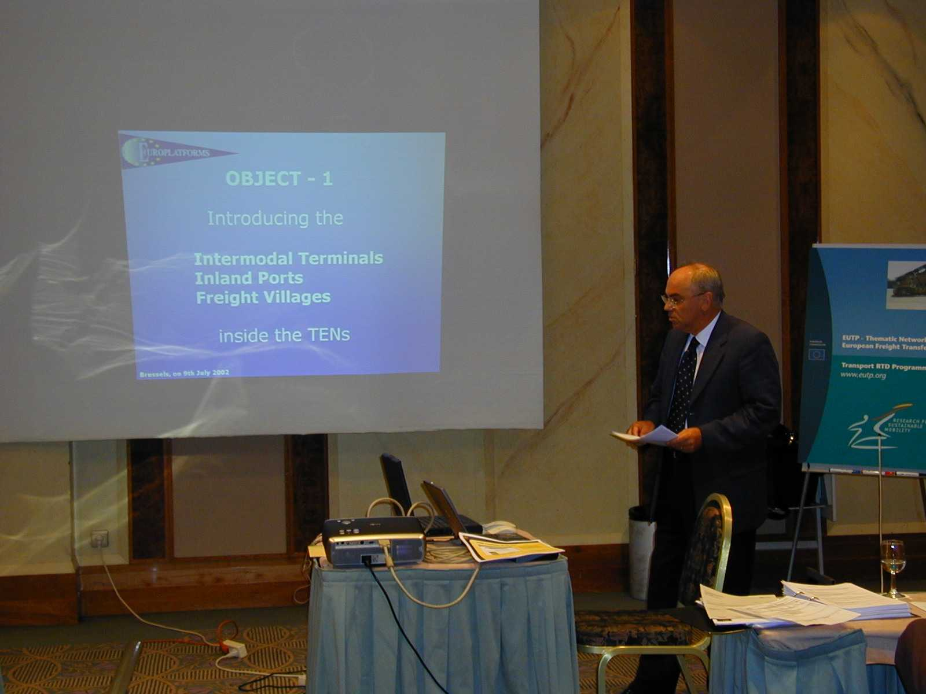
Figure 2. Mr Galloni: Where are the Nodes?

4.14 3rd Steering Committee Meeting 2003

The third Steering Committee meeting took place in Frankfurt 29 April 2003. National presentations from Austria, Belgium, Denmark, Finland, France, Germany, Ireland, Italy the Netherlands and Portugal were given. The national presentations dealed with national research programmes including Interreg, telematics developments, infrastructure usage and some intermodal projects such as CESAR, CroBIT (Cross-border information technology) and co-operation with ERTICO.

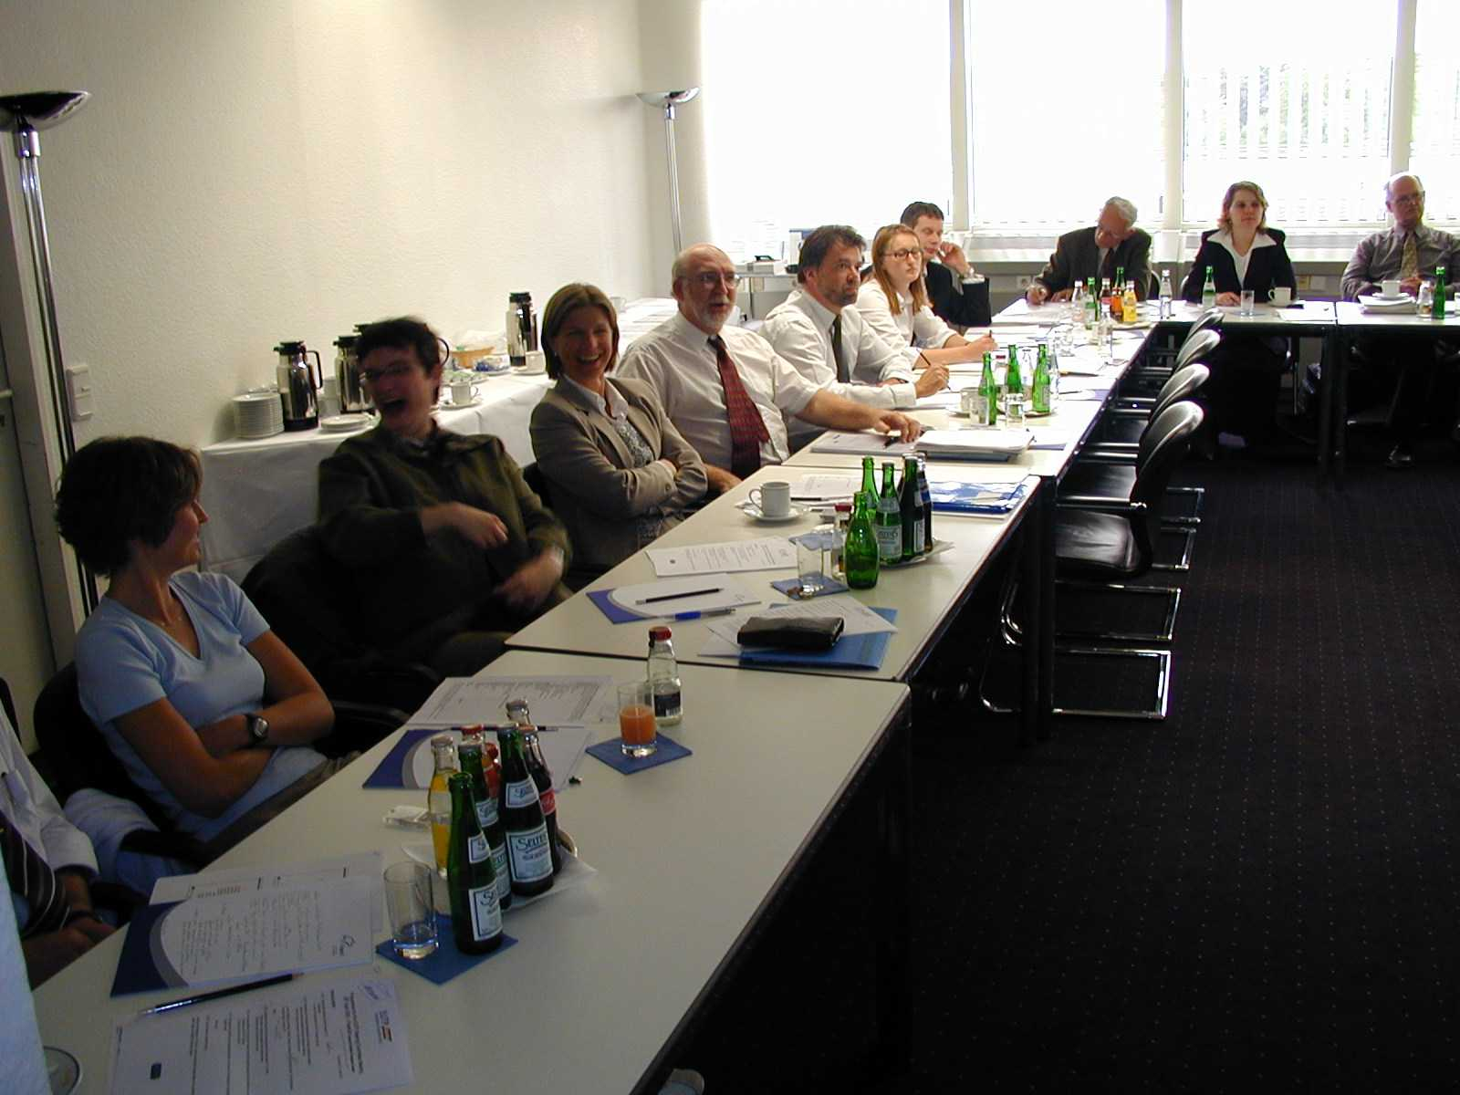
Figure 3. Steering Committee meeting 3 in Frankfurt 2003.

Nectar (Network on European Communication and Transportation Activities Research) cluster and Europlatforms, European association of Freight Villages on intermodality, were presented by Laetitia Vereecken (VUB) and Gilberto Galloni. Interesting Mega-Hub project in Germany discussed by Peter Franke (Noell Crane Systems GmbH). Clustering activities, ITIP project and recommendations for policy and research activities (EUTP deliverable 4.1) was discussed and priorities were given to the proposed actions.

4.15 4th Steering Committee Meeting 2004

Antti Permala gave a re-cap of the current developments in the EUTP network. New EU policy and research initiatives such as Marco Polo programme, intermodal loading units, freight integrator action plan, logistics research activities and transport security were presented by Mark Major.

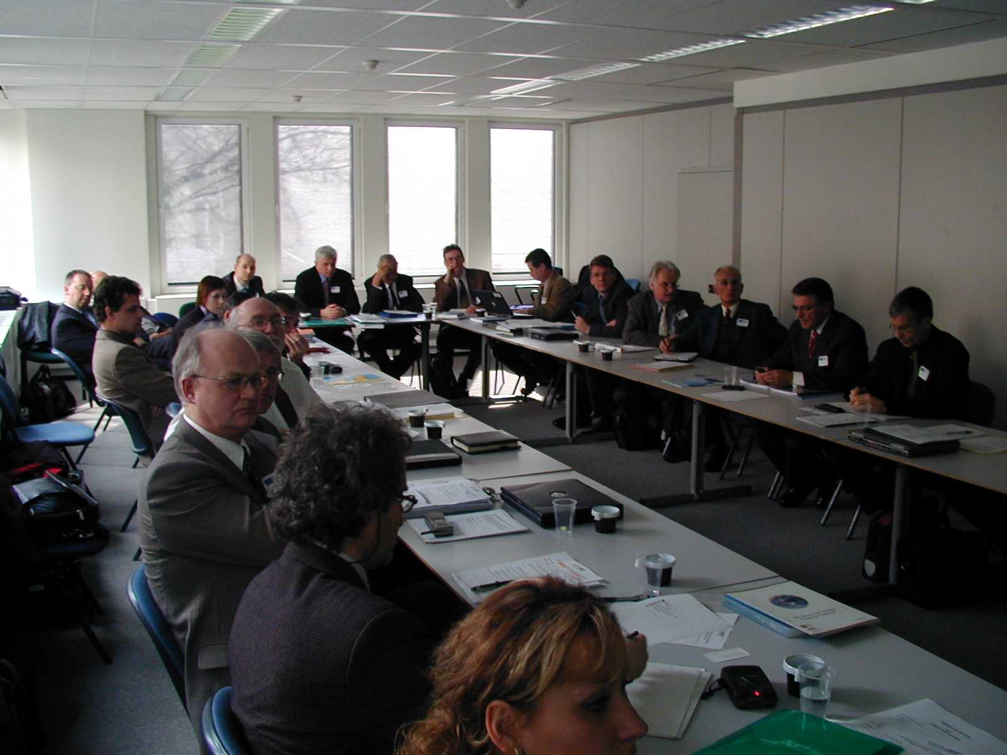
Figure 4. Steering Committee 4 in Brussels 2003.

Presentations of national developments were given from Austria, Denmark, Finland, Germany, Portugal, Switzerland and from NAS countries Czech Republic, Hungary (Mahart and Bilk terminals), Romania and Poland (written form). ITIP NAS Integration was presented by Marcel Huschebeck.

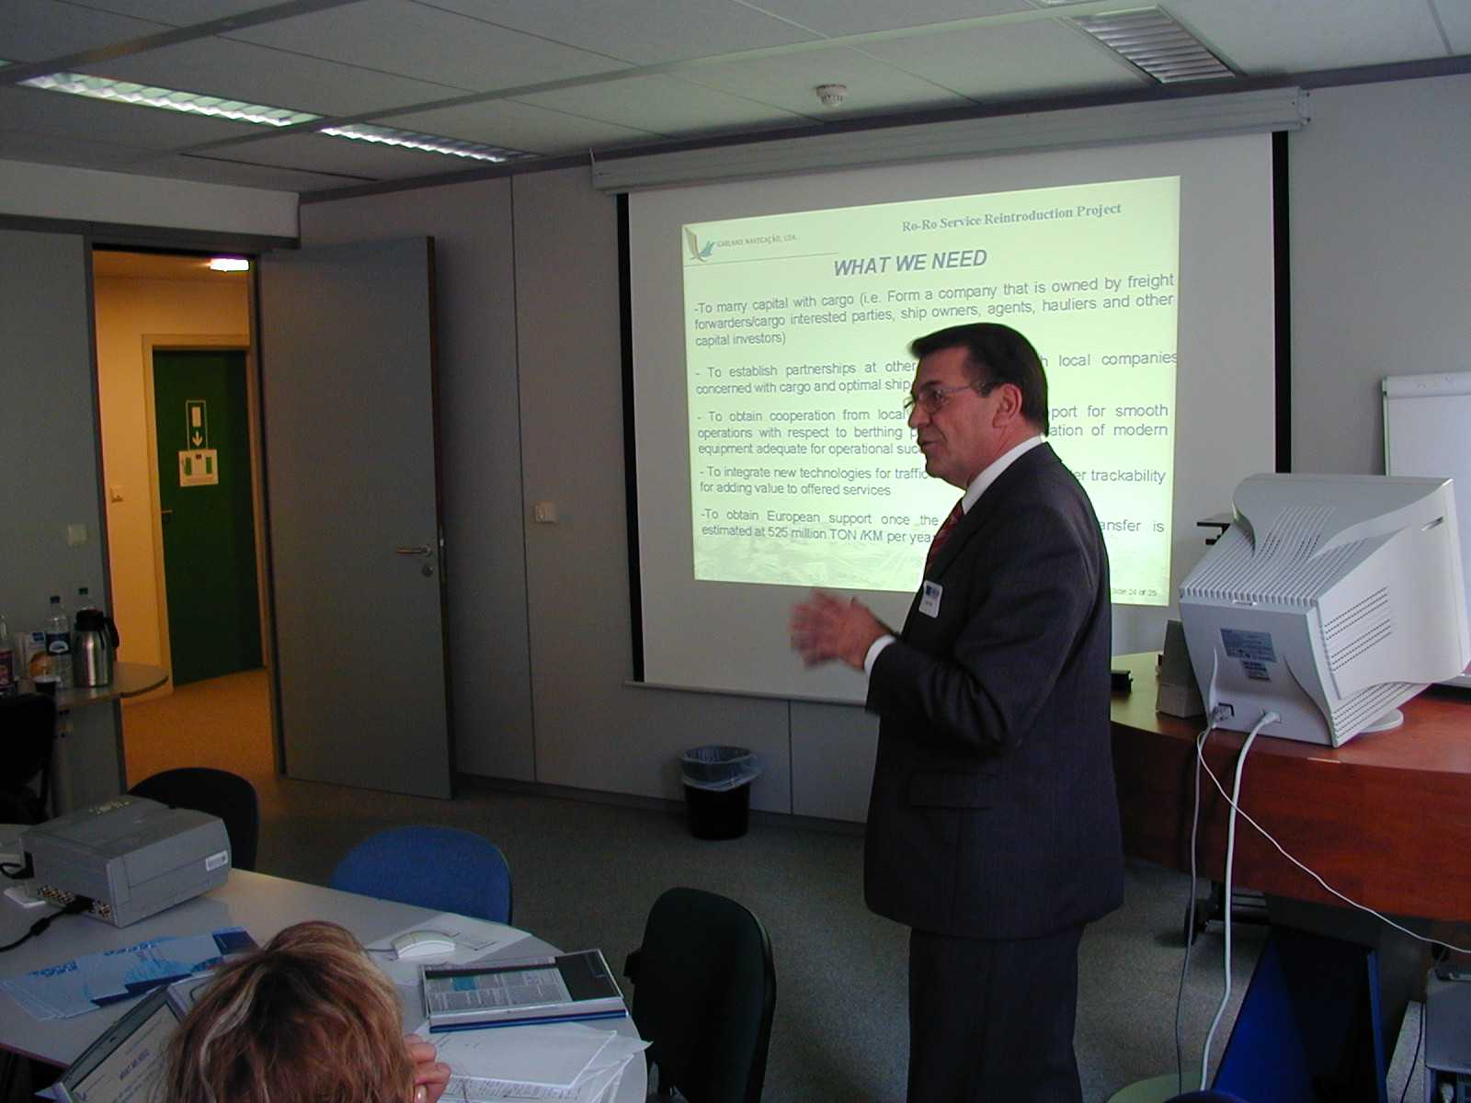
Figure 5. Mr Azeredo in the 4th Steering Committee Meeting 2004.

Martin Burkhardt and Eric Feyen (UIRR) discussed about the evolution of combined transport in Europe, especially quality problems with railways. Modalohr system was presented by Bernard Josselin (Combiconcept). At the end of the meeting Antti Permala summarised EUTP activities and results from four activity years.

4.16 Participation in the Steering Committee

Altogether, 104 people participated in four EUTP Steering Committee meetings. 36 were EU member state representatives, 40 EUTP members and 21 other participants.

Table 1. Participation in EUTP Steering Committee activities.
 | Steering Committee Meeting Number
 | 1 | 2 | 3 | 4 | Total
Member State Representatives | 9 | 12 | 8 | 7 | 36
Other organisations and RTD | 3 | 1 | 1 |  | 5
EUTP Members | 9 | 11 | 10 | 10 | 40
ITIP Members | 4 | 4 | 2 | 6 | 16
Total of participants | 26 | 29 | 20 | 29 | 104

4.17 SC conclusions - Different national policies to support intermodal transport and terminals

The following list summarises the topics of national and international presentations made by national representatives in the EU Steering Committee meetings. More detailed summary can be found in annex 1. Steering committee minutes are in annex 2.

Transport policy actions
- EU policy and national goals - in line with the White Paper - shift from road to other modes; rail, short sea shipping and inland waterways
- National investment and funding programmes for combined transport
- Subsidy programmes for terminals
- The toll system is expected to increase road costs by 15–20% in Germany - effects on rail pricing are discussed
- TEN networks - port terminals are included TEN but other intermodal non-port terminals such as road/rail are not.

National research programmes

Mode specific actions; rail
- Subsidies for national rail operators in order to decrease intermodal freight prices
- Rail terminal financing aids

Mode specific actions; waterways
- Inland waterways development, container vessels and traffic
- Via-Donau company
- Short sea shipping

Transport telematics
- Information systems e.g. RIS, Cesar

Other actions
- Road tolls
- East–West transport
- Research networks such as Nectar

4.2 Country reports (EUTP Deliverable 2.1)

EUTP has produced country reports for Austria, Belgium, Czech Republic, Denmark, Finland, France, Germany, Greece, Ireland, Italy, Lithuania, Poland, Sweden, Switzerland, The Republic of Slovenia, Romania, The Netherlands, and The United Kingdom (see CD Aannex).

The collected information on policy initiatives and European RTD is presented and discussed in EUTP Deliverable 2; Inventory on the State of the Art (dated 15. August 2001). Best practice examples are presented and relations are established between national and European research programmes. One of the aims was to identify gaps in current research and proposing topics for future research. Furthermore, this deliverable will shortly identify problems within the intermodal industry and in particular within the terminals. Results have been further developed in EUTP Deliverable 4.1, Recommendations for policy and research activities (see chapter 4.5).

4.3 Clustering

4.31 Introduction

The cluster approach is employed to enhance the co-operation between national and European RTD on freight transfer points and to discuss research and policy issues with all relevant stakeholders. Three clusters have been created and each cluster consists of members from the consortium and 6–8 experts selected from the research sector, public authorities and the transport industry. The selection procedure has been co-ordinated by the consortium in co-operation with the EUTP Steering Committee representatives.

The goal of each cluster has been to define results and recommendations from research projects and from pilot and demonstration activities. Furthermore, each cluster makes recommendations for policy initiatives. The clustering meetings in the different working groups have been taken place independently, and results are presented in form of short reports and discussed with the Steering Committee.

The output is in the form of (1) proposals for actions to be taken by policy makers and (2) input to the research programmes at both the European and national levels. The Commission will be able to use the contributions from the working groups when defining new research tasks or when selecting proposals from existing calls for proposals.

The three clusters defined are:

- Policy, organisational aspects and network integration
The objectives of Cluster 1 are to discuss initiatives that can assist in the policymaking process in relation to public and private investment strategies; to analyse integration problems in peripheral regions of Europe and towards third countries; to analyse possibilities to strengthen organisational aspects within transfer points; and to assist in the formulation of new strategies for the integration of the transfer points in the TEN-T.

- Infrastructure, transport equipment and transfer means
The objectives of Cluster 2 are to analyse the market development for infrastructure, transport equipment and transfer systems; to review innovative technical developments in the fields of terminal technology, transport means and loading units (compare also the ITIP project); to define new areas for demonstration projects; and to analyse the development of the European research in the field.

- Information and communication systems
The objectives of Cluster 3 are to analyse the development of the European research and policy; to define missing links in relation to standardisation issues; to analyse new area for demonstration projects; and to define data collection problems and strategies.

This cluster approach enhances the co-operation between national and European RTD on freight transfer points and acts as a forum for discussing research and policy issues with relevant stakeholders. In total four clustering meetings have been held, one each year:

- 13 October 2000 in Brussels
- 26 October 2001 in Prague
- 12 December 2002 in Rotterdam
- 1 December 2003 in Bologna.

4.32 1st Clustering in Brussels 2000

Cluster I (Policy, organisational aspects and network integration) discussed about knowledge on intermodal terminal network on European level which is lacking. A proposal for a public database provided by EU was introduced. A clear diversity in financing schemes in different member states for intermodal terminals was found Financial aid from the European Union should be introduced as a part of TEN financing policy and terminals should be a more integrated part of the TEN-network. Intermodal traffic needs to set more progressive targets, for example 10% or 20% share of the transport.

Cluster II (Infrastructure, transport equipment and transport means) discussed about new transfer systems and technologies and interoperability / interconnectivity.

Cluster III (Information and Communication Systems) discussed about logistics Trends and the chain perspective, EDI and Internet in ports and IT applications in freight villages. Majority of statements are of organisational and not of technological nature.

4.33 2nd Clustering seminar in Prague 2001

13 NAS representatives from Czech, Estonia, Lithuania, Slovenia, Hungary, Poland and Turkey were present. The EUTP project and the web-site were demonstrated. The benefits of EUTP to candidate countries are the same as to EU countries. NAS countries can join EUTP as active members and participate in steering committee and clustering activities. WEB-site and other dissemination are open to all interested.

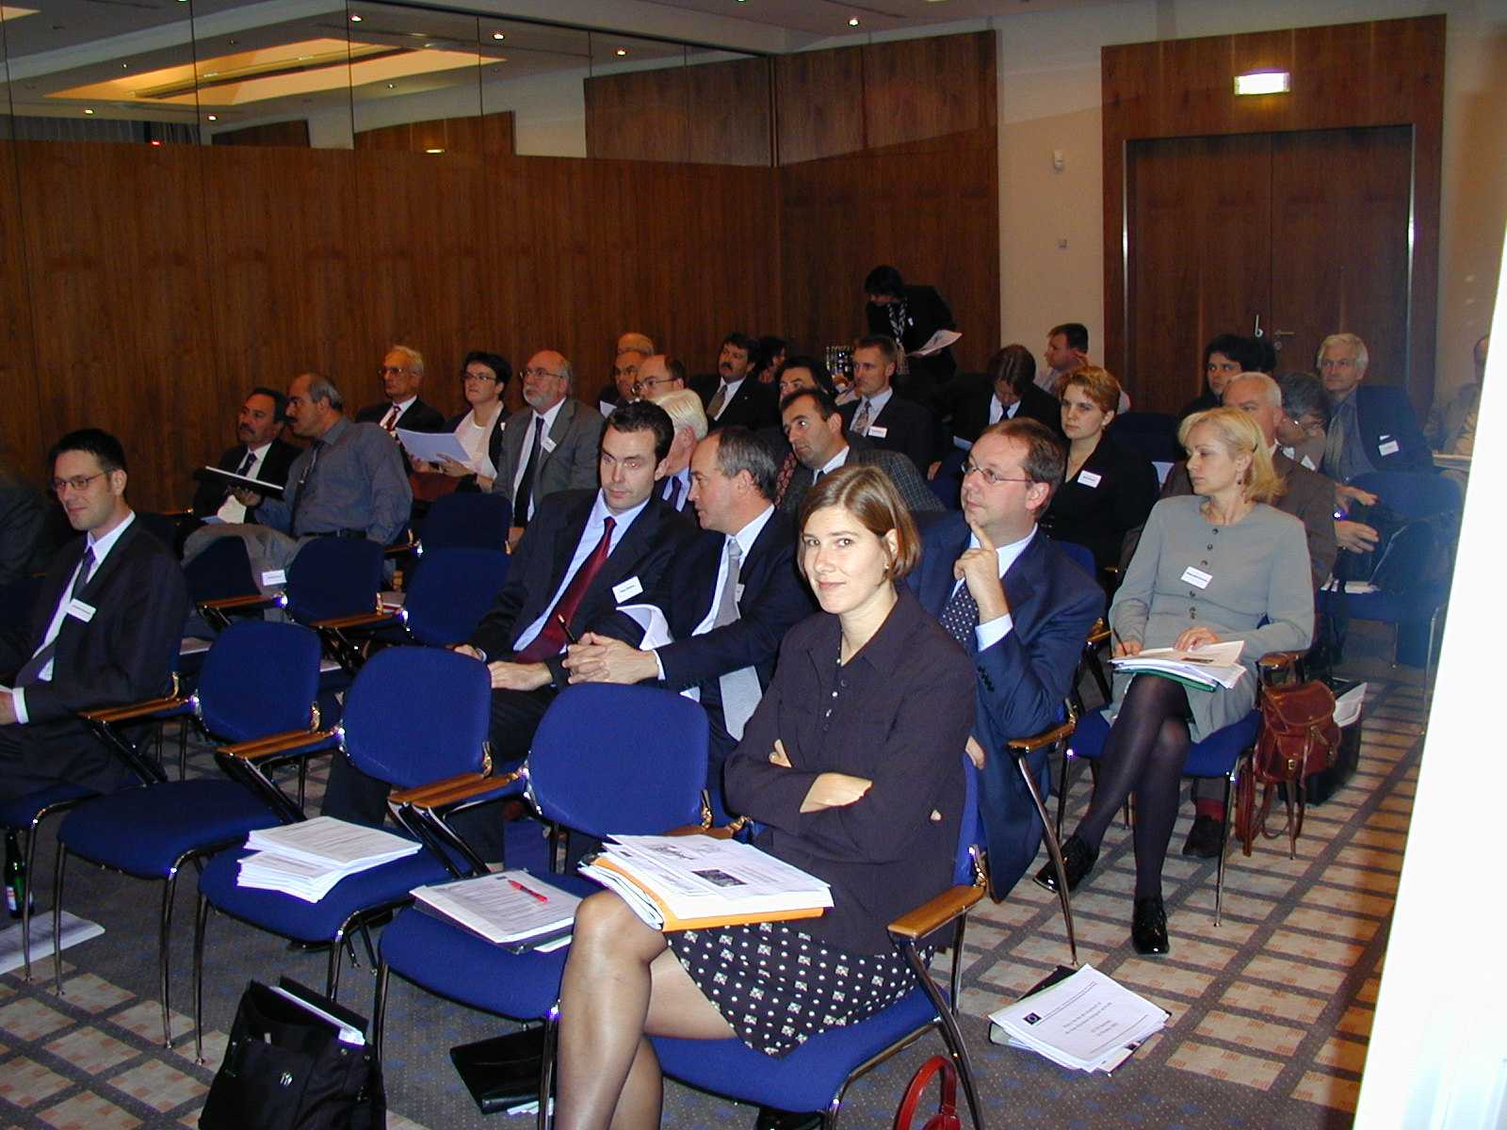
Figure 5. Clustering Seminar Prague 2001.

Commission White Paper, FP6, TEN-T policy, TINA-corridor policy and European Reference Centre for Intermodal Freight Transport (EURIFT were presented. Investment criteria were discussed.

A panel consisting of representatives from Czech Republic, Poland, Lithuania and Hungary was arranged.

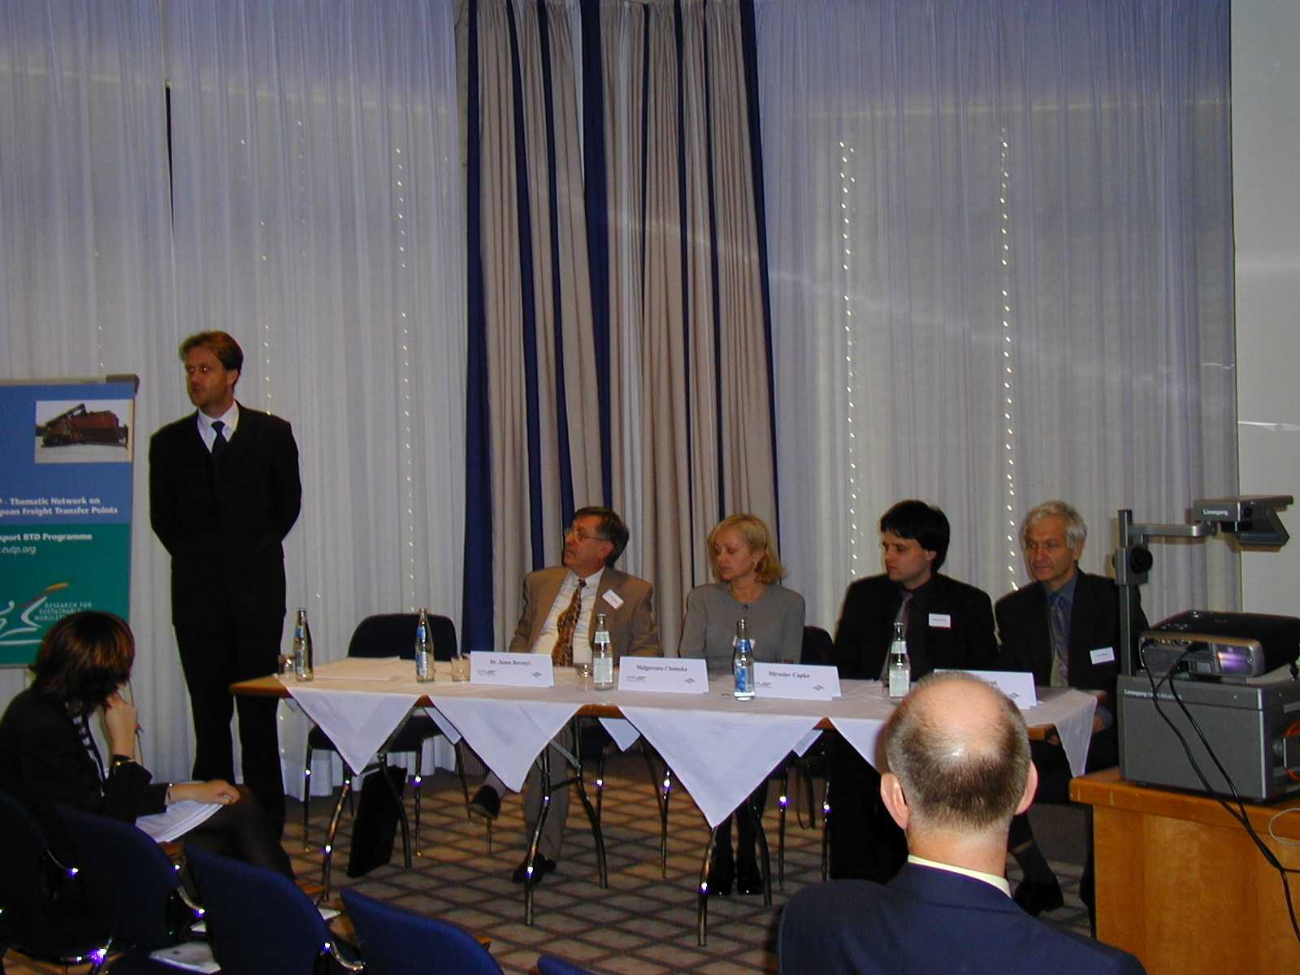
Figure 6. Panel in Clustering Seminar in Prague 2001.

4.34 3 Clustering in Rotterdam 2002

The 3rd EUTP Clustering Meeting was held in connection with the Intermodal Transport & Logistics Conference 2002 Conference.

In Cluster 1, Infrastructure, Transport Equipment and Transfer Means, the presentations covered three aspects of terminals; Funding policy developments, i.e. the German approach, use of freight platforms as a standardisation tool to improve service levels and quality and transhipment profiles and problems/opportunities in NAS countries, i.e. the Hungarian case.

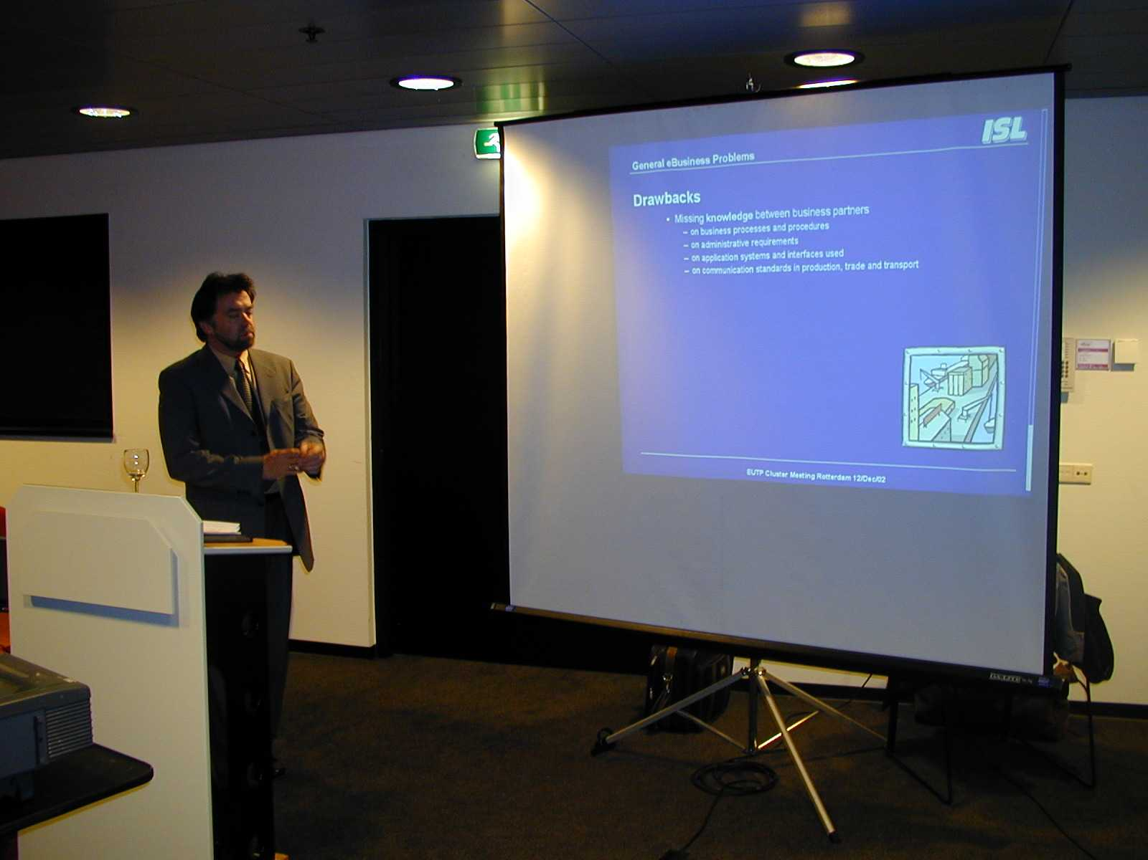
Figure 7. Mr Arendt from ISL in Rotterdam clustering 2002.

Cluster 3 covers information and communication systems. The presentations showed that – although covering different transport modes (shipping, inland waterway transport, combined transport) – obvious similarities can be detected. These are harmonisation of procedures and IT interfaces for clients, integration of systems instead of replacement and the use of EDI and web-based technology.

Nodes in the TEN-T network were discussed.

4.35 4 Clustering in Bologna 2003

Cluster 1 dealt with dedicated concepts for improving intermodal border crossing terminal operations, Polcorridor, Scanning the potential for intermodal transport and Securities such as sea safety, security of freight and shipments and monitoring of hazardous goods.

Cluster 2 discussed about horizontal transfer techniques and European Reference Centre for Intermodal Freight Transport, IT technologies such as radio-frequency transponders, satellite navigation/positioning systems and automatic identification of vehicles, cargo units and goods.

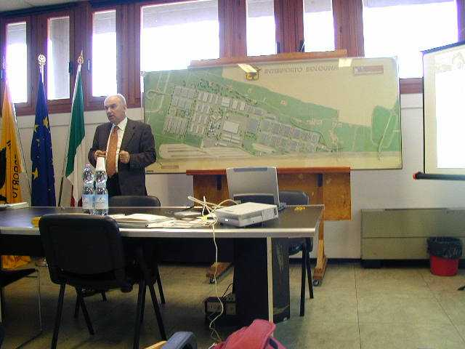
Figure 8. Mr Galloni presenting Interporto Bologna in 2003 Clustering.

4.36 Participation in Clustering Activities

Altogether, 197 people participated in nine clusters in four EUTP clustering meetings. 69 were EUTP members and 118 other participants. Clustering minutes are in annex 3.

Table 2. Participation in EUTP clustering activities.
 | Clustering Meeting Number
 | 1 | 2 | 3 | 4 | Total
Cluster 1 | 14 | 54 |  | 14 | 81
Cluster 2 | 16 |  | 22 | 14 | 52
Cluster 3 | 29 |  | 22 | 14 | 64
Total | 59 | 54 | 44 | 42 | 197

4.37 Clustering review report (EUTP Deliverable 3.1)

This EUTP deliverable 3.1 presents the main conclusions from the clustering meetings held. The cluster approach is employed to enhance the co-operation between national and European RTD on freight transfer points and to discuss research and policy issues with all relevant stakeholders.

Policy, Organisational Aspects and Network Integration
Elementary knowledge on intermodal terminal network on European level is lacking. Research is needed on this area. There is very little information on international Origin Destination (O–D) flows. Some EU financed research projects include this kind of information but further integration of this information is needed. Intermodal traffic needs a clear target, for example 10 or 20% share of the transport. Today, the definition of intermodal traffic is too narrow and unclear.

Framework conditions for intermodal transport, derived from supply chain management trends, are collaboration / partnership, supply chain visibility / transparency and outsourcing. How these trends are in line with the White Paper on Transport? The main messages of the transport policy are mode shift, eliminating bottlenecks and placing the user at the heart of the transport policy. The direction of European transport policy must change because now modal split and growth are heavily weighted towards road transport. Currently there is high congestion in urban areas and in the TEN systems. Are the main actions (integrating waterborne transport, promoting intermodality, eliminating bottlenecks by revising TEN guidelines and introducing efficient charging) enough to fulfil the policy demands and current business trends?

There is no common view of financing of intermodal terminals at the European level. Every country has different financing systems. Earning potential for investors is not clear. The financing mechanisms and cash flow potentials should be recognised and made explicit to prospective investors. In Germany the financial aid for terminal construction has stimulated the implementation of new intermodal terminals. Intermodal terminals are not included in the TEN-networks today. In case the terminals will be a part of TEN-network, also financial aid from EU should be introduced as a part of TEN financing policy.

An innovative use of inland waterways is needed to meet the challenges of the future. The realisation of multimodality requires an EC multimodal policy approach and a new way of viewing inland ports. Modes need to cooperate also on the policy side. Today the focus is mainly on rail-road when discussing intermodality. On the EC research side it is important to strengthening the coordination and avoiding repetition of work in order to make tangible results.

Improvement of the interoperability of transport networks at border crossing terminals inside the EU and between EU and CEESs is important topic. Removing of these bottlenecks e.g. border crossings will pave the way to new intermodal services. The INTERFACE-project (Dedicated concepts for improving intermodal border crossing terminal operations) is an attempt to improve the interoperability of transport networks at border crossing terminals – inside the EU and between EU and CEESs – in order to overcome the technical and operational barriers. The project aims at identifying and testing new ways to improve border crossing terminal operations.

A case of new intermodal corridor is Polcorridor which is a new freight corridor (road, ro-ro, rail and ship) stretching from the Nordic countries to SE Europe. Instead of running through Germany this corridor passes through Poland, Czech Republic and Austria. Development of this corridor is largely a question of organisational issues although there are also some issues of infrastructure improvements required.

Infrastructure, transport equipment and transfer means
Overview of previous EC research on intermodal transport and terminals shows that most of last decade’s research has focussed on the terminal and transhipment technologies which do not appear to be the main problem. The economic and efficient performance of the facility as part of the overall logistics chain is a key for competitive terminals operating at a high quality service level and integrated within the transport network.

The terminal should be considered as just one element of the complete door-to-door intermodal chain, and therefore terminal issues, especially as far as costs are concerned, should be evaluated within the general framework of the complete integrated transport chain. When looking for success and failure in a terminal or for a single technology used within there is no such feature as a definite success or failure. Success and/or failure always depend on the circumstances and a definite classification is not possible.

Improvement in the framework conditions to promote intermodal transport can be reached by effective services of the railways, strengthening the role and specific advantages of each transport mode, initial financial supports, optimal use of existing infrastructures and capacities and effective use of telematic systems. On the political side the “instruments” for supporting intermodal transport are subsidies, investments, taxation, regulations and legislation.

Recently some terminals have been built from scratch. The reasons for this are aims at cutting in operating costs, better service and capacity growth.

1995 study was conducted on behalf of German railways on how to attract combined transport to rail, so called Mega-Hub Project. The idea was to form mega-hubs to bundle container flows. The conclusion was that there should be 3 locations (north near Hanover, Woltzburg and South-West). The shunting procedure is not quick enough in itself and therefore the proposal was to tranship containers between trains – i.e. not to shunt but to tranship. The idea is that six trains would enter the terminal within a specific time window of 40 min, stay together for 20 min, and then leave. So after 90 min the position of some 360 containers could be changed.

The new horizontal transhipment technologies most likely to succeed are based on existing loading units and rolling stock. All In.hot.ra project demonstrators take containers from the train without the need to disassemble the train. They are designed for low scale terminals of 10–20000 loading units annually.

Objectives of standards are to reach interoperability between modes, infrastructure, equipment, involved partners etc, to liberalize the procurement of services and products and to reach high quality services. History has already shown that the prices in international transport (long distances) have dropped considerably (and globalisation increased) due to the successful introduction of a standard box. Harmonisation / standardisation is a tool to promote more efficient transport. It is possible to have stackable swap bodies. The box size is the same as for a trailer, width of 2,55m and maximum gross weight of 34 tonnes resulting in a maximum gross for the entire vehicle of 44 t. EU is not in favour of a 45 ft. box length because of problems it would create in the road network (not conforming to EU Directive on road vehicle maximum sizes), rail systems and in tunnels – also against rounded corners because it is a dangerous avenue to follow since industry will then want even more (e.g. a rectangular box)

Information and communication system
One of the main issues was to analyse the relation between requirements arising from the chain management perspective and solutions provided by nodes such as freight transfer points which is the scope of EUTP. The following topics are of priority:
- Cost-benefit aspects on implementation and operation of ICS (Quality of information, Automation)
- Automation
- Awareness and knowledge about ICS
- Technology harmonisation and standardisation
- Organisational aspects in the logistics chain (Market, Organisation/services)
- Exception management
- Technology.

The quality of information is in general too low and should be enhanced. Manual data entry leads to quality problems. If the costs for automating technologies will decrease, the quality of information will increase. Motivation of using electronic communication can be enhanced by bonus systems like in the Finnish Port@Net system. Because of the internationality of transport, harmonisation efforts should be performed globally and not restricted on Europe, i.e. including the US and Asia.

Supply Chain Management is a highly competitive market. Information is money, so there must be good reasons to make the processes and events transparent. If big players feel that they have a competitive advantage, they don’t like to support to their competitors. It is difficult to bring the big players together, e.g. for talks about harmonisation. Freight transfer points (e.g. Interporto Bologna or ports) already offer IT services for their companies or clients; extensions from Port Community Systems to the hinterland in order to support the chain perspective are in progress. Rail systems for tracking and tracing are not compatible and prevent interoperability.

The basic technology for solving operational problems in freight transfer points and along transport chains is there. Organisational and legal problems prevent the fast and efficient creation of solutions. One focal point is the question how to utilise and adapt existing technology in the best possible way. There are too many players and projects in e-network environment. Real needs of the industries and what is happening in the environment need to be understood better to capture the changes. Some actions can support this such as creation of a reference centre for freight terminals.

Today, there is lack of integration and interactive processing between the operating parties within intermodal transport and logistics chains. Intermodal transport can be made more attractive by reducing technical barriers by performing harmonisation of information exchange between CT operators and between operators and customers. Clustering gave three good examples of possible solutions:

- The integration of ports into intermodal transport chains by means of harmonisation of administrative procedures and offering a set of information and communication (ICT) tools and services for easing the mandatory data supply as well as the data delivery to other partners in the chain. There is a need only for a single entry point for administrative data which have to be reported on a mandatory basis. Use of the Portal concept allows the existing information systems to be integrated. Internet site and a decentralised virtual portal offer a set of tools and services.

- A software solution is developed to support intermodal transport chains. This solution is based on a central data hub. One special feature is the link between traffic and transport/ logistics information. There are different modules available such as order processing, chain planning, tracking & tracing, and deviation management. Also here, EDI and web-based interfaces exist.

- A web-based platform for combined transport has been developed allowing EDI communication as well. Operators created an add-on to their existing IT systems forming an umbrella and serving as one interface to clients for all three operators.
The system has modules on booking, tracking & tracing, irregularities and timetables.

The cluster presentations showed that – although covering different transport modes (shipping, inland waterway transport, combined transport) – obvious similarities can be detected. These are:
- Harmonisation of procedures and IT interfaces for clients, i.e. the users of transport services, in order to ease the way of generating and retrieving information
- Integration of systems instead of replacement (Single Desk, Central Database, Umbrella)
- Use of EDI and web-based technology in order to serve both levels of clients.

4.4 EUTP Seminars on new development in intermodal terminals

The following actions have been taken place:
- Technical visit to VR intermodal terminal in Pasila, Helsinki 9th of March 2001
- Technical visit to The Donau-Oder-Elbe Association, hosted by Otto Schwetz 26 of October 2001
- 2 EUTP seminars on new developments in intermodal terminals were held during the project lifetime (Minutes are in annex 4).
- Ludwigshafen - BASF - A case of public funded intermodal terminal in Germany 30 April 2003. 22 participants
- 2. Interporto Bologna – The case of a road / rail intermodal terminal in Italy December 2003. 12 participants.

4.41 Intermodal demonstration in Pasila intermodal terminal, Helsinki 2001

The presentation of the intermodal activities within Finland and towards the rest of Europe and Russia were made by representatives from VR. Titta Holmberg from VR explained the features of the RAILTRACE project. International rail traffic requires efficient ways to control international logistic chain. RAILTRACE is a consignment and wagon tracking and tracing system. It covers transport between most European countries and Russia. The users of RAILTRACE are export and import companies, railway operators and other logistics service companies that transport goods to Finland, from Finland or via Finland. RAILTRACE is the first open tracking system over the Internet. It integrates wagon and consignment information from various rail freight operators. RAILTRACE facilitates the control of the goods by combining online status information from various European railway operators and other logistics service companies. RAILTRACE service is implemented in co-operation with other European railways and other logistics service companies, RAILTRACE Partners. Information is exchanged every time consignment or wagon data is processed:
- on departure
- at border crossing
- at reloading
- on arrival.

Information from the checkpoints above is entered into a centralised database. RAILTRACE users may connect to the service via secured Internet interface and make queries to the database.

During the terminal visit representatives from VR (Finnish Railways) demonstrated some of the techniques used in Finland for intermodal transport of trailers, swap bodies and containers. The environment in particular at this time of the year demands some extra measures to be taken in relation to the low temperatures.

4.42 1st EUTP seminar in Ludvigshafen 2003

EUTP Seminar on new development in intermodal terminals was held on 30 April 2003 at Combined Transport Terminals in Ludwigshafen. The first part was BASF - A case of public funded intermodal terminal in Germany, hosted by Mr. Ralf Dahlinger. The programme dealt with composite structures and quantities, motivation for the construction of a CT Terminal and the state of the current terminal planning activities.

BASF is one of the world leaders in the chemical industry. Its product line comprises high-value-added chemicals, plastics, colorants and pigments, dispersions, automotive and industrial coatings, crop-protection agents, fine chemicals, oil and gas. Basf is producing 8000 commercial products from only 8 basic raw materials. The intermodal terminal handles 13,9 mio tonnes and over 100 000 TEU per year and 50'000 intermodal road/rail loadings per year. The modal share is 45% barge (16 ships a day), 31% road (1700 trucks a day) and 24 rail (370 wagons per day).

Opening of rail market created a Basf railway undertaking. Main goal for own railways was stimulation of competition. Outsourcing will happen when appropriate. Block train system exists. Problem area is border crossings. Motivation for building a new terminal was reduction of costs, higher performance and less traffic.

The next part of the programme covered business areas, terminal organisation and business. Twenty-one-meter high state-of-the-art gantry cranes with 36-meter spans tower over the railroad lines and truck tracks. The terminal has a maximum handling capacity of 150,000 containers annually. Basf is awarding company and owner of a terminal. KTL is a public terminal with integrated logistics functions. Investment was 28,2 mio € of which 20,7 federal funds. More demand exists but there are no slots available, also capacity is filled (capacity is 12000 units per month).

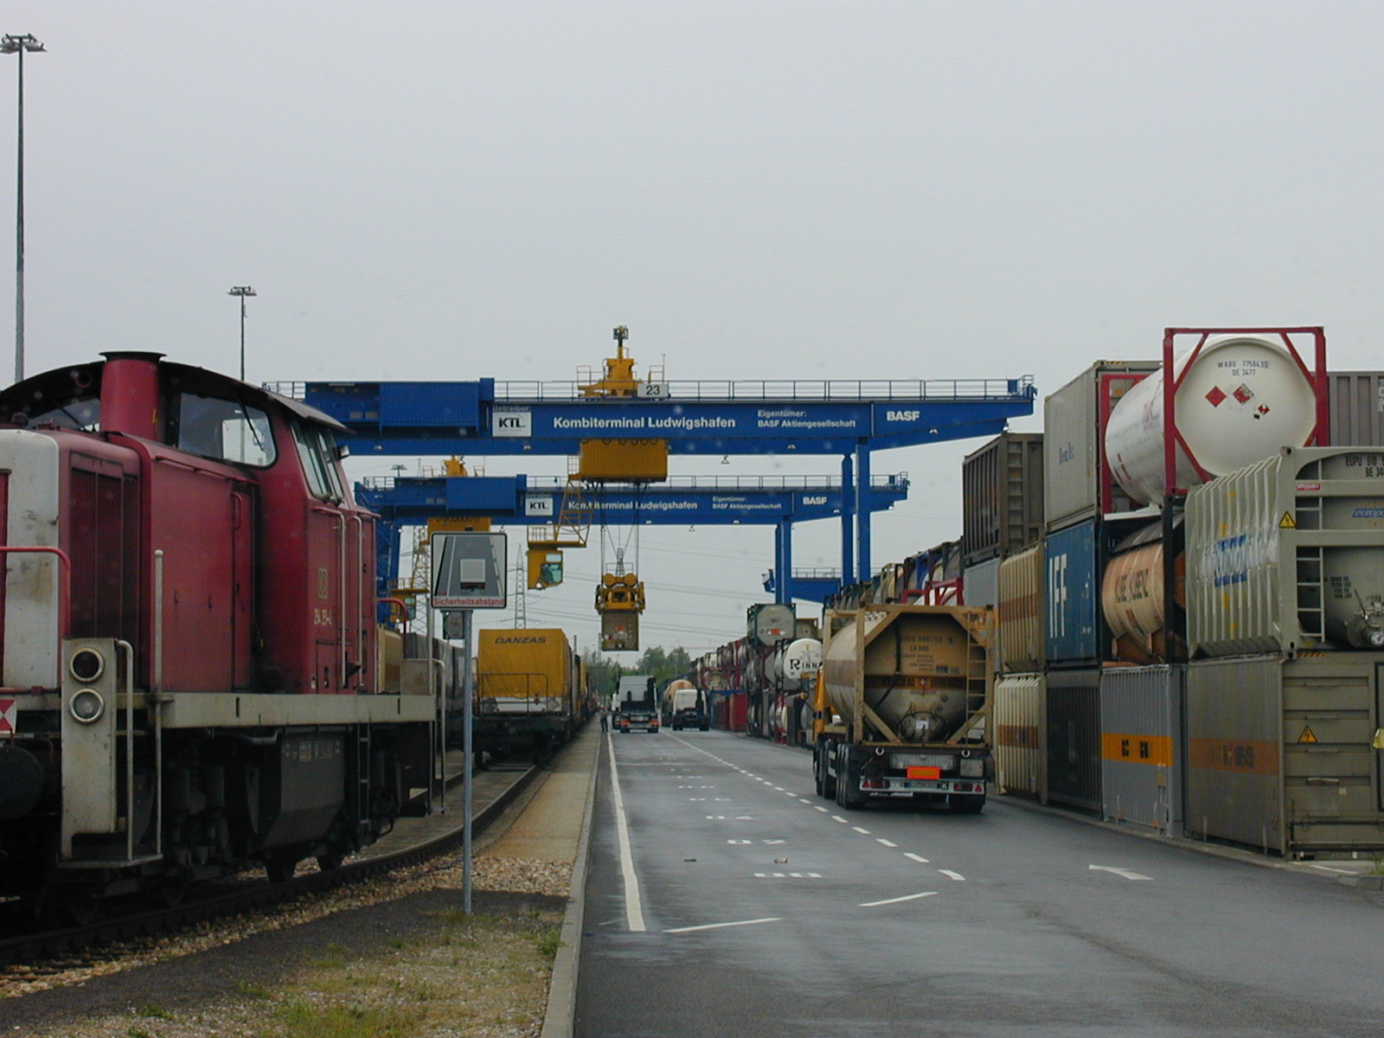
Picture 9 . BASF / KTL Kombiterminal Ludwigshafen.

Visit to CCS Combined Container Service GmbH & Co was hosted by Mr Heinrich Kerstgens.
Programme dealed with regular business transactions and operations on the rail/water/road trimodal terminals and terminal planning and realisation activities. CCS is a tri-modal combined container terminal, transport amount annually 300'000 TEU. Index of costs between Ludwigshafen–Rotterdam is 100 barge, 120 rail, and 180 truck
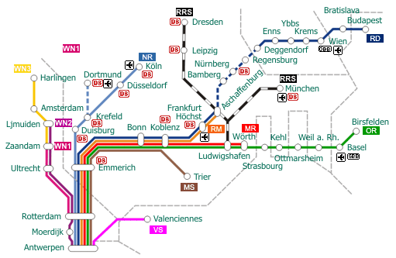
Picture 10 . CCS Rhine River traffic system.

4.43 2nd EUTP seminar in Bologna 2003

EUTP second seminar on new developments in intermodal terminals was held on 2nd December 2003 in Interporto Bologna. The case was a road / rail intermodal terminal in Italy, hosted by Mr. Gilberto Galloni, Managing Director of Interporto Bologna SpA. The Bologna freight village is an integrated system of infrastructure (intermodal terminal and logistic activity and transport services) aimed at carrying out all the transport and intermodal activities. It is a central focus point for the distribution of goods from north to south and vice versa. The Bologna freight village is managed by a Private Public Partnership (PPP).

Throughput was in 2002 2.2 million tonnes road transport and 1.7 million tonnes rail of which 822.000 container, 586.000 combined and 292.000 traditional wagon trains (e.g. bulk). About 400.000 lorries a day are moved. About 20% of the traffic arriving is to the intermodal terminal. Activities include:
- Determine the infrastructural requirements including the Logistics Centre layout
- Provide the general infrastructures, the warehouses and the integrated services
- Leasing and sales activities
- All related services – administrative, financial, commercial, operating management of the Logistics Centre
- Upkeep and management of common property
- Freight village is dedicated to both infrastructure and freight logistic services – no other commercial or industrial.

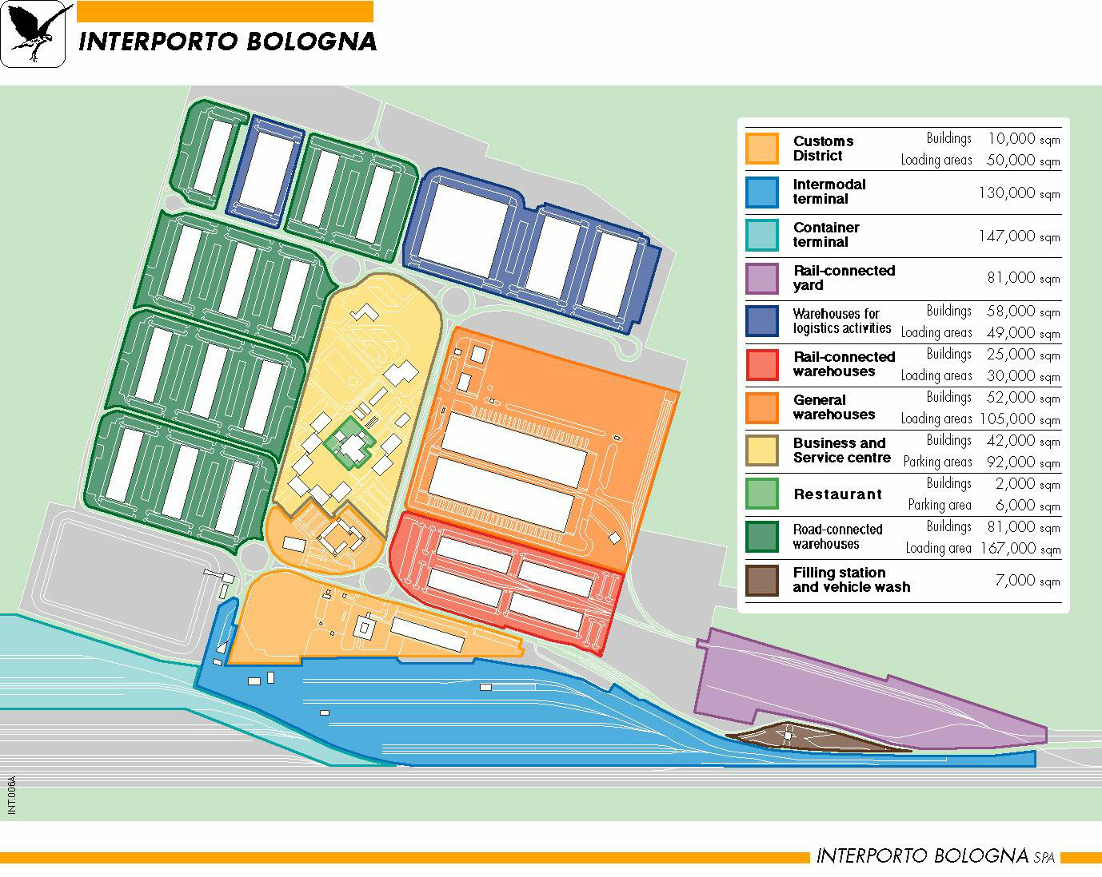
Figure 11. Interporto Bologna.

Interporto is working to improve the quality of the transport chain (by rail) serving ports on both the Mediterranean and Adriatic Seas and then connecting onward to Germany. The 81 companies in the freight village fall into the following categories:
- Couriers for distributing goods throughout Italy and in urban areas (Bologna)
- International forwarders
- Logistic service providers for storage and distribution of large quantities of industrial products, appliances, machinery etc world-wide.

The new approach in Bologna Interporto is to cater to the mid-sized industrial sector (companies that do not have the professional ability or dimension for out-sourcing) by providing warehousing and professional logistic services. National competitiveness and thus increased. The big challenge is reducing the cost of loading and unloading to encourage intermodal – otherwise it’s the lorry.

4. 5 Recommendations for policy and research activities (EUTP Deliverable 4.1)

4.51 Top priorities

EUTP Deliverable 4.1 provides a concise summary and analysis of the work established in WP2 Inventory and carried out in WP3 Clustering Activities. The goal is to identify interrelated RTD activities with a view to presenting future policy and research requirements. In this respect, bottlenecks in the field of intermodal freight transport and in particular those related to intermodal terminals are identified.

The following priority topics for improving the productivity of intermodal freight transport are identified and then described in terms of their definition and detailed tasks required for their elaboration.

Initiatives that can assist in policy making process for public and private investment strategies, in organisational aspects, and in new strategies for network integration deal with
- inland waterways
- Trans-European transport corridors
- logistics integration of the entire chain,
- interoperability issues between NAS and EU
- funding mechanisms for financing terminals, and
- planning principles for developing a terminal.

From the infrastructure, transport equipment and transfer means standpoint, successful technology development and innovation is key from a broad technological, economic and social perspective. Standardisation of loading units and as a tool for interoperability is another critical means to promote more efficient transport.

In terms of information and communication systems, better integration of existing and future systems is needed. This should be based on internationally agreed process and message standards. In certain areas also collaboration and often centralised systems (or a one-stop shop) are required. Furthermore logistics management tools are required to cover the whole transport chain and the establishment of a reference centre for freight terminals would improve knowledge and harmonisation transfer. As part of this the distribution of costs and benefits of ICT implementation and operation must be addressed.

Other future ideas include open access to SMEs in intermodal terminals, role of rail border crossings, efficiency of intermodal operations, gauge change between west/east and west technology, city logistics, safety and security of terminals and units (including tracking and tracing), the quality of intermodal transport services, inland navigation investment criteria and role, information and communication systems to compete with unimodal transport, co-ordination of timetables and the need to promote e-logistics so that it does not fall behind other e-business and communication.

Recommendations are then made to industry, transport operators, terminal owners, and policy makers with regard to the following general top priority themes:
- European intermodal terminal network
- Quality of services
- Security
- Organisation between actors
- Intelligence (IT and architectures).

4.52 Future priorities and outlook

From the top priority identified in the previous chapter, the participants at the EUTP 2003 Steering Committee Meeting (April 29 in Frankfurt) were asked to define the five most important future topics for improving the productivity of intermodal freight transport. These “top five” were:
- Logistics chain management tools
- Reference centre for freight terminals
- Intermodal nodes as a part of TEN network
- Organisational aspects in the logistics chain - integration of actor
- Centralised information/data for information flow management.

Based on all of the clustering activities and seminars carried out, they were later re-worked by the EUTP Consortium to be:

- European intermodal terminal network
There are three basic aspects:
- Basic knowledge of intermodal terminal network on European level is lacking.
- There is no common view of financing for intermodal terminals.
- Intermodal terminals are not directly connected to the TEN-T network

- Quality of services
Quality negotiations underway with traditional railways but no real results have been attained yet. Railways will not compensate if trains are late. Now end users are paying the same for a train regardless of how late it is. The Commission has proposed in the 3rd Railway Package a directive that makes a certain compensation obligatory. Good quality helps everyone i.e. client, operators and railways

- Security (in the terminal and along the chain)
Security is the priority challenge now. Currently, there is a lack of overall vision for implementing security measures for passenger and goods transport in an integrated fashion. There is a series of regulations e.g. IMO, WCO (World Customs Organisation) and in the maritime sector the new ISPS Code is creating tension The main question is, will ports become economic bottlenecks? In this respect need:
- To have adequate training for all actors along the entire logistics chain
- Traceability of goods which is becoming mandatory – need EC guidance for this
- To avoid disruption of competition (Europe cannot become marginalised)
- To ensure that security provisions should not become another burden to intermodal transport
- To co-ordinate world-wide at the national and international levels.

This requires a comprehensive research of existing regulations at an international level. Risk assessment along all points in the chain needs to be undertaken.

A remaining question is who pays for these standardised procedures? Operators may not be able to afford it and voluntary participation does not work.

- Organisation between actors
- Collaboration / Partnership which means sharing of information, processes and resources. Two examples are CPFR (Collaborative Planning, Forecasting, and Replenishment) and VMI (Vendor Managed Inventory). Collaboration needs standards and models (telematics architectures). Collaboration improves competitiveness (e.g. lower costs, shorter lead times, better quality of service).
- Supply Chain Visibility / Transparency. Visibility improves ability to manage (planning, control, tracking...) deliveries in all parts of supply chain (leanness, agility, responsiveness, bullwhip effect even out, management of incidents improves). Visibility improves effectiveness of the network (transparent data and metrics) - e.g. costs, lead times, inventory levels.
- Strategies – Outsourcing. Outsourcing is an ongoing process in all phases of supply chains, also in terminals.

- Intelligence (IT & Architectures)
IT and logistics must be integrated to form the smart supply chain.
The IT system can be:
- Terminal oriented – management of the internal operations from the gate to the shunting area. Terminal operating systems have many different modules that include: gate and truck monitoring, yard planning, ship stowage planning, rail planning, container packing information, customs access, EDI, equipment monitoring and performance reporting. These systems optimise yard space, minimise equipment utilisation, real-time monitoring of container handling etc. And in so doing, these integrated systems help shippers transact business efficiently.
- Intermodal network oriented – terminal to terminal communication (loading list) and management of the wagon fleet (maintenance, corridor allocation, positioning). Intermodal transport agencies operate different information systems. Co-operation is required for interchange of booking or accounting information. This is transmitted via different media (e-mail, EDI messages etc). The latest developments for CT are on-line booking systems (e.g. CESAR).
- Rail supply oriented – intermodal operator and railway.
Improvement of data exchange will have a major impact on the quality of intermodal transport processes. EDI systems are not currently used to their full capability (of the case studies Vainikkala is the most advanced). Much of the data exchange is still by paper. And, intermodal transport operators and terminal owners do not have direct electronic connect to the railway authorities.
- Integrated with the intermodal transport chain – physical, administrative and documentary information about the train. Currently, there are many isolated “closed” information systems used by the different actors along the transport chain. Interfaces and links between the different systems are nowadays happening still via fax or e-mail messages and are not automated.

4.6 Other findings of EUTP

4.61 The evolution of combined transport

65% of the combined transport (CT) in the past few years is made by UIRR member companies (maritime transport with containers is not included). Especially international transport has had a very high increase in the last 20 years. National traffic is stagnating more or less. Main traffic flows are:
- Rolling motorway – in the Alpine area and also between Hungary and Austria
- Unaccompanied traffic – Alpine crossing traffic (Germany–Italy, Austria, Switzerland and Belgium–France)
Some facts:
- In comparison, wherever normal EU railway conditions have flows that are relatively small even if long distances (e.g. Germany & Spain)
- UIRR member companies are handling 2,3 million consignments i.e. 9200 lorries a day on a average trip length of 600-700 km
- International traffic growth big until end of 90s (after 1998 only a few % points a year) – a now very severe quality problems in international traffic – this lead to operators in co-operation with railway companies set up working groups to start quality monitoring (about 20000 trains included) by collecting statistics about punctuality (technical and commercial delays) – RUs are main cause of delays (missing traction and loco drivers)
- Brenner axis is the first case of competition between railways (2 private ones) – overall quality has increased a lot for both private and traditional railway companies – demand also increased (1/3 more consignments carried than 2 years ago)
- Quality negotiations underway with traditional railways but no real results yet – railways won’t compensate if trains are late – now paying the same for a train regardless of how late it is – Commission proposed in 3rd Railway Package a directive that makes a certain compensation obligatory – good quality helps everyone i.e. client, operators and railways

UIRR membership – 19 members in 14 European countries – membership changing somewhat with some companies dropping out while others joining – certain concentration in operators – life for smaller operators becoming more difficult (need to collaborate with bigger companies to survive in the market) due to economic climate and liberalisation that causes some structural changes (prices rise and trend to complete trains that is costly to provide – need flow and capacity) – still far from market where real competition/liberalisation but on the way

Public opinion approves CT but often more in words e.g. between France – UK where now only ¼ of the traffic that had a few years ago – emphasis has been oh HS passenger rail – in terms of TEN projects that are big and prestigious need to do a cost-benefit analysis for each part because the financial means are limited (need maximum output for the input provided)

In terms of enlargement structure of traffic different – mainly unaccompanied traffic of loading units in western Europe while rolling motorway predominant in CEEC – traffic development stagnant now – rolling motorway use may change substantially due to removal of limitations after 1 May regarding lorry licences and ownership – need to manage the flows to maintain and even increase the flows – a danger is that many of the terminals in Eastern Europe need to be upgraded (i.e. handle larger containers) – road pricing will give an incentive to shift to CT and rail.

4.62 Mega-Hub Project in Germany

1995 study was conducted on behalf of German railways on how to attract CT traffic to rail. The idea was to form mega-hubs to bundle container flows. The conclusion was that there should be 3 locations (north near Hanover, Woltzburg and south-west). A competition was then held to determine the technology to handle the flows. The winning proposal was a mega-hub that was placed in a shunting yard that allowed bundling of CT as well as train splitting etc in order to form direct trains. The shunting procedure is not quick enough in itself and therefore the proposal was to tranship containers between trains – i.e. not to shunt but to tranship. The idea is that six trains would enter the terminal within a specific time window of 40 min, stay together for 20 min, and then leave. So after 90 min the position of some 360 containers could be changed.

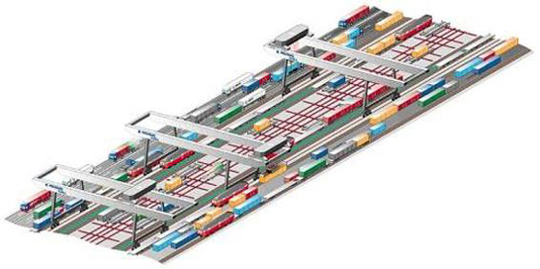
Figure 12. Noell Mega-Hub.

The technical solution to do this was selected and it was decided to first carry out a feasibility study and then a demo. But then the privatisation of German railways posed a problem. Two of the 4 new companies (DB Network and DB Cargo) were connected to the mega-hub project. The problem was that the guarantee required for public terminals was impossible to get since DB Cargo couldn’t be sure that they would use DB Net’s terminal due to the uncertainties involved in liberalisation.

The Ministry of Transport though still wanted to make use of the bundling / transhipment concept to divert traffic from road to rail. It was decided to set up a corporation of all partners that would be involved in running the trains. This process is now underway. Approval is expected at the end of 2003 at which time the terminal construction can begin.

The German Ministry of Research has launched a nation RD project and part of this deals with all IT requirements in such a mega-hub production system. There are also plans to set up gateway hub and spoke systems in Germany. They are applicable for all modes – air (e.g. Frankfurt), maritime (e.g. Singapore), and truck.

4.63 TEN - Where are the nodes?

The knowledge on intermodal terminals is lacking. Some discussion and a research proposal:
- there is a need to introduce intermodal freight villages in TEN for developing intermodality and improving the quality of the transport system (the transport chain and equipment)
- inland ports now have a Directive 1692/96/CE
- provide input to EU for revising TEN
- The proposal: 1st analyse the current situation (data collection, analysis and description of the current situation), then set the selection criteria (for road traffic and rail/maritime traffic) , an finally formulate a concrete proposal
- need collaboration and support from transport associations.

4.64 Terminal developments

UIRR terminals on the net (www.uirr.com) give an overview of 150 terminals (EU & NAS) in 14 countries:
- general info (operator, address, map, internet links to terminal manger etc)
- characteristics (cranes, tracks etc)
- main axes
- services.

4.7 Website and database

EUTP Website goals are:
- Comprehensive database of information
- Relationship to other websites
- Intermodal Transport Portal
- Dissemination tool.

The database contains current and past projects (both EU and national) dealing with intermodal transfer points, related papers and country reports. All database related issues were completed within the first project year and were continuously revised during the project to obtain even better functionality and usability. Database content is presented in the annex.

This is a tool for the analysis of ongoing and completed national, European or international RTD projects with a view to contribute to the development of a future policy and research approach.

The outcome, in terms of expanding the inventory of the state of the art and best practice developed in EUTP, is used for policy-making purposes and to identify shortcomings in the current national and European research efforts. This will have an effect on research activities in future RTD, TEN-T, ERDF and PACT / Marco Polo programmes, to mention but a few of the EU financed programmes/funds where transfer points constitute an integral part today.

The figure 15 displays the overall number of visits (monthly) to the EUTP Web site. There were 113 daily visits in average. The number of visitors was 10'112 (most from USA), of which 2366 visited more than once. Most downloaded document was ITIP D1 Annex 1 with 4842 downloads.

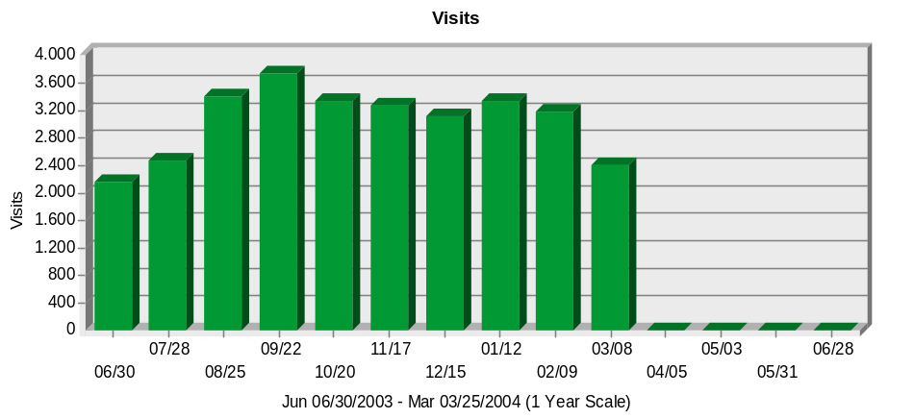
Figure 15. Number of visits in the EUTP website between 30.6.2003–25.3.2004.

4.8 Dissemination and exploitation

All of the papers produced (steering committee, clustering, seminars, country reports etc.) as well as a large number of related projects have been entered into the Website. Links to other relevant websites have also been established. And, the website has been updated.

EUTP has had in use its own business card, poster and CD.

An article "Co-ordination and dissemination" was published in Freight Transport review, spring 2003 by Public Service Communication Agency (www.publicservice.co.uk).

5 List of deliverables

Schedules of deliverables
Type and description of deliverables | Availability | WP | Responsible | Activity |  | Status
(Title) | C-R-P |  |  | Start | Due
D0.1 1st Progress Report  D0.2 2nd Progress Report/  D0.3 Mid-term ass. report  D0.4 3rd Progress Report  D0.5 4th Progress Report  D0.6 Final report | C  C  C  C  C  P | 0 | EURA  EURA/VTT  EURA/VTT  EURA/VTT  EURA/VTT  EURA/VTT  EURA/VTT | T25 | T25 | Approved  Approved  Approved  Delivered  This report  This report
D1.1 Supporting papers and minutes from the Steering committee meetings | P | 1 | EURA/VTT |  |  | Delivered
D2.1 Inventory on the State of the Art | P | 2 | EURA/VTT | T1 | T15 | Approved
D3.1 Clustering Review Report | P | 3 | EURA/VTT | T1 | T45 | Delivered 5/2004
D3.2 RTD Project Database | P | 3 | EURA/VTT | T1 | T40 | Existing
D4.1 Recommendations for policy and research activities | P | 4 | EURA/VTT | T1 | T24/T40 | Final Delivered 5/2004
D5.1 Information leaflets  D5.2 EUTP II Home Page | P | 5 | EURA/VTT  EURA/VTT | T0 | T2 | Finalised
C = confidential, R = restricted, P = public

All planned EUTP deliverables exist. Due to the changes in project coordination, deliverables D3.1 and D4.1 were delivered later than planned.

6 Results and conclusions

The Steering Committee concluded the following main findings:

Transport policy actions
- EU policy and national goals are in line with the White Paper - the objective is the shift from road to other modes; rail, short sea shipping and inland waterways
- There are several and different types of national investment and funding programmes for combined transport and subsidy programmes for terminals
- The toll system is expected to increase road costs by 15-20% in Germany - effects on rail pricing and mode shift are discussed
- TEN networks – port terminals are included in TEN but other intermodal non-port terminals such as road/rail are not
The are several national intermodal research programmes
Mode specific actions; rail
- There are subsidies for national rail operators in order to decrease intermodal freight prices
- There are also rail terminal financing aids
Mode specific actions; waterways
- Inland waterways development is ongoing (container vessels and traffic), a good example is the Via-Donau company
- Short sea shipping is also developing
Transport telematics
- New advanced information systems e.g. RIS and Cesar are promoting the intermodal market
Other actions which have influence on intermodal
- Road tolls
- East – West transport
- Research networks such as Nectar

Three clusters were created and each cluster consisted of members from the consortium and 6–8 experts selected from the research sector, the public administration and the transport industry. The goal of each cluster has been to define results and recommendations from research projects and from pilot and demonstration activities. Furthermore, each cluster will make recommendations for policy initiatives. The three clusters defined are:
- Policy, organisational aspects and network integration
- Infrastructure, transport equipment and transfer means
- Information and communication systems.

The main conclusions from the clustering meetings are the following:

Elementary knowledge on intermodal terminal network on European level is lacking. There is no common view of financing of intermodal terminals at the European level. Every country has different financing systems. Earning potential for investors is not clear. An innovative use of inland waterways besides road-rail intermodal transport is needed to meet the challenges of the future.

The terminal should be considered as just one element of the complete door-to-door intermodal chain, and therefore terminal issues, especially as far as costs are concerned, should be evaluated within the general framework of the complete integrated transport chain. Overview of previous EC research on intermodal transport and terminals gives the result that most of last decade’s research has focussed on the terminal and transhipment technologies which do not appear to be the main problem. The economic and efficient performance of the facility as part of the overall logistics chain is key for competitive terminals operating at a high quality service level and integrated within the transport network.

Standardisation is important mean to reach interoperability between modes, infrastructure, equipment, involved partners etc, to liberalize the procurement of services and products and to reach high quality services.

One of the main issues in information and communication systems is the relation between requirements arising from the chain management perspective and solutions provided by nodes such as freight transfer points which is the scope of EUTP. Key elements are harmonisation of procedures and IT interfaces for clients, i.e. the users of transport services, in order to ease the way of generating and retrieving information, integration of systems instead of replacement and use of EDI and web-based technology.

Participation in the EUTP has been wide including four different terminal networks that have been actively involved: Federation of European Private Port Operators (FEPORT), The European Federation of Inland Ports (EFIP), International Union of Combined Road-Rail transport companies (UIRR) and Europlatforms via Interporto Bologna.

The following priority topics for improving the productivity of intermodal freight transport are identified and then described in terms of their definition and detailed tasks required for their elaboration.

Initiatives that can assist in policy making process for public and private investment strategies, in organisational aspects, and in new strategies for network integration deal with
- inland waterways,
- Trans-European transport corridors,
- logistics integration of the entire chain,
- interoperability issues between NAS and EU,
- funding mechanisms for financing terminals, and
- planning principles for developing a terminal.

From the infrastructure, transport equipment and transfer means standpoint, successful technology development and innovation is key from a broad technological, economic and social perspective. Standardisation of loading units and as a tool for interoperability is another critical means to promote more efficient transport.

In terms of information and communication systems, better integration of existing and future systems is needed. This should be based on internationally agreed process and message standards. In certain areas also collaboration and often centralised systems (or a one-stop shop) are required. Furthermore logistics management tools are required to cover the whole transport chain and the establishment of a reference centre for freight terminals would improve knowledge and harmonisation transfer. As part of this the distribution of costs and benefits of ICT implementation and operation must be addressed.

Other future ideas include open access to SMEs in intermodal terminals, role of rail border crossings, efficiency of intermodal operations, gauge change between west/east and west technology, city logistics, safety and security of terminals and units (including tracking and tracing), the quality of intermodal transport services, inland navigation investment criteria and role, information and communication systems to compete with unimodal transport, co-ordination of timetables and the need to promote e-logistics so that it does not fall behind other e-business and communication.

Recommendations are then made to industry, transport operators, terminal owners, and policy makers with regard to the following general top priority themes:
- European intermodal terminal network
- Quality of services
- Security
- Organisation between actors
- Intelligence (IT and architectures).
- Annexes

Annex 1 The topics of national and international presentations made by national representatives in the EU Steering Committee meetings.
Annex 2 Minutes of the Steering Committee Meetings
Annex 3 Minutes of the Clustering Meetings
Annex 4 Minutes of the EUTP Seminars
Annex CD Presentations in the meetings
The database
Country reports

