TRAIN-ALL
Integrated System for driver Training and Assessment using Interactive education tools and New training curricula
for ALL modes of road transport
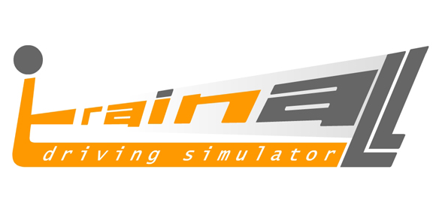
Contract no. 031517

Simulator sickness aversion design guidelines
Deliverable No.: |  | D3.9
Dissemination Level |  | Public
Workpackage No. | WP3 | Workpackage Title | Enabling technologies
Activity No. | A3.8 | Activity Title: | Simulator sickness aversion
Activity No. | A3.8 | Activity Leader: | COAT
Workpackage Leader |  | CERTH/HIT
Authors (per company, if more than one company provide it together) |  | M. Delahaye (COAT); Sebastian Poschadel (IFADO)
Status (Final; Draft; Revised Draft): |  | F
File Name: |  | TRAIN-ALL D3.9_final.doc
Project start date and duration: |  | 01 November 2006, 38 Months
Submission date: |  | December 2009
Version Number: |  | V3
Pages Number: |  | 47
Distribution |  | TRAIN-ALL Consortium

Version history table

Version | Date | Modifications
V1 | 8 December 2009 | First version sent to CERTH/HIT for comments.
V2 | 11 December 2009 | Second version sent for quality review
V3 | 18 December 2009 | Final version, after peer review comments; ready for submission

Table of Contents

Table of Contents 3
List of figures 4
List of tables 5
Abbreviations list 6
EXECUTIVE SUMMARY 7
1 Design and Development Guidelines for the Aversion of Simulation Sickness in VR Applications 8
1.1 Simulation sickness - causes and effects 8
1.2 Design guidelines on wayfinding, navigation and object selection and manipulation 9
1.2.1 Wayfinding 9
1.2.2 Navigation 14
1.2.3 Object selection and manipulation 18
1.3 Design guidelines on auditory and haptic output 20
1.3.1 Auditory output 20
1.3.2 Haptic output 21
1.4 Design guidelines on engagement, usability, comfort and ergonomics 22
1.4.1 Engagement and usability concerns (Presence and Immersion) 22
1.4.2 Comfort 24
1.5 List of technical factors influencing Simulator Sickness 25
2 Prediction of simulator sickness in TRAIN ALL 27
2.1 Introduction 27
2.2 Theories 27
2.3 Motion Sickness Susceptibility Questionnaire 29
3 BPP test results 30
3.1 Test design 30
3.2 Hypothesis 30
3.3 Results 31
4 HIT, CRF, VTI tests results 38
4.1 Test design 38
4.2 Hypothesis 38
4.3 Results 38
5 Checklist for simulator driving instructors 41
6 Conclusion 43
7 References 44

List of figures
Figure 1: VR System usability criteria 9
Figure 2: DOF restriction may provide better user movement depending on the application (IFA 2008 – Consumer Electronics Expo) 16
Figure 3: Natural Locomotion Device that allows lateral rotation while moving forward (Virtusphere Inc.) 17
Figure 4: Object manipulation using a wand device (Photo: Univ. of Central Florida CS Dept.) 18
Figure 5: Force-feedback enabled exosuit to enable full-body haptic display (Photo: Univ. of Buffalo – Dept. of Media Study) 21
Figure 6: High velocity change of scenery can lead to motion sickness (Photo: “The Mirror’s edge”, EA games) 23
Figure 7: Visually Disturbing use of patterns and textures (Photo: Anita Fontaine - a Second Life art installation) 23
Figure 8: Headtracked HMD Display in combination with haptic gloves (Photo: NASA R&D) Comfort and Ergonomics 24
Figure 9: The level of simulator sickness of each individual driver per minute for the first drive (highway); BPP tests 31
Figure 10: The level of simulator sickness of each individual driver per minute for the first drive (Urban); BPP tests 32
Figure 11: The level of simulator sickness of each individual driver per minute for the second drive (urban); BPP tests 33
Figure 12: The level of simulator sickness of each individual driver per minute for the second drive (highway); BPP tests 34

List of tables
Table 1: List of technical factors influencing simulator sickness (outcome of the discussion within the TRAIN ALL consortium and a summary of the literature survey) 26
Table 2: Motion History Questionnaire [Kennedy et al. 1992] 28
Table 3: The TRAIN ALL Consortium developed motion sickness prediction questionnaire 29
Table 4: Mean sickness scores per simualtor scenario; BPP tests. 35
Table 5: Correlation of driving experience and fatigue with mean sickness score per simulator scenario; BPP tests 36
Table 6: Correlations between the different sickness scores and all items from the “Simulator Sickness Prediction Questionnaire” (high correlations are marked in green): 37
Table 7: SPSS Items and overview of four possible models 39
Table 8: SPSS: significance check of four possible models 40
Table 9: SPSS: Significance level and beta weight 40
Table 10: Psychophysiological parameters which reflect simulator sickness (D3.8) 43

Abbreviations list
Abbreviation | Definition
ADAS | Advanced Driver Assistance Systems
BCI | Brain Computer Interface
CBT | Computed Based Training
ECG | Electro Cardiogram
EEG | Electro Encephalogram
EOG | Electro Oculogramm
EMG | Electro Myogram
FoV | Field of View
GADGET(matrix) | Driver Training model
GDE | Goals for Driver Education (driver training model)
HLA | High level Architecture
HMI | Human Machine Interface
IVICS | In-Vehicle Information and Communication Systems
NoE | Network of Excellence
P2P | Peer to Peer
SSQ | Subjective sickness Questionnaire
SWOT | Strengths, Weaknesses, Opportunities and Threats analysis
TLC | Time to Line Crossing
TTC | Time To Collision
VE | Virtual Environment
VR | Virtual Reality

EXECUTIVE SUMMARY
TRAIN-ALL developed an integrated simulator-based training system for land-based drivers of passenger vehicles, motorcycles, trucks and emergency vehicles. The TRAIN-ALL system is a cost-effective solution for training, assessment and monitoring of the driver student during all modes of vehicle operation (pre-trip, on-trip, emergency handling).

In order to make use of simulators, drivers/users have to accept them. The problem is that most people have severe physiological symptoms when they start driving in a simulator and therefore cannot focuse on the relevant task or even quit the drive. This Deliverable has a closer look at design guidelines to overcome the sickenss and to develop a questionnaire for people who might get simulator sick. Work reported in D3.9, as well as earlier work included in D3.8, is according to the Activtiy 3.8 of TRAIN-ALL ‘Simulator sickness aversion’.

The Deliverable gives an overview about:
- the SoA in design and development guidelines for the reduction of simulation sickness in VR applications,
- the development and validation of the „Simulator Sickness Prediction Questionnaire”. The questionnaire was developed on the basis of the theoretical background reported in D3.8 (e. g. physiological indicators, individual characteristics like mental rotation ability or the perceptual style). In continuation to D3.8, this Deliverable summarises the evaluation results during the pilot phase (using the “Simulator Sickness Prediction Questionnaire”). The questionnaire aims to help to predict simulator sickness and to identify people who might have a high risk of getting simulator sick. The original idea is that people with a high score in the questionnaire will undergo a special training (e.g. a short simulator training drive) at the beginning (before they start the actual simulator session).

Two data sets will be analysed. The investigators from BPP did a continuous evaluation and asked the participants every minute, how sick they were. Theses sickness scores were the background for hyothesis testing (e.g. sleepiness, driving experience, progress of the sickness, etc.). The predicitve validity of the „Simulator Sickness Prediction Questionnaire” was also tested. A second data set from HIT, VTI and CRF focussed only on the evaluation of the „Simulator Sickness Prediction Questionnaire”, with 50 participants. Both analyses are reported herein.

The main findings are summarised below:
- The most important outcome of the study was the identification of four items in a regression model which can explain 71 % of the variance of upcoming simulator sickness.
- Driving experience in years has a positive impact an the development of simulator sickness.
- The influence of fatigue remains unsolved: there is no evidence that participants who are more tired get sicker.
- After the third minute of driving most people develop more severe symptoms.
- Therefore: to overcome simulator sickness the pre-driving should be short but intense (urban road)!

Design and Development Guidelines for the Aversion of Simulation Sickness in VR Applications

Simulation sickness - causes and effects

The health and safety risks associated with Virtual Environment (VE) exposure complicate usage protocols of VR applications and lead to numerous usability concerns. It is thus essential to understand these issues when developing VR applications and creating Virtual Environments. The most important physiological effect attributed to prolonged VE exposure is described by the term Simulator Sickness or VR-induced Sickness.

Simulation sickness refers to a number of effects and symptoms relating mainly to motion sickness but also covering effects like balance disturbances, visual stress, disorientation, altered hand-eye coordination, dizziness, headache, nausea, fatigue, and general malaise [Kennedy et al. 1989] which may present themselves during the use of the VR system but also as after-effects following the end of a VE session. More than 80% of users will experience some level of disturbance, with approximately 12% ceasing VE exposure prematurely due to such adversity [Stanney et al. 2003]. Out of those who fail to complete a VE session due to simulation sickness, almost 10% can be expected to express nausea by means of vomiting or gagging, however in the totality of VE users these occurrences translate to 1-2% maximum. The effects of simulation sickness tend to manifest themselves more as the VE session tends to have a bigger duration [Kennedy et al. 2000].

The cause of simulation sickness is attributed mainly to what is called “cue or sensory conflict”. A simplified description of this effect is as follows: Under natural conditions of self-propelled locomotion, all of the sensory components of the basic orienting system of humans (vision, proprioception, kinesthetics etc.) transmit correlated information with regard to the position and motion of the body. In a synthesized environment, however, such as a VE where the user most of the times remains stationary while immersed in moving environments, the harmony which normally exists between the receptors can be disrupted so that the inputs from one or more of these functionally related receptors conflicts with the other inputs, and, as a result, the combined influx is incompatible with stored expectations. [Reason & Brand, 1975]. Studies have shown that the biggest conflicts experienced in VR systems are between visual and vestibular senses [Stanney et al. 1998].

From the above, it is evident that in order to design and develop VR applications that are safe to immerse in and non-taxing on the users’ physiological and psychological status, certain considerations must be taken into account and specific guidelines must be drawn that alleviate the majority of potential issues that stem from simulation sickness. The following diagram [Fig.1 – Stanney et al., 2003] depicts the way the usability of a VR system breaks down to specific subsystems and features of the system and the VE that is developed. In the following paragraphs, these guidelines will be presented according to each subsystem in the organisation of a VR system and categorised based on the area of application design and development they affect, along with suggestions on how the usability of VR applications can further improve as technology advances allow for better implementation of certain technical remedies to simulation sickness.
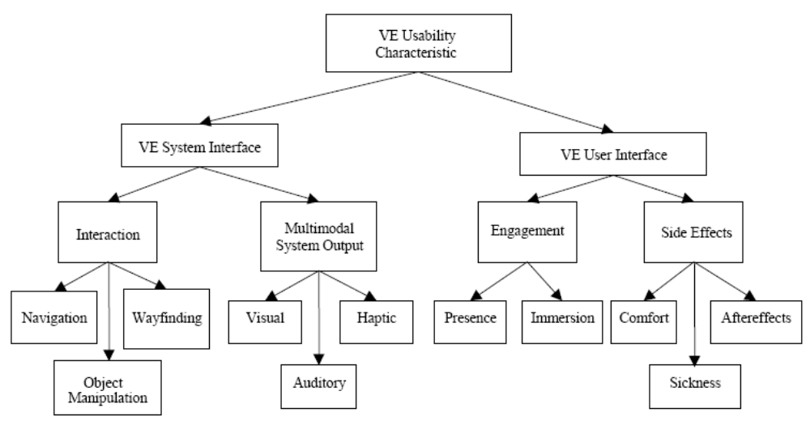
Figure 1: VR System usability criteria

Design guidelines on wayfinding, navigation and object selection and manipulation
As we have already discussed, one of the symptoms of VR-induced sickness is disorientation, which can either be manifested during a VE session or after its conclusion when the users try to acclimate themselves back into the real environment. In order to avert this symptom there are a number of questions that need to be asked during the design phase of a VR application that deal with navigating, wayfinding and manipulating objects within a VE.

In general, apart from designing and developing ways to avert specific issues that may trouble users once they are immersed inside a virtual environment it is always good practice to verbally describe to them what kind of environment they are entering, what is their purpose within this environment and what are their immediate goals, beforehand. This way, the users will have at least a general impression of how the world they are entering will be and thus they will be less prone to a sudden mismatch of experience between real and virtual world.

A tutorial on use of the system is also imperative, before the users begin their session, so that they get accustomed to its characteristics, the form and fit of any hardware that they may have attached, the navigation methods they will have at their disposal, the proper use of the interaction device used as well as the limits of the system with regard to mobility, view angles, feedback, etc.

Wayfinding

By wayfinding we describe the ability of a user to orient and position themselves inside a VE. This means that when we design a Virtual Environment, we need to make sure that the users are able to always know where they are inside the virtual world. By providing sufficient clues and methods to orient the user inside the virtual environment we make sure that there is no ambiguity on the users’ location, orientation and spatial understanding of their environment.

Therefore we need to address the following questions during the design phase of a Virtual environment as well as take steps so that the VR application implementing this environment provides the means to fulfil these requirements:

- How will the users know where they are in the virtual environment (e.g. in which position on the road, or can the user watch out as far as he wants for example when he goes into a curve, etc.)?
- Does the system provide appropriate types of user wayfinding support? (e.g. naïve search, primed search, exploration) [Darken & Smith, 1996b]
- Does the system facilitate the users’ acquisition of survey knowledge on their surroundings? [Darken & Smith, 1996a]
- Is the environment properly labelled in key locations and are landmarks included in that environment? [Bennett et al. 1996], [Darken & Silbert, 1996a, 1996b]
- Is there a mechanism present that the user can use to determine their location at will? (maps, compass etc.)
- Does the system effectively provide information to determine where the user wants to go and how to get there? [Wickens & Baker, 1995]
- Is aural information effectively used to provide additional directional and distance cues?
- Does the system provide effective 3-dimensional audio feedback when separation, isolation, position, spatial or directional content are required? [Barfield & Danis, 1996]
- Is sensory information other that visual or auditory provided to assist in wayfinding?
- Are environmental cues and their effects (e.g. wind, rain, fog) effectively integrated and presented with regard to the users’ location and situation?
- Is variety of scenery used effectively to distinguish between areas of the VE?

Taking these requirements one by one we can use a number of methods to fulfil them:

1. How will the users know where they are in the virtual environment?

There are specific visual cues that can be used to effectively place the user in a distinct location within the virtual environment and do so without ambiguity or false interpretation.

One of the basic visual cues is the distinction between ground and sky, namely, a visible horizon. The user must always be aware which side is up and which down inside the virtual world and the presence of a horizon is paramount to this effect. In addition, incorporating realistic visual details in the sky such as the sun, the moon, clouds etc., further provide the users with static or semi-static landmarks in the sky in order to orient themselves.

The use of uneven terrain or relief is another visual cue that gives the users a sense of position and direction. Although not as direct as the presence of specific landmarks that is discussed further on, the use of a non-flat terrain helps alleviate inconsistencies when the users are moving their views laterally.

2. Does the system provide appropriate types of user wayfinding support? (e.g. naïve search, primed search, exploration)

Wayfinding tasks are classified into three primary categories:
Naïve search: Any searching task in which the navigator has no a priori knowledge of the whereabouts of the target in question. A naïve search implies that an exhaustive search is to be performed.
Primed search: Any searching task in which the navigator knows the location of the target. The search is non-exhaustive.
Exploration: Any wayfinding task in which there is no target.
The classifications of wayfinding tasks are mutually exclusive. However, they are often compounded into sequences. In cases where the navigator has general knowledge of the target's position without enough precision to find it directly, a primed search is performed to the target's general proximity followed by a naive search within that area.
Although purely naive searches are rare in the real world, in virtual worlds, spatial naïveté is common in first-time explorers of a space; even by the world builder. E.g. a scientist visualizing data sets computed off-line may have no preconceived idea as to the shape or organization of the data. Therefore, wayfinding assistance requires support for both exhaustive and directed searches and must facilitate topological knowledge acquisition.

An optimal exhaustive search requires that the user traverses the entire space once (in the worst case). To facilitate this, there must be a method of organizing the space to eliminate multiple passes or skipping entire areas. A primed search, on the other hand, requires only that the navigator knows a path to the target. If movement is unrestricted, (as it often is in virtual worlds) the navigator needs to only know the direction and distance to the target. Minimal configurational knowledge is required relating the navigator's present position to the target's position.

3. Does the system facilitate the users’ acquisition of survey knowledge on their surroundings?

Wayfinding tasks in general require that the navigator be able to conceptualize the space as a whole. This is analogous to what Thorndyke refers to as survey knowledge. [Thorndyke, 1983]
Survey knowledge represents configurational or topological information. Object locations and inter-object distances are encoded in terms of a geocentric, fixed, frame of reference. Survey knowledge is map-like in nature. Accordingly, it can be acquired directly from map use. However, survey knowledge acquired from a map tends to be orientation-specific. Prolonged exposure to navigating an environment directly results in survey knowledge which tends to be orientation-independent.
Survey knowledge is hierarchical in nature [Stevens et al. 1978]. Rather than encode the absolute positions and directions to every place encountered, fewer large, general, logically selected places (e.g. Athens, Greece) are encoded with subnetworks of smaller, more specific places (e.g. The Acropolis) being defined within each.

4. Is the environment properly labelled in key locations and are landmarks included in that environment?

Based on what is known about spatial knowledge and its role in wayfinding tasks, environmental designers have concerned themselves with developing a design methodology focussed on environmental organization and map use. Urban elements such as paths, landmarks, and districts can be used to divide the environment into smaller, clearly connected, more manageable pieces. These pieces can then be directly encoded into a hierarchy of spatial knowledge. The importance of frequent directional cues to orientation maintenance. Similar is the case on outdoor environments, where sufficient landmarks must be included to distinguish an area from another (e.g. a stream or a cabin in a forest area can be used as a landmark).
[Passini, 1984] expanded on these ideas applying them to architectural design. A space should have a basic organizational principle behind it. For example, Manhattan's streets are organized in a grid. We use this information directly to structure spatial knowledge. Most importantly, a space must have in it a number of "places" which are easily discernible to any wayfinder. A "place" is most simply defined as a distinct, recognizable location or region of a larger space. Passini also notes that if a map is to be used, it should show the organizational principle of the space as well as the design elements described by Lynch. The observer's position must always be shown and Levine's forward-up principle must be adhered to.

5. Is there a mechanism present that the user can use to determine their location at will? (maps, compass, etc.)
As in all wayfinding tasks, wether they are to be performed in the real or virtual world, having a graphical representation of the area where the users’ can position themselves on a larger scale of what they can experience in person, always provides better understanding of their bearings and orientation. However, in virtual environments, there are cases where the use of maps is either not feasible due to the inability to represent the virtual world in fewer dimensions (as is the case in the example of visualising datasets mentioned above).

The resulting inflexibility of spatial knowledge acquired from maps leads us to study what effect this phenomenon has on map design. What research on the subject showed is that in order to facilitate efficient map use, the map must be congruent with the environment it represents. This is illustrated in the forward-up equivalence principle which states that the upward direction on a map (assuming it is mounted perpendicular to the floor) must always show what is in front of the viewer.

The use of other paradigms used in the real world (e.g. a compass, altimeter, etc.) is desirable in many cases but also limited to applications where the virtual world is a representation of the physical world.

6. Does the system effectively provide information to determine where the user wants to go and how to get there?

If we combine the previous 3 requirements we are lead to the conclusion that survey knowledge is the key to successful wayfinding in any environment. Therefore, based on the literature previously introduced, a set of design principles is presented for wayfinding augmentations to virtual worlds which will facilitate survey knowledge acquisition.
Organizational principles are meant to provide the necessary structure by which an observer can mentally organize the environment into a spatial hierarchy capable of supporting wayfinding tasks. The basic principles are:

Divide the large-scale world into distinct small parts, preserving a sense of "place".
Organize the small parts under a simple organizational principle.
Provide frequent directional cues.

The importance of maps to spatial knowledge acquisition cannot be overlooked. Ideally, this knowledge should be flexible, as if the observer had obtained it from direct experience. Therefore, the design principles below are intended to present spatial information in such a way as to produce a flexible, orientation-independent representation of the environment. The basic principles of map design are:

Show all organizational elements (paths, landmarks, districts, etc.) and the organizational principle.
Always show the observer's position.
Orient the map with respect to the observer such that the forward-up equivalence principle is accommodated.

7. Is aural information effectively used to provide additional directional and distance cues?
In the recently widespread GPS systems used in cars, the visual information provided combines a map, directional cues overlaid on the map and positional and distance values. The system’s users, however, is not able to focus attention on the GPS screen while performing the task of driving to obtain this information in order to position and orient themselves. The use of a text-to-speech system provided solves this problem by providing aural information about these cues to the drivers freeing them to perform their task. Similarly, there are applications in VR, where the user needs to focus on a task while maintaining survey knowledge. To this end, a VR system should automatically provide aural information when it is required by the circumstances of the users, but also be manually invoked if so the users require.

8. Does the system provide effective 3-dimensional audio feedback when separation, isolation, position, spatial or directional content are required?

The importance of 3-dimensional audio is second only to visual cues regarding one’s placement into an environment since they define the position, orientation, direction of motion, occlusion, texture and other aspects of objects within a virtual world. When used in conjunction with visual stimuli they create a realistic representation of one’s surroundings and help orient the user in a much better way than monaural or stereo audio cues. The way that the sound reflects and refracts on the objects within the users’ surroundings provides information that users may not be able to discern solely by visual information provided. Therefore, the inclusion of a 3d-spatial sound system is of great importance when developing a VR system.

9. Is sensory information other that visual or auditory provided to assist in wayfinding?

In certain VR applications, depending on the way the user interacts with the environment cues other than visual or auditory may be of use to help the users position and orient themselves within the world. When olfactory information is provided, e.g. smoke, the user can understand non-visible information such as the presence of a fire hazard nearby. When haptic information is also provided, the users can ‘feel’ their surroundings augmenting in this way their understanding of where they are in the virtual world.

10. Are environmental cues and their effects (e.g. wind, rain, fog) effectively integrated and presented with regard to the users’ location and situation?

Coming back to visual cues, the realistic visualisation of environmental effects is very important in order to provide relevant sensory information. The visualisation of rain e.g. provides a static visual cue that is always presented relative to the users’ position, thus helping alleviate some of the ill effects of lateral motion. Fog and what is called a ‘soft horizon’ (the blurring of the horizon as is the case in the real world due to heat or haze) also provide more realistic representations of actual environments and directional cues. As it is mentioned throughout this report, the more realistic the visual cues in a VR application, the less conflicting the sensory information is for the users’ and therefore the less evident are the effects that cause VR-induced sickness.

11. Is variety of scenery used effectively to distinguish between areas of the VE?

In order to avoid confusion and to provide a better organization of a Virtual Environment, it is important that the areas within the VE are not filled with similar objects but a variety is used, in order to distinguish between areas and provide better orientation cues. E.g. in an urban environment, the designers must make sure that the houses, streets, signs and other props used are not all copies of the same models but enough variety is employed to help the users obtain a survey knowledge by distinguishing each area from its neighbors. Similarly, in a rural area, the use of a variety of plants, rocks, fences etc. helps make areas not look the same to each other.

Navigation

Similarly as in the case of wayfinding, by navigation we describe the actions and means available the users have at their disposal in order to move inside the virtual environment, re-orient themselves, and interact with their surroundings by means of relocating themselves within them. Aside from simple head movements, navigation is the most basic and common type of interaction within a virtual environment [Bowman, 1999]. For most VE users, navigation (i.e., travel) is what is necessary to allow users to move into position to perform required tasks. Navigational techniques should be easy to use and not cognitively cumbersome or obtrusive. Unfortunately, current VE navigational techniques have not always met these criteria, which oftentimes leads to VR-induced sickness. Here are the basic design and implementation considerations for efficient navigation within a VE.

- Is it easy for users to move and reposition themselves in virtual environment [Kalawsky, 1999]?
- Does system avoid use of mode-based navigation where only locomotion is allowed [Fairchild et al., 1993]?
- Is the level of user movement control appropriate for task(s) [Kalawsky, 1999]?
- Does user control metaphor effectively match application tasks [Fairchild et al., 1993], [Neale and Carroll, 1997]?
- Are user movement DOF (Degress of freedom) integral and separable [Jacob et al., 1994], [Zhai and Milgram, 1993b]?
- Do extraneous user movement DOF, those not necessary to support tasks, make user movement difficult [Hinckley et al., 1994]?
- Does system effectively use multiple (integral) DOF for coarse user movement, high gain for gross user movement, low gain for fine user movement and separable DOF for precision user movement [Hinckley et al., 1994], [MacKenzie, 1995]?
- Is user movement constrained by natural locomotion devices (e.g. treadmill) [Slater et al., 1995]?
- Is hand-based steering employed when little object manipulation is required, users are seated, and/or when there is limited space [Dandekar et al., 1998]?
- Is head-based steering employed when direction of gaze and travel are logically connected [Bowman et al., 1997]?
- Is concurrent object manipulation and body-centered steering (e.g. head-based steering) supported [Davies, 1996], [Slater et al., 1995], [Dandekar et al., 1998]?

The requirements stemming from the aforementioned considerations are the following:

1. Is it easy for users to move and reposition themselves in virtual environment?
The ability to move and reposition oneself easily and intuitively inside a virtual environment is most important when it comes to maintaining a correlation between the users’ senses. If the motion of the users does not follow the rest of the stimuli they receive from the system, then the probability for simulation sickness effects increases dramatically. The designers and developers of VR systems must make sure that motion is unhindered by outside restrictions and that the resulting movement and positioning of the user within the environment matches the users’ expectations.

2. Does the system avoid use of mode-based navigation where only locomotion is allowed?

When the users are abruptly forced to change from one mode of motion to another then simulation sickness effects are prone to appear. When, for example, the user expects to continue walking (in place most of the times) and then the system switches the motion one of flying or hovering, then the continuity of motion perception for the user breaks with resulting sensory discrepancies. Whenever it is necessary for the user to change modes of navigation the system must warn beforehand and allow for the user to get accustomed to the new mode.

3. Is the level of user movement control appropriate for task(s)?

Depending on the task the user is required to perform, the designers of the system must take into consideration, the appropriateness of movement control to that particular task. If, for example the task is to drive a land-based wheeled vehicle, the user must be seated accordingly and no other motion must be allowed than what is required to control the vehicle and change the users’ viewpoint. If on the other hand, the users must perform a virtual operation, they should be able to freely rotate around on a fixed position, in order to access tools, materials and the virtual patient at the same time.

4. Does user control metaphor effectively match application tasks?

Depending on the task at hand for each VR application, the control metaphor must as well as possible match the equivalent in real world (if such an equivalent exists). If the application involves control within completely synthetic environments (e.g. manipulation of data visualisation in 3-dimensions) the control metaphor must as closely as possible match the users’ expectations of how such a control scheme must be. The system must provide alternative methods of control where this is possible in order to allow for more user customisation. This way, cue conflict resulting from unmatched user expectations with regard to control will be mitigated.

5. Are user movement DOF integral and separable?

Each of the users’ degrees of freedom regarding their movement must be integral and separated from the others (e.g. moving forward should produce a forward motion in the application and none other). This requirement ensures that the users’ movement expectation does not conflict with the resulting movement they experience in the VE.

6. Do extraneous user movement DOF, those not necessary to support tasks, make user movement difficult?

If the task required involves a reduced set of DOF, then it is most of the times, more confusing for users to be able to use the extra DOF they have at their disposal. If, for example, when in a driving simulator application (Fig. 2), the user can also rotate their virtual bodies laterally, horizontally or vertically inside the virtual car, then they are distracted from the required task which only involves rotating their head and using a set of controls to manipulate the vehicle’s motion, thus resulting on sensory overload.

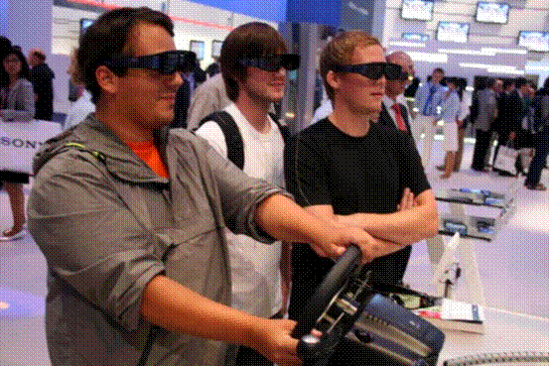
Figure 2: DOF restriction may provide better user movement depending on the application (IFA 2008 – Consumer Electronics Expo)

7. Does system effectively use multiple (integral) DOF for coarse user movement, high gain for gross user movement, low gain for fine user movement and separable DOF for precision user movement?

The system must provide different DOF schemes depending on the task at hand. Moreover, it must provide different degrees of amplification of the users’ actual motion to resulting motion within the VE. However, this amplification must remain relative to what the users perceive as ‘normal’ rates in acceleration, torque, impulse etc. In cases when the task requires precision, the system must be able to separate the DOF on user request to make such tasks easier to accomplish, thus reducing frustration, confusion and irritation.

8. Is user movement constrained by natural locomotion devices (e.g. treadmill)?

Whenever external natural locomotion devices are used, the designers of the system must make sure that such devices do no hamper or constrain the users’ motion in any other way than what the device is designed for. If, for example a treadmill is used to emulate a walking sequence, then the system must not allow for rotation because this is counterintuitive to the degrees of freedom of motion a treadmill allows.

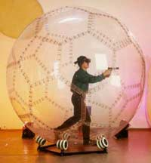
Figure 3: Natural Locomotion Device that allows lateral rotation while moving forward (Virtusphere Inc.)

9. Is hand-based steering employed when little object manipulation is required, users are seated, and/or when there is limited space?

Since humans are accustomed to move using their bodies, in most cases it appears counter-intuitive to use a hand-wielded device or other hand-based scheme to perform steering within a virtual world. However, in cases where the users’ motion is inhibited either by lack of space or user stance, such steering schemes are necessary. It is the designers’ responsibility to provide the best possible control scheme and feedback for such steering methods, in order to make the experiences as less disconnected from users’ expectations as possible.

10. Is head-based steering employed when direction of gaze and travel are logically connected?

Studies have shown that when the direction of gaze and travel logically coincide, users tend to prefer steering directly with their head than with any other methods. However, it is very important to make sure that such a motion is lag free and the visual refresh rate is fast enough to provide a constant motion, otherwise this kind of steering mechanism can lead to dizziness and nausea.

11. Is concurrent object manipulation and body-centred steering (e.g. head-based steering) supported?

Whenever the task of a VR application requires the users to concurrently manipulate an object and at the same time move their virtual selves within the VE, then a body-centred steering scheme is the most appropriate in order to decouple the use of the users’ hands from the movement and allow the manipulation of the object to be performed efficiently and naturally. This way, the user does not get confused as to what is the action attributed to their hands and they can focus on the task they have to perform.

Object selection and manipulation

The second most important aspect of user interaction, apart from navigation within a VE, is object selection and interaction. All tasks within a VR application require some form of interaction with objects of the virtual world, therefore it is imperative that the method used to select and manipulate objects does not conflict with the other subsystems of the VR application in order to avoid VR-induced sickness. With this in mind, the following is a selection of the most important considerations on object selection and manipulation in the bibliography.

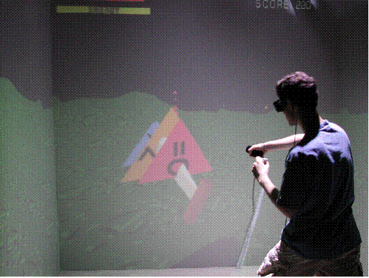
Figure 4: Object manipulation using a wand device (Photo: Univ. of Central Florida CS Dept.)

- Input devices should be easy to use and control (not too sensitive or too sluggish) (Fig. 4) [Kalawsky, 1999].
- It should be easy to select, move, and alter basic attributes of objects (color, shape, labels) [Kalawsky, 1999].
- Object selection points should be obvious and clear, and it should be easy to select multiple objects.
- Bounding boxes, marquees, rubber bands or other means to readily select multiple objects should be used effectively [Mapes and Moshell, 1995].
- Transparency should be used to avoid occlusion during object selection [Hinckley et al., 1994; Zhai and Milgram, 1994].
- Query formation (command or speech input) can be used to assist with object selection methods [Esposito, 1996].
- When selecting distant objects via direct manipulation, size, appearance, and inter-object distance should be effectively exaggerated [Mine et al., 1997].
- It should not be difficult to examine objects from multiple perspectives [Witmer and Singer, 1998].
- Spatially relevant and revealing point-of-view (egocentric, exocentric) should be provided to ease object manipulation [ine et al., 1997], [Wickens and Baker, 1995].
- Exocentric point of view(s) should be provided for relative positioning and relative user-object motion control.
- Accurate depiction of location and orientation of object surfaces should be provided so users can readily judge motion [Wickens and Baker, 1995].
- Exoskeleton-based gloves should be used effectively for very fine-grained manipulation and avoided for casual manipulation [Exos, 1997].
- Use of datagloves should be avoided for fine-grained manipulation [Sturman and Zeltzer, 1994]. Non-body centered devices (e.g. mice, joystick) that hamper object manipulation should not be used [Bricken, 1990], [Davies, 1996].
- Elastic rate controllers should be considered for object manipulation and positioning tasks [Zhai and Milgram, 1993a; 1994].
- Complex multi-DOF haptic systems should not be used for object manipulation [McNeely et al., 1995].
- Traditional input devices (e.g. keyboard, mice) should not be used in combination with 3D free-space devices [Hinckley et al., 1994]
- DOF of object manipulation should be integral and separable [Jacoby et al., 1994], [Zhai and Milgram, 1993b].
- Do not incorporate extraneous DOF, those not necessary to support tasks, which make object manipulation difficult [Hinckley et al., 1994].
- Object manipulation should effectively use multiple DOF for coarse positioning tasks, high gain for gross positioning tasks, separable DOF for precision tasks, and low gain for fine positioning tasks [Hinckley et al., 1994], [MacKenzie, 1995].
- Multimodal and two-handed object manipulation should be supported when appropriate [Brooks, et al., 1990], [Hinckley et al., 1994], [Wickens and Baker, 1995].
- The dominant hand should be assigned to fine-grained object manipulation [Guiard, 1987], [Hinckley et al., 1994].
- Kinesthetic or tactile feedback should be provided to support manipulation tasks [Kontarinis and Howe, 1995].
- Interface queries should be available to determine actions available for objects [Esposito, 1996].
- Low lag (<50 ms) input devices should be used for 3D target acquisition tasks [Ware and Balakrishnan, 1994].
- Head lag should be separated from hand lag for 3D target acquisition tasks, and target and cursor should be decoupled from the rest of the environment during such a task [Ware and Balakrishnan, 1994]
- Ray casting should be used when objects to be selected are very small or co-located; cone casting should be used when selecting regions or large, sparse objects [Hinckley et al., 1994], [Liang and Green, 1994].
- Spotlighting or other visual cues should be used when selecting via cone casting [Liang and Green, 1994].
- When a position controller is needed, isotonic (free-moving) input devices (e.g. tracked gloves) should be used [Zhai and Milgram, 1993b].
- When a rate controller is needed, isometric (infinite resistance) input devices (e.g. SpaceBall) should be used [Zhai and Milgram, 1993b].
- Clutching or ratcheting should be employed when rotating objects via wrist flexion [Hinckley et al., 1994].
- Targeting of 3D objects based upon relative motion (e.g. of hand, body, desktop) should be supported [Hinckley et al., 1994].
- Selection based on spatial attributes (location, shape, orientation) should be supported via direct manipulation [Shneiderman, 1992].
- Selection based on temporal, descriptive, or relational attributes should be supported via non-direct manipulation (e.g. queries).

Design guidelines on auditory and haptic output

Auditory output

As we mentioned earlier, audio information is the second most important after visual information regarding the users’ immersive experience within a VE. In order to make the best use of auditory stimuli with regard to averting simulation sickness, the following are a selection of the most important design and implementation requirements for auditory output as they appear in the bibliography.

- Auditory display should be seamlessly integrated into user task activity [Gabbard and Hix, 1997].
- Auditory display lag should not be cumbersome [Richard et al., 1996], [Sturman et al., 1989], [Ware and Balakrishnan, 1994] ,[Wickens and Baker, 1995].
- Real-time sounds should be generated effectively to accentuate user actions, observations, and experiences [Cohen and Wenzel, 1995].
- Aural information should be used effectively to improve user task performance [DiGiano and Baecker, 1992], [Mereu, 1995], [Mereu and Kazman, 1996].
- Aural information should be meaningful, timely, and useful [Cohen and Wenzel, 1995].
- It should not be difficult for users to identify and localize sounds [Witmer and Singer, 1998].
- High bandwidth aural information should support simultaneous, dynamic presentation of different sounds from different locations [Cohen and Wenzel, 1995].
- Headsets should be used when portable, cost-effective audio is needed for remote single users [Gabbard and Hix, 1997].

Haptic output

The use of haptic devices, enhances the overall immersive experience within a VE and provides amore natural way of interaction with the virtual world. This means that it helps to diminish the discrepancies between senses, since being able to have tactile and kinaesthetic feedback increases the degree of realism within a virtual context. The following are some of the most important guidelines regarding the use of haptic technologies in VR applications, in order to provide the best experience possible and thus avert simulation sickness symptoms, as they appear in the bibliography:

- Haptic display should be seamlessly integrated into user task activity.
- Haptic display lag should not be cumbersome [Richard et al., 1996], [Sturman et al., 1989], [Ware and Balakrishnan, 1994], [Wickens and Baker, 1995].
- Haptic output should have high frame rates and low latency [Richard et al., 1996], [Ware and Balakrishnan, 1994].
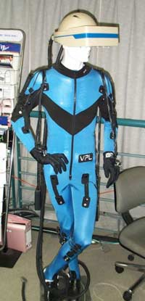
Figure 5: Force-feedback enabled exosuit to enable full-body haptic display (Photo: Univ. of Buffalo – Dept. of Media Study)

- Incredibly high (spatial) resolution must be emplyed to avoid making it difficult to use haptic devices.
- Users should be able to actively search and survey the environment via touch and easily identify objects through physical interaction [Witmer and Singer, 1998].
- Haptic feedback should be used effectively in areas where other senses are unusable [Kaczmarek and Bach-Y-Rita, 1995].
- Other senses and vibratory cues should be used effectively to enhance haptic tasks (Fig. 5) [Burdea and Coiffet, 1994].
- Strength, speed, high-resolution force, and position should be presented effectively via haptics [McNeely et al., 1995].
- Reliable, intuitive, low fatigue interaction should be effectively provided via haptics [McNeely et al., 1995].
- Simultaneous presentation of complex haptic patterns, sensations, and objects should not be difficult to perceive [Kaczmarek and Bach-Y-Rita, 1995].
- Presenting and semantically binding a large number of haptic intensity levels should be avoided [Kaczmarek and Bach-Y-Rita, 1995].
- ‘‘Tools with mass’’ must be effectively integrated to provide users with natural, gravitational, and inertial kinesthetic feedback [Hinckley et al., 1994] ,[Stoakley et al., 1995].
- Haptic devices employed should support both kinesthetic and tactile information [Kaczmarek and Bach-Y-Rita, 1995].
- High bandwidth force reflection with high stiffness between master and slave devices should be supported [McNeely et al., 1995].

Design guidelines on engagement, usability, comfort and ergonomics

Engagement and usability concerns (Presence and Immersion)

The combination of all the guidelines we have described so far in the various subsystems that comprise a VR system must result in the design and development of applications that immerse the users within the virtual world and allow them to feel as though they are part of their virtual surroundings and not disjoint to them. In order to ensure the highest degree of user presence and immersion, which in hand results in better acclimatisation of the users within a VE, the following are the most important guidelines that should be followed during the design and development of VR applications:

- Image quality should be used to enhance presence [Kalawsky, 1999].
- Visual, audio, and haptic aspects of VE should engage users [Witmer and Singer, 1998].
- VE should effectively engage multiple senses [Witmer and Singer, 1998].
- Object movement should be compelling to users [Witmer and Singer, 1998].
- It should not be difficult for users to predict responses to their actions [Witmer and Singer, 1998].
- Users should have a compelling sense of self-motion when moving throughout a VE and be able to quickly adjust to the VE experience [Witmer and Singer, 1998].
- Users should feel as if they are part of the VE and not isolated from it [Kalawsky, 1999].
- Users should have control over events during the VE experience and become emotionally involved in the experience [Witmer and Singer, 1998].
- VE should respond naturally to user-initiated actions [Witmer and Singer, 1998].
- FOV (Field of view) should not reduce users sense of engagement [Gabbard and Hix, 1997], [Kalawsky, 1999].
- Setting should be used to increase presence [Barfield et al., 1995], [Gabbard and Hix, 1997].

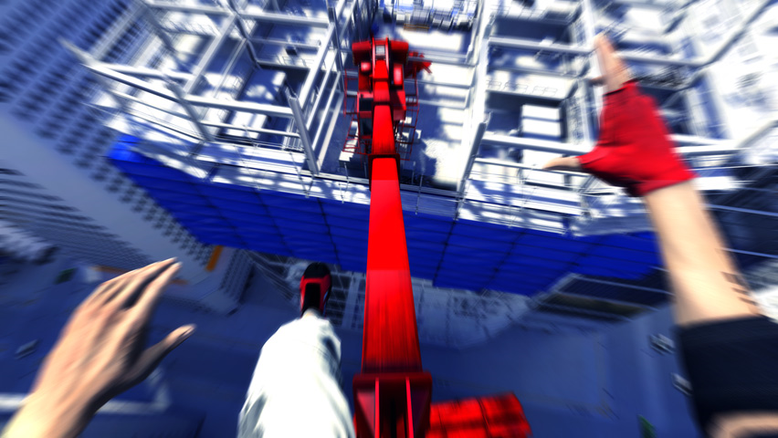
Figure 6: High velocity change of scenery can lead to motion sickness (Photo: “The Mirror’s edge”, EA games)

- VE experience should be consistent with similar real-world experiences [Witmer and Singer, 1998].
- Head-tracking should improve presence without hindering task performance [Barfield et al., 1997], [Gabbard and Hix, 1997; Snow, 1996].
- Visual presentation should not be disturbing, distracting, or interfering (Fig. 6, Fig. 7) [Witmer and Singer, 1998].

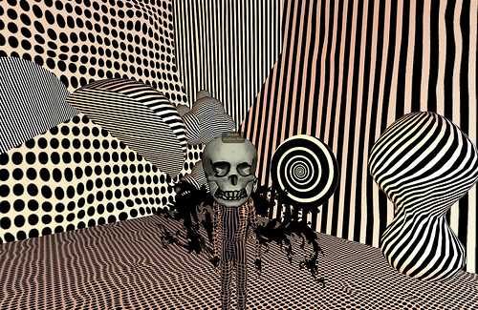
Figure 7: Visually Disturbing use of patterns and textures (Photo: Anita Fontaine - a Second Life art installation)

- An egocentric view should be provided when a strong sense of presence is desired [Gabbard and Hix, 1997].
- Non-immersive VEs may employ head tracking to increase presence [Barfield et al., 1997], [Hinckley et al., 1994], [Gabbard and Hix, 1997].
- Users should be isolated from, not distracted by activities outside VE [Witmer and Singer, 1998].
- Interface boundaries should be eliminated for seamless user inclusion [Bricken, 1990], [Gabbard and Hix, 1997].
- Users should be able to readily concentrate on VE experience and not the use of control devices [Gabbard and Hix, 1997], [Kalawsky, 1999].
- HMD should be used effectively to immerse users in VE (Fig. 8) [Gabbard and Hix, 1997]
- It should be difficult for an outside observer to get users’ attention when they are engaged in a VE [Kalawsky, 1999], [Witmer and Singer, 1998].

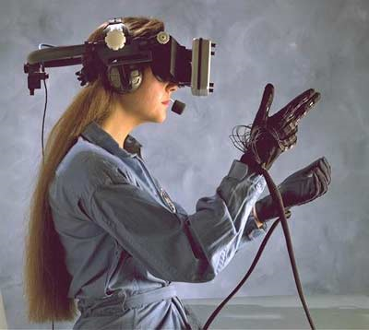
Figure 8: Headtracked HMD Display in combination with haptic gloves (Photo: NASA R&D) Comfort and Ergonomics

Comfort

Finally, apart from the technological factors we have described so far, a great deal of attention must be paid to the human factors pertinent to the use of a VR system. The following are a set of consideration that must be taken into account in order to make the system ergonomic and comfortable to use, thus alleviating many of the factors that result in simulation sickness:

- Is the VE system comfortable for long-term use and does it effectively support users of different statures (e.g. size, weight) [Gabbard and Hix, 1997], [Kalawsky, 1999]?
- Does prolonged use of input device(s) lead to fatigue [Card et al., 1991], [Gabbard and Hix, 1997], [Zhai, 1995]?
- Do electro-mechanical devices pose potential safety risks to users (e.g. pinch, jab) [Gabbard and Hix, 1997]?
- Do HMD tethers limit user mobility, or is the HMD weight and support mechanism cumbersome and uncomfortable [Gabbard and Hix, 1997], [Kocain and Task, 1995]?
- Do haptic devices maximize user comfort and ease-of-use, and are hand-worn devices lightweight, portable, and unencumbering, thus allowing freedom of movement [Gabbard and Hix, 1997], [Hannaford and Venema, 1995], [Wiker et al., 1991]?
- Do mechanical exoskeleton joints fit user joints allowing for natural body movement [Zyda et al., 1995]?
- Is excessive eye fatigue experienced [Kalawsky, 1999]?
- Do control devices allow for comfortable manipulation of objects via the fingers, or do control devices lead to fatigue by employing large muscle groups [Hannaford and Venema, 1995], [Zhai et al., 1996]?
- Are real-world props used effectively to reduce body fatigue while sitting or standing and to reduce hand/arm fatigue while users interact with VE [Stoakley et al., 1995]?

These questions must be asked by the designers at the early stages of the design process and depending on the application that is to be developed most of them should be answered positively at the end of that process. In order to facilitate the desired comfort level and ergonomic design, the designers must select appropriate devices, methods and technologies to ensure that the users have a positive outlook on the application.

Moreover, even if all steps have been taken to ensure the best user experience possible from a design and development point of view, during the actual use of the system, the users must never be forced to operate the system for prolonged durations, they must be able to rest within sessions and the controllers of the system must always be vigilant to recognise simulation sickness symptoms and when such a symptom appears, they should terminate the session immediately. At the end of a VR session, the users should be given time to acclimate back to the real world, especially if they will be handling equipment or performing tasks in which they could exhibit after-effects of simulation sickness.

List of technical factors influencing Simulator Sickness
Due to expert knowledge of the Consortium and the intensive literature study mentioned above which is based on a broad level for all kind of VR topics, the following guidelines summarize the findings of design guidelines especially for driving simulators in order to reduce Simulator Sickness.

Factor | Description
Latency between control impuls and motion | Lower the latency between control inputs and response of the visual and the motion system!
Grid pattern: Use the dirty windscreen! (fixed background) | It is well known in the field of virtual environments that less immersive environments tend to generate less motion sickness. By interrupting the scene with a clearly visible grid pattern superimposed upon the virtual sky or walls, the immersive effect of the virtual environment is curtailed, thus reducing the level of motion sickness.
Motion Base | Well adjusted motion supports should decrease the simulator sickness. Bad adjusted motion supports will increase the simulator sickness.
Frame rate | If the frame-rate is too low, the driver will not see a fluid pictures. Especially in curves this effect might cause simulator-sickness. The Frame rate should not be less than 30 pictures per second.
Antialiasing | Missing Antialiasing will lead to a flickering picture. This effect might cause simulator sickness. Simulators should include graphic cards which supports good antialising.
Flickering Monitors | Especially RTC-monitors to have a flickering effect (normally 50 or 60hz). For some drivers that might cause the simulator-sickness effect. A bettersolution are for example LCD screens.
Distance to the screens | The distance to the screens influences the simulator sickness effect. This effect correlates with the “Size of Screens” effect and the “Flickering Monitors” effect). Additionally the eyes have to adapt to the close distance to the screen. During normal driving the eyes has to adapt to infinity. A small screen lowers the simulator sickness but also the level of presence. It has a balance process which has to be decided individually.
Modelling of scenarios | Curves or turns during a ride will increase the simulator sickness. Scenarios which are located on a straight road will cause much less sickness. Therefore scenarios should avoid curves or turns as long as they are not needed for the aim of the scenario.
Table 1: List of technical factors influencing simulator sickness (outcome of the discussion within the TRAIN ALL consortium and a summary of the literature survey)

Prediction of simulator sickness in TRAIN ALL

  - Introduction

As is evident from the colleciton of existing design guidelines in Chapter 1, VR applications guidelines stem from various application fields (e.g. architecture, training simulation, medicine, entertainment, etc). Beside technological, usability and cost effective problems and the challenge of natural-likeness, one major issue is that many users feel uncomfortable during or after working with, (driving or navigating through) virtual environments. In the worst case Simulator Sickness arises. The users report sick feelings and feelings of discomfort.

  - Theories

As presented in D 3.8, no model describes completely the origin of Simulator Sickness. The theory which is mentioned quite frequently in the literature is called: “Cue Conflict-Theory”. In the very beginning of driving simulators only static simulators without any motion were used, where people got very sick. One assumed that the cause of sickness would be the missing of real movement and forces on the body. People get sick if discrepancies/conflicts appear between the signals of different senses while using a driving simulator. While the visual system registers and expects a movement (e.g. while driving a curve) the equilibrium organ perceives no movement and therefore a "Cue-Conflict" emerges. In order to ease the symptoms, it seemed logically to add movement to the simulators. Originally these were random induced vibrations but it gave no improvement. Progress in the simulation technology makes it possible to adapt the simulated acceleration effects relatively well to the real driving behaviour. However, also in highly technological mobile simulators people get sick. It is currently under discussion if this is still due to the sense conflict appearing if the visual stimulation and the simulation of the forces are not synchronized. Especially the simulation of breaking a car is a huge technological challenge. Again, the perception of the equilibrium organ and the visual information are conflicting. Critics claim that the theory is not sufficient and can only explain the symptoms when they have already appeared.
To the author’s opinion the best overview about prediction of Simulator Sickness is given in E.M. Kolasinski’s [1995] review of literature concerning simulator sickness, motion sickness, and virtual environments. The appearance of Simulator Sickness depends on many different factors and can’t be led back to a single cause. All factors can be divided in three categories:

1. Factors depending on the individual.
2. Factors depending on the simulator.
3. Factors depending on the task to be fulfilled.

Given the potential discomfort to the individual, as well as the operational consequences of sickness, there would be clear benefits to the ability to predict who will become symptomatic in a simulator. If the occurrence or severity of sickness could be successfully predicted based on characteristics of an individual, at-risk users could be identified, properly warned and, perhaps, even trained in some way to reduce their risk. Furthermore, if prediction was based solely on characteristics of the individual, such prediction might generalize to many situations such as different simulators and different tasks performed in the simulator. Although several characteristics of an individual have been found to be significant predictors of simulator sickness, few characteristics are consistently found to be significant predictors. It is likely that the wide individual differences in susceptibility and great variation in responsivity to simulators make consistent relationships difficult to attain. Although the large individual differences in susceptibility create a large amount of non-error variation which makes statistical prediction of sickness relatively easy, the great variation in responsivity means that different people get sick for different reasons. Thus, a set of individual characteristics which consistently predict sickness for all individuals in all situations may be very hard to find.

One common approach for the prediciton of simulator sickenss is the postular stability test. Beside others, Villard et al. [2008] suggested that postural activity (prior to motion sickness onset) may predict motion sickness incidence. Similar conclusions have been reached by Smart et al. [2002] and Smart, Otten, and Stoffregen [2007], who modeled postural data from several different venues, including a physical moving room, a flight simulator, and a head-mounted display. In all three of those studies, motion sickness in a VR environnement (=simulator sickness) across experiments and venues was predicted by variability of head position, accounting for up to 60% of the variance and correctly classifying up to 70% of individual participants as being either sick or well, which is a good result.

An already existing questionnaire to measure motion sickness history (e.g., a person’s previous experience of motion sickness in various settings) is from Kennedy et al. [1992]. This questionnaire has often been used to predict simulator sickness (although it measures motion sickenss in the past). Maybe therefore all in all it can be stated that existing questionnaire and schemes for predicting motion sickness susceptibility across situations have had limited success. Motion sickness history typically captures less than 35% of the variance in motion sickness incidence (incl. VR environnemt) across situations (e.g. Kennedy, Dunlap & Fowlkes, 1990).

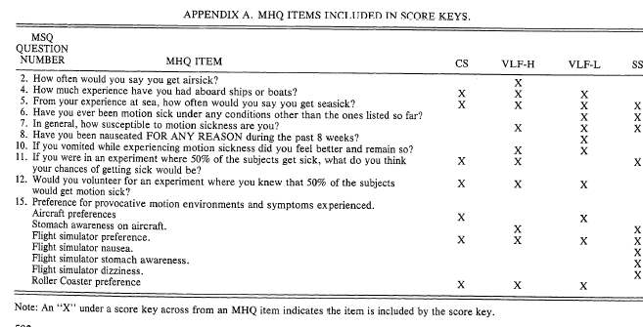
Table 2: Motion History Questionnaire [Kennedy et al. 1992]

Having a close look at the items and by discussing them in the Consortium we decided to improve the predictive validity by using better items.

Motion Sickness Susceptibility Questionnaire

The below described motion sickness susceptibility questionnaire was tested by different partners (mainly BPP, CRF, VTI and HIT) during TRAIN-ALL pilot tests. The theoretical background was descibed in detail in D3.8. In total, two data sets have been analysed. The first study was preformed at BPP. The second study was performed at HIT, CRF and VTT. The final outcome (mainly the predictive validity) is described in the following paragraphes.

Strongly  Disagree | 1 | 2 | 3 | 4 | 5 | 6 | 7 |  | Strongly  agree
I like to sit in the front rows when I go to the movies. | ❑ | ❑ | ❑ | ❑ | ❑ | ❑ | ❑ |  | ❑ No answer
I get sick while reading a book in a car while somebody else is driving. | ❑ | ❑ | ❑ | ❑ | ❑ | ❑ | ❑ |  | ❑ No answer
I like playing computer games. | ❑ | ❑ | ❑ | ❑ | ❑ | ❑ | ❑ |  | ❑ No answer
I play computer games with interactive simulations. | ❑ | ❑ | ❑ | ❑ | ❑ | ❑ | ❑ |  | ❑ No answer
I feel dizzy during playing interactive computer games. | ❑ | ❑ | ❑ | ❑ | ❑ | ❑ | ❑ |  | ❑ No answer
I feel dizzy when I watch somebody else playing interactive computer games. | ❑ | ❑ | ❑ | ❑ | ❑ | ❑ | ❑ |  | ❑ No answer
I like watching wide screen TV. | ❑ | ❑ | ❑ | ❑ | ❑ | ❑ | ❑ |  | ❑ No answer
I suffer from sea-sickness/ motion sickness. E.g. Airplane, boat, car (backseat). | ❑ | ❑ | ❑ | ❑ | ❑ | ❑ | ❑ |  | ❑ No answer
I am interested in technology and new technological developments. | ❑ | ❑ | ❑ | ❑ | ❑ | ❑ | ❑ |  | ❑ No answer
I get sick in roller coasters or in similar entertainment machines. | ❑ | ❑ | ❑ | ❑ | ❑ | ❑ | ❑ |  | ❑ No answer
I am able to stand in a 180° or 360° ankle of view surround cinema dome. | ❑ | ❑ | ❑ | ❑ | ❑ | ❑ | ❑ |  | ❑ No answer
In my past, I experienced Simulator Sickness during a simulator drive/fly. | ❑ | ❑ | ❑ | ❑ | ❑ | ❑ | ❑ |  | ❑ No answer
Table 3: The TRAIN ALL Consortium developed motion sickness prediction questionnaire

BPP test results

Test design
In total 40 (30 male/ 10 female) young police officers were tested at BPP. The participants had to drive two times for 12 minutes each (with a 10 minute break). Every minute they were asked about their level of sickness (subjective) from 0 (fit to drive) to10 (very sick almost stopping the drive). An interviewer documented the answers. During the break no questions about the sickness level were asked and the participants remained in the simulator car. The age range of the participants was rather young (between 19 to 25 years).

Hypothesis

A first hypothesis was that the level of simulator sickness will be influenced by the order of driving parcours. Two parcours had to be fulfilled: one urban road parcours (with a lot of visual cues, and a lot of driver-subjective expected forces to the equilibrium system of the inner ear), and a highway parcours (with less visual cues and a constant speed and therefore less expected forces to the equilibrium system). The concrete first hypothesis was that people get less sick when they start with the highway parcours followed by the urban parcours. Thereotical packground is that people need to get aquainted to the missing forces in the simulator. A lower level of visual cues (as first drive) should therefore be a better start (= less simulator sickness) than an overwhelming amount of visual impact (= urban road as first drive). [Draper et al. 1997]

The second hypothesis is that the number of driving experience in years (= real car driving) is a positive predictor for simulator sickness [Corbett et a. 2006] (people who have more driving experience get more and faster sick as their equilibrium system expects more forces/stimulation).

The third hypothesis was that sleepiness is a positive predictor for simulator sickness (people who are more tired get more and faster sick) [Kolasinski, E.M., 1995].

The fourth hypothesis was to validate the predictive validity of the above described questionnaire. A critical score should be the final goal as the outcome of the evaluation phase of the questionnaire. People who score above the threshold should undergo a special training (see D.3.8).

Results

The following four tables and graphs show the Sickness scores (means) per minute of the four different test parcours. In all four parcours the sickness increased.

1. Mean sickness  First drive (Highway) | Min.0 | Min.1 | Min.2 | Min.3 | Min.4 | Min.5 | Min.6 | Min.7 | Min.8 | Min.9 | Min10 | Min.11 | Min.12
1. Mean sickness  First drive (Highway) | 0.15 | 0.95 | 1.35 | 1.65 | 2.00 | 2.20 | 2.50 | 2.60 | 2.65 | 2.65 | 2.85 | 2.65 | 2.80

Between the second and fourth minute a critical phase can be identified: the sickness builds up in between these two points for most people.

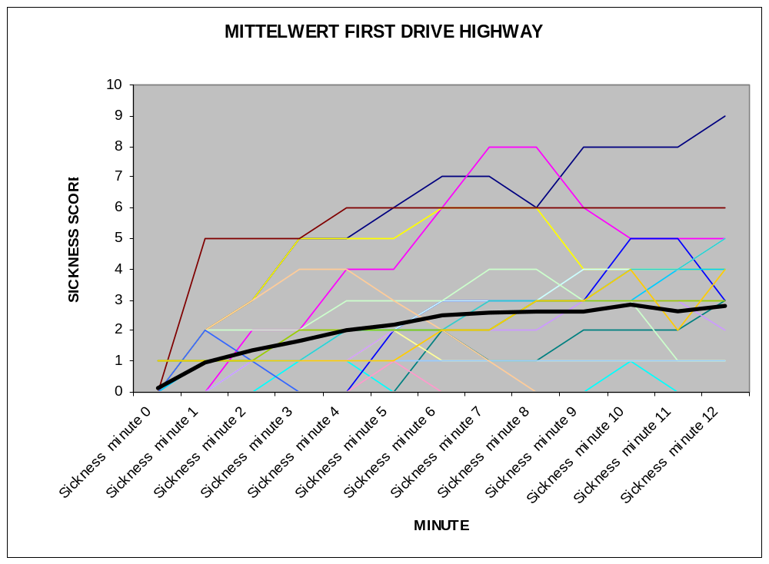
Figure 9: The level of simulator sickness of each individual driver per minute for the first drive (highway); BPP tests

2. Mean sickness  First Drive (Urban) | Min.0 | Min.1 | Min.2 | Min.3 | Min.4 | Min.5 | Min.6 | Min.7 | Min.8 | Min.9 | Min10 | Min.11 | Min.12
2. Mean sickness  First Drive (Urban) | 0.00 | 0.55 | 1.05 | 1.40 | 1.85 | 2.25 | 2.25 | 2.25 | 2.35 | 2.50 | 2.80 | 3.05 | 3.20

Between the second and fith minute a critical phase can be identified: the sickness builds up in between these two points for most people.

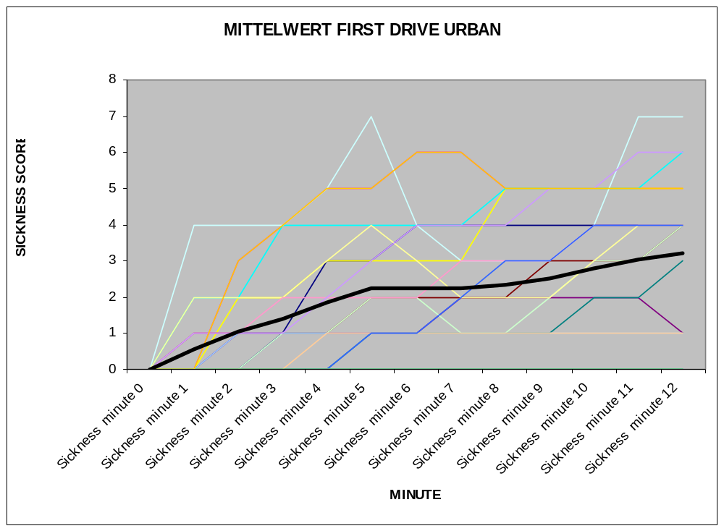
Figure 10: The level of simulator sickness of each individual driver per minute for the first drive (Urban); BPP tests

3. Mean sickness  Second Drive (Urban) | Min.0 | Min.1 | Min.2 | Min.3 | Min.4 | Min.5 | Min.6 | Min.7 | Min.8 | Min.9 | Min10 | Min.11 | Min.12
3. Mean sickness  Second Drive (Urban) | 0.25 | 1.10 | 1.65 | 2.10 | 2.90 | 3.20 | 3.90 | 3.39 | 3.22 | 3.61 | 4.00 | 4.28 | 4.33

The values are much higher for this drive. If the second drive is an urban drive, the participants get most sick. For further detail please see next paragraph (first hypothesis).

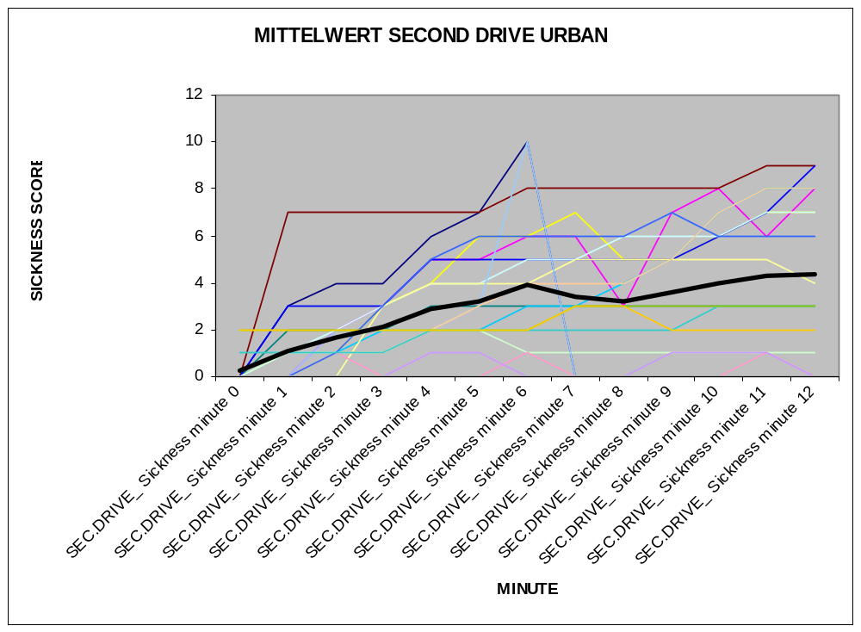
Figure 11: The level of simulator sickness of each individual driver per minute for the second drive (urban); BPP tests

4. Mean sickness  Second Drive (Highway) | Min.0 | Min.1 | Min.2 | Min.3 | Min.4 | Min.5 | Min.6 | Min.7 | Min.8 | Min.9 | Min10 | Min.11 | Min.12
4. Mean sickness  Second Drive (Highway) | 0.15 | 0.95 | 1.10 | 1.40 | 1.65 | 1.80 | 1.95 | 2.00 | 2.20 | 2.40 | 2.55 | 2.75 | 2.95

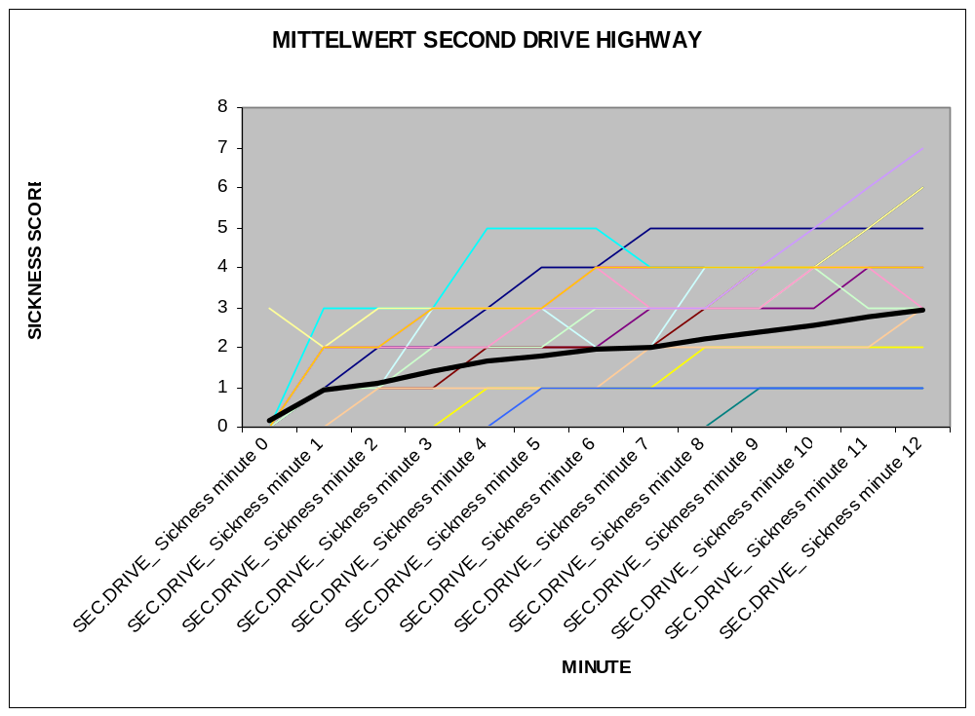
Figure 12: The level of simulator sickness of each individual driver per minute for the second drive (highway); BPP tests
First Hypothesis (order of the simulator scenario):
In the following table the different mean scores for the differentscenarios are described:
Parcours | Mean Sickness Score (Maximal Score)
HIGHWAY FIRST DRIVE  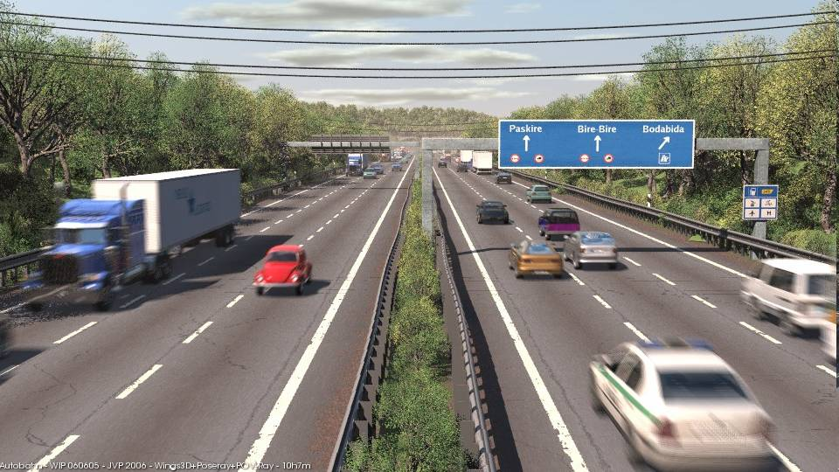 | 2.08 (MAX: 9)
URBAN FIRST DRIVE  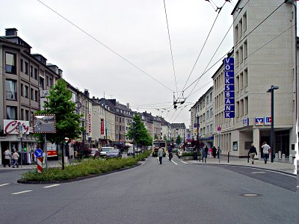 | 1.96 (MAX: 7)
URBAN SEC. DRIVE | 2.88 (MAX: 10)
HIGHWAY SEC. DRIVE | 1.83 (MAX: 7)
Table 4: Mean sickness scores per simualtor scenario; BPP tests.

Conclusion: For the first drive it does not matter with which parcours the candidate starts. There is no big difference in the level of sickness (2.08 to 1.96; not sig.) BUT: if another parcours follows in the near future (with 10 minutes break), which is very likely if you want to train people, the design of the first parcours (urban or highway) has clearly an influence on the sickness level during the second drive (2.88 to 1.83; sig. p<0.012). The outcome is not as expected. In the hypothesis we expected that people get less sick when they start “smoothly” with a highway parcours and then do the urban parcours. But the results show the opposite: people get less sick in the second drive when they do the “tough” urban drive first.

Second and Third Hypothesis: (Driving experience and Fatigue)

Scenarios | Driving experience:  Correlation with Mean Sickness score | Fatigue:  Correlation with Mean Sickness score
HIGHWAY FIRST DRIVE | 0.20 | -0.28
URBAN FIRST DRIVE | 0.41 | 0.60
URBAN SEC. DRIVE | 0.56 | -0.22
HIGHWAY SEC. DRIVE | 0.37 | 0.30
Table 5: Correlation of driving experience and fatigue with mean sickness score per simulator scenario; BPP tests

Conclusion: Driving experience in years has a clear positive correlation with simulator sickness. The more experience a person has in years, the more sick s/he gets. The role of fatigue seems to remain unsolved. There is a high posive (.r= .60) as well as slightly negative correlations (.r= -.28/ -.22)

Fourth Hypothesis: (Predictive validity of the new simulator sickness prediction questionnaire)
 | Movies | Reading in car | Playing computer games | Playing interactive computer games
Final sickness score at the end of both drives for both groups | -0.20 | 0.20 | 0.13 | 0.05
Sickness score after the first drive for both groups | -0.29 | 0.32 | 0.03 | 0.31
Sickness score after the first drive “highway” | -0.48 | 0.32 | 0.15 | 0.39
Sickness score after the first drive “urban” | -0.15 | 0.32 | -0.07 | 0.23
Sickness score after the second drive “urban” | -0.21 | 0.15 | 0.40 | 0.19
Sickness score after the second drive “highway” | -0.20 | 0.38 | -0.07 | -0.01

 | Dizzieness playing interactive computer games |  | Dizzieness seeing  interactive computer games |  | Wide sreen TV |  | Suffering sea  sickness
Final sickness score at the end of both drives for both groups | -0.03 |  | 0.30 |  | 0.23 |  | 0.04
Sickness score after the first drive for both groups | -0.01 |  | 0.29 |  | 0.13 |  | -0.11
Sickness score after the first drive “highway” | 0.23 |  | 0.23 |  | 0.04 |  | 0.22
Sickness score after the first drive “urban” | -0.15 |  | 0.36 |  | 0.19 |  | -0.41
Sickness score after the second drive “urban” | 0.35 |  | 0.40 |  | 0.15 |  | 0.39
Sickness score after the second drive “highway” | -0.04 |  | 0.49 |  | 0.26 |  | -0.25
 |  | New  technology |  | Roller  coasters |  | Surround  Cinema dome |  | Earlier simulator  sickness
Final sickness score at the end of both drives for both groups |  | 0.08 |  | 0.10 |  | 0.16 |  | 0.01
Sickness score after the first drive for both groups |  | 0.23 |  | -0.10 |  | 0.38 |  | 0.18
Sickness score after the first drive “highway” |  | 0.23 |  | -0.02 |  | 0.49 |  | 0.20
Sickness score after the first drive “urban” |  | 0.24 |  | -0.21 |  | 0.24 |  | 0.18
Sickness score after the second drive “urban” |  | 0.17 |  | 0.17 |  | 0.30 |  | 0.07
Sickness score after the second drive “highway” |  | -0.01 |  | 0.08 |  | 0.09 |  | 0.25
Table 6: Correlations between the different sickness scores and all items from the “Simulator Sickness Prediction Questionnaire” (high correlations are marked in green):

Conclusion: As is obvious from the results, there are some clear indicators for the prediction of simulator sickness. Especially the first item “I am not able/ I do not like it to sit in the front rows of a movie theatre” is a clear predictor that s/he is susceptible for motion sickness (up to r= - .48). Also the “unability to read a book in a car while it is moving” (second item) has a clear positive correlation with upcoming sickness during the simulator drive (up to r= .38). If a person gets “dizzy while s/he watches somebody else is playing computer games” (item 6) this is also a good predictor for developing simulator sickness (up to r= .49). Nevertheless, some results are contradictionnary: e.g. “suffering from sea sickness” (item 8) has a positive and a negative correlation and it remains therefore unclear if it is a protective ability if you are not getting sick on a ship or a plane or if you are more likely to get simulator sick when you have problems in a ship or a plane. The reason why “earlier simulator sickness” (item 10) has such a low correlation is easy to explain: the test participants never drove a simulator before. The reason why “the ability to stand in a surrounding cinema” (item 9) has a positive influence on the development of simulator sickness is very interesting. At the first look this is not logic: why should somebody get sick if s/he is able to watch a movie while standing in a surrounding cinema? It must have something to do with the postural stability (see D3.8). Maybe people who can stand in a surrounding cinema but get sick in a driving simulator indeed ‘select’ sometimes to be standing as they may feel sick if they seat and watch from a close distance or maybe they are differently immersed to the VR driving simulator world than to the cinema surrounding. The exact reason remains unresolved.

HIT, CRF, VTI tests results
  - Test design
As in BPP, participants at HIT, VTI and CRF were invited to take part in a driving similar test with different scenarios. The study included 50 participants, the mean age was 22. In total 19 women and 31 men participated. After each test drive the participants were asked about their sickness level and the different symptoms using the SSQ (SSQ = Subjective sickness Questionnaire Pro & Post testing (symptom checklist) by Kenndy at al. 1993. For the statistical analysis the total score and not the different subscores will be used.

  - Hypothesis
The hypothesis is to validate the the above described screening questionnaires (see table 3). The identification of clear predicitors with a high predictive validity is the major goal. The outcome of the evaluation phase should be the design of a questionnaire to identify people who might develop simulator sickness and therefore should undergo a special training.

  - Results
Participants did not report any simulator sickenss symptoms before the actual drive. Some reported sweating as they were positive excited about the simulator drive. The focus of the second study was to create a valid Regression Model. The data set from HIT, VTT and CRF shows the following results. In this analysis the Criteria was the SSQ score in total (not sickness per minute as at BPP).

Model Summary
Model | R | R Square | Adjusted R Square | Std. Error of the Estimate
1 | .641ª | .410 | .398 | 9.582
2 | .796^{b} | .633 | .618 | 7.635
3 | .826^{c} | .683 | .662 | 7.180
4 | .844^{d} | .712 | .687 | 6.914
a. Predictors: (Constant), I get sick in roller coasters or in other entertainment machines.
b. Predictors: (Constant), I get sick in roller coasters or in other entertainment machines., I have no problems reading a book or a map in a car while somebody else is driving.
c. Predictors: (Constant), I get sick in roller coasters or in other entertainment machines., I have no problems reading a book or a map in a car while somebody else is driving., I feel dizzy or uncomfortable during playing interactive computer games.
d. Predictors: (Constant), I get sick in roller coasters or in other entertainment machines., I have no problems reading a book or a map in a car while somebody else is driving., I feel dizzy or uncomfortable during playing interactive computer games., I suffer from sea-sickness/ motion sickness? E.g. Airplane, boat, car (backseat).
Table 7: SPSS Items and overview of four possible models

In the model summary in table 7, all 12 questionnaire items were tested to find the best way to predict simulator sickness (by using the SSQ). 4 different models with different predictive validity scores can be identified. In the second column, R square gives the percentage to which degree simulator sickness can be explained by each model.

In total, 4 sig. Regression Models can be detected. The R² varies from .41 to .71. The best model has an R² of 0.71. It contains the following 4 items:
- I get sick in roller coasters or in other entertainment machines.,
- I have no problems reading a book or a map in a car while somebody else is driving.,
- I feel dizzy or uncomfortable during playing interactive computer games.,
- I suffer from sea-sickness/ motion sickness? E.g. Airplane, boat, car (backseat).

R square of 71 means that 71% of the variance of the upcoming sickness can be predicted by these 4 items. These results are extraordinairy good! Just with four questions you can identify people with an 71 % accuracy of getting sick in a driving simulator. The model does not get better if you add more items. These results are even better than the ones mentioned above from Villard et al (2008) who were using the postural stability test!

ANOVA^{e}
Model |  | Sum of Squares | df | Mean Square | F | Sig.
1 | Regression | 3066.875 | 1 | 3066.875 | 33.404 | .000ª
1 | Residual | 4406.979 | 48 | 91.812
1 | Total | 7473.854 | 49
2 | Regression | 4734.425 | 2 | 2367.212 | 40.614 | .000^{b}
2 | Residual | 2739.430 | 47 | 58.286
2 | Total | 7473.854 | 49
3 | Regression | 5102.371 | 3 | 1700.790 | 32.990 | .000^{c}
3 | Residual | 2371.483 | 46 | 51.554
3 | Total | 7473.854 | 49
4 | Regression | 5322.863 | 4 | 1330.716 | 27.839 | .000^{d}
4 | Residual | 2150.991 | 45 | 47.800
4 | Total | 7473.854 | 49
Table 8: SPSS: significance check of four possible models

ANOVA are the classical instrument to test the significance level of the regression models. In the last column of the ANOVA the significance level is high enough for all models (p < 0.0001). This means that all all four models could be a possible (significant) solution for the regression. As you can see in table 7, the fourth model has the highest predictive validity. In other words: if a driving instructor wants to predict simulator sickness or identify somebody who might get sick, s/he should use the four questions.

The β-coefficients are as expected. The second item has a negative weight as the item is verbalized in a negative way.
Coefficientsª
Model |  | Unstandardized Coefficients |  | Standardized Coefficients | t | Sig.
 |  | B | Std. Error | Beta | t | Sig.
4 | (Constant) | 7.011 | 4.162 |  | 1.685 | .099
4 | I get sick in roller coasters or in other entertainment machines. | 3.875 | .914 | .391 | 4.241 | .000
4 | I have no problems reading a book or a map in a car while somebody else is driving. | -2.399 | .532 | -.390 | -4.506 | .000
4 | I feel dizzy or uncomfortable during playing interactive computer games. | 3.174 | 1.363 | .212 | 2.330 | .024
4 | I suffer from sea-sickness/ motion sickness? E.g. Airplane, boat, car (backseat). | 2.226 | 1.036 | .199 | 2.148 | .037
a. Dependent Variable: Total
Table 9: SPSS: Significance level and beta weight

Checklist for simulator driving instructors
The following checklist is the resumee of D3.8 and D3.9. The questions will help the Simulator Driving Instructor to identify possible candidates who might be susceptible for Simulator sickness. There are two parts: the first one focuses on the time before the actual drive; if participants might be at risk special measures must be undertaken (training drive). The second part focuses on simulator sickness symptoms during the drive.

a) Before the drive
1. Did you give a hint at the beginning that the drive can always be stopped?
Yes No
If “No”:
Say at the beginning: “We can always stop the drive.”
2. Did you ask the participant if s/he ever got motion sick?
Yes No
If the participant says “Yes”:
Start with a short training drive with less visual cues for 3 minutes (Urban)
3. Did you ask the participant if s/he can read a book in a moving car?
Yes No
If the participant says “No”:
Start with a short training drive with less visual cues for 3 minutes (Urban)
4. Did you ask the participant if s/he gets sick in roller coasters or in other entertainment machines ?
Yes No
If the participant says “No”:
Start with a short training drive with less visual cues for 3 minutes (Urban)

5. Did you ask the participant if s/he gets dizzy or uncomfortable during playing interactive computer games?
Yes No
If the participant says “No”:
Start with a short training drive with less visual cues for 3 minutes (Urban)
6. Did you ask the participant if s/he suffers from sea-sickness/ motion sickness? E.g. Airplane, boat, car (backseat)?
Yes No
If the participant says “No”:
Start with a short training drive with less visual cues for 3 minutes (Urban)

7. Did you inform the participant the more experience s/he has in real car driving the more susceptible s/he is for motion sickness?
Yes No
If the participant says “No”:
Do so! To reduce his/her fear of reporting symptoms!
b) During the drive
1. Can you observe tension of the neck or the shoulders?
Yes No
If “Yes”:
Ask the participant if s/he wants a break
2. Is the Respiratory of the participant fast (Is s/he trying to relax?)
Yes No
If “Yes”:
Ask the participant if s/he wants a break
3. Does the person sweat? Changes in the Physiology indicates “something”
Yes No
If “Yes”:
Ask the participant if s/he wants a break

It could further help to turn on or turn off the sound. Realistic sound contributes in addition to the visual system to a corresponding stimulation and therefore could possibly reduce the Cue-Conflict.
- It appeared that breaks during using the simulator can help to avoid simulator sickness or at least to delay the onset of the symptoms.
- If symptoms appear, the use of the simulator should be stopped. Otherwise the symptoms of sickness become more and more worse with progressive using time.
- The human organism can become accustomed to many unusual situations, as well as at the causes of the simulator sickness.
- Not to consume alcohol. Alcohol influences the sense perception and reinforces the cue-conflict.

Conclusion

The whole idea of Activity 3.8 was to identify counteractive measures to reduce simulator sickness. The first approach was a physiological. In D3.8 different psychophysiological parameters were identified which reflect simulator sickness:

Physiological Signal | Indication
EEG- Muscular tension | Muscular tension starts to built up strain
EOG | EOG is angular and oscillating when participant gets sick - form of nystagmus
Skin resistance | Positive tendency when a person starts feeling nausea.  Neg. tendency between skin resistance/ sweating and nausea when continuing
Table 10: Psychophysiological parameters which reflect simulator sickness (D3.8)
In general it can be said that the focus for the simulator driving instructor (who has no physiological measuring battery) should lie on observations of changes of the physiological state. A change in physiology always indicates “something”. On the basis of manifest physiological factors, a checklist for simulator driving instructors was developed (D3.8) which now has to be modified in accordance to the findings in chapters 3 and 4:
First: a short training drive should not be longer than 3 minutes (instead of 5 minutes see question 2, D3.8).
Second: the “predrive” (=training drive) should be an urban scenario (instead of the highway!).
Third: In order to include the 4 questions with a high predictive validity (see Regression model 4 above) and the findings from the BPP study, a few more screening questions have to be added!
It is important to detect simulator sickness at an early stage. The motion sickenss susceptibility questionnaire will help to identify people who might get sick. Preventive actions like a training drive with less simulator time (3 minutes) but a lot of visual cues (like an urban drive) should follow the a crucial screening. It does not make any sense to creat a cut-off score as some people (especially elderly) never played computer games (question 3-6 of the checklist of chapter 5) or never drove a simulator before (question 12 of the checklist of chapter 5).

Future research should clearly lie in the idenfication of physiological signals which can be interpreted by the driving simulator software.

References
Barfield, W. and Danis, E. (1996) Comments on the use of olfactory displays for virtual environments. Presence: Teleoperators and Virtual Environments 5 1, pp. 109–121.
Bennett D., Chapelle B.D.L, Zeltzer D., Bryson S.T., Bolas M. (1996). The future of virtual reality: Head-mounted displays versus spatially immersive displays. Special Panel Session at SIGGRAPH ’96, New Orleans, LA, August 4–9.
Bowman, D., (1999) Interaction techniques for common tasks in immersive virtual environments: Design, evaluation, and application. Unpublished doctoral dissertation, Georgia University of Technology, Georgia.
Bricken, M. (1990) Virtual worlds: No interface to design. Technical Report R-990-2, HIT Lab, University of Washington.
Brooks Jr., F.P., Ouh-Young, M., Batter, J.J., Kilpatrick, P.J. (1990) Project grope—haptic displays for scientific visualization. Computer Graphics 24 (4), 177–185.
Burdea, G., Coiffet, P. (1994) Virtual Reality Technology. Wiley, Inc., New York.
Card, S.A., Mackinlay, J.D., Robertson, G.G. (1991) A morphological analysis of the design space of input devices. ACM Transactions on Information Systems 9 (2), 99–122.
Cohen, M., Wenzel, E.M. (1995) The design of multidimensional sound interfaces. In: Barfield, W., Furness III, T.A. (Eds.), Virtual Environments and Advanced Interface Design. Oxford University Press, London, pp. 291–346.
Corbett, M; Singh, P;Thomas, M (2006) Simulator Sickness & Fatigue in RAAF High-Fidelity Simulators. Presented at: Australian Aviation Psychology Association. Manly.
Dandekar, K., Templeman, J., Sibert, L., Page, R. (1998) The Hobbes software architecture for virtual environment interface development. Technical Report.
Darken, R. P. and Sibert, J. L. (1996a) Navigating in large virtual worlds. The International Journal of Human-Computer Interaction 8 1, pp. 49–72.Software and Technology, Atlanta, GA, pp. 157–165.
Darken, R. P. and Sibert, J. L. (1996b) Wayfinding strategies and behaviors in large virtual environments. In: Human Factors in Computing Systems, CHI ’96 Conference Proceedings, Vancouver, BC, pp. 142–149.
Davies, C. (1996) Cognition, Perception, and Experience in Virtual Environment: Do You See What I See? Special Panel Session at SIGGRAPH ’96, New Orleans, LA, August 4–9.
DiGiano, C.J., Baecker, R.M., 1992. Program auralization: Sound enhancements to the programming environment. In: Proceedings of Graphics Interface ’92, Vancouver, BC, pp. 44–52.
Draper, M.H; Viirre, Erik. S; Furness, T.A.; Parker, D.E.(1997). Theorized Relationship Between Vestibulo-ocular Adaptation and Simulator Sickness in Virtual Environments. Human Interface Technology Laboratory, University of Washington, Seattle WA. USA 98105 To be presented at International Workshop on Motion Sickness , Marbella Spain, May 26-28, 1997.
Esposito, C. (1996) User interfaces for virtual reality systems. In Human Factors in Computing Systems, CHI ’96 Conference Tutorial Notes.
Exos (1997) Woburn, MA, USA.
Fairchild, K.M., Lee, B.H., Loo, J., Ng, H., Serra, L. (1993) The heaven and earth virtual reality: Design applications for novice users. In: 1993 IEEE Virtual Reality Annual International Symposium (VRAIS ’93) Proceedings, Seattle, Washington, pp. 47–54.
Gabbard, J.L., Hix, D. (1997) A taxonomy of usability characteristics in virtual environments
Guiard, Y. (1987) Asymmetric division of labor in human skilled bimanual action: the kinematic chain as a model. The Journal of Motor Behavior 19 (4), 486–517.
Hannaford, B., Venema, S. (1995) Kinesthetic displays for remote and virtual environments. In: Barfield, W., Furness III, T.A. (Eds.), Virtual Environments and Advanced Interface Design. Oxford University Press, London, pp. 415–436.
Hinckley, K., Pausch, R., Goble, J.C., Kassell, N.F. (1994). A survey of design issues in spatial input. In: Proceedings of ACM Symposium on User Interface Software & Technology (UIST ’94), Marina de Ray, California, pp. 213–222.
Jacob, R., Sibert, L.E., McFarlane, D.C., Mullen Jr., M.P. (1994) Integrality and separability of input devices. ACM Transactions on Computer-Human Interaction 1 (1), 3–26.
Kaczmarek, K.A., Bach-Y-Rita, P. (1995) Tactile displays. In: Barfield, W., Furness III, T.A. (Eds.), Virtual Environments and Advanced Interface Design. Oxford University Press, London, pp. 349–414.
Kalawsky, R.S., (1999) VRUSE—a computerized diagnostic tool: for usability evaluation of virtual/synthetic environments systems. Applied Ergonomics 30, 11–25.
Kennedy, R.S., Milienthal, M.G., Berbaum, K.S., Balztley, D.R. & McCauley, M.E. (1989) Simulator sickness in US Navy flight simulators. Aviation, Space and Environmental Medicine, 60(1), 10-16.
Kennedy, R. S., Dunlap, W. P., & Fowlkes, J. E. (1990). Prediction of motion sickness susceptibility. In G. H. Crampton (Ed.), Motion and space sickness (pp. 179–216). Boca Raton, FL: CRC Press.
Kennedy, R.S. Lane, M.E., Lilienthal, M.G., Berbaum, K.S. & Hettinger, L.J. (1992) Profile Analysis of Simulator Sickness Symptoms: Application to Virtual Environment Systems. Presence 1(3) 295-301.
Kennedy, R.S., Stanney, K.M. & Dunlap, W.P., (2000) Duration and exposure to virtual environments: sickness curves during and across sessions. Presence, 9 (5), 436-472.
Kolasinski, E.M. (1996) Simulator Sickness in Virtual Environments. US ARI Technical Report 1027
Kolasinski, E.M.( 1995). Simulator Sickness in Virtual Environments, U.S. Army Research.
Kocain, D.F., Task, H.L. (1995) Visually coupled systems hardware and the human interface. In: Barfield, W., Furness III, T.A. (Eds.), Virtual Environments and Advanced Interface Design. Oxford University Press, London, pp. 175–257.
Kontarinis, D.A., Howe, R.D. (1995) Tactile display of vibratory information in teleoperation and virtual environments. Presence: Teleoperators and Virtual Environments 4 (4), 387–402.
Levine M., Marchon I., and Hanley G. (1984) The Placement and Misplacement of You-Are-Here Maps. Environment and Behavior, 16(2): p. 139-157.
Liang, J., Green, M. (1994) JDCAD: a highly interactive 3d modeling system. Computers and Graphics 18 (4), 499–506.
MacKenzie, I.S. (1995) Input devices and interaction techniques for advanced computing. In Virtual Environments and Advanced Interface Design. Oxford University Press, London, pp. 437–440.
Mapes, D.P., Moshell, J.M. (1995) A two-handed interface for object manipulation in virtual environments. Presence: Teleoperators and Virtual Environments 4 (4), 403–416.
McNeely, W.A., Burdea, G.C., Hannaford, B., Hirose, M., Jacobsen, S., Salisbury, K., Tachi, S. (1995) Panel: Whither force feedback. In 1995 IEEE Virtual Reality Annual International Symposium Proceedings, Research Triangle Park, North Carolina, pp. 226–227.
Mereu, S.W. (1995) Improving depth perception in 3D interfaces with sound. Unpublished Master’s Thesis. University of Waterloo, Waterloo, Ontario, Canada.
Mereu, S.W., Kazman, R. (1996) Audio enhanced 3D interfaces for visually impaired users. In Human Factors in Computing Systems, CHI ‘96 Conference Proceedings, Vancouver, BC, pp. 72–78.
Mine, M.R., Brooks, Jr., F.P., Sequin, C. (1997) Moving objects in space: Exploiting proprioception in virtual environment interaction. In: SIGGRAPH ‘97 Conference Proceedings, Los Angeles, California, pp. 19–26.
Neale, D.C., Carroll, J.M. (1997) The role of metaphors in user interface design. In: Helander, M., Landauer, T.K., Prabhu, P. (Eds.), Handbook of Human–Computer Interaction. North-Holland, Amsterdam, Netherlands, pp. 689–715.
Passini, R., Wayfinding in Architecture. (1984) New York: Van Nostrand Reinhold Company Inc.
Richard, P., Birebent, G., Coiffet, P., Burdea, G., Gomex, D., Langrana, N. (1996) Effect of frame rate and force feedback on virtual manipulation. Presence: Teleoperators and Virtual Environments 5 (1), 95–108.
Shneiderman, B. (1992) Designing the User Interface, 2nd Edition. Addison-Wesley, Reading, MA.
Slater, M., Usoh, M., Steed, A. (1995). Taking steps: the influence of walking technique on presence in virtual reality. ACM Transactions on Computer–Human Interaction 2 (3), 201–219.
Smart, L. J., Otten, E. W., & Stoffregen, T. A. (2007). It’s turtles all the way down: A comparative analysis of visually induced motion MOTION SICKNESS IN A VIRTUAL ENVIRONMENT 345 sickness. In Proceedings of the Human Factors and Ergonomics Society 51st Annual Meeting (pp. 1631–1634). Santa Monica, CA: Human Factors and Ergonomics Society.
Smart, L. J., Stoffregen, T. A., & Bardy, B. G. (2002). Visually induced motion sickness predicted by postural instability. Human Factors, 44, 451–465.
Snow, M. (1996) Charting presence in virtual environments and its effects on performance. Unpublished doctoral dissertation. Virginia Tech, Blacksburg, VA.
Stanney, K.M. & Hash, P. (1998) Locus of user-initiated control in virtual environments: Influences on cybersickness. Presence, 7(5), 447-459.
Stanney K. M., Mollaghasemi M, Reeves L., Breaux R., Graeber D. A. (2003) Usability engineering of virtual environments (VEs): identifying multiple criteria that drive effective VE system design, International Journal of Human-Computer Studies, Volume 58, Issue 4, April 2003, Pages 447-481
Stevens, A. and Coupe P. (1978) Distortions in Judged Spatial Relations. Cognitive Psychology. 10: p. 422-437.
Stoakley, R., Conway, M.J., Pausch, R. (1995) Virtual reality on WIM: Interactive worlds in miniature. Human Factors in Computing Systems, CHI ’95 Conference Proceedings, Denver, Colorado.
Sturman, D.J., Zeltzer, D., Pieper, S. (1989) Hands-on interaction with virtual environments. In: Proceedings of ACM Symposium on User Interface Software & Technology (UIST ’89), pp. 19–24.
Sturman, D.J., Zeltzer, D. (1994) A survey of glove-based input. Computer Graphics & Applications 14 (1), 30–39.
Thorndyke, P.W. and Goldin S.E. (1983) Spatial Learning and Reasoning Skill, in Spatial Orientation: Theory, Research, and Application, H.L. Pick and L.P. Acredolo, Editors., Plenum Press: New York. p. 195-217.
Villard, S.; Moira, J.; Flanagan, B.; Albanese, J. M.; Stoffregen, T. A. (2008). Postural Instability and Motion Sickness in a Virtual Moving Room. University of Minnesota, Minneapolis, Minnesota. HUMAN FACTORS, Vol. 50, No. 2, April 2008, pp. 332–345. DOI 10.1518/001872008X250728. Human Factors and Ergonomics Society.
Ware, C., Balakrishnan, R. (1994) Reaching object in VR displays: lag and frame rate. ACM Transactions on Computer–Human Interaction 1 (4), 331–356.
Wickens, C.D. and Baker, P. (1995) Cognitive issues in virtual reality. In: Barfield, W. and Furness III, T.A., Editors, 1995. Virtual Environments and Advanced Interface Design, Oxford University Press, London, pp. 516–541.
Wiker, S.F., Vandereheiden, G., Lee, S., Arndt, S. (1991) Development of tactile mice for blind access to computers: Importance of stimulation locus, object size, and vibrotactile display resolution. In: Proceedings of the Human Factors Society 35th Annual Meeting, San Francisco, pp. 708–712.
Witmer, B., Singer, M. (1998) Measuring presence in virtual environment: a presence questionnaire. Presence: Teleoperators and Virtual Environments 7 (3), 225–240.
Zhai, S., Milgram, P. (1993b) Human performance evaluation of manipulation chemes in virtual environments. In: 1993 IEEE Virtual Reality Annual International Symposium Proceedings, Seattle, Washington, pp. 155–161.
Zhai, S. (1995) Human performance in six degree of freedom input control. Unpublished doctoral dissertation. University of Toronto, Canada.
Zhai, S., Milgram, P., Buxton, W. (1996) The influence of muscle groups on performance of multiple degree-of-freedom input. In: Human Factors in Computing Systems, CHI ’96 Conference Proceedings, Vancouver, BC, pp. 308–315.
Zyda, M.J., Pratt, D.R., Shirley, M., Barham, P.T., Falby, J.S. (1995) NPSNET-HUMAN: Inserting the human into the networked synthetic environment. In: Proceedings of the 13th DIS Workshop on Standards for the Interoperability of Distributed Simulations, Orlando, Florida, September, pp. 13–22.

