TRANSPORT AND LOGISTICS IN CROATIA
September 2016.
Yazmin Valleyo Sarmiento, Ivan Vandija, Marija Grsetic

Executive Summary
This research intends to show what the current position of Croatia is in terms of transport and logistics. As it is known, Croatia became independent in 1991, and since that time all its efforts have been focused in reconstructing the country. These efforts are most reflected in the level of development reached currently in all economic sectors.

The transport sector counts for 8% of the total GDP of Croatia. There are three main branches: ground, water and air transport. They differ from each other in many aspects.

Ground transportation has also two branches: road transport (cars, buses and public transportation) and railroad transport. The road transport is highly developed and almost all the roads meet the European Union Standards and safety measures. The roads are safe and reach all the parts of Croatia.

Railroad sector is poorly developed and there are still huge infrastructure lacks. A lot of work can be done in this sector in order to reach better standards. Currently, major work is being done on those routes that are part of important corridors for international transport to increase line speed and capacity.

Water transport is one of the most important activities in the country and one of the crucial activities in the general economy. Water transport includes sea ports, transport in river and pipelines. Croatia has 3 big main ports that are very important for foreign investment: Rijeka, Split and Ploce. As of recent, major plans are discussed for revitalization of river transport which is stagnant and underused. River port of international significance is Port Vukovar on Danube.

Air cargo only represents an insignificant part of goods transport. Air passanger transport is fairly well developed and over past decade there is a constant increase in the number of passangers and investments in infrastructure were undertaken to increase the capacity, especially in summer months (tourist season).

In the field of logistics, Croatia has improved over the last couple of years and education in the field is available; but this is still regarded as a new business for the country.

Table of Contents

Executive Summary 2
Table of contents 3
CROATIA OVERVIEW 6
Economic Profile 7
Economic Environment Overview 11
Croatian Economic Environment SWOT Analysis 12
CROATIA SWOT 13
CROATIAN TRANSPORT SECTOR 14
Introduction to the Transport Sector in Croatia 14
Transportation Networks and Accessibility of Regions 14
RAILWAY NETWORK 16
INLAND WATERWAYS AND INLAND PORTS NETWORK 17
ROAD NETWORK 18
MARITIME TRANSPORT NETWORK 19
AIR TRANSPORT NETWORK 20
URBAN, SUB-URBAN AND REGIONAL TRANSPORT NETWORK 21
Transport Sector Overview 22
Ongoing Projects 23
Planned Projects 25
Related Links 25
Regulation Dependencies of Croatia 26
AIR TRANSPORT IN CROATIA 27
Main Airports 28
Croatian Airlines Companies 33
Related Links 34
RAIL TRANSPORT IN CROATIA 35
Major Rail Routes 36
Network Connection Problems 38
Power Systems 39
New Developments in Croatian Rail Sector 39
Modernization Undertakes of Croatian Rail Sector 40
Related links 44
ROAD TRANSPORT IN CROATIA 45
Motorways and Expressways 46
List of Completed Motorways 47
Motorway Sections Under Construction 48
Planned Motorway Sections 48
Management 49
Other Motorways 49
Major Roads 50
Minor Roads 51
Related Links 51
BUS TRAFFIC 52
MARITIME TRANSPORT IN CROATIA 53
Ports 53
RIJEKA 53
PLOČE 55
ZADAR 57
ŠIBENIK 58
SPLIT 59
DUBROVNIK 61
Maritime Transport of Passangers 62
Maritime Transport of Cargo 62
Related Links 63
RIVER TRANSPORT IN CROATIA 64
River Ports 64
Related Links 65
PIPELINE TRANSPORT IN CROATIA 66
Adria Pipeline (OIL) 66
Varosfold-Slobodnica Pipeline (GAS) 68
Ionian-Adriatic Pipeline (GAS), Planned 68
Related Links 68
MULTIMODAL TRANSPORT IN CROATIA 69
LOGISTICS 70
Logistics Report of Croatia 70
Related Links 71
CONCLUSION 72
COMPREHENSIVE LIST OF CONTACTS 73
TRANSPORT – PUBLIC AND GOVERNMENT AGENCIES AND SERVICES 73
RAIL TRANSPORT 73
- GOVERNMENT OWNED COMPANIES 73
- RAIL TRANSPORT OF FREIGHT, RAIL TRANSPORT AS PART OF INTERMODAL SERVICE 73
ROAD TRANSPORT 75
- ROAD TRANSPORT 75
- ROAD TRANSPORT OF DANGEROUS GOODS (ADR) 80
- ROAD TRANSPORT BY FRIGO TRUCKS 82
- ROAD TRANSPORT OF VERY LARGE EQUIPMENT AND CARGO 85
AIR TRANSPORT 86
- AIRPORTS 86
- AIRLINES 87
RIVER TRANSPORT 87
- PORT AUTHORITIES 87
- RIVER PORTS, SHIPPERS, FORWARDERS AND AGENTS 87
SEA TRANSPORT 88
- PORTS AND PORT AUTHORITIES 88
PORT OF RIJEKA 89
- PORT OF RIJEKA – SHIPPERS 89
- PORT OF RIJEKA - AGENTS 89
- PORT OF RIJEKA - QUALITY AND QUANTITY MERCHANDISE CONTROL 90
- PORT OF RIJEKA - FORWARDING AGENCIES 90
- PORT OF RIJEKA - STATE INSTITUTIONS 93
- PORT OF RIJEKA - OTHER SERVICES 93
PORT OF PLOČE 94
- PORT OF PLOČE - OPERATORS FOR LIQUID CARGOES 94
- PORT OF PLOČE – ACCOMPANYING SERVICES, AGENCIES, FORWARDING SERVICES 94
- PORT OF PLOČE - QUANTITY AND QUALITY CONTROL 95
- PORT OF PLOČE - SHIP SUPPLY 96
- PORT OF PLOČE - RETAIL TRADE OF THE FUEL ON THE PASSANGER QUAY 96
- PORT OF PLOČE - UNDERWATER DIVING INSPECTION AND SHIP REPAIR ACTIVITIES 96
- PORT OF PLOČE - STATE SERVICES 96
PORT OF DUBROVNIK 96
MULTIMODAL TRANSPORT 97
LOGISTICS 98

CROATIA OVERVIEW
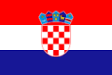
As Communism collapsed throughout Eastern Europe and Yugoslavia began to unravel along ethnic and religious lines, Croatia declared its independence in 1991. Years of conflict between Croats and Serbs ended formally in 1995 with the Dayton Peace Accords. From that time the country underwent the transition proces to market economy. Croatia became a member of NATO in April 2009, completed accession negotiations with the European Union in June 2011, and entered in July 2013.
Source: www.vlada.hr
People

Population: 4.46 mio (July 2015 est.)
Ethnic groups: Croat 89.6%, Serb 4.5%, other 5.9%(including Bosniak, Hungarian, Slovene, Czech, and Roma) - (2011 census).
Religions: Roman Catholic 87.8%, Orthodox 4.4%,other Christian 0.4%, Muslim 1.3%, other and unspecified 0.9%, none 5.2%
Languages: Croatian 96%, other 4% (including Italian,Hungarian, Czech, Slovak, and German)
Literacy: age 15 and over can read andwrite total population: 98.1%. Male: 99.3%. Female: 97.1%

Geography

Area: 56,542 sq. km (22,830 sq. mi)
Border countries: Bosnia and Herzegovina 932 km,Hungary 329 km, Serbia 241 km, Montenegro 25 km, Slovenia 455 km.
Climate: Mediterranean and continental; continentalclimate predominant with hot summers and cold winters; mild winters, dry summers along coast
Terrain: geographically diverse; flat plains alongHungarian border, low mountains and highlands near Adriatic coastline and islands.
Natural resources: oil, some coal, bauxite, low-gradeiron ore, calcium, gypsum, natural asphalt, silica, mica, clays, salt, hydropower.

General data

Population: 4,464,844 (July 2015 est.)
Main cities:Zagreb (Capital), Split, Rijeka, Osijek
National currency:Kuna
GDP:€43.921billion (2015 est., source – Croatian National Bank)
GDP per capita:€10.364
GDP - composition, by sector of origin:
- agriculture: 4.3%
- industry: 26.7%
- services: 69.1% (2015 est.)
VAT: 25%
Unemployment rate: 16,3%
Major export countries: Bosnia and Herzegovina, Slovenia, Italy, Serbia.

Political profile

Government:Parliamentary Democracy
Head of State:Kolinda Grabar-Kitarović
Membership of International Organisations: United Nations, Organisation for Security and Co-operation in Europe, Council of Europe, Regional Cooperation Council, International Monetary Fund, World Bank, World Trade Organisation, European Bank for Reconstruction and Development, Partnership for Peace, NATO
Accession to the European Union: 1st July 2013 – 28th Member State

Source: www.heritage.org/index/country/croatia
Economic profile
Real GDP growth rate
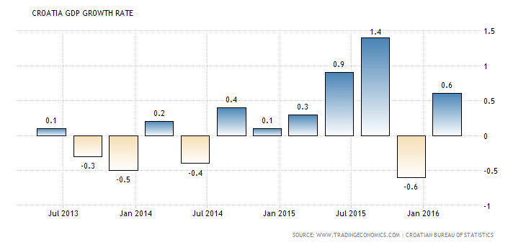
The Gross Domestic Product (GDP) in Croatia advanced 0.6 percent in the first quarter of 2015 over the previous quarter, compared to a downwardly 0.6 percent contraction in the previous period. GDP Growth Rate in Croatia averaged 0.35 percent from 2001 until 2015, reaching an all time high of 4.20 percent in the first quarter of 2008 and a record low of -3.70 percent in the first quarter of 2009. GDP Growth Rate in Croatia is reported by the Croatian Bureau of Statistics.
Balance of trade
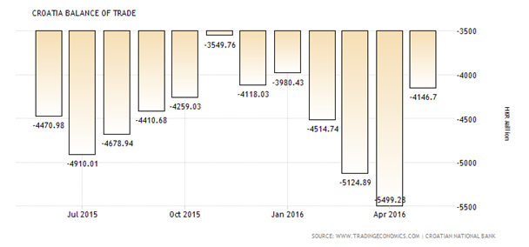
Croatia recorded a trade deficit of 4146.70 HKR Million in May of 2016. Balance of Trade in Croatia averaged -3541.99 HKR Million from 1993 until 2016, reaching an all time high of 502.62 HKR Million in August of 1993 and a record low of -8379.31 HKR Million in April of 2008. Balance of Trade in Croatia is reported by the Croatian National Bank.

Croatia unemployement rate
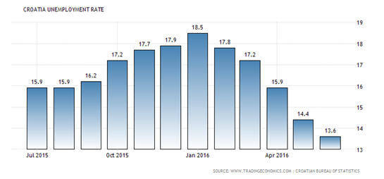
Unemployment Rate in Croatia decreased to 13.60 percent in June of 2016 from 14.40 percent in the previous month, reaching to the lowest level since December 2008. Unemployment Rate in Croatia averaged 18.18 percent from 1996 until 2016, reaching an all time high of 23.60 percent in January of 2002 and a record low of 12.20 percent in July of 2008. Unemployment Rate in Croatia is reported by the Croatian Bureau of Statistics.
Croatia government debt to GDP
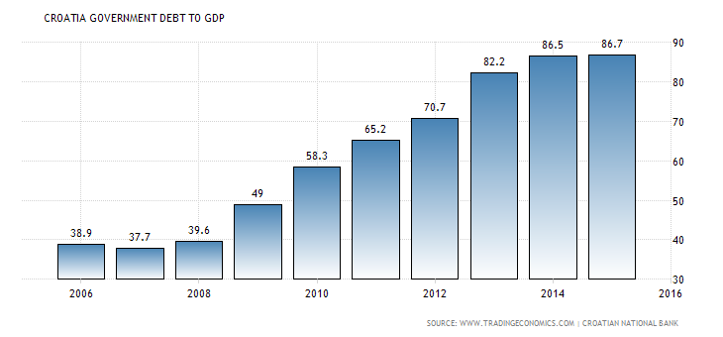

Croatia recorded a Government Debt to GDP of 86.70 percent of the country's Gross Domestic Product in 2015. Government Debt to GDP in Croatia averaged 52.70 percent from 2000 until 2015, reaching an all time high of 86.70 percent in 2015 and a record low of 35.50 percent in 2000. Government Debt to GDP in Croatia is reported by the Croatian National Bank.

Croatian Inflation Rate
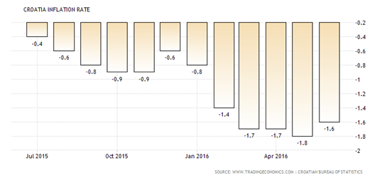
Consumer prices in Croatia went down 1.6 percent year-on-year in June of 2016, following a 1.8 percent decrease in the previous month. Prices fell the least since February, as cost declined at a slower pace for housing and utilities (-2.6 percent from -3.3 percent in May) and transport (-6.2 percent from -7.7 percent in May). In contrast, prices of food and non-alcoholic beverages (-0.4 percent from -0.3 percent in May) dropped further. On a monthly basis, consumer prices edged down 0.1 percent. Inflation Rate in Croatia averaged 2.50 percent from 1999 until 2016, reaching an all time high of 8.43 percent in July of 2008 and a record low of -1.80 percent in May of 2016. Inflation Rate in Croatia is reported by the Croatian Bureau of Statistics.
Croatia interest rate
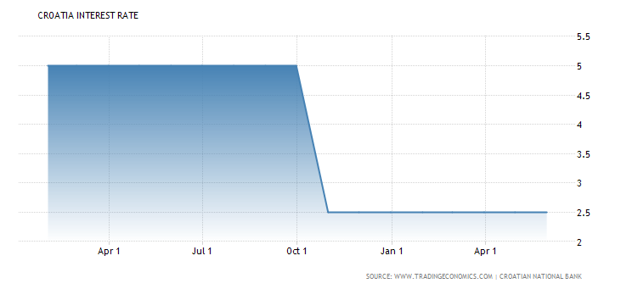
The benchmark interest rate in Croatia was last recorded at 2.50 percent. Interest Rate in Croatia averaged 93.36 percent from 1992 until 2016, reaching an all time high of 4290.85 percent in September of 1993 and a record low of 2.50 percent in October of 2015. Interest Rate in Croatia is reported by the Croatian National Bank.Croatia recorded a Government Debt to GDP of 86.70 percent of the country's Gross Domestic Product in 2015. Government Debt to GDP in Croatia averaged 52.70 percent from 2000 until 2015, reaching an all time high of 86.70 percent in 2015 and a record low of 35.50 percent in 2000. Government Debt to GDP in Croatia is reported by the Croatian National Bank.

Foreign direct investment in Croatia
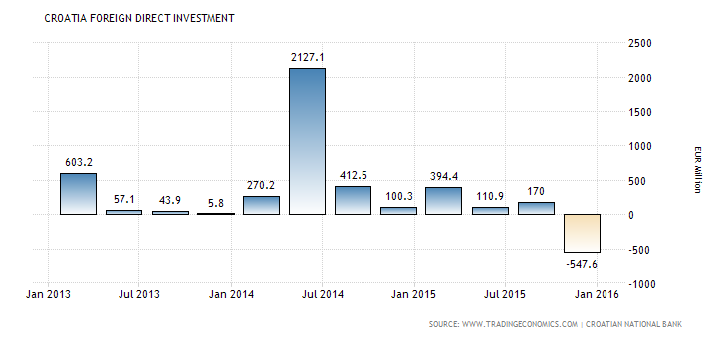
Foreign Direct Investment in Croatia decreased by 547.60 EUR Million in the fourth quarter of 2015. Foreign Direct Investment in Croatia averaged 409.56 EUR Million from 2000 until 2015, reaching an all time high of 2127.10 EUR Million in the second quarter of 2014 and a record low of -547.60 EUR Million in the fourth quarter of 2015. Foreign Direct Investment in Croatia is reported by the Croatian National Bank.
HRK/EUR Exchange rates
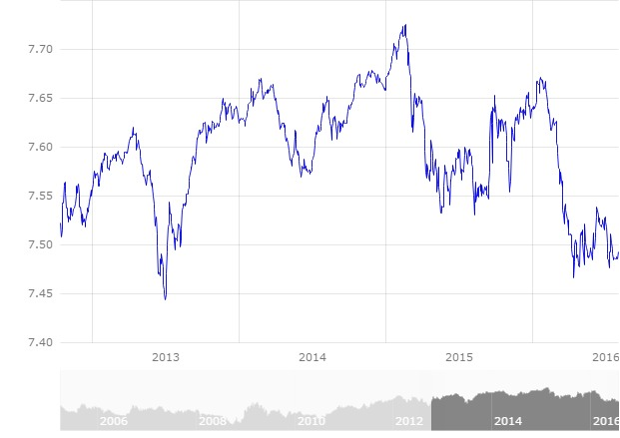
Croatian currency is kept stable in relations to Euro by Croatian National Bank. Typicaly, relatively larger fluctuations happen with seasonal changes, in summer due to touristic season and during winter due to energy prices. Daily exchange rate is reported by Croatian national bank.
Source: www.tradingeconomics.com/croatia/indicators

Economic environment overview
Croatia's economy has experienced deep transformation since 1992 when the country got its independence. From that time, it went trough structural reform becoming market economy. After fulfilling requirements Croatia became member of the European Union in 2013. Until the global economic recession, the economy enjoyed macroeconomic stability with relatively high growth, low inflation, a stable exchange rate and falling unemployment. The budget operated a surplus of HRK3.6bn in 2007, largely thanks to proceeds from the privatization of the state-owned telecoms company. But the underlying budget deficit remains around 3% of GDP. The State still plays a significant role in the local economy and unemployment (9% according to ILO criteria) is high.

In 2015, Croatia finally came out of its six-year long recession. Between 2008 and 2014, GDP shrunk by more than 12 % in real terms and unemployment surged from below 9 % to more than 17 %. The situation started to improve at the end of 2014, and in the course of 2015 real GDP growth surpassed expectations. Economic activity was expected to have expanded by 1.8 % in 2015. The external sector performed strongly, and Croatia recovered some of the lost market shares. Growth was however mainly driven by the rebound in consumption and, to some extent, investment.

The recovery is set to strengthen over the next couple of years, but risks remain. By 2017, GDP growth is forecast to attain 2.1 % and unemployment to contract to below 14 %, while the current account surplus should stabilize at around 3 % of GDP. The external sector is expected to continue to contribute to this positive performance, but the main driver of growth will be internal demand. Investments, in particular, are set to start growing more robustly, on the back of an increased absorption of EU structural and investment funds.

Nevertheless, growth is projected to remain subdued for a catching up economy and it will take several years before output returns to pre-crisis levels. In a low inflation environment, high government and private debt, jointly representing more than 200% of GDP in 2014, public and private investment as well as household consumption will continue being constrained. Eventually, however, the economy is set to return to its long-term potential growth, currently estimated at below 1 %.

Source: ec.europa.eu/europe2020/pdf/csr2016/cr2016croatiaen.pdf

CROATIAN ECONOMIC ENVIRONMENT SWOT ANALISYS
 | STRENGHTS | WEAKNESSES | OPPORTUNITIES | THREATS
GOVERNMENT INSTITUTIONS | Low costs and threat of terrorism, crime and violence. | Wasteful budgetary spending, low public trust in politicians, lack of transparency, regulative burden on business freedom. | Improving the ethics, increasing transparency, introducing informatisation. | Political changes.
INFRA-  STRUCTURE | Well developed highway roads and telecomunications. | Underdeveloped local roads, lack of sustainable planning. | Increasing investments in ports, railways, airports and other transportation infrastructure.
MACRO-  ECONOMIC ENVIRONMENT | Low annual inflation rate. | Low GDP growth rate, slow recovery from global crisis. | Decreasing accumulated government debt, decreasing trade balance deficit. | Volatile external environment, fiscal vulnerability.
HIGHER EDUCATION AND TRAINING | Competitive advantages are mathematics and science education. | Low awailability of research and training services. | Educational reform focused on flexible skills based curriculum.
GOODS  MARKET EFFICIENCY | Short business registration period, relatively low profit taxation. | Expensive agricultural policy, overregulated business environment, weak local competition. | Reducing standard VAT rate, developing business climate, protection against monopolies and cartels, implementing privatisation.
LABOR  MARKET EFFICIENCY |  | „Brain drain“. | Increasing labor market flexibility by easy rule on hiring and firing workers. | Political changes.
FINANTIAL MARKETS  AND DEVELOPMENT |  | Low venture capital availability. | Easier loan acess for entreprenurial activities and investments. | External vulnera-bility.
TECHNO-  LOGICAL READINESS |  | Low technology absorption in firms. | Increasing forreign direct investment for new technologies.
BUSINESS SOPHISTICATION |  | Low number of quality local suppliers, low production process sophistication. | Cluster development, specialisation, establishing economic diplomacy.
INNOVATION | Quality of scientific research institutions. | Low level of university-industry collaboration in research. | Developing closer ties between industry and university.
Source: made by authors

CROATIA SWOT

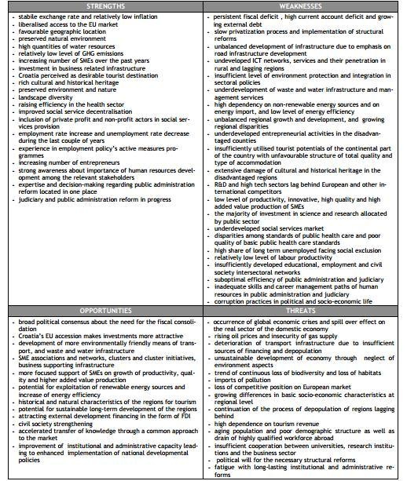

Source: www.weforum.org/docs/WEF_GCR_Report_2011-12.pdf

CROATIAN TRANSPORT SECTOR

Introduction to the Transport Sector in Croatia

Transport in Croatia relies on several main modes, including transport by road, rail, water and air. Road transport incorporates a comprehensive network of state, county and local routes augmented by a network of highways for long-distance travelling. Water transport can be divided into sea, based on the ports of Rijeka, Ploče, Split and Zadar, and river transport, based on Sava, Danube and, to a lesser extent, Drava. Croatia has 9 civil airports, seven of which are international. The country also has several airlines, of which the most notable is Croatia Airlines. Rail transport is fairly developed, with dual track and electrification not very common, although high-speed tilting trains are used on some routes. However, bus still tends to be more common than rail as a mode of inter-city transport.

Transportation Networks and Accessibility of the Regions

After attaining the status of the accession country in June 2004, Croatia benefited from various pre-accession instruments provided by the European Union relevant to the transport sector, namely on ISPA (Instrument for Structural Policies for Pre-Accession) and IPA (Instrument for Preaccession Assistance) getting big impact in the Croatian transport sector. In order to ensure an uninterrupted structural adjustment process in the transport sector and the utilisation of the finance under the IPA Component III – Regional Development, Croatia drafted a Transport Operational Programme (TOP) for the period 2007-2013. The TOP covers the key issues and information such as the transport policy background, status of transposition of EU transport acquis into national legislation, transport sector assessment and strategies and measures to meet transport sector development needs, in line with accession and post accession requirements.

Croatia has also maintained an active role in cooperation under the Memorandum of Understanding on development of the South-East Europe Core Regional Transport Network and has continued implementation of the multi-annual development plan for 2011-2015 for the South East Europe Transport Observatory (SEETO).

Croatia revised Transport Development Strategy of the Republic of Croatia, 1999, development of the National Traffic Model (NTM). In 2016, once the NTM will be elaborated and main results available, the Strategy 2014 will be assessed and updated if necessary. Later revisions of the Strategy will be made as a preparation for the EU upcoming programming periods but also in case of any significant impacts to the transport sector in Croatia in the future arise.

Strategy has taken into account the concern for sustainable development and by great sensitivity to environmental concerns and criteria. As a result, it constitutes a decisive commitment to the future of the Republic of Croatia, to its economic development and its competitiveness, to its social and territorial cohesion and to the improvement of the quality of life of its citizens, with a set of measures designed to create a transport system which is more integrated, safer, efficient and respectful of its environment.

As far back as 2000, within the framework of the Stabilization and Association Process, Croatia started its active international and regional activities in order to improve traffic and transportation links with the neighboring countries. The South-East Europe Transport Study TIRS (2000) and the Regional Balkan Infrastructure Study - REBIS (2003) were produced with the assistance of EU funds. REBIS determined the South-east Europe basic transport network.

As the signatory of the Memorandum of Understanding on the development of the South East Europe Core Regional Transport Network on 11 June 2004, the Republic of Croatia is committed in the implementation of transport projects defined in the multimodal Core Transport Network for South East Europe. This core network is based in part on the alignment of the relevant Pan-European Corridors (notably Corridors V, VII, VIII and X). As a SEETO Participant, Croatia has been involved in the preparation of the Five Year Multi Annual Plan 2010–2014. Moreover, according to EC regulations, the Cohesion Fund supports the preparation and the implementation of transport projects which are linked with the TEN-T corridors. So, it is clear that Croatia is proposing to co-finance from EU and from national resources priority projects that are part of Pan-European corridors.

- RAILWAY NETWORK

The Croatian railway network comprises 2.604 km and presents a good ratio of railway kilometres over the population of the country, 1.556 people per kilometre, close to countries like Switzerland and higher than others like Czech Republic or Hungary. However, the 90% are single track lines and only 36% of lines are electrified. Almost 55% of the network is dedicated to those lines that are significant for the international transport. Of these 2.604 km, only 5,4% is capable to reach speeds between 141 and 160 km/h, 17% has a maximum speed above 100 km/h, and 37,5% has maximum speeds below 60 km/h29.

RAILWAY NETWORK MAP:
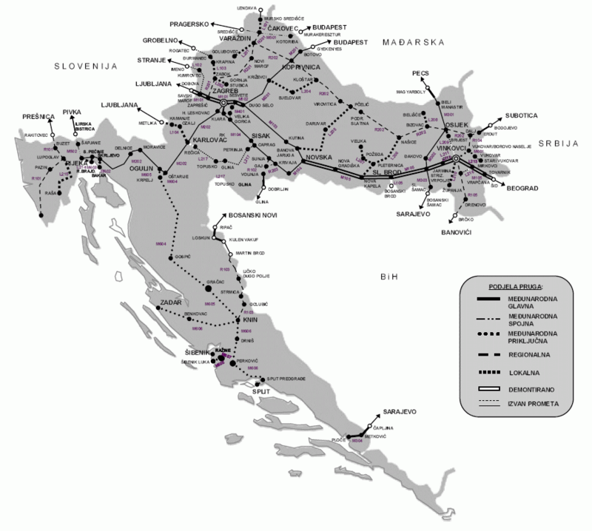Source: hr.wikipedia.org/wiki/Datoteka:Railroads_in_Croatia.gif

INTERNATIONAL RAILWAY CORRIDORS:
- TEN-T core and comprehensive network (Pan EuropeanCorridor X),Salzburg –Thessaloniki
- TEN-T Mediterranean corridor (Pan Europeancorridor Vb), Budapest – Rijeka
- TEN-T comprehensive network (Pan Europeancorridor Vc), Budapest –Ploče

PRIORITIES OF RAILWAY SECTOR:
- Modernisation of the remaining sections of the TEN-T core network lines according to their functionality,
- Analysing the potential to increase the use of railways for commuters in Zagreb and Rijeka and implement the measures defined through the Strategy
- Increase the sustainability of the railway network by performing a reorganisation of the sector, improve the efficiency of the maintenance, reduce the environmental impact and implement measures to increase the safety and the interoperability of railways,
- Modernisation of local and regional lines with the objective of creating preconditions for the development of integrated public transport system.

- INLAND WATERWAYS AND INLAND PORTS NETWORK

The Croatian network of inland waterways represents a significant, but at the same time, completely unexploited part of national values of Croatia. The overall length of the current inland waterways in Croatia is 1016.8 km, of which 601.2 km has been integrated into the European network of inland waterways of international importance. The Danube part of the Republic of Croatia`s inland waterways system forms a part of the RhineDanube Corridor. Ports Vukovar and Slavonski Brod are classified as core ports in the EU TEN-T network, while Osijek and Sisak are classified as comprehensive ports.

Within the complete inland waterways sector in the Republic of Croatia there are two separated sub-systems with their specific characteristics: Danube`s basin sub-system which encompasses the Danube’s waterway as well as Drava’s waterway, and the Sava basin sub-system which encompasses the waterways of the Sava, Kupa, and Una. The Croatian inland waterways ports Vukovar, Osijek, Slavonski Brod and Sisak and their port areas have been characterised by an undeveloped infrastructure and unconnected logistical port network.

PRIORITIES OF CROATIAN INLAND WATERWAYS:
- Establishing and maintaining conditions for safe and reliable inland navigation, especially to maintain international waterways according to the required international navigational class standard,
- Developing and modernising international inland ports according to internationalstandards in order to satisfy the existing and expected transport demand,
- Increase the sustainability of the system by performing a reorganisation of the sector, improving the efficiency of the maintenance, reducing the environmental impact and implementing measures to increase the safety and the interoperability of the system,
- Improve the accessibility of the ports and their connections to other transport modes to facilitate the development of multi-modal transport.
- ROAD NETWORK

Regarding its integration in international traffic, it should be emphasized that Croatia is already today, with its highly developed motorway network (90% constructed), close to high European standards regarding international road connections.

INTERNATIONAL ROAD CORRIDORS:
- TEN-T Mediterranean corridor/PanEuropean corridor
- Vb: Rijeka-Zagreb-Budapest; TEN-T comprehensive network/Pan-European corridor
- Vc: Ploce- Sarajevo- Osijek- Budapest; TEN-T core network/Pan-European corridor
- X: Salzburg- Ljubljana- Zagreb- Beograd- Niš- Skopje- Veles-Thessaloniki;
- TEN-T comprehensive network/Pan-European corridor
- Xa: Graz- Maribor- Zagreb
It is also necessary to analyse and determine the real need and sustainability of building a bypass of Zagreb Area, which would interconnect the highway network (A1, A2, A3, A4 and A11) and by this would improve connection between different corridors.

ROAD NETWORK MAP:
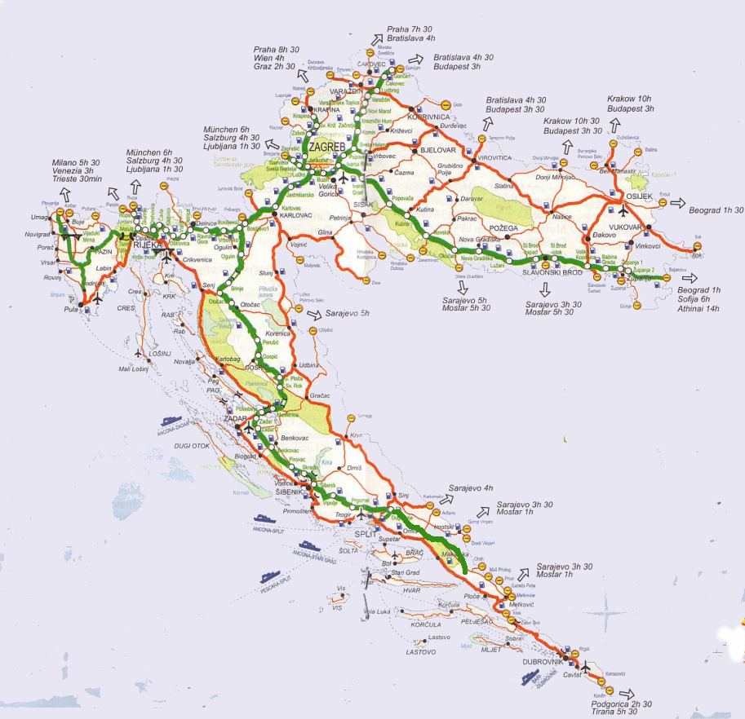

PRIORITIES OF ROAD SECTOR:
- Completion of the modernisation of the remaining sections of the TEN-T core network lines according to their functionality,
- Improving connectivity of Dubrovnik with the rest of Croatian territory and with the neighbouring countries,
- Increase the sustainability of the road system by performing a reorganisation of the sector, increase the efficiency of the maintenance of the network, reduce the environmental impact (especially the reduction of greenhouse gas emissions) and implement measures to increase the safety and reduce the influence of the seasonal constraints,
- Improve the accessibility to ports, airports and other relevant nodes considering local and regional transport needs.

- MARITIME TRANSPORT NETWORK

Today, Croatian ports annually reloaded about 21 million tons of cargo and transported more than 13 million passengers (data for 2015). Croatian ports are integrated into a comprehensive network of European transport corridors, which represents a growth potential that allows the inclusion of trade flows to the intra-European and world markets, as well as the transformation of port systems in modern logistics and distribution of economic centres.

Maritime Transport Statistics (year) | 2015. | 2014. | 2013.
CARGO (‘000 tones) | 21 376 | 20 335 | 24 744
PASSANGERS (‘000) | 13 082 | 13 029 | 12 770
Source of data: www.dzs.hr

Six major ports (Rijeka, Zadar, Sibenik, Split, Ploce and Dubrovnik) are located along the mainland coast and all are declared ports of special (international) economic interests for the Republic of Croatia. Croatian seaports are conveniently positioned to facilitate maritime transport between Central and Eastern Europe and Southern Asia, Australia and Oceania and Europe (via the Suez Canal). They enable a shortening of voyages by 5 to 8 days, or by a minimum of 2 000 km compared to north European ports. Currently on EU market, Adriatic ports take only 3% of total freight. Therefore, there is a large potential to increase freight transport of all Adriatic ports.
The further development of Ports of Rijeka and Ploce depends partially on the development of their connections to the railways. The most important common interest project for cargo maritime sector is the development and reconstruction of railway section from Rijeka to Hungary while further railway development in Bosnia and Herzegovina is of crucial importance for the development of port of Ploce. Ports Pula, Zadar, Sibenik, Split, Dubrovnik and Ploce are classified as comprehensive ports on the TEN-T Network.
PRIORITIES OF MARITIME TRANSPORT SECTOR:
- Specialisation of the ports according to the demand potential,
- Increase the sustainability of the system by performing a reorganisation of the sector, improving the efficiency of the maintenance, reducing the environmental impact and implementing measures to increase the safety and the interoperability of the system,
- Improve the accessibility of the ports and their connections to other transport modes to facilitate the development of multi-modal transport.

- AIR TRANSPORT NETWORK

The historical legacy and political, market and financial circumstances resulted in one main national airline, Croatia Airlines, also a member of Star Alliance.

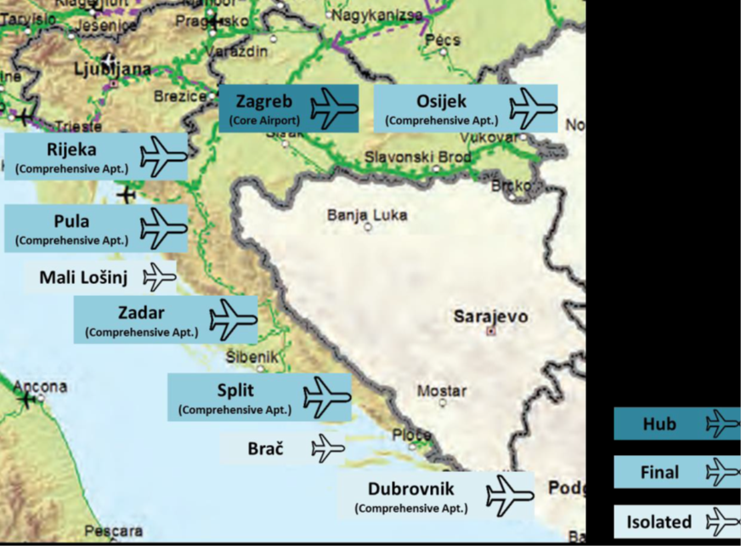
CIVIL AIRPORTS: 9 (total)
INTERNATIONAL AIRPORTS: 7
Airline companies: 3 (2016.)

Airport Traffic Statistics  (year) | 2015. | 2014. | 2013.
FREIGHT  (t) | 7 766 | 7 567 | 7 569
PASSANGERS  ('000) | 7 175 | 6 703 | 6 304
Source of data: www.dzs.hr

PRIORITIES OF AIR TRANSPORT SECTOR:
- Modernisation of Zagreb as the core airport of the Republic of Croatia and the Dubrovnik Airport due to need to improve accessibility of the Dubrovnik region,
- Adaptation of the relevant airports to the required safety and traffic management European requirements, to cope with the demanding seasonal peaks and to prepare airports to the potential adhesion of Croatia to the Schengen treaty,
- Increase the sustainability of the aviation system by performing a reorganisation of the sector, increasing the efficiency of the maintenance of the airports and reducing the environmental impact,
- Improve the accessibility to airports, especially by means of public transport.

- URBAN, SUB-URBAN AND REGIONAL TRANSPORT NETWORK

In 2015, road transport accounted for 71% of all passanger transport (29% railways) in category of inland transportation. An increase in the number of registered cars, passenger car mileage and the general use of passenger cars has been observed at the same time as usage decrease of public transport options.

The predominance of private transport is made evident by the big traffic jams on access roads towards urban centres, which contribute to increased pollution and noise level, lack of parking space and rising costs for citizens. At present, public transport in the Republic of Croatia is not integrated, as there are no coordinated timetables or single tickets for different modes of transport. Intermodal terminals, which enable transit from one mode of transport to another, do not exist or are extremely rare. On certain lines, bus and rail carriers have "parallel routes". The contribution of rail transport is penalized by the fact that average age of the rolling stock is close to the end of its service life, while in road transport; the average age of buses is approximately 15 years. PT services exist in the areas of the major cities such as Zagreb, Rijeka, Osijek, Split and their agglomerations, as well as Varaždin, Karlovac, Zadar and Pula. PT by tram is conducted in Zagreb and Osijek, while PT by railway is conducted in Zagreb and Split. In inland waterways navigation, public passenger transport for the purpose of daily migrations does not exist, while public transport in the maritime sector is focussed on the connection of islands with the mainland.

PRIORITIES:
- Establishing integrated transport systems in the main cities and their suburban and/or regional areas
- Developing measures to increase the share of public transport and zero emission modes such as P&R, restriction to private traffic in the centres of the cities, prioritisation for public transport through ITS systems, etc.
- Increase the sustainability of the system by performing a reorganisation of the sector, reducing the environmental impact and implementing measures to increase the safety of the system.

Source: www.mppi.hr/UserDocsImages/TR-DEVLP STRAT-M-DOC3010-14 FINAL 25-12_15.pdf

Transport Sector Overview

According to the World Bank transport in Croatia has a crucial role in international trade which has become more important since independence in reestablishing profitable transit traffic, promoting tourism and unifying the country.

CROATIA'S TRANSPORT SYSTEM
29,500 km of classified interurban roads
22,000 km of local roads
2,726 km of railway network
- - 1000 km electrified
- - 250 km double track
2 main sea ports (Rijeka, Ploce)
5 secondary sea ports
River ports on 918 km of Sava and Drava rivers
2.5 million deadweight tons (DWT) river and ocean-going vessel capacity
9 international airports

Transport demand and necessities have changed with full EU accession.
Most of the traffic is now international and flows are reoriented towards Western Europe. Serbia and Slovenia do no longer use the Port of Rijeka to a significant degree. EU Corridor 10 (via Belgrade), blocked since the war, is only now reopening as is transit traffic through Bosnia Herzegovina. Currently, Croatia placed emphasis on EU Corridor 5 (Rijeka-Zagreb-Hungary), which competes with a parallel corridor in Slovenia. The growth of private automobiles stalled during and after the war, but has now resumed; traffic congestion and pollution are increasing in Zagreb. As a combined result, maritime, port and river transport have fallen dramatically, while truck and airline traffic in particular have grown.

As a result, Croatia's existing transport infrastructure provides ample capacity with few exceptions for a number of years in the future. The railway carries less than a third of its pre-war traffic volume, and rail traffic is not expected to reach pre-war levels for a long time – at best around 2020 according to optimistic forecasts. Even then, more than 90% of rail traffic would be carried on routes adding up to less than 50% of the system, a clear indication of where and by how much the system needs to be reduced. Road traffic densities are also low, with only about 120 km carrying 15,000 vehicles per day (vpd) or more.

Croatia is also very well equipped with airports of various sizes and standards. There are, for example, seven airports that can receive wide-body aircraft while only three or four are needed.

The World Banks’ assistance to Croatia was focused on reconstruction and restructuring activities because of the destruction of war in the early 1990’s and the need to modernize transport institutions. Beyond reconstruction, Bank assistance for financing infrastructure investments was requested by the Government for railways, roads and ports including investments for facilitating trans-border trade and transport.

The Railway Modernization Project has been assisting the Government and Croatian Railways torestructure the company, including reductions in the labor force and related social measures, gradual privatization of non-core businesses and sustainable reductions in central budget subsidies. Efficiency measures were under way, including cutbacks in non-economic services, improved Croatian Railway's financial standing and reduced the need for fiscal transfers in the future.

Ongoing projects

The Rijeka Gateway Project aims at increasing Croatia's trade competitiveness by improving the international transport gateway through Rijeka.

Specific objectives include:
- Increasing efficiency and improving environmental and social conditions at Rijeka Port by preparing to privatize port operations, rehabilitating infrastructure and replacing equipment,
- Improving the financial performance of Rijeka Port with a view to reducing Government contributions in the medium term,
- Preparing to redevelop part of Rijeka Port for urban purposes,
- Improving international road connections linked to the Rijeka gateway, and the administration of the road sector.

The project include rehabilitation and construction works at the Rijeka port, construction of the western part of Rijeka bypass and connecting road to the port, rehabilitation of Krk bridge, rehabilitation of a section of the Zagreb-Macelj motorway, elimination of black spots, the purchase of port equipment and software for the Port of Rijeka Authority and the Luka Rijeka port operator, and redundancy payments and a social program for surplus Luka Rijeka workers. Technical Assistance aim at: preparing to privatize port terminal operations, preparing for urban redevelopment of a port area, assisting Croatian Motorways to obtain an ISO 9002 certification and satisfactory bond rating, assisting Croatian Roads to implement the pavement and bridge management systems and to enforce axle load regulations.

Zagreb Pier Container Terminal Project - cargo terminal is beeing built as part of the ongoing project and is to be completed by 2017. Upon the completion of the first stage of the project, the terminal's annual transloading capacity will be 400,000 containers, and after it is extended, the terminal will be able to handle 650,000 containers a year. It includes construction of 280 metre quay wall extension, reconstruction of the cargo section of the Rijeka railway station and construction of intermodal yard.

Source:
www.vlada.gov.hr/news/new-container-terminal-in-rijeka-port-to-be-completed-in-2017/16255 , www.portauthority.hr/en/development_projects/rijeka_gateway_project

Krizevci-Koprivnica-Hungarian Border railway project includes modernisation and construction of a second 43.2 kilometre track of the Krizevci-Koprivnica-Hungarian Border railway line, for which EUR241.3 million in EU co-financing is earmarketed for the project. The railway route is part of Mediterranean corridor, one of the nine corridors of the Trans-European Transport Network (TEN-T).

The document preparation project is worth 5.3 million euros, of which 85% will be covered with EU funds. The project will be prepared over the next three years in cooperation with foreign partners, and work on the reconstruction of the existing track and construction of a new one is expected to begin in 2016.

Source:
www.mppi.hr/default.aspx?id=9827
www.railjournal.com/index.php/europe/reviving-a-war-torn-network.html
www.total-croatia-news.com/item/13136-12-large-transportation-projects-draw-306-million-euro

Svilaj Bridge Project's Contract for construction of the Bridge Svilaj across the Sava River at Corridor Vc was signed on July 15, 2016. Bridge Svilaj across the Sava River shall be built at the Motorway A5, in Croatia, at Section from Sredanci to BiH border crossing and in Bosnia and Herzegovina at Section from Odžak to the border crossing of the Republic of Croatia. The planned completion period is two years starting from site installation and initiation into the works by the Contractors, companies Viadukt and Hering, which is envisaged to take place not later than the beginning of September this year. The value of works according to the Tender is EUR 22,308,022.34 exclusive of VAT, and Hrvatske ceste have applied for co-financing of a portion of the construction costs from EU Funds in ratio of 85 percent, the confirmation of which is expected during July.

Source: www.viadukt.hr/signing-of-contract-for-construction-of-bridge-svilaj

Other transport projects:
- CoRISMa cross border cooperation for data exchange
- SESAR programme implementations
- EAST-E development of of electric vehicle-related infrastructure
- Crocodile II coordinated trafic management project.

Source:
ec.europa.eu/inea/en/connecting-europe-facility/cef-transport/projects-by-country/croatia
www.total-croatia-news.com/item/13136-12-large-transportation-projects-draw-306-million-euroconnecting-europe-facility-croatia-to-receive-e306-million-for-12-transport-projects

Planned projects

A7 Highway (Rupa-Rijeka-Zuta Lokva); 56 kilometers long continuation (marked orange) to be built is split into three parts:
- Krizisce-Novi Vinodolski (25,2km)
- Novi Vinodolski-Senj (16,3km)
- Senj-Zuta Lokva (15km).
Financing plans state construction will be financed via concession (public-private partnership). No begin date has been stated yet.
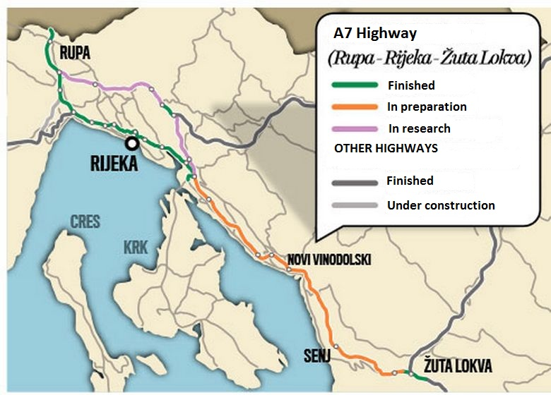

Related Links

Transport Development Strategy of Republic of Croatia (2014-2030)
The Strategy sets out the basic guidelines for the development of the transport sector within the Republic of Croatia over a medium and long-term horizon (2014-2030), aiming to define an overall and coherent framework to ensure the linkage of infrastructure and transport policy and enabling decision making.
Source: www.mppi.hr

General Transport Statistics of Croatia
This web site provides general statistics of the transport sector in Croatia in all of its categories (Ground, Water and Air Transportation)
Source: www.nationmaster.com/red/country/hr-croatia

The World Bank: Documents about transportation
World Bank website provides some documents about projects in Croatia in the transport sector.
Source: www-wds.worldbank.org

Quarterly transport statistics; Croatia
www.dzs.hr/Eng/Publication/2009/5-1-5_2e2009.htm

Regulation Dependencies of Croatia

Transport in Croatia is regulated by theMinistry of the Sea, Transport and Infrastructure.
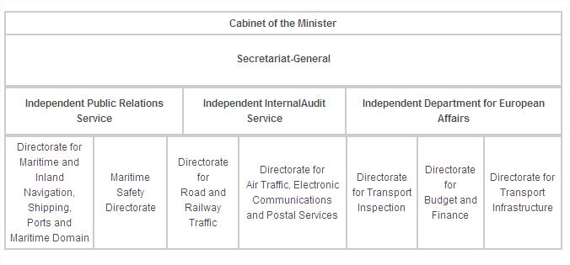

Ministry of the Sea, Transport and Infrastructure
Prisavlje 14, 10000 Zagreb, Croatia
Tel. +385 16 169 111
www.mppi.h
AIR TRANSPORT IN CROATIA
There are international airports in Zagreb, Zadar, Split, Dubrovnik and Rijeka (on the island of Krk). Recently, Osijek Airport in Slavonia has been renovated for regional traffic. Pula Airport (Istria) was renovated as a destination for low cost airlines. Croatia Airlines (member of Star Alliance) is major Croatian airlines company.

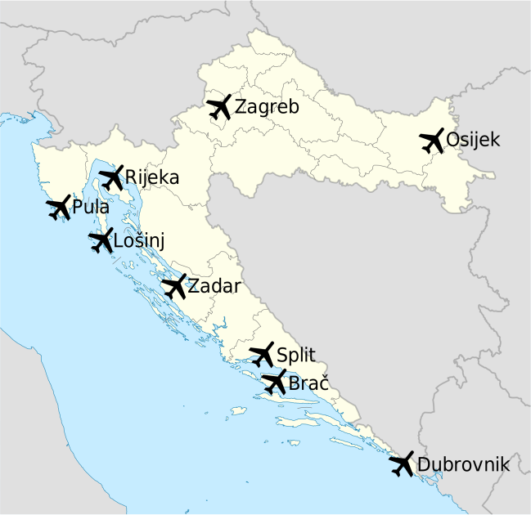
Source: www.en.wikipedia.org

In January 2011 the U.S. Federal Aviation Administration (FAA) assessed the Government of Croatia's Civil Aviation Authority announcing that Croatia complied with International Civil Aviation Organization (ICAO) aviation safety standards for oversight of Croatia's air carrier operations. This means that the country has IASA Category 1 rating and that Croatian air carriers are authorized to establish direct flights from Croatia to the US.
Croatia's nine commercial airports handled over seven million passengers last year, with Zagreb, Split and Dubrovnik accounting for over a half of all travellers. Zagreb Airport saw its busiest year on record, welcoming 2.587.798 passengers through its doors. The figure represents growth of 6.5%. In addition, it registered 39.854 aircraft movements, up 3.9%, while 9.225 tons of cargo were handled, an increase of 4.1% on the year before.
Source: www.airport-suppliers.com/news/Airport_News_140/
General Statistics
Overall: 68 airports (2004 estimate)
Heliports: 3 (2008)

Airports with paved runways (2004 estimated):
total: 23
10,000 ft (3,047 m) or more: 2
8,000 to 9,999 ft (2,438 to 3,047 m): 6
5,000 to 7,999 ft (1,524 to 2,437 m): 2
3,000 to 4,999 ft (914 to 1,523 m): 4
under 3,000 ft (914 m): 9

Airports with unpaved runways, (2004 estimated):
total: 45
5,000 to 7,999 ft (1,524 to 2,437 m): 1
3,000 to 4,999 ft (914 to 1,523 m): 7
under 3,000 ft (914 m): 37

This year, 2016, number of passangers in July amounted to 1.48 million which is 19% more than in July last year according to Croatian Civil Aviation Agency. Airport Split noted biggest increase (24.4% more than last year); Dubrovnik comes second (16.5% more passangers) and Zagreb (10.6% of passangers more than last year).
Source: “Privredni Vjesnik”, www.privredni.hr; 5th of September 2016.

Main Airports

Zagreb Airport

Source: www.zagreb-airport.hr

Zagreb Airport is the largest and busiest international airport in Croatia. Terminal 2, currently under construction of Zagreb airport was named after Franjo Tuđman, the former president of Croatia. It is also known as Pleso Airport.

The airport has been given to ZAIC consortium (Zagreb Airport International Company) in a 30-year concession under the terms of contract signed by the Government of Croatia and mentioned consortium. The contract includes financing, designing and construction of a new passenger terminal.

Construction of new 70,000 m² (750,000 sq ft) passenger terminal officially started on 18 December 2013. Terminal with capacity of 5.5 million passengers in the first phase should be completed by end of 2016 and 250,000 m² (2,700,000 sq ft) airport apron will also be added as part of the whole expansion project. The main terminal building itself is rather small measuring only 200 × 58 m (660 × 190 ft) or around 20,000 m² (220,000 sq ft). The apron or airport ramp measures 950 × 187 m (3,120 × 614 ft) and can accommodate around 15 medium and 2 wide body aircraft.

On 12 April, 2012, Aeroports de Paris received a 30 year concession of the airports from the Government of Croatia. The contract includes financing, designing and construction of a new passenger terminal. ZAIC will operate the entire airport for 30 years, including the runways, the current passenger terminal during the entire construction period, the new terminal, the cargo terminal, car parks and future property developments. The concession contract involves a total investment of €324m (£259m): €236 million for the design and construction of the new terminal and €88 million for operation of all airport infrastructures for the entire period of the concession.

Accompanying the terminal will be a second parallel runway. The rail line alongside the Eastern bypass of Velika Gorica, which extends from Zagreb across the Homeland Bridge, was completed by 2007. These elements created an entirely new east entrance into the city adding to the one via D408 state road. The airport was built in such manner that more expansions can be conducted easily if needed.

Source: www.exyuaviation.com/2016/01/croatian-airports-post-record-numbers.html

Traffic at Zagreb Airport
Year | Passengers | Passenger %  Change | Aircraft Landings | Cargo (tonnes)
2006 | 1,728,414 | 11.4 | 20,442 | 10,393
2007 | 1,992,455 | 15.2 | 21,625 | 12,564
2008 | 2,192,453 | 10.0 | 22,271 | 12,697
2009 | 2,062,242 | 5.9 | 20,342 | 10,065
2010 | 2,071,561 | 0.5 | 19,906 | 8,156
2011 | 2,319,098 | 11.9 | 21,180 | 8,012
2012 | 2,342,309 | 1.0 | 19,527 | 8,133
2013 | 2,300,231 | 1.8 | 18,437 | 7,699
2014 | 2,430,971 | 5.6 | 19,174 | 8,855
2015 | 2,587,798 | 6.4 | 19,927 | 9,225
2016 (until 31 July) | 1,533,107 | 6.6 | 11,700
Source: en.wikipedia.org/wiki/Zagreb_Airport

News and Developments

In 2017, expansion of the fleet is planed.
Source: www.exyuaviation.com/2016/05/croatia-airlines-to-expand-fleet-in-2017.html

A new state-of-the-art passenger terminal is being constructed at Zagreb International Airport, Croatia, to replace the existing terminal, which has reached the saturation point. It is expected to be finished in March 2017. Investment totals EUR331 million (from which EUR243 million for design and constructon of passanger terminal and EUR88 million for maintainance during concession period of 30 years). New terminal building will spread on 65,000 square meters of which 6,000 for commercial purposes.
Source:
www.airport-technology.com/projects/new-terminal-zagreb-international-airport
“Privredni Vjesnik”, www.privredni.hr; 5th of September 2016.

Split Airport

Source: www.split-airport.hr

Split Kastela/Resnik Airport (Airport Split) (IATA: SPU, ICAO: LDSP) is the airport serving Split and Kaštela in Split-Dalmatia County, Croatia.

The airport is the second largest in Croatia in terms of passenger numbers, handling 1,955,400 passengers in 2015. It is an important hub for Croatia Airlines offering flights to many European cities such as; London, Amsterdam, Frankfurt, Rome and Paris.
Traffic at Split Resnik Airport
Year Passengers Cargo
2005 934,049 877
2006 1,095,852 1,459
2007 1,190,551 1,482
2008 1,203,778 1,081
2009 1,115,099
2010 1,219,741
2011 1,300,381
2012 1,425,749 649
2013 1,581,734 462
2014 1,752,657 429
2015 1,955,400

Source:en.wikipedia.org/wiki/Split_Airport

In September 2011, the new airport ramp was opened. The cost of this investment was 13 million euro, and it includes 34,000m² of new parking space for the airplanes, as well as a large support space on the lower level. This level is actually a ground level, and the airplanes are parked on the roof of the structure. Starting in 2009 and running trough 2014, major overhaul work was conducted and currently running project is expected to result in expanded terminal with 4 jetways and with new apron.

News and Developments

The Croatian government has announced the construction of a new multi million euro terminal at Split Airport, which will stretch over 34.500 square metres and increase the airport’s capacity to 3.5 million passengers per year. Furthermore, the car park and bus area will be expanded by 35.500 square metres. Work on the 59.3 million euro expansion project is expected to begin in autumn or early winter. It is estimated to take just over two years to complete the investment. The new terminal will improve the quality of passenger services and will enforce European Union standards for international border crossings in line with the Schengen Agreement.
Source: www.exyuaviation.com/2015/06/split-airport-to-get-new-terminal.html

Osijek Airport

Source: www.osijek-airport.hr

Osijek Airport (IATA: OSI, ICAO: LDOS) is the airport serving Osijek, Croatia. The airport is located 20 km East-Southeast of Osijek and is situated near the Osijek - Vukovar regional road.

In 2016, increase in number of passangers from 2015 was noted and it amounted to 30%. Therefore, Osijek Airport is planning to increase numer of lines to other Croatian airports and wishes to focus on also introducing flights to destinations abroad. In 2015, contract for building of aviohangar was signed:
Source: “Privredni Vjesnik”, www.privredni.hr; 5th of September 2016.

Rijeka Airport

Source: www.rijeka-airport.hr

Rijeka Airport (IATA: RJK, ICAO: LDRI) is the airport serving Rijeka, Croatia.

Most of the traffic to and from the airport occurs during the summer months, when it is used by several European low-cost airlines flying tourists to the northern parts of the Croatian coast.

Traffic figures at Rijeka Airport

 | Year |  | Passengers |  | Change |  | Aircraft |  | Change
 |  |  |  |  |  |  | movements
2003 |  | 41,498 |  |  |  | 2,630
2004 |  | 51,349 |  | 23,74% |  | 2,753 |  | 4,68%
2005 |  | 118,244 |  | 130,28% |  | 3,043 |  | 10,53%
2006 |  | 166,675 |  | 40,96% |  | 3,497 |  | 14,92%
2007 |  | 160,862 |  | 3,49% |  | 3,407 |  | 2,57%
2008 |  | 109,706 |  | 31,80% |  | 2,521 |  | 26,00%
2009 |  | 110,208 |  | 0,46% |  | 2,759 |  | 9,44%
2010 |  | 61,478 |  | 44,22% |  | 2,016 |  | 26,93%
2011 |  | 78,890 |  | 28,32% |  | 2,680 |  | 32,84%

Source: www.en.wikipedia.org/wiki/Rijeka_Airport

Zadar Airport

Source: www.zadar-airport.hr

Zadar Airport (IATA: ZAD, ICAO: LDZD) is the airport serving Zadar, Croatia. It is located in Zemunik Donji, 8 km from the Zadar railway station. The airport serves as the flying base for Lufthansa's flight school InterCockpit and Croatian Air Force main training base. Zadar airport is one of the few airports in the world where the runway intercepts a traffic road.

Airport Zadar experiences steady growth. In 2016; July, 15.1% passengers more were recorded in comparison to July 2015. To Airport Zadar currently flies 25 operators, from which is Ryanair most important with 13 lines and totals 60% of traffic.
Source: “Privredni Vjesnik”, www.privredni.hr; 5th of September 2016.
Dubrovnik Airport

Source: www.airport-dubrovnik.hr

Dubrovnik Airport (IATA: DBV, ICAO: LDDU), also referred to as Cilipi Airport, is the international airport of Dubrovnik, Croatia.
The airport is located at approximately 15.5 km from Dubrovnik city centre, near the suburb of Cilipi. The airport is the third largest in Croatia in terms of passenger numbers and with the longest runway.

At the time Airport Dubrovnik is undergoing modernization as 65% of all visitors come by plane, making it very important to local turisam. Investment amounts to HRK1.1 billion with EU co-financing HRK950 million expected to be finished by 2019.
Source: “Privredni Vjesnik”, www.privredni.hr; 5th of September 2016.

Pula Airport

Source: www.airport-pula.hr

Pula Airport (IATA: PUY, ICAO: LDPL) is the airport serving Pula, Croatia and is located 6 km from the city centre. Thanks to favorable climatic and technical conditions Pula is designated as the alternative airport for parts of Slovenia, Italy and even Austria.
Pula has a special interest in jet set passengers flying privately or rented aircraft, visiting the Brijuni islands or attending concerts and shows at Pula Arena and sailing their yachts. Presently, Pula airport is capable of handling large aircraft such as Boeing 747 and Ilyushin Il-86.

Brac Airport

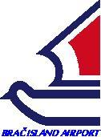
Source: http://airport-brac.hr

Bol Airport or Brac Airport (IATA: BWK, ICAO: LDSB) is an airport on the Croatian island of Brač, close to the town of Bol. It is primarily served by charter traffic from Europe during the summer seasons. Operators during the summer months are Croatia Airlines, Austrian Airlines and Private Wings Flugcharter. Most of the traffic occurs between Brač and Austrian cities.

Airport Mali Lošinj

Lošinj Airport (IATA: LSZ, ICAO: LDLO) is an airport 5.9 km from Mali Lošinj on the island of Lošinj. It is registered for domestic and international traffic. The runway is 900 m long and 30 m wide, and is equipped with 1C signalization according to the ICAO. A non-precision instrument approach using an NDB located near the city is published. The traffic consists primarily of small aircraft. As of 1 September 2016, European Coastal Airlines serves the airport and connects it between once and twice daily with Pula (downtown-seaport) and Split (downtown-seaport).
Source: www.airportmalilosinj.hr

Great expansion is being planned; which includes elongment of the rumway from 900m to 1800m and raising of the new airport building which will allow landing of up to 180 passanger capacity planes and making charter lines awailable to the island. Project was listed on Strategic Investment Project List of Republic of Croatia in 2014. According to current estimates total value of investment will amount to EUR35 million.
Source: “Privredni Vjesnik”, www.privredni.hr; 5th of September 2016.

Croatian Airlines Comapanies

Croatia currently has three domestic air transport companies: Croatia Airlines (passanger transport, Franjo Tudman Airport Zagreb), Trade Air (charter, cargo transport, dangerous cargo transport licensed, Franjo Tudman Airport Zagreb) and European Coastal Airlines (hidroplanes, Split).

Croatia Airlines d.d.

Source: www.croatiaairlines.com

Croatia Airlines Ltd. is the state-owned flag carrier of Croatia. It is headquartered in Buzin near Zagreb and operates domestic and international services mainly to European destinations. Its main hub is Franjo Tuđman Airport with focus cities being Dubrovnik, Split, and Zadar. Since November 2004, the airline has been a member of Star Alliance.

Trade Air d.o.o.

Source: www.trade-air.com

Trade Air d.o.o. is a passenger and cargo charter airline based in Zagreb, Croatia. The company is registered as an airline whose main activities are passenger charter flights and cargo operations, organized either on charter chain flights or ad hoc flights. Trade Air also specialises in the transportation of dangerous goods.

European Coastal Airlines Ltd.
Source: www.ec-air.eu
European Coastal Airlines is a Croatian seaplane operator headquartered in Split. Founded in 2000, the company launched scheduled services in August 2014 and serves domestic flights within Croatia as well as services to nearby Italy. First of trans-Adriatic routes between Croatia and Italy began in November 2015 with four weekly flights between Split downtown and Ancona and also, between Rijeka Airport and Ancona.

Related Links
Croatian Ministry of Maritime Affairs, Transport and Infrastructure Website:
www.mppi.hr

Croatian Civil Aviation Agency:
www.ccaa.hr

Croatian Airports:

- ZAGREB: www.zagreb-airport.hr
- SPLIT: www.split-airport.hr
- DUBROVNIK: www.airport-dubrovnik.hr
- ZADAR: www.zadar-airport.hr
- BRAČ: www.airport-brac.hr
- OSIJEK: www.osijek-airport.hr
- PULA: www.airport-pula.hr
- RIJEKA: www.rijeka-airport.hr

Aviation News Portal for Croatia and Ex-Yugoslavia Countries:
www.exyuaviation.com

Croatian Airlines Companies:
- CROATIA AIRLINES: www.croatiaairlines.com
- TRADE AIR: www.trade-air.com
- EUROPEAN COASTAL AIRLINES: www.ec-air.eu

Croatian Bureau of Statistics:
www.dzs.hr

RAIL TRANSPORT IN CROATIA
The railways are being modernized because since the disintegration of Yugoslavia there have been hardly any investment in railway infrastructure. Many important routes are not electrified and are only single track traffic around 'bends'. Major improvements are being underway especially on routes that can be best economicaly exploited for cargo transport. A result of this has been an increase in the maximum speed on the railway line on the Pan-European Corridor X, from the Slovenian border via Zagreb, Novska and Vinkovci to the Serbian border. In places the line's speed limit has been raised from 80 km/h to 120 km/h, and plans have been made to raise this further to 160 km/h on certain sections.

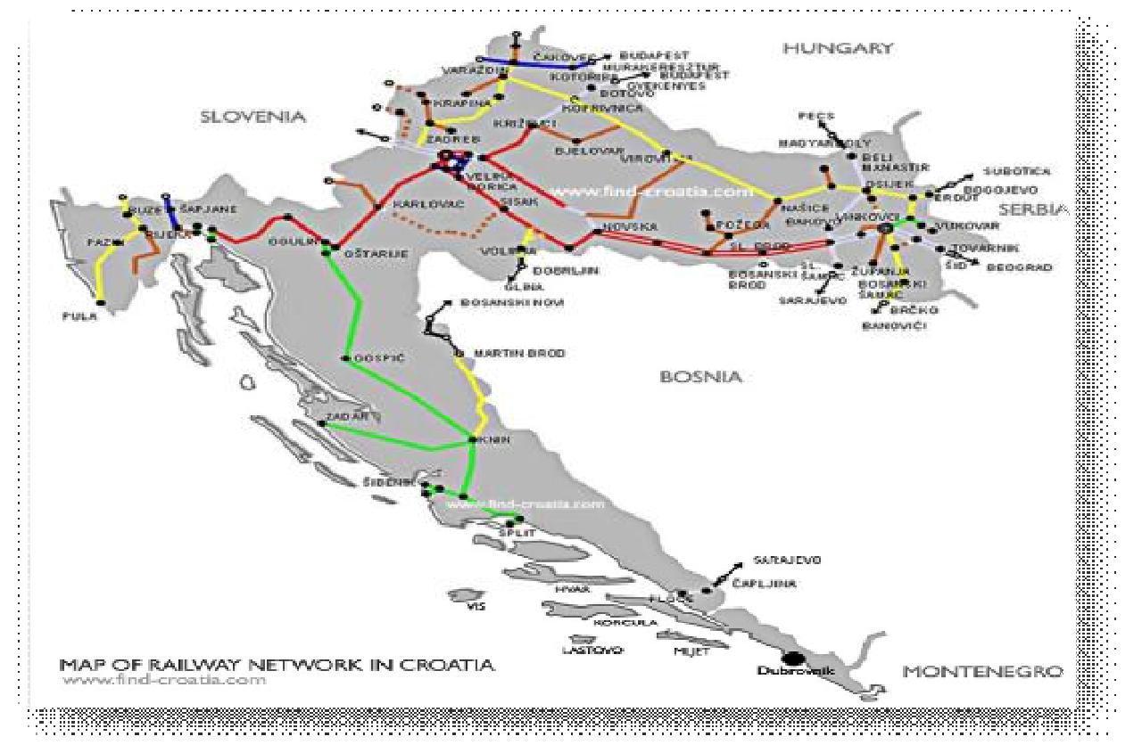

The railway line of the Pan-European Corridor Vb, from the Hungarian border via Koprivnica, Zagreb and Karlovac to the seaport of Rijeka had slow section through Gorski Kotar, which underwent a major overhaul in 2014.
The railway line of the Pan-European Corridor Vc, from the Hungarian border via Beli Manastir, Osijek, Đakovo or Vinkovci, Slavonski Šamac, to the Bosnian border, is also being modernised, the aim is to allow speeds of up to 160 km/h along the entire length.

RAIL LINKS WITH ADJACENT COUNTRIES:
- Slovenia
- Hungary
- Serbia
- Bosnia and Herzegovina

MAJOR RAILWAY ROUTES IN THE COUNTRY:
- from Zagreb to Vinkovci
- from Zagreb to Osijek via Koprivnica
- from Zagreb to Rijeka
- from Zagreb to Split

Railway length
TOTAL: 2,974 km
248 km is double track
1,228 km is electrified (41.3%)

The official rail speed record in Croatia is 181 km/h. This is just below the official 200 km/h high speed rail definition. This speed is never reached in regular service.
Croatia does have a locomotive class capable of this speed, and during the Yugoslav era there were plans for 'high speed' rail. The increasingly elderly high-speed rolling stock has had its speed limited to 120 km/h for safety reasons.

Recently Croatian Railways introduced a series of modern tilting trains produced by the German branch of Bombardier Transportation. They usually deployed on the mountainous route between the two largest Croatian cities, Zagreb and Split, although they can sometimes be found on Inter City routes in the continental part of the country. The trains on the Zagreb-Split route offer passengers a more comfortable and quicker journey. The previous service used to take 9 hours, whereas the tilting trains take no more than 5.5 hours. There are plans to expand the tilting train service since they turned out to be very profitable on longer routes.
Croatian Railways aims to revitalize rail traffic through further improvements, thus establishing rail as serious competitor to the car, particularly during the busy summer months.

Croatian Railways' plan to build their first high-speed railway service is progressing. The journey from Zagreb to Rijeka will be cut to one hour compared to 4 hours with the existing track. The line is intended to carry the increasing amount of goods that enter Europe, at the Croatian port of Rijeka and are then transported to destinations across central and Eastern Europe. The plans have originally foreseen 2008-2010 as the date for completion. Due to the world economic crisis, building start date is prolonged to a yet undefined date. The project plans have been drawn, however.

Pan-European Corridor X is going to be upgraded to higher speed sometime in the future. Possibly by building a new high capacity connection line from Sisak via Kutina to Lipovljani. The line should allow for speeds of up to 250 km/h.

Functioning of the entire Croatian railway system is based on three companies:
HŽ INFRASTRUKTURA d.o.o.

HŽ Infrastructure Limited Liability Company for Management, Maintenance and Building of Railway Infrastructure
www.hzinfra.hr

HŽ CARGO d.o.o.
HŽ Cargo Limited Liability Company for Cargo Transport
www.hzcargo.hr
HŽ PUTNIČKI PRIJEVOZ d.o.o.
Passenger Transport Limited Liability Company
www.hzpp.hr

Major Rail Routes

- Dobova-Tovarnik line (International corridor X)

The railway line between Dobova and Tovarnik, operating the length of Croatia East-West via Zagreb, is the country's most important rail line, and part of the Pan-European corridor X.
It is also the most advanced and busiest, being completely electrified and consisting mostly of double tracks. In a longitudinal manner it crosses Croatia's Northern regions Slavonia, Posavina and the Greater Zagreb Region, connecting the most economically developed towns in Croatia with each other.

The route is as follows:
- Dobova (Croatian border with Slovenia)
- Zagreb
- Sesvete (track split towards Sisak - electrified)
- Dugo Selo (track split towards Botovo - electrified)
- Ivanić Grad, Kutina
- Village Banova Jaruga (again track split towards Virovitica (non-electrified))
- Novska (track split backwards towards Sisak (electrified))
- Nova Gradiška
- Combined villages Nova Kapela-Batrina (track split towards Požega, and via Pleternica towards Našice (non-electrified))
- Slavonski Brod
- Combined villages Strizivojna-Vrpolje (two track splits: towards Osijek (currently non-electrified) and towards Slavonski Šamac (electrified, Croatian border to Bosnia and Herzegovina))
- Vinkovci (four track splits: towards Osijek, Vukovar, Županja and Brčko in Bosnia and Herzegovina, before the Croatian war of Independence, this was one of the biggest East European junction stations, for both passengers and freight)
- Tovarnik (Croatian border with Serbia)

At Vinkovci the track splits and branches towards: Županja, Vukovar, both non-electrified. The connection towards Osijek was severely damaged in the Croatian War of Independence. Repairs began in 2003 and in December 2008 the line was reopened.

- Ogulin-Knin line

The Ogulin-Knin line, also known as the "Lička pruga" or Lika line, is part of the railway connection between Zagreb and Split. As of 2007, this line is being heavily upgraded with many sharp bends and grades removed in order to allow tilting trains to travel at nearly full speed on most parts of the track. This track was not intended as the shortest distance between Zagreb and Split. The line via Martin Brod which forms the border with Bosnia has not been reopened to passenger traffic since the conflict.

The problems faced are that, as the line was constructed a long time ago and contained many curves (often in difficult terrain), services were slow and speed severely restricted. The modernization has involved rebuilding complete sections of track, straightening many curves, by repositioning and by renewing track and enabling for higher speeds. Electrification of the line is not scheduled for the near future.

- International corridor V
International corridor V has two branches in Croatia, the "b" and "c" branch. Corridor Vb enters Croatia in Botovo, and runs to Zagreb. The part from Zagreb to Rijeka should become part of this corridor, as soon as the extension towards Rijeka is built.
Corridor Vc is a Pan-European railway line, running north to south within Croatia. It enters Croatia at Beli Manastir, on the border with Hungary, and runs through Osijek to enter Bosnia and Herzegovina in Slavonski Šamac. It enters Croatia again in Metković, in the very south-east of Dalmatia, where it ends at the Ploče harbour. The line crosses the Dobova-Tovarnik line in Strizivojna-Vrpolje. The line is currently being heavily modernized in order to revitalize Ploče harbour.
The part from Strizivojna-Vrpolje towards Slavonski Šamac is fully electrified, and recently the modernized catenaries have been put into operation. The passenger traffic scheduled from Vinkovci to Slavonski Šamac (now performed by electrical power) is still fragmented. The remaining part from Strizivojna-Vrpolje to the region of Osijek (heart of the region Slavonia) is scheduled to be electrified, as soon as the general overhaul of the line track is completed, after which operating speed will finally be raised to 160 km/h (100 mph). The line will stay single track.

- The Vinkovci-Osijek line
The Vinkovci-Osijek line was, before the dissolution of Yugoslavia, one of the most heavily used branch lines of Croatia, linking two regional centers. The line allowed speeds of up to 120 km/h. After the war, only about 10 km of the 35 km line remains preserved. Most of the track was removed by the Serbian forces, which used it as barricades and for other war purposes. The reconstruction of this vital route was finally finished in 2008. Test driving with a measuring vehicle has been successful, and speeds of 60–80 km/h have been reached. Test train went on maiden voyage in 2008. The regular revenue service was restarted in the same year.

- The "Unska pruga" route
The route called Unska pruga (litteraly the Una track) that connects Zagreb and Split along the Una river valley was once an integral part of the Yugoslav Railways system. Today, this route remains largely unused, since much of it virtually runs over the border between Croatia and Bosnia-Herzegovina, crossing it multiple times, on the section between Knin and Bihać.
Although this route is largely well preserved and electrified at 25 kV/50 Hz (making it compatible with the Croatian electrification system), administrative problems concerning the many border crossings cause this route to be used only for limited freight traffic services. The designated border crossing along the line between the two countries is at the town of Martin Brod.

Network connection problems
There are some rail network connection problems, which have historical causes. When Croatia was part of Yugoslavia, the rail network was consistently connected and managed by Yugoslav Railways. As the Yugoslav constituent states demerged, important rail links were severed. Istria has no direct connection through Croatia. Currently, the whole rail transport operates through Slovenia, though this could be solved with a tunnel north of Rijeka. The Dubrovnik broader Area is again a special case. Dubrovnik and its surrounds are an exclave, divided by the small Bosnian Neum sea district. There is no direct rail link through Croatia toward Dubrovnik. If needed, rail traffic must be rerouted via Bosnia- Herzegovina (there was previously a narrow-gauge rail line operating from Mostar). Croatian Railways operates a short line between the port town of Ploče and the border town of Metković which sees both daily freight and passenger traffic. Historically, the region has been developed through sea travel.

Power Systems
The original decision in former Yugoslavia was to use 3 kV DC electrification for the railway network. This was performed on the Rijeka-Zagreb line, which due to the mountainous Gorski kotar region had a need for more powerful trains than the traditional diesel powered ones.
Beginning with the modernisation of the Zagreb-Belgrade line an electrification system of 25kV/50Hz was used. Electrification on other lines in Croatia was then made exclusively 25kV/50Hz. Later, the majority of the Zagreb-Rijeka line was re-electrified to 25kV/50Hz, but there is still a part that is 3 kV DC. Consequentially a power system break still exists at Moravice. All railway power systems in Croatia are exclusively of type overhead catenaries.

New Developments in Croatian Rail Sector

In the transport sector, Croatia’s accession to the EU has determined the authorities to reform and rethink the transport system, with special focus on railway transport, and in order to benefit from the future financial support of the EU, they have to provide the right administrative capacity to manage funds and elaborate viable projects. Thus, Croatia is eligible for structural and cohesion funds and EC approved investment plans for the cohesion policy worth EUR 449.4 Million.

Since the end of the war for independence and trough the period of transition railways were in bad and underdeveloped state. Over the period of last ten years many sections of railways were under repair in order to make them safer and their traffic capacity and speed limit higher.
Moreover, starting with 2011, Croatian Railways and the owners of old industrial lines have launched a new plan for revitalizing old industrial lines for transport of goods and proposed building new industrial lines to be integrated into distribution chains of Croatian companies (Jamnica d.d. in Jastrebarsko planning to build 300m of railway to connect warehouses with public railroads is one of the proposed projects).
HŽ Infrastruktura is carrying out projects with investments promoted by the government and local authorities aimed to encourage cross-border railway traffic. For example, development of railway connection between Rijeka Port and the Hungarian border is being carried out at the time with help of cohesion funds. Another project has been carried out for the rehabilitation of the line Vinkovci-Serbian border, part of Corridor X, for which the European Investment Bank allocates EUR 31 Million out of the total cost of the project worth EUR 65 Million. The double line is 33-km long and will permit local and international transport operations.

Source: www.promet-eufondovi.hr

Modernization Undertakes of the Croatian Rail Sector

As well with all these investments, currently the first railway line in Croatia to be equipped with European Rail Traffic Management System (ERTMS) / European Train Control System (ETCS) technology has commenced operations in the central European state.
In 2012, commercial services commenced on the 33.5 km section of the Pan European Corridor X from Vinkovci to Tovarnik, following installation of an INTERFLO 250 ERTMS/ETCS system by Bombardier Rail Control Solutions.

INTERFLO 250 is an ERTMS/ETCS Level 1 solution for main lines (SIL4). This solution comprises all the trackside products required for the route and also includes the Automatic Train Protection (ATP) as well as the ATP system onboard the train. It is commonly applied as an overlay to existing national ATP networks providing higher levels of safety, but providing an economical migration and early experience with ERTMS Level 1 technology.

Increased line speeds

The introduction of the new technology on the Vinkovci to Tovarnik section enables trains to operate at speeds of up to 160 km/h, from a previous maximum line speed of 120 km/h.

The route upgrade forms part of an extensive programme of network modernisation being undertaken by Croatian Railways (HZ). In addition to suffering from lack of investment over a significant period during the 1990s, coinciding with the outbreak of war in the former state of Yugoslavia, damage caused as a result of the conflicts also took an expressly punitive toll on the rail network.

Pan European Corridor X was the tenth corridor added to a number of major routes – comprising road, rail and waterways – which, whilst requiring investment, had been identified as being strategically important to the transport infrastructure in Central and Eastern Europe.

The initial 9 routes had been identified in a sequence of Pan European Transport conferences held in Prague in 1991 and in Crete in 1994. A third conference, held in Helsinki, proposed a new Corridor X to link Salzburg in Austria with Thessaloniki in Greece passing through Austria, Slovenia, Croatia, Serbia, Macedonia and Greece and with one of four branches routing to Istanbul in Turkey.

Once the full corridor has been implemented the trade benefits could be significant for Croatia, facilitating considerably shorter journey times for freight transport on the East-West corridor and encouraging a modal shift in favor of rail.

The upgrade of this rail route using the latest ETCS technology from Bombardier will have the benefits of creating an interoperable corridor section that will both contribute to the development of the national network in Croatia and enhance transport links with the rest of Europe.

Within Croatia, the rail corridor from Vinkovci in the East of the country to Zagreb in the West covers approximately 300 km.

Croatian Railways and its infrastructure arm HZ Infrastruktura d.o.o. placed the contract in 2008 for the upgrade of the 33km section to Tovarnik with a consortium comprising Bombardier and SITE S.p.A with SITE responsible for the installation, power supply and telecommunications. The double track route incorporates 3 existing stations and 9 level crossings.

ERTMS Installation

Being the first ERTMS Level 1 project in Croatia, the project presented complex challenges on various levels as Domenico Fraioli, Project Manager for Bombardier Transportation Rail Control Solutions explains:

“This was the first electronic signalling system in Croatia and hence the new technology was unfamiliar to the client. The complexity of the project was compounded by the fact that we needed to design a system that could interface between the old level crossings and the new electronic systems. For cost reasons, the customer was keen to retain and modernise the existing crossings rather than introduce completely new equipment”.

The project has ensured the introduction of the latest generation EBI Lock 950 computer-based interlocking (CBI) system and wayside equipment, and certification of the system for operation in Croatia. This milestone follows the successful delivery of EBI Gate level crossing systems for the same line.

Bombardier installed 3 new EBI Gate 2000 level crossings (one for each station), developing a special interface for the old open line level crossings (EBI Gate 1100) and the EBI Lock. This enabled the existing level crossings to be interoperable with the new generation of signalling.

Interlocking systems

EBI Lock 950 computer-based interlocking systems supervise and control wayside objects, including signals, point machines and level crossing protection equipment.

The interlocking system receives route commands from traffic control centres, or local control systems and sends indications or status reports back. The interlocking system checks that conditions for the commands are fulfilled, locks routes and releases them after the train passes. EBI Lock 950 systems comprise an interlocking computer, an on-line back up computer and centrally located or distributed object controllers. Object controllers provide the interface to the wayside units and are located with the interlocking computers in racks or cabinets holding printed circuit boards, power suppliers, connectors and cables.

A Bombardier TRAXX F140 MS (multisystem) locomotive, owned by CB Rail, was leased to be used as the onboard unit for the wayside tests. Whilst configured for Germany-Austria-Belgium-Netherlands routes, the locomotive has been used in several countries for testing purposes.

ERTMS solutions

Since the inception of ERTMS, Bombardier, working closely together with UNIFE, has been a leader in the development of the specifications governing the system design and operational characteristics of the ERTMS standards particularly in areas such as balise transmission technology.

Its ERTMS product strategy is based on offering a solution with low life cycle costs to customers. Solutions can be individually tailored to customers’ needs, encompassing integrated control rooms, computer-based interlocking systems, onboard equipment, point machines, signals and level crossings, as well as onboard and wayside automatic train protection (ATP) equipment.

The company’s advanced solutions are now operating or being delivered on more than 2,500 vehicles and 15,000 km of track in 16 countries, including the highest speed ERTMS-equipped lines in China.

In addition, Bombardier has delivered its ERTMS Level 2 solution for the Amsterdam-Utrecht line in the Netherlands, one of the busiest mainlines in Europe, as well as Sweden’s first high speed ERTMS Level 2 line, the Botniabanan, and other lines in Korea, Taiwan and Spain.

As part of extensive framework agreements in Sweden and Norway, Bombardier is delivering further onboard and wayside technology for ERTMS roll-out, including the world’s first Regional ERTMS application – the INTERFLO 550 solution on the Västerdalsbanan. Bombardier has also been awarded contracts for the first ERTMS systems in Algeria, Poland, Brazil and Hungary.

As this latest project has demonstrated, the widespread adoption of ERTMS is paving the way for exciting new rail corridors, contributing to a revitalisation of the rail network across Central Europe to the Balkan states and beyond.

2016 - Croatia will receive EUR306 Million for 12 transport projects

Ministry of Maritime Affairs, Transport and Infrastructure (MPPI) received a formal approval from the EU for EUR306.9 million in EU co-financing, under the Connecting Europe Facility (CEF) for 12 approved transport projects. The lion's share of the funding (EUR 241.3 million) is emarked for the Krizevci-Koprivnica- Hungarian Border railway project. The second largest project is the upgrade of the Rijeka Port Infrastructure (i.e. the Zagreb pier container terminal, for which EUR26.8 million in CEF financing is emarkedd). The EC also approved funding for the construction of the Svilaj Bridge on the Sava River project.

2012 – 2013 bring EUR 2 Billion infrastructure projects

To increase goods volume, the “Bosphorus Europe Express 25h” project, on Ljubljana– Zagreb–Belgrade–Sofia–Istanbul/Halkali route, is very important as it stimulates railway transport competitiveness compared to road and maritime modes, by increasing freight transport volumes. For Croatia, this project means increasing the quality level of services and safety standards and the operation of cars both by private and national operators. One of the great advantages of this project consists in accessing new markets by using smaller taxes and reducing travel time by 39% compared to road and maritime modes.

For rail infrastructure projects, Croatia benefits from European Union funds for Corridor X and Vb. Projects include rehabilitation and modernisation works on line Dugo Selo – Novska and construction works on the second line Dugo Selo – Novska, both projects on Corridor X. For Corridor Vb, the construction of the second line is in plan (doubling the Zagreb – Rijeka line), doubling the Dugo Selo – Koprivnica line and construction of a link to Corridor VII (Danube with Croatian ports) by upgrading and electrifying the Vinkovci – Vukovar line.

For 2010-2011, Croatia will benefit from EU funds estimated at EUR 65.75 Million through the Operational Programme for elaborating the technical documentation necessary on Corridor Vb. As for the entire railway network, Croatia has elaborated draft projects estimated at EUR 982 Million per year for modernization, rehabilitation and construction of new lines for the period 2012-2013. “Infrastructure projects will be co-financed by EU with EUR 350 Million per year. In fact, over the next 2 years, Croatia will implement projects totalling EUR 2 Billion. We want to attract transport volumes to rail, but in order to do this; we will first have to invest in infrastructure. Indeed, Croatia has invested in roads so far, but now is the right time for tracks to go first”, concluded Ivan Matasic, during the WBSA “Railway Days” Summit.

Related Links

Croatian Ministry of Maritime Affairs, Transport and Infrastructure:
www.mppi.hr

EU Funds and Ministry of Maritime Affairs, Transport and Infrastructure:
www.promet-eufondovi.hr

EU Funds News and Developments; Croatia-Bruxelles relations:
www.vlahovicgroup.com

Croatian Railway System Companies:
- HŽ Putnički Prijevoz (HŽPP): www.hzpp.hr
- HŽ Cargo: www.hzcargo.hr
- HŽ Infrastruktura: www.hzinfra.hr

Croatian Railway News Portals:
- www.zeljeznice.net
- www.vlakovi.hr

ROAD TRANSPORT IN CROATIA

From the time of Napoleon and building Lujzijana between 1803 and 1809 beeing finished by the French Empire, the road transport in Croatia has significantly improved, topping most European countries. Croatian highways are widely regarded as being one of the most modern and safest in Europe. This is also due to the fact that the largest part of the Croatian motorway and expressway system has been recently constructed, and further construction is continuing.
A major reason for the motorway construction "mania" of the 2000s is that in the last 20 years of Yugoslav Communist rule, during which Croatia formed part of the former Yugoslavia, no major projects had been realized. When Croatia declared independence in 1991, the only true motorways in the country were Zagreb-Karlovac (A1) and Zagreb-Slavonski Brod (A3), the latter being part of the highway "Bratstvo i jedinstvo". This highway was later extended, and today it connects Zagreb to the Croatian borders with both Serbia (near Lipovac) and Slovenia (near Bregana).
The dream to connect the two largest Croatian cities Zagreb and Split with a motorway (autocesta) went back to the times of the Croatian Spring. However, the construction of this project has always been blocked by the ruling Communist Party. Recently, after so many years of waiting, this long awaited dream has been realized, and now the Zagreb-Split motorway is a reality. There is also a motorway from Zagreb to Rijeka, a motorway from Zagreb to the Northeast (Hungarian border), as well as a motorway from Zagreb to the northwest (Slovenian border).

From 2007, the construction of eleven different motorways was planned of which two: A3 (Bregana-Zagreb-Slavonski Brod-Serbian border) and A2 (Zagreb-Krapina-Macelj) are completed, one (A4: Zagreb-Varaždin-Hungarian border) was integrated into European route E71, three A6 (Zagreb-Rijeka) B8 and B9 (Istrian Y) are completed.

Tourism is of major importance for the Croatian economy, and most tourists come on vacation in Croatia in their own cars. Without adequate roads, the traffic would get rather jammed during the summer months. For this reason, and as a means for stimulating urgently needed economic growth, highways have become indispensable for the sustainable development of this country. Croatia already has a considerable highway density for a country that still has to cope with the consequences of Communism and the recent war. As of 2006, Croatia has 28,344 kilometers of roads. Out of these, there are 23,979 km of paved and 4,365 km of unpaved roadways.

The road network of the Republic of Croatia is being managed by:
Hrvatske autoceste d.o.o.

Company for operation, construction, and maintenance of motorways.
www.hac.hr

Concession societies

Societies for the construction, maintenance and operation of motorways and objects for toll collection.

Hrvatske ceste d.o.o.

Company for operation, construction and maintenance of State roads.
www.hrvatske-ceste.hr

Motorways and Expressways

In Croatia, the term autocesta (motorway or just highway) describes a divided road with two lanes in each direction and a shoulder on the right side reserved for vehicle breakdowns. The road signs for autocesta are green with white inscriptions similar to the Swiss Autobahn.
The term brza cesta or expressway refers to a road with two lanes in each direction, without a shoulder for emergencies. Polu-autocesta or semi-highway refers to a two-lane, undivided road running on one roadway of a motorway while the other is in construction. The designations of motorways are "A" and the motorway's number. The expressways are designated "B" with a number. The "E" numbers are designations of European routes.

List of completed motorways

Motorway | County | Length | Description | Notes
 | Zagreb, Karlovac, Lika-Senj, Zadar,Šibenik-Knin, Split-Dalmatia,Dubrovnik-Neretva and the City of Zagreb | 480.7 km | The A1 starts in Lučko interchange, a part of Zagreb bypass where the A3 motorway junction is found. The motorway proceeds south from Zagreb to Karlovac and further on toBosiljevo 2 interchange where the A6 motorway branches off towards Rijeka. The route continues south to Gospić, Zadar, Šibenik, Split. The southernmost sector of the motorway proceeds from Split to Ploče and Metković. | Additional sections planned.
 | Zagreb, Krapina-Zagorje and the City of Zagreb | 59.4 km | The A2 starts on the border of Slovenia near Macelj. The motorway passes west of Krapina and proceeds south towards Zagreb. The southernmost section of the motorway forms a part of Zagreb bypass and it terminates in Jankomir interchange with the A3 motorway. | 3.75 km as a semi-motorway.
 | Zagreb, Sisak-Moslavina, Brod-Posavina,Vukovar-Syrmia and the City of Zagreb | 306.5 km | The A3 starts on the border of Slovenia near Bregana. The motorway passes north of Samobor and proceeds west towards Zagreb, passing to the south of the city and forming a part of Zagreb bypass, where the route contains junctions with the A2, A1 and A4 motorways. It continues east to Kutina, Slavonski Brod, Sredanci interchange with the A5 motorway and further east to Županja and terminating on the border of Serbia near Lipovac | Entire route completed.
 | Međimurje, Varaždin  and Zagreb and the City of Zagreb | 96.3 km | The A4 starts on the border of Hungary near Goričan. The motorway passes near Čakovec and Varaždin south towards Zagreb and the southernmost part of the route is a part of Zagreb bypass, where the motorway terminates in Ivanja Reka interchange, where the traffic defaults to the westbound A3 motorway. | Entire route completed.
 | Osijek-Baranja and Brod-Posavina | 53.2 km | The A5 starts near Osijek and proceeds south bypassing Đakovo to Zoljani interchange near the A3 motorway. | Additional sections planned.
 | Primorje-Gorski Kotar | 78.6 km | The A6 starts in Bosiljevo 2 interchange, branching off from the A1 motorway and proceeds west bypassing Delnice to Rijeka and Orehovica interchange with the A7 motorway. | Entire route completed.

 | Primorje-Gorski Kotar | 44.7 km | The A7 starts at the border of Slovenia and heads south to Rijeka, passes the city as Rijeka bypass. The Rijeka bypass section comprises an interchange with the A6 motorwayand proceeds east terminating near Šmrika where the traffic defaults to the D8 state road | Additional sections planned.
 | Istria and Primorje-Gorski Kotar | 64.0 km | The A8 spans between Kanfanar and Matulji, i.e. the A9 and A7 motorways. As of November 2011, the Kanfanar–Rogovići section is brought to the motorway standards, and the rest is a limited access two-lane route. | 45.9 km as a semi-motorway
 | Istria | 76.79km | The A9 starts near Umag and the Slovenian border, meets the A8 expressway at Kanfanar interchange, and proceeds south to Pula, forming the western arm of Istrian Y. | 2 km as a semi-motorway.
 | Dubrovnik-Neretva | 3.9 km | The A10 starts at Metković interchange and runs to border crossing–Metković. | Entire route completed.
 | Zagreb and Sisak-Moslavina | 29.2 km | The A11 starts at Velika Gorica interchange and runs south to Lekenik interchange. It was connected to A3 in November 2015. It is finished to Lekenik. | Additional sections planned.
Motorway section under construction

Motorway | County | Length | Section | Description | Scheduled completion
 | Osijek-Baranja | 2.5 km | Drava Bridge | As of 2015, this subsection is in construction | Later than April 2017
 |  | 3.8 km | Drava Bridge–Osijek | As of 2015, this subsection is in early construction stages.

Planned motorway sections

Motorway | County | Length | Section | Notes
 | Dubrovnik-Neretva | 39.7 km | Metković–Doli | As of 2015, no funds are allocated for this section.
 |  | 29.6 km | Doli–Osojnik (Dubrovnik) | Funding was planned for development of detailed designs for this section. As of 2015, no funds are allocated for this section.
 | Osijek-Baranja | 5.25 km | Branjin Vrh border crossing–Beli Manastir | The section is included in the applicable legislation, but as of 2015, no funds are allocated for this section.
 |  | 18.3 km | Beli Manastir–Drava Bridge | In 2015, this section was planned to enter construction stages, but the public tender process was aborted in May 2015.
 | Brod-Posavina | 0.6 km | Sava Bridge | This is a border bridge near Svilaj between Croatia and Bosnia and Herzegovina. As of 2015, an international tender was still being organized. In March 2016, the tender process was completed.

 | Primorje-Gorski Kotar andLika-Senj | 56 km | Križišće–Žuta Lokva | As of 2015, studies are being funded for the sections Križišće–Novi Vinodolski–Senj–Žuta Lokva.
 | Istria | 45.9 km | Rogovići–Matulji | An upgrade of the existing two lane expressway is planned along the A8 route on the sections Rogovići–Lupoglav (23.95 km), Lupoglav–Vranja (4.16 km), Vranja – Učka Tunnel - Kvarner portal (8.01 km) and the Učka–Matulji Tunnel.
 | Sisak-Moslavina | 11 km | Lekenik–Sisak | As of 2015, the section is still in a pre-construction phase.
 |  | 6.2 km | Sisak–Mošćenica | As of 2015, this section continues to be mentioned in the overall plan but no investments are being made in it.

Management

Hrvatske autoceste (HAC) or Croatian Motorways Ltd is a Croatian state-owned limited liability company tasked with management, construction and maintenance of motorways in Croatia pursuant to provisions of the Croatian Public Roads Act enacted by the Parliament of the Republic of Croatia. Tasks of the company are defined by Public Roads Act and its Founding Declaration, and the principal task of the company is management, construction and maintenance of the motorways. In practice, Hrvatske autoceste is responsible for management or development the following motorway sections:

Number | Control cities
 | Bosiljevo (A6) - Split - Ploče
 | Bregana - Zagreb (A1, A2, A4, A11) - Slavonski Brod - Sredanci (A5) - Županja - Lipovac
 | Ivanja Reka (A3) - Varaždin - Goričan
 | Sredanci (A3) - Đakovo - Osijek
 | Jakuševec (A3) - Velika Gorica - Buševec
 | Sveta Helena (A4) - Vrbovec

The company was first established on April 6, 2001, under the law promulgated on on April 5, 2001, with the share capital of the company worth 131,140,100.00 Croatian kuna. Hrvatske autoceste is organized in six business sectors: Design and development, Construction, Maintenance, Toll collection, Transport, Financial and business operations and Legal, personnel and general sectors. All profits generated by Hrvatske autoceste are used for construction and maintenance of the roads the company manages.

Toll
A toll is charged on most motorways, the only notable exception being the Zagreb bypass. Payment in kuna, all major credit cards and euro are accepted at all toll gates. There are two toll collection systems in Croatia: the open and the closed system. Open system is used on some bridges and tunnels and short stretches of tolled highway. In this system, there is only one toll plaza and drivers immediately pay the toll upon arriving. In the closed system, every driver passes through two toll plazas. As the driver enters the system, they are given a receipt on the first toll plaza. This receipt states the point of entry. The receipt is presented upon leaving the highway through the second toll plaza. It is needed to calculate the toll. If the driver loses the receipt, they are charged with the maximum possible toll. If the receipt is more than 24 hours old, the driver must present the toll attendant with a reasonable explanation. There are also reduced rates for transport companies, which should prevent heavy traffic along regional roads. Hrvatske ceste (Croatian road authority) imposes additional fees for trucking companies that frequently use a route.

TOLL FEE CALCULATOR: www.hellotourist.net/info.php

Non-cash toll payment

Not counting cash and credit cards, there are several ways to pay toll on Croatian motorways:
- SMART card, a nonrefundable and non-expiring prepaid toll card showed to the toll attendant. As of August 2007, a SMART card costs 20 kn. Additional toll may be prepaid at owner's will. The SMART card enacts a 10% discount on toll when used. It is not recommended to use the SMART card for paying less than 200 kuna in toll. 200 kuna equals to a round-trip in relation Zagreb - Zadar. SMART card must be purchased pre-paying at least 100 kuna of toll.

- Additional money can be added to the toll account at any time. The SMART card has recently been refitted to allow use by flashing the card in front of a magnetic card reader.

- Seasonal SMART card offers a significantly higher discount rate of 23.5% usable during specified five months. Unused amount upon expiry of these five months will be used with the standard, 10% discount. As of August 2007, a class I vehicle seasonal SMART card costs 1200 kuna. The full amount is submitted to the toll account.

- Electronic toll collection (ETC) is a contactless toll collection method without mediation of a toll attendant in which the toll collection process is conducted by means of an ETC-device mounted on the windshield of the driver's car and the antenna in the toll lane.ETC-device can be used as electronic media for toll collection on the following motorways: Zagreb-Split-Ploče Motorway, Zagreb-Rijeka Motorway, Bregana-Zagreb-Lipovac Motorway, B.Manastir-Osijek- Svilaj Motorway, Zagreb-Varaždin-Goričan Motorway, Krk Bridge toll plaza and Rupa-Rijeka

- At peak traffic volumes at toll plazas the company Hrvatske Autoceste d.o.o. reserves the right to convert the toll lanes ETC into combined toll lanes where toll can be paid using ETC device, by credit cards, foreign and national currency as well as with SMART card which should make the road speed at toll plazas greater.

- ENC has been criticized for incompatibility among motorway concessioners and often malfunctions.

Other motorways

All heavily traveled routes towards Slovenia, Hungary and Serbia are motorway connections, and almost all parts of Croatia are now easy to reach using motorways. Since June 2005 the Istrian Y extends from the Slovenian border in Istria and the A7 connects Slovenia to Rijeka. The A2 connection between Zagreb via Zagorje to Maribor was completed in May 2007.

Motorway A3 extends from Slovenia via the Zagreb bypass through the length of Slavonia to the Serbian border. In Slavonia there is now another motorway, A5, along the European route E73 (European north-south corridor Vc) between the Hungarian border at Beli Manastir, Osijek and the Bosnian border. This route will eventually continue as a modern motorway towards Sarajevo and further on to the Croatian sea port of Ploče.

The A4 connection from Zagreb to Varazdin and Cakovec exists since 2003, which was extended to the Hungarian border in October 2008 to complete the upgrade of the European route E71. The A6 route between Rijeka and Zagreb was constructed as an expressway in spring 2004, and upgraded to a full motorway in October 2008, thus upgrading the Croatian section of the European route E65. Together these two upgrades completed the European North-South corridor Vb. A motorway connection of Zagreb to the important industrial city of Sisak is planned to be constructed as A11.

Significant tunnel and bridge construction projects in Southern Dalmatia are finished, such as the Biokovo tunnel near Makarska, which now connect the panoramic seashore road with A1, and a 2,374 m (7,789 ft) long Peljesac bridge, connecting the Pelješac peninsula to the Croatian mainland.

By 2008, numerous service areas and petrol stations had been constructed along all Croatian motorways. All Croatian motorways are equipped with enclosed service areas with gas stations and parking. Many areas have restaurants and children's playgrounds.

Major Roads

Major roads that aren't part of the motorway system are državne ceste (state routes). They are marked with the letter D and the road's number.

The most traveled state routes in Croatia are:

- D1 connects Zagreb and Split via Lika - passes through Karlovac, Slunj, Plitvice, Korenica, Knin and Sinj.

- D2 connects Varazdin and Osijek via Podravina - passes through Koprivnica, Virovitica, Slatina and Našice.

- D8 connects Rijeka and Dubrovnik, widely known as Jadranska magistrala and part of E65 - runs along the coastline and connects many cities on the coast, including Crikvenica, Senj, Zadar, Sibenik, Trogir, Split, Omis, Makarska and Ploce. Since the construction of A1 motorway beyond Gorski kotar started, D1 and D8 are much less used.

These routes are monitored by Croatian roadside assistance because they connect important locations. Like all state routes outside major cities, they are only two-lane arterials and do not support heavy traffic. All state routes are routinely maintained by Croatian road authorities. The road sign for a state route has a blue background and the route's designation in white. State routes have one, two or three-digit numbers.

Minor Roads

Secondary routes are known as county roads. They are marked with signs with yellow background and road number. These road designations are rarely used, but usually marked on regional maps if these roads are shown. Formally, their designation is the letter Ž and the number. County roads have four-digit numbers. The least known are the so-called local roads. Their designations are never marked on maps or by roadside signs and as such are virtually unknown to public. Their designations consist of the letter L and a five-digit number.

Related Links
Croatian Ministry of Maritime Affairs, Transport and Infrastructure:
www.mppi.hr

STATE-OWNED COMPANIES; MANAGEMENT OF CROATIAN ROADS:

- Croatian Motorways/Highways; Hrvatske Autoceste (HAC):
www.hac.hr

- Croatian Motorways Maintainence and Tolling:
www.hac-onc.hr

- Croatian Roads; Hrvatske Ceste:
www.hrvatske-ceste.hr

- RIJEKA –ZAGREB Motorway
www.arz.hr

Croatian Association of Toll Motorways Concessionaires, Hrvatske Udruga Koncesionara za Autoceste s Naplatom Cestarine (HUKA):
www.huka.hr

HAK (Hrvatski Autoklub); Croatia Traffic Info:
www.hak.hr

BUS TRAFFIC

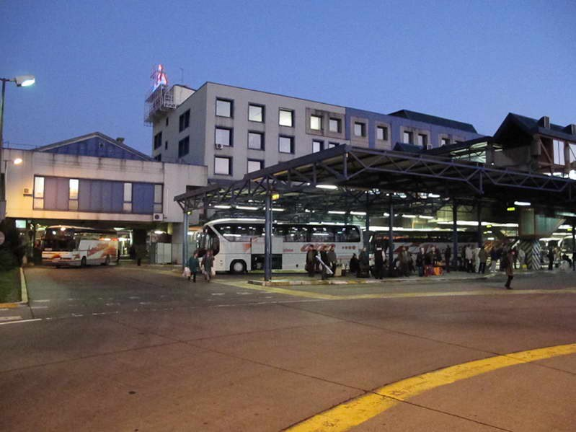
Source: www.zgh.hr

In contrast to the fairly underdeveloped rail traffic, buses represent the most-accepted, cheapest and widely-used means of public transport. National bus traffic is very well developed and it is very easy to reach even the remotest parts of Croatia by bus. Almost all buses on national routes are air-conditioned and offer pleasant traveling comfort. The Croatian parliament has passed a law that no bus should be older than 12 years - however, this decision is currently frozen because of the high cost for bus operators.
In practice, bus fares are collected on the bus while traveling, which is sometimes even cheaper than when paying at the ticket office (there is an additional fee for stored luggage) and sometimes a "ticket office fee".

BUS TERMINALS PORTAL:
www.autobusni-kolodvor.com

BUS TRANSPORT PORTALS:
www.getbybus.com/hr/autobus-hrvatska
www.busradar.hr
www.buscroatia.com

From Croatia, there are many international bus routes to the neighboring countries (Slovenia, Bosnia and Herzegovina, Serbia etc.), as well as to Austria, Germany, Slovenia, Switzerland and to other European countries. International buses correspond to European standards.

Zagreb has the largest and most modern bus terminal in Croatia. It is located near the downtown in Trnje district on the Marin Držić Avenue. It sports specially designed waiting areas above the bus stopping and parking area. The Zagreb bus terminal is close to the central train station, and it is easy to reach by tram lines and by car. Croatian bus transport companies are usually small and medium-sized and serving one or two counties, only small number offers transport nationwide.

Source:
www.asecap.com/english/documents/HUKA.pdf
www.mmpi.hr/ ENG%20FINAL% 20II.pdf

MARITIME TRANSPORT IN CROATIA

Croatia has several large seaports. The largest seaport with the deepest channel to a port in the Adriatic is Rijeka on the northern Croatian coast, followed by Ploče in southern Dalmatia. The port of Ploče is of strategic importance for the industries of Bosnia and Herzegovina. The largest Croatian passenger port is Split in Dalmatia, also called gateway to the islands, followed by Zadar. There are 66 inhabited islands along the Croatian coast which means there are a large number of local ferry connections.

Source: www.railwaypro.com

SEA PORTS AND HARBORS

MAJOR TRANSPORT SEAPORTS:
- - Omisalj
- - Ploce
- - Rijeka
- - Sibenik

OTHER SEAPORTS:
- - Dubrovnik
- - Dugi Rat
- - Pula
- - Split
- - Zadar
MERCHANT MARINE (from 2010):
TOTAL________________77 ships
BULK CARRIER__________24
CARGO________________7
CHEMICAL TANKER_______8
PASSENGER/CARGO______27
PETROLEUM TANKER_____10
REFRIGERATED CARGO____1

INLAND WATERWAY PORTS
- VUKOVAR (Danube)
- SISAK (Sava)
- SLAVONSKI BROD (Sava)
- OSIJEK (Drava)

Ports

The Republic of Croatia counts six ports open for public traffic of outstanding (international) economic importance and those are the ports: Rijeka, Zadar, Sibenik, Split, Ploce and Dubrovnik. Total investment into projects regarding them amounts to EUR499.5 million, financed from national budget, World Bank loans, European Investment Bank, European Bank for Reconstruction and Development, with government guarantees, while some of the new projects are co-financed from EU funds.

RIJEKA

Port of Rijeka is well sheltered harbour with good and safe outside anchorage, situated in the Nort part of Adriatic. Breakwaters are 1.754 m and 420 m. Port entrance is 270 m wide. The width of entrance to Susak Basin is 43 m. Depth at port of Rijeka entrance is about 40 m, in mid-harbour 20 to 28 m, at quays 6 to 10 m. Bay of Bakar, 4.700 m long, 700 m wide, average depth 26 m, at entrance 44 m. Entrance to Bay of Bakar is 400 m wide. Max tidal range is 1.2 m.

TERMINALS:
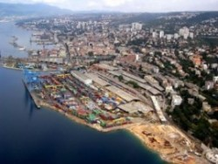Source: www.eldmarc.com

General cargo terminal (Basin Rijeka/Sušak)
- Sea depth – 5m-14m
Grain terminal (Basin Rijeka)
- Sea depth - max. 14m
- Silos capacity – 57,000t
Liquid cargo terminal (Omisalj)
- Sea depth - 30m
- Storage capacity – 130,000t
Container and Ro-Ro terminal (Brajdica)
- Sea depth – 11m-12m
- South shore - 300m - 2 STS container cranes; an additional 300m of the coast with the accompanying infrastructure and superstructure is under construction (predicted total capacity in future is 500,000 TEU)
- West shore - 164m - 2 STS container cranes
Grain terminal (Bakar-Podbok)
- Sea depth - 18m : Storage capacity - for 130,000t (coal) or 400,000t (ore)
Ro-Ro terminal Bakar (Goranin)
- Planned capacity approx. 50,000 cars per year. It will be an exclusive port for particular type of vehicles or a mixed terminal for various types of vehicles, depending on the market needs. Planned area includes 60,000m² of the former coke plant plateau. Project is in preparation.
Terminal Skrljevo
- Warehouse complex has the status of a free zone. The total area of 417,413m² with open storages (130,000m²) and closed warehouses (44,000m²) with free area (243,000 m²). The terminal is connected to the railway infrastructure (6 tracks). In 2006, expansion project of the warehouses capacity has been completed, making available additional 140,000 m² of storage space.
Terminal Rasa – Brsica
- Sea depth - 8m: Storage capacity – 510,000m²
Passenger terminal
- Sea depth - 7.5m: Total length of the shore - 900m

Ongoing projects
Ongoing Rijeka Gateway Program is bringing multiple benefits to the Port, the city, and more importantly the inhabitants of Rijeka and its surroundings. The Port is aiming to achieve the potential to develop into a major regional Container Port with sound financial performance generating over USD20.7 million of annual revenue. The port activities could generate annually over USD109 million of revenue for the various transport participants in Croatia. City life will be enhanced by providing the inhabitants and visitors with much improved access to the sea, while the Delta and the Port of Baroš areas transform into lively urban areas in an attractive location. Finally, global experience in port city redevelopment points to opportunities for job creation in Rijeka and its surroundings in the first phase of Delta redevelopment. Currently, effort is made to connect it efficiently with the railroad network to make profitable transport route with Europe.

The Rijeka Gateway Project includes:

- The reconstruction of the Viennese and Prague coast will create an important 4 hectares operating area.

- The building of an infrastructural corridor 2.5km long will secure a quality traffic route along the Western part of the port. Reconstructed lines of all installations and reconstructed railroad tracks will be part of the corridor.
- Besides the Zagreb coast, there are plans for the building of a new coast which will be 1.200m long. Although the first phase will include only the construction of a 300 meter coast line, the newly built coast area will cover a space of 10ha and it will be used for the transshipment of general cargo.

- The passenger terminal is located at the root of the Rijeka mole. The final layout of the terminal will include two berths for passenger ships and a building for the reception of passengers.
Source:
www.portauthority.hr/en/development_projects/rijeka_gateway_project
www.siteresources.worldbank.org/Ollivier_Rijeka-Gateway.pdf
www.portauthority.hr

PLOCE

The Port of Ploce is located on the Adriatic Sea coast in the area of the Neretva River. Its facilities include terminals and other structures in Ploce and in Metkovic, which lies on the Neretva approximately 20 kilometres inland to the east of Ploce. The Port of Ploce is at the southern terminus of Pan-European transport corridor V, branch C, representing a maritime extension of the rail and road routes leading to and from the Ploce area. These routes include modern roads such as: the Croatian A1 motorway, accessed via the D425 and D513, of E65 and connecting Zagreb Budapest and Vienna, the planned A10 motorways which are parts of European route E73. All the port's quays are linked by tracks connected to a single-track railway to Mostar, Sarajevo, Osijek and further north towards Budapest.
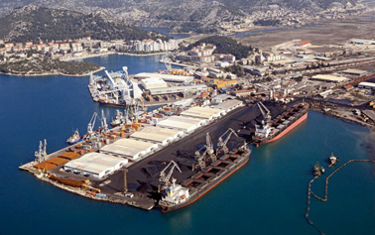Source: www.eldmarc.com

TERMINALS:
General Cargo Terminal
- Processing, packaging and storage facilities
- Six berths and a 9.2m draught

Bulk Cargo Terminal
- Storage facilities
- Three berths and 13m draught
- Capacity of 15,000t of cargo per day
Liquid Cargo Terminal
- Handles fuel and other liquid cargo; it has 92,000m³ of storage capacity overall
- A single berth and a 12m draught. Its cargo storage and handling facilities are operated by Luka Ploce Trgovina d.o.o. and Naftni Terminali Federacije d.o.o. (owned by the Federation of Bosnia and Herzegovina).

Grain Cargo Terminal
- Handles transshipment, packaging and storage of cereals and oil seeds, with capacity of 400t per hour; it has a single berth, 45,000t of storage capacity and a 9.8m draught.
Wood Terminal
- Handles, stores and processes timber; it has a single berth and a 9.2-metre draught.

Alumina and Petroleum Coke Terminal
- It has a 9.2m draught; for alumina it has a storage capacity of 20,000t and a transshipment capacity of 600t per hour; for petroleum coke it has 10,000t of storage capacity and 260t per day handling capacity.

Container Terminal
- Handles intermodal containers; it has a roll-on/roll-off ramp and accommodates Panamax ships. Its annual capacity is 60,000 TEUs.

Bulk Cement Terminal
- Has 200t per hour handling capacity and 4,000t storage capacity; it is part of Business Unit Metkovic, located in Metkovic on the Neretva river, which is 5m deep at the site.
General Cargo Terminal (Metkovic)
- Adjacent to the Bulk Cement Terminal, forming a part of Business Unit Metkovic.
Slag Terminal
- 10,000t storage capacity adjacent to the Bulk Cement Terminal, forming a part of Business Unit Metkovic.

Passenger Terminal
- Two moorings: the primary mooring is used for international transport and accommodates vessels up to 120m LOA (length overall), with an 8m draught; the secondary mooring is used for local and international transport and accommodates vessels up to 65m LOA, with 5m draught.

The Port of Ploce is the second largest cargo seaport in Croatia, mostly serving Bosnia and Herzegovina, along with some local and regional users. The port is administered by the Port of Ploce Authority, with Luka Ploce d.d. as the primary concessionaire. Subcontractors that operate the liquid cargo terminal facilities are Naftni Terminali Federacije d.o.o. and Luka Ploce Trgovina d.o.o., while passenger and vehicle transit is handled by Jadrolinija. Jadrolinija ferries sail between Ploce and Trpanj on the Peljesac peninsula and the D415 state road.

Ongoing projects

Port of Ploce is projecting new terminal for liquid cargo including the building of completely new terminal 160.000m² large with capacity to warehouse 280.000m³ of oil and 35.000 m³ of liquified gas. Bulk cargo terminal was finished by 2015, while all the cargo handling machinery will be installed during 2017. Yearly capacity is 4.600.000t with possible increase of capacity to 6.200.000t. Terminal will include equipment for handling cargo, transport system, packaging and equipment return and industrial railroad platform. Container terminal is planned to be elongated in the future for 330m and storage capacity increased by 25ha.
Source:
www.ppa.hr/index.php/2015-04-17-08-54-45/projekt-itt.html
www.port-authority-ploce.hr/statistics.asp
www.luka-ploce.hr
ZADAR

The Port of Zadar is directly linked to the Zagreb- Split highway and to the central Croatia by two railways and consists of:
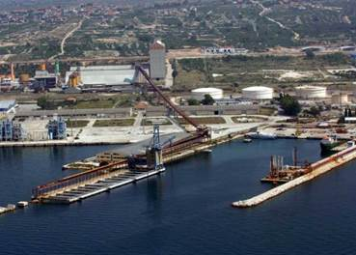Source: www.eldmarc.com

Passenger Port
- island, coastal, international ferry, Ro-Ro traffic
Cargo Port Gazenica
- liquid, bulk, general cargo

New Passenger Port Gazenica:
- island, coastal, international, ferry, traffic

- passenger traffic, mega cruisers
- Ro-Ro traffic

TERMINALS:

Terminal for liquid cargo
- 60 m coastline (mooring up to 190m), draft 10.3m - 12m, mooring of ships up to 40,000 DWT.
- Tanks for petroleum products with capacity of 60,000m³, tanks for chemicals with capacity of 15,000m³, 16 pipelines, floating protective barrier of 300m.
- Cargo: diesel, gasoline, VCM.
The terminal for the supply of oil platforms
- 180m coastline, the draft from 4.8m - 7.1m, 9m long ramp, an open storage area of 20,000m², closed warehouses and workshops.
- Cargo: terminal spare parts, supplies and materials, various equipment
Terminal loading/unloading of bulk freight
- Shore length 140m, draft 12m with possibility of mooring of ships up to 80,000 DWT.
- Terminal capacity is 500,000t annually with a capacity of unloading 500t/h, simultaneous loading of wagons on two railway tracks, closed storage with capacity of 30,000m³, grain silo capacity of 38,000m³. The terminal has a loading and unloading station with capacity of 240t/h.
- Cargo: soy, wheat, corn and other cereals.
Terminal loading/unloading and storage of tropical fruits
- Shore length of 135m, the draft 7 m to 11.4m, possibility of mooring of ships up to 10,000 DWT. Terminal capacity is 35,000t per year. The terminal also uses a railway track and a conditioning warehouse with five separate cooling chambers with total area of 3,400m² and total capacity of 17,000m³.
Terminal for loading/unloading of general cargo
- Shore length 150m, draft of 8.7m to 10.2m with possibility of mooring of ships up to 20,000 DWT, RO - RO ramp length 24m, closed warehouse with area of 34.000m² and open storage area of 150,000m², industrial railway track capacity 140 wagons per day.
- Cargo: sea salt, iron fittings, wood, various palletized cargo, heavy cargo, equipment for drilling sets and special cargo: windmills.
Terminal for loading/unloading of of cement
- Annual capacity of 80,000t with the possibility of unloading the ship from both piers for general cargo, distribution to trucks and weighing up to 50t.
Ongoing projects

New passanger port Gazenica is currently running project whose last phase is scheduled to begin in 2016 (that of building the terminal buildings with technical, control, traffic and commercial contents) and is expected to finish at the end of 2017.
Source:
www.luka-zadar.hr
www.port-authority-zadar.hr

SIBENIK

The Port of Sibenik is connected to the Croatian littoral by the road, to continental Croatia and Europe by highway and it is also linked to hinterland by the railway.
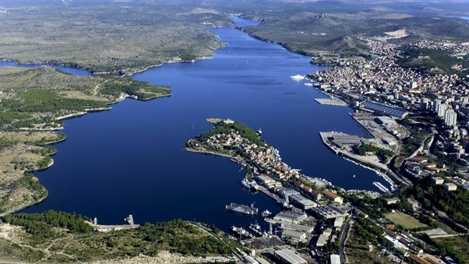Source: www.eldmarc.com
TERMINALS:

Passenger terminal (Vrulje)
- Terminal capacity is 1 000 000 passengers
- total surface is 24 156 m², 3 berths
Terminal for transhipment of phosphate (Dobrika)
- terminal capacity is 1million tonnes
- maximum ship size is 30,000t
- unloading capacity is 4000t/day
- storage capacity is 110,000t
- Cargo: phosphate, KCL, DAP, MAP…
Bulk and general cargo terminal (Rogac)
- Terminal capacity is 800,000t a year, maximum ship size is 30,000t, loading capacity is 3000t/day and storage capacity is 2 x 2 500m².
- Cargo: KAN, UREA, NPR, cereals, beet strips, aluminium blocks, iron ore

Timber terminal
- terminal capacity is 120,000m³ a year, maximum ship size is 6000t, closed storage capacity is 13,500m², open storage capacity is 55,000m²
- Extra services: drying of the timber and wooden products, sorting, cutting, packing and marking.
Ongoing projects
The construction of a passenger terminal (EUR4 million) is planned for Sibenik and the supra-structure will be constructed based on a concession on grounds of an international tender.
Currently, city of Sibenik has no adequate passenger terminal, and the traffic partly takes place along the shore which is specified for the transshipment of cargo. With the construction of a passenger terminal, the question of passenger traffic at the port of Sibenik will remain solved for a long time. Another problem which will be taken care of is the acceptance of cruisers, as well as the question of creating adequate working space for the harbormaster’s office, customs and port authority.
Source:
www.lukasibenik.hr
www.portauthority-sibenik.hr
SPLIT

The port ranks as the largest passenger port in Croatia and the third largest passenger port in the Mediterranean, with annual passenger volume of approximately 4 million. The port is managed by the Port of Split Authority. In the late 2000s, Port of Split Authority and the port operators, Trajektna Luka Split d.d. and Luka d.d. Split, started to implement an investment plan aimed at increasing both passenger and cargo traffic volume, scheduled to be completed by 2015, which would allow the port to handle up to 7 million passengers per year. The Port of Split is the largest passenger port in Croatia and the third largest passenger seaport in the Mediterranean. The port is administered by the Port of Split Authority, and the primary concessionaires Trajektna Luka Split and Luka Ltd. Split, as well as 11 secondary concessionaires awarded concessions to use the port facilities or provide services in the port. The primary concessionaires are operating the City Port Split and Vranjic-Solin basin area, respectively, with the secondary concessionaires’ active in Vranjic-Solin area of the port and the terminals based in Kastela.

Transport Facilities
The Port of Split is located on the Adriatic Sea coast in a bay protected by the Split peninsula and a string of islands. Its facilities include terminals and other structures in Split, Solin and Kastela, all located on approximately 15 kilometers of coast. The port is connected by the International E-road network routes E65 and E71 carried by the Croatian A1 motorway and the D1 state road. The port is also connected with Zagreb by an electrified single-track railway, which runs through Knin and Karlovac.

TERMINALS:

The Port of Split
- Handles yachts, fishing vessels, passenger ships, navigation safety craft, sailing ships, tugboats and ferries; passenger terminal and a rail link, 28 berths for vessels up to 250m with draught up to 7.9m.
Resnik-Divulje passenger terminal
- Designed to facilitate transfer of ship passengers to the Split Airport, located just 950m away; single berth accommodating craft up to 40m with draught up to 4.5m.
Vranjic-Solin basin
- used as a container cargo terminal, comprising 5 berths, a roll-on/roll-off ramp, 8 storage warehouses, including refrigerated storage and open storage area; the terminal accommodates ships up to 198m with draught up to 10.2m; The facility is connected by railway and its own truck terminal. The terminal encompasses a 19.8ha area.
Kaštela basin A
- reserved for mooring of ships under instructions by the port authority
Kaštela basin B
- cargo terminal used by the secondary concessionaires for their own transport needs, accommodating ships with draught up to 8.2m
Kaštela basin C
- mooring for laid-up vessels, pest control, fishing boats etc; the terminal accommodates craft with draught up to 11.6m

Container and RO-RO Terminal
- Yard surface 20,000m³, container terminal has daily terminal capacity of 2000 TEU, perfectly connected with variety of big global container ports, while the modern highway and railway connect it to entire Europe. Terminal is serviced by three forklifts: one with bearing capacity of 22t and two of 10t, two container handlers with bearing capacity of 44t. The terminal is equipped with container workshop, attachment for frigo containers and other container equipment. RO-RO ramp, with maximum draft of 7.5m, meets all international requirements. The ramp provides ability of loading empty containers onto ships deck with quay crane, bearing capacity 5t, as the container terminal is in the vicinity of the ramp. Between the terminal and the ramp there are two railroad tracks and a road for trucks that brings containers directly to the ships.
Truck terminal
- 80 parking spots, 24/7 entrance and payment supervising, customs clearance, customs warehousing and technical support

Ongoing projects:
a) Extension and rehabilitation of the passenger wharves on the outer side of the breakwater in the City Port of Split. Nowadays annual traffic through the Port of Split reaches the number of ca. 4.5 million passengers and 650,000 vehicles. National and international traffic in the port have been continuously increasing, showing further growing tendency. The construction of wharves on the outer side of the breakwater in the city port of Split started in June 2014. The Project provides for the construction of two wharves for berthing of ships in national and international traffic of passengers and vehicles, and berthing of cruise vessels.
The construction works are divided in two phases: I phase of the works should becompleted until January 2016, and II phase until the end of July 2016.
The completion of the works shall provide for larger operative area thus enabling better flow of passengers and vehicles, higher safety of traffic in the port and higher quality of port services.
b) EcoPort
Considering the construction of new infrastructure in the Port of Split, and according to contemporary requests to implement the environmental protection policy standards, and peculiarities of the area managed by Port Authority Split, particularly due to: location of the port (six fully separated locations – basins, one of them situated practically in the old city core), environmental conditions, and peculiarities of administrative powers and competences (system of concessions, large number of concessionaires and public stakeholders), the need has arisen to formalise and standardise the environmental management in the Port of Split, applying EcoPort (ESPO) principles.
Environmental management system according to ESPO (EcoPort EMS) principles includes classical system of quality management and environmental protection management, traditional system of environmental protection action plans – plans for environmental preservation and development of institutional management documents; it is oriented to all the partners, particularly to social community and communication with the community. EcoPort in fact develops close interconnection among development, environmental protection and management system based on sustainable development principles. EcoPort is developed as the process which enables all the partners’ continuous and active participation, allowing them to give their own contribution of responsibility in resolving or preventing the problem, and enables the impact, control and supervision of all the procedures within the process.
Source:
www.portsplit.com
www.lukasplit.hr

DUBROVNIK

Dubrovnik is a prestigious Mediterranean destination for cruise ships that are in transit. The port consists of the following components:
- Berth Grad - passenger traffic

- Port of Gruz - passenger traffic; receives up to three mega cruisers from round trips as well as passenger ferries on regular routes between all Croatian major ports and Italian ports of Ancona, Bari and Pescara.

Ongoing projects:

1200 m of operative quay

FIRST PHASE
The project of reconstruction and rebuild of operative quay 810 m long line, within the Gruž Bay is intended mainly for cruise ships - completed in 2009.
The works on the first phase of infrastructure project at the area Batahovina I, that started in November 2010 creating new 220 m of operative quay - completed in 2011.
Dubrovnik Port Authority is planning to carry out the second phase of infrastructure project Batahovina II, creating additional 400 m of quay line.
The Batahovina area will be intended for local and international ferry traffic, oriented on development of multi-modal transport.

SECOND PHASE
Second phase of modernization of Passenger Port Dubrovnik, port superstructure project / development of port facilities is at the moment in preparation phase which includes feasibility study, environmental study, architectural solution and producing of tender documentation.
Within next few years, Dubrovnik Port Authority expects to have a modern port with cruise passenger terminal, large multipurpose trade center, public garage, city congress hall and a huge range of different leisure and entertainment facilities.

Links: www.portdubrovnik.hr

Maritime Transport of Passangers
Source: www.jadrolinija.hr
Other companies:
JADROLINIJA
Biggest Croatian ferry service is provided by national company Jadrolinija, headquartered in Rijeka. Offers transport of passangers between mainland and islands, in between islands and international lines.

G & V LINE d.o.o.
www.gv-line.hr

RAPSKA PLOVIDBA d.d.
www.rapska-plovidba.hr

MIATRADE d.o.o.
www.miatours.hr

LINIJSKA NACIONALNA PLOVIDBA d.d.
www.lnp.hr

LOŠINJSKA PLOVIDBA - HOLDING d.d.
www.lp-holding.hr

Maritime Transport of Cargo (SHIPPERS)
ANIMO d.o.o.
www.animo.hr

PANALPINA CROATIA d.o.o.
www.panalpina.com

TANKERSKA PLOVIDBA d.d.
www.tankerska.hr

ATLANTSKA PLOVIDBA d.d.
www.atlant.hr

ULJANIK PLOVIDBA d.d.
www.uljaniksm.com

JADROŠPED d.o.o.
www.jadrosped.hr

KUEHNE & NAGEL d.o.o.
www.kuehne-nagel.com

BRODOSPAS d.d.
www.brodospas.net

ŠPEDTRANS WORLD d.o.o.
www.spedtrans.hr

ADRIATIC LOGISTIKA d.o.o.
www.adriaticlogistics.hr

PELJARSKO TRGOVAČKO DRUŠTVO BRANKO PILOT d.o.o.
www.branko-pilot.hr

RAPSKA PLOVIDBA d.d.
www.rapska-plovidba.hr

JADROAGENT d.d.
www.jadroagent.hr

FELBERMAYR CROATIA d.o.o.
www.felbermayr.cc

DAMCO d.o.o.
www.damco.com

ANGLO ADRIATIC POMORSKA AGENCIJA d.o.o.
www.angloadriatic.hr

BANDIĆ d.o.o.
www.bandic.hr

JADROPLOV d.d.
www.jadroplov.com

SPLITSKA PLOVIDBA d.d.

ELDMARC d.o.o.
www.eldmarc.com

Related links
Croatian Ministry of Maritime Affairs, Transport and Infrastructure Website:
www.mppi.hr

Port Authority Websites:

- PORT AUTHORITY RIJEKA: www.portauthority.hr

- PORT AUTHORITY PLOČE: www.port-authority-ploce.hr

- PORT AUTHORITY ZADAR: www.port-authority-zadar.hr

- PORT AUTHORITY ŠIBENIK: www.portauthority-sibenik.hr

- PORT AUTHORITY SPLIT: www.portsplit.com

- PORT AUTHORITY DUBROVNIK: www.portdubrovnik.hr

Technical Information on Croatian Ports:
www.eldmarc.com

Port Websites:

- PORT RIJEKA: www.lukarijeka.hr

- PORT PLOČE: www.luka-ploce.hr

- PORT ZADAR: www.luka-zadar.hr

- PORT ŠIBENIK: www.lukasibenik.hr

- PORT SPLIT: www.lukasplit.hr

- PORT DUBROVNIK: www.dubrovnik-port.com

Croatian Bureau of Statistics:
www.dzs.hr

RIVER TRANSPORT IN CROATIA

Croatia is also on the important Danube waterway, which connects Eastern and Central Europe. The major ports are Vukovar on Danube, Osijek on Drava River, Sisak and Slavonski Brod on Sava River.
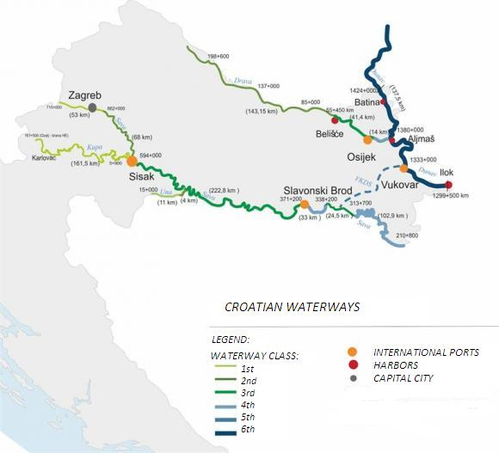
Perennially
navigable
rivers:

-Danube

-Sava

-Drava

Total
waterway
length:

785 km

Source: www.propisi.hr

STATISTICS: Transport of Goods on Inland Waterways in Croatia

TRANSPORT OF GOODS ON INLAND WATERWAYS | Unit of Measurement | 2015 | 2014 | 2013
National Transport | ‘000t | 51 | 51 | 42
International transport | ‘000t | 515 | 441 | 535
Transit | ‘000t | 6076 | 4886 | 5246
Source of data: www.dzs.hr

River Ports
Croatian river ports on inland waterways are under jurisdiction of Ministry of Maritime Affairs, Transport and Infrastructure, each having their own port authority which grants concessions for usage.

Port Osijek
The proximity to port and use of inland waterway transport brings Europe and the world closer and makes shipments of raw materials and products more favourable. Experience in managing different types of cargo and capacities guarantees the competence in performing port activities. The Osijek Port has all that is necessary to meet the needs of economic operators in its area. Primarily, human resources and technical staff are prepared for any kind of challenge – from reloading of heavy general cargo, bagged goods and bulk cargo, to most demanding users’ requirements. The basis of this experience is the material resources, which prove to be more than enough in meeting the growing needs of economy.
Source: www.port-osijek.hr

Port Vukovar
Vukovar port is situated on 1335km of the downstream flow of Danube River, on its right coast. Port stretches towards the East and West and it is 850m long and 45m wide. The port is very well situated to the main current of the river Danube, which makes it possible for the port to be navigable during the whole year regardless of water level, so even during the period of the lowest water levels of the Danube; the port is operational and active. It has the technical characteristics of E port to the European Agreement on Main Inland Waterways of International Importance (AGN; 16/98), the status of an international river port.

Port has a terminal for embarkation of bulk cargo (cereal, oil-seeds, mineral fertilizers) with the equipment capacity of 120t/h and separation of pebbles capacity 39m³. During 2001 the new vertical coast has been put into use, 50m long, which makes it possible to trans-ship goods even at the time of lowest water level. Currently the port transships about 100.000t of different kinds of goods over the year (mostly sugar in bags, cereal, oil-seed, mineral fertilizers), although its capacities are greater. In the European intermodal traffic, Port of Vukovar has become important part of the bypass between the internal European waterways, the Danube through Croatian territory to the Mediterranean.

Source:
www.port-authority-vukovar.hr
www.luka-vukovar.hr

Port Slavonski Brod
With the Inland Waterway Ports Act, the Government of the Republic of Croatia founded the Port Authority in Slavonski Brod as a public institution in charge of management and development of ports and piers on the river of Sava from 207-467rkm. The Port Slavonski Brod was declared a very important port for the Republic of Croatia. The Government of the Republic of Croatia has with its Directive on determination of the port area of the Port Authority Slavonski Brod declared the port area of the Port Authority Slavonski Brod open for public transportation.

The Act on Navigation and Inland Waters Harbours determined the Port Authority Slavonski Brod as the public institution for management of ports and piers in the area of local jurisdiction of the Port Administration office Slavonski Brod. Within performance of its activities, it will ensure constant and non-disturbed port traffic and control over trade companies that perform various port activities.
Source: www.en.lucka-uprava-brod.hr

Port Sisak
Port Sisak is divided into two basins: Basin Crnac – for loading and unloading of crude oil, refined oil and derivatives, trough the pipeline it is connected to the oil refinery in Sisak; and Basin Galdovo – shipbuilding dock.
Source: www.luckaupravasisak.hr

HRB DUNAVSKI LLOYD-SISAK d.o.o.
Port Sisak is home port of only Croatian Inland waterway shipper “Dunavski Lloyd Sisak”

Source: www.dunavski-lloyd.hr
Dunavski Lloyd performs inland waterway transport and combined transport of goods on the Danube, Drava and Sava and agency services in the ports of Osijek and Vukovar.

Related Links
Croatian Ministry of Maritime Affairs, Transport and Infrastructure Website:
www.mppi.hr

Croatian Agency for Inland Waterways:
www.vodniputovi.hr

International Sava River Basin Commision Website:
www.savacommission.org

Hrvatske Vode (“Croatian Waters”, legal entity for water management):
www.voda.hr

Inland Navigation and Inland Ports Act (NN 109/07, 132/07, 51/13, 152/14):
www.zakon.hr

Croatian Bureau of Statistics Website:
www.dzs.hr

PIPELINE TRANSPORT IN CROATIA

Adria Pipeline (OIL)
The Adria pipeline starts at the Omišalj Oil Terminal. From Omišalj the main line runs to Sisak, while spur pipelines connects terminal and refinery in Urinj. In Sisak the northern and eastern branches are split. The norther branch runs further to Virje, where branch section runs to Lendava in Slovenia, and Gola, where the pipeline crosses Croatian–Hungarian border.It continues through Hungary up to the Duna refinery in Százhalombatta, where it is connected with the southern line of Druzhba and the Druzhba's branch between Hungary and Slovakia. The annual capacity of Hungarian section is 10 million tonnes of oil per annum. The maximum rated capacity in the Slovak section is at 3.68 million tonnes per year.

The eastern branch runs from Sisak to Slavonski Brod. From there, the branch section runs to Bosanski Brod in Bosnia and Herzegovina, while the main line continues to Sotin at the Croatian–Serbian border. In Serbia, the pipeline runs to Novi Sad and further to Pančevo.

- JANAF SYSTEM

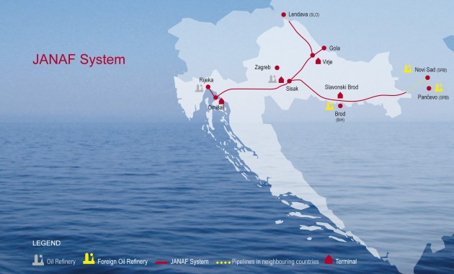Source: www.janaf.hr
The JANAF system was built as an international crude oil transportation system from the Port and Terminal of Omišalj, Island of Krk, Croatia to both local and foreign refineries in Eastern and Central Europe.The designed capacity of the pipeline amounts to 34 million tons of oil annually (MTA), while its installed capacity is 20 MTA.
Pipeline is around 622 km long comprising the following sections:
Omišalj – Sisak
Sisak – Virje – Gola
Virje – Lendava
Sisak – Slavonski Brod
Slavonski Brod – Sotin

The JANAF system consists of the following:

Crude oil handling Omišalj Terminal on the Island of Krk, with storage tank farm of 1.000.000 m3 and 60000 m3 for oil products; the accompanying pumping and metering stations and the Port of Omišalj. Crude oil handling terminals in Sisak, Virje and Slavonski Brod, with storage tank farms (100,000m3 in Sisak and 40,000m3 in Virje), with the accompanying pumping and metering stations. Submarine oil pipeline Omisalj-Urinj, linking the Omisalj Terminal with INA-Oil Refinery in Rijeka, oil products terminal Zitnjak-Zagreb (capacity 142,000m3). JANAF has a total storage capacity of 1.54million m3 for crude and 202,000m3 for oil products.
Source: www.britannica.com/topic/Adria-pipeline

Városföld-Slobodnica Pipeline (GAS)
The Városföld–Slobodnica pipeline is a bi-directional high pressure natural gas pipeline between Városföld in Hungary and Slobodnica in Croatia. It is a part of the New European Transmission System. The pipeline is operated by FGSZ in Hungary and by Plinacro in Croatia.
Length of the pipeline is 293 kilometres, of which 205 kilometres is located in Hungary and 88 kilometres in Croatia. The pipeline has diameter of 800 millimetres and its working reassure is 75 bars (7,500 kPa). Its capacity is 7 billion cubic metres per annum. The pipeline has compressor stations at Városföld and Báta, and international metering stations at Drávaszerdahely and Donji Miholjac.
Source: www.plinacro.hr

Ionian-Adriatic Pipeline (GAS), Planned
An international goodwill agreement has been signed regarding a proposed westbound pipeline that would carry natural gas from the Caspian basin, starting from Greece via Albania and the Adriatic Sea to Italy and further to Western Europe. Leaders of Albania, Bosnia Herzegovina, Montenegro and Croatia signed the document at a ceremony in the Albanian capital, Tirana. The agreement covers construction of two new pipelines - the Trans-Adriatic (TAP) and the Ionian-Adriatic (IAP). In Split, the pipeline would be connected with the existing gas transmission system of Croatia. In addition, it may be connected with other new gas infrastructure, including the proposed Adria LNG terminal in Krk.The length of pipeline would be 516 kilometres. The pipeline would be bi-directional and its capacity would be 5 billion cubic metres of natural gas per year.
Source: www.naturalgaseurope.com

Related Links
Croatian Pipeline Operators:
- JADRANSKI NAFTOVOD (JANAF): www.janaf.hr
- Plinacro d.o.o.: www.plinacro.hr

MULTIMODAL TRANSPORT IN CROATIA

The comparative advantage of the Republic of Croatia lies in the interconnectedness of Pan-European traffic corridors, namely V, VII and X, with the ports of the Adriatic basin and the flows of the rivers Danube and Sava. The advantage is visible in determining the EU key corridors, namely, out of nine key EU corridors, two of them (the Mediterranean Corridor and the Rhine-Danube Corridor) cut through Croatia.

The Adriatic is an arm of the Mediterranean Sea, most deeply cut into the European mainland. By shipping the goods in containers across the sea to the northern Adriatic, without doubt, the cheapest mode of transportation is used, thereby maximally shortening the route, as opposed to more expensive transport by land. It is the natural, the shortest and the most economical route to connect Europe with the Mediterranean, and further through the Suez Canal with the majority of Asian, African and Australian countries.

The European Union itself has, in its long-term transport strategy, listed the Port of Rijeka as the head intermodal centre and the starting point of one of the transport routes.
The sea route between the Suez Canal and the Port of Rijeka in the northern Adriatic extends to a distance of only 1,254 km, while the routes to the ports of the North Sea match nearly three times the distance.

Therefore, the navigation from the Suez to the ports of the North or the Baltic Sea is 10 to 14 days longer (one direction only). In the light of the rapid increase in fossil fuel prices, the advantages of the Adriatic route become more and more evident. The Adriatic route connects two large areas of the world, complementary in their economies.

Based on the construction project of the new Zagreb - Rijeka lowland double line electrified railway, it stretches from Zagreb to Karlovac, passes near Duga Resa and Ogulin to Josipdol, Dreznica and runs through the Velika Kapela to reach Novi Vinodolski. One branch line would lead to Bakar and Rijeka, and the other one across the newly built bridge for the road and railway transport, directly to the aforementioned business zone of the Omisalj (Krk Island) container terminal.

The new Botovo - Zagreb - Rijeka railway (Hungary - Croatia border) would be 328.7 km in length, while the length of the Zagreb - Rijeka line would be shortened by 57 km. The construction of this railway will boost the freight transport five times in capacity, cargo trains will run at the approximate speed of 120 km/h, while passenger trains at 160 to 200 km/h. The cargo traffic will comprise 80%, and the passenger traffic 20% of the total transport.

Railway transportation, in combination with inland river transport, is the most appropriate mode of transport of goods, since it completely meets the requirements of the '3E' Model (ecological sustainability, energy rationalization and economic benefits). For this reason, the EU dictates that this combination of transport modes and means (railway and river mode) should comprise 85%, while the roads transport only 15% of the total transportation.

At the current time project for establishing multimodal route for connecting Mediterranian Sea with northeastern Europe trough Hungary has been started and Croatia will develop multimodal transport.

Source:
bib.irb.hr/datoteka/741855.dpn26780_Naletina_SC_Book_1.pdf
www.shortsea.hr

LOGISTICS

Companies operating in Croatia mostly have their own logistic networks for their needs (eg. Kaufland; has its own logistic distribution centre), therefore integrated logistic service specialist suppliers are not numerous. It is a new field of business in Croatia as outsourcing of warehousing, transport and distribution isn't common. As of recent education in the field became available too; Transport Systems and Logistics can be studied at undergraduate level at Faculty of Transport and Traffic Engeneering, courses and seminars are also available.
Logistics Report of Croatia

In 2016, Croatia's Logistics performance index places it on 51st place in global ranking. In 2014, Croatia was placed 55th.
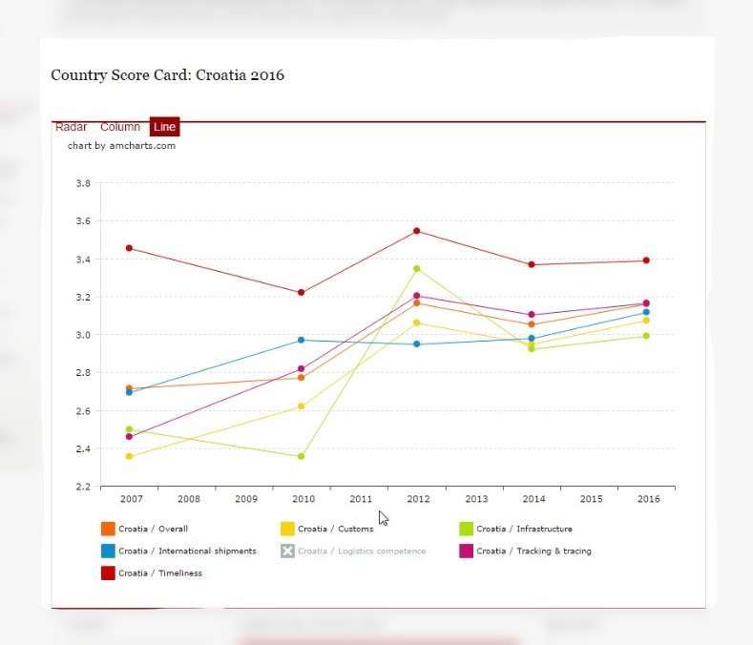
Source:lpi.worldbank.org/international/scorecard/line/254/C/HRV/2016#chartarea
Related links

Worldbank, data source for macroeconomic and sector related statistics for Croatia:
www.data.worldbank.org/country/croatia
- Trade and transport integration:
www.worldbank.org/projects/P093767/trade-transport-integration?lang=en
- Transport projects:
www.worldbank.org/en/topic/transport/projects/all?countryname_exact=Republic+of+Croatia

European Bank for Reconstruction and Development:
www.ebrd.com

Transport Research and Priorities in Croatia:
www.wbcinco.net/attach/NationaLBackgroundReportonTransportforCroatia.pdf

International Transport Forum:
www.internationaltransportforum.org/jtrc/environment/CO2/Croatia.pdf

Croatian Supply Chain Management & Logistics Portal:
www.logistika.com.hr

CONCLUSION
In general, Croatia has a good network connection in terms of transportation. It is connected with the most important spots in Croatia and with the EU, but still there is a deep gap between the different transport sectors.
Croatia has a highly well-developed road network, while the railway sector has huge lacks as a result of the inactivity in the last 50 years, in terms of infrastructure improvements which are now being adressed. With education, concentration on improving the infrastructure and funding Croatia aims to establish important transit route for integrated and intermodal railway and maritime transport (Railway Hungarian border – Port of Rijeka).

COMPREHENSIVE LIST OF CONTACTS

TRANSPORT – PUBLIC AND GOVERNMENT AGENCIES AND SERVICES

MINISTRY OF MARITIME AFFAIRS TRANSPORT AND INFRASTRUCTURE
Prisavlje 14, 10000 Zagreb
Tel. +385 1616 9111
E-mail: ministar@mppi.hr
Web: www.mppi.hr

HGK – Croatian Chamber of Economy
Transport and Communication Department
Draškoviceva 45, 10000 Zagreb
Tel. +385 1460 6726 Fax. +385 1460 6731
E-mail: promet@hgk.hr
Web: www.promet@hgk.hr

HUP – Croatian Employers’ Association
Transport Association
Radnička cesta 52/I, 10000 Zagreb
Tel. +385 1489 7571 Fax. +385 1489 7581
E-mail: ana.falak@hup.hr
Web: www.hup.hr

G.I.U. ASSOCIATION OF CROATIAN ROAD HAULIERS
- Web portal
Tel. +385 16182 465
Web: www.hrvatskiprijevoznik.hr

TRANSPORTKOMERC-CROATIAN ROAD TRANSPORT ASSOCIATION
Marticeva 8, p.p.839, 10001 Zagreb
Tel. +385 1461 5715 Fax. +385 1461 5105
E-mail: transportkomerc.giu@gmail.com
Web: www.transportkomerc.hr

RAIL TRANSPORT

- GOVERNMENT OWNED COMPANIES

HZ INFRASTRUKTURA d.o.o.
Antuna Mihanovica 12, 10000 Zagreb
Tel. +385 1378 3301 Fax. +385 1378 2811
E-mail: infrastruktura.upiti@hzinfra.hr
Web: www.hzinfra.hr

HZ CARGO d.o.o.
Heinzelova 51, 10 000 Zagreb
Tel. +385 1457 7576 Fax. +385 1457 7617
E-mail: info@hzcargo.hr
Web: www.hzcargo.hr

HZ PASSANGER TRANSPORT d.o.o.
Strojarska cesta 11, 10000 Zagreb
Tel. +385 1378 3061 Fax. +385 1457 7604
E-mail: info@hzpp.hr
Web: www.hzpp.hr

- RAIL TRANSPORT OF FREIGHT, RAIL TRANSPORT AS PART OF INTERMODAL SERVICE

AGIT d.o.o.
Heinzelova 51, 10000 Zagreb
Tel. +385 1235 0800 Fax. +385 1235 0833
E-mail: agit@agit.hr
Web: www.agit.hr

DHL International d.o.o.
Utinjska ulica 40, 10020 Zagreb-Novi Zagreb
Tel. +385 1665 1111 Fax. +385 1665 1120
E-mail: info.hr@dhl.com
Web: www.dhl.hr

PRIMACOSPED d.o.o.
Jankomir 25, 10090 Zagreb-Susedgrad
Tel. +385 1344 0717 Fax. +385 1378 9920
E-mail: pok@primaco.hr
Web: www.primacosped.hr

PPD TRANSPORT d.o.o.
Kneza Branimira 22, 10000 Zagreb
Tel. +385 1645 8280 Fax. +385 1645 8289
E-mail: info@ppd-transport.hr
Web: www.ppd-transport.hr

Rail Cargo Logistics - Croatia d.o.o.
Radnicka cesta 39, 10000 Zagreb
Tel. +385 1248 0060 Fax. +385 1248 0080
E-mail: office@express-interfracht.hr
Web: www.railcargologistics.hr

LAGERMAX AUTOTRANSPORT d.o.o.
Zagorske Magistrale 14, 10296 Luka
Tel. +385 1334 0400 Fax. +385 1334 0420
E-mail: lagermax@lagermax.hr
Web: www.lagermax.hr

LANERIS d.o.o.
Slavka Kolara 72, 10410 Velika Gorica
Tel. +385 1561 7601
E-mail: laneris@laneris.hr
Web: www.laneris.hr

KUEHNE & NAGEL d.o.o.
Gospodarska 2, 10431 Sveta Nedjelja
Tel. +385 1344 1600 Fax. +385 1344 1681
E-mail: prodaja@kuehne-nagel.com
Web: www.kuehne-nagel.com

ENGLMAYER d.o.o.
Bani 73b, 10010 Zagreb-Slobostina
Tel. +385 1237 1778 Fax. +385 1237 1779
E-mail: office@englmayer.hr
Web: www.englmayer.hr

ADRIATIC LOGISTIKA d.o.o.
Janka Polica Kamova 8, 51000 Rijeka
Tel. +385 5161 5420 Fax. +385 5137 4511
E-mail: logistics@adriaticlogistics.hr
Web: www.adriaticlogistics.hr

TRAST d.d.
Gat Sv. Duje 4, 21000 Split
Tel. +385 2139 0100 Fax. +385 2139 0156
E-mail: prodaja@trast.hr
Web: www.trast.hr

JADROSPED d.o.o.
Andrije Kasica Miosica 13/I, 51000 Rijeka
Tel. +385 5137 3654 Fax. +385 5137 3576
E-mail: info@jadrosped.hr
Web: www.jadrosped.hr

MURASPID d.o.o.
Vinogradska 14, 40320 Donji Kraljevec
Tel. +385 4060 8038 Fax. +385 4039 6075
E-mail: muraspid@ck.t-com.hr
Web: www.muraspid-ck.com

TRANSPED d.d.
Kranjceviceva 11, 10000 Zagreb
Tel. +385 1382 0455 Fax. +385 1382 1536
E-mail: transped@transped.hr
Web: www.transped.hr

JADROAGENT d.d.
Trg I. Koblera 2, 51000 Rijeka
Tel. +385 5178 0500 Fax. +385 5121 3616
E-mail: info@jadroagent.hr
Web: www.jadroagent.hr

ANIMO d.o.o.
Brajda 2, 51000 Rijeka
Tel. +385 5133 5715 Fax. +385 5132 2350
E-mail: nenad@animo.hr
Web: www.animo.hr

INTERSPED medunarodna i unutarnja spedicija d.o.o.
Trg kralja Tomislava 22, 20340 Ploce
Tel. +385 2067 9948 Fax. +385 2067 9649
E-mail: mario.orsulic@intersped.hr
Web: www.intersped.hr

SPEDTRANS WORLD d.o.o.
Vukovarska 7b, 51000 Rijeka
Tel. +385 5167 3584 Fax. +385 5167 3573
E-mail: spedtrans@spedtrans.hr
Web: www.spedtrans.hr

ROAD TRANSPORT
- ROAD TRANSPORT

KUEHNE & NAGEL d.o.o.
Gospodarska Ulica 2, 10431 Sveta Nedelja
Tel. +385 1344 1640 Fax. +385 1 3441 695
E-mail: prodaja@kuehne-nagel.com
Web: www.kuehne-nagel.com

TRAST d.d.
Prisavlje 2, 10000 Zagreb
Tel. +385 13 444 906
E-mail: prodaja@trast.hr
Web: www.trast.hr

AGIT d.o.o.
Heinzelova 51, 10000 Zagreb
Tel. +385 12350 818
E-mail: cargo@agit.hr
Web: www.agit.hr

CARGO AS d.o.o.
Bjelovarska 32, 10360 Sesvete
Tel. +385 12040 640
E-mail: www.cargoas-sesvete@inet.hr

CETRA d.d.
Ivana Sibla 9, 10020 Zagreb
Tel: +385 1663 7700 Fax. +385 1663 7915
E-mail: info@cetra.hr
Web: www.cetra.hr

LAGERMAX AED CROATIA d.o.o.
Zagorske magistrale 16, 10296 Luka
Tel. +385 1 3440555 Fax. +385 1344 0577
E-mail: lagermax-aed@lagermax-aed.hr
Web: www.lagermax-aed.hr

RALU LOGISTIKA d.o.o.
Gospodarska ulica 11, 10 370 Dugo Selo
Tel. +385 1 6285 205 Fax. +385 1 6285 225
E-mail: ralu@ralu.hr
Web: www.ralulogistics.com

RENATO P.P. d.o.o.
Zeleni Trg 2, 10000 Zagreb
Tel. +385 47 611764 Fax. +385 47 611774
E-mail: info@renatopp.hr
Web: www.renatopp.hr

KOS TRANSPORTI d.o.o.
Cehovska ulica 13, 42000 Varazdin
Tel. +385 42 403 000
E-mail: mihael.kos@kostransporti.hr
Web: www.kostransporti.hr

V.S.T. d.o.o.
Svetonedeljska 89, 10436 Zagreb
Tel. +385 1333 5833 Fax. +385 1333 5866
E-mail: info@vst.hr
Web: www.vst.hr

INTERCARGO d.o.o.
Varaždinska 133, 42202 Trnovec Bartolovečki
Tel. +385 42 207110
E-mail: intercargo@vz.htnet.hr

CROKOMBI d.o.o.
Andrije Hebranga 10, 10000 Zagreb
Tel. +385 16151 867 Fax. +385 16151 869
E-mail: crokombi@crokombi.hr
Web: www.crokombi.hr

GEBRUEDER WEISS d.o.o.
Jankomir 25, 10000 Zagreb
Tel. +385 13436 945 Fax. +385 13871 834
E-mail: prodaja-hr@gw-world.com
Web: www.gw-world.hr

Hudek-Trgotrans d.o.o
Biljevec 77, 42243 Marusevec
Tel. +385 42 729 255 Fax. +385 42 729445
E-mail: drago.hudek@vz.t-com.hr
Web: www.hudek-trgotrans.hr

KLANATRANS d.o.o.
Klana 98, 51000 Rijeka
Tel. +385 51215 152 Fax. +385 51339 637
E-mail: klanatrans@ri.t-com.hr
Web: www.klanatrans.com

LEOPOLD d.o.o.
Ulica Kestenova 141, 31000 Osijek
Tel. +385 3128 0588 Fax. +385 3128 0585
E-mail: ljdumancic@leopold.hr
Web: www.leopold.hr

TRANS-KUKOVEC d.o.o.
Dravska 59d, 40000 Cakovec
Tel. +385 4033 4818, Fax. +385 4033 3201
E-mail: trans-kukovec@ck.t-com.hr

M.TRANSPORT I OTPREMNISTVO d.o.o.
Rebar 23, 10000 Zagreb
Tel. +385 1 2347 181 Fax. +385 1 2347182
E-mail: info@m-transporti.hr
Web: www.m-transporti.hr

MZA-TRANSPORTI d.o.o.
Ljudevita Posavskog 39, 10360 Sesvete
Tel. + 385 1245 5142 Fax. + 385 1245 5147
E-mail: info@mza-transporti.hr
Web: www.mza-transporti.hr

PRIMACOSPED d.o.o.
Jankomir 25, 10090 Zagreb
Tel. + 385 1344 0777 Fax. + 385 1344 0788
E-mail: road@primaco.hr
Web: www.primacosped.hr

SAVATOURS d.o.o.
Jankomir 25, 10090 Zagreb
Tel. +385 9820 8443 Fax. +385 1349 6569
E-mail:info@savatours.hr
Web:www.savatours.hr

SCHENKER d. o. o.
Dugoselska cesta 5, 10370 Rugvica
Tel. +385 12480 900 Fax. +385 12480 970
E-mail:info.hr@dbschenker.com
Web: www.dbschenker.hr

SPEDTRANS WORLD d.o.o.
Vukovarska 10a, 51000 Rijeka
Tel. +385 5150 5300 Fax. +385 5154 5400
E-mail: transport@spedtrans.hr
Web: www.spedtrans.hr

SPOLJAR-TRANSPORT d.o.o.
Zagrebačka 1a, Pojatno, 10295 Kupljenovo
Tel.+385 1500 5300 Fax. +385 1500 5323
E-mail:info@spoljar-transport.hr
Web:www.spoljar-transport.hr

TRANSPED d.d.
Kranjčevićeva 11, 10000 Zagreb
Tel. +385 13820 455 Fax.+385 13821 536
E-mail:transped@transped.hr
Web: www.transped.hr
RICARDO d.o.o.
Industijska zona 2, Mece, 31236 Darda
Tel. +385 3156 2255 Fax.+385 31561 121
E-mail: info@ricardo.hr
Web: www.ricardo.hr

GOTRA LOGISTIKA d.o.o.
Druškovec Humski 73,49231 Hum na Sutli
Tel. +385 4934 0939 Fax.+385 49 340 617
E-mail:info@gotra-logistika.com
Web: www.gotra-logistika.com

DOMUS CARGO d.o.o.
Velika cesta 33, 10020 Zagreb
Tel. +385 1 6065 770 Fax. +385 1606 5777
E-mail: info@domuscargo.com
Web: www.domuscargo.hr

RIJEKA TRANS d.o.o.
Kukuljanovo 337, 51223 Skrljevo
Tel. +385 5164 2012, Fax. + 385 5164 5262
E-mail: rijekatrans@gmail.com
Web: www.rijeka-trans.hr

LARIX d.o.o.
Krizine 55, 52470 Umag
Tel. +385 5275 6065 Fax. +385 5274 1226
E-mail: larix@pu.t-com.hr
Web: www.larix-umag.hr

RUZIC d.o.o.
Ruzici 8, 51213 Jurdani
Tel. +385 5127 9404, Fax. +385 5160 3328
E-mail: ruzic@ruzic.hr
Web: www.ruzic.hr

AUTOPRIJEVOZNIK d.o.o.
Bana Josipa Jelacica 157, 32100 Vinkovci
Tel. +385 98 31 5311
E-mail: mrlikvk@gmail.com

SINJOR
Krizci 6, 10312 Klostar Ivanic
Tel. +385 1282 3196 Fax.+ 385 1283 0524
E-mail: nikola.sinjor@zg.t-com.hr
Web: www.sinjor.hr

SEIFERT I BOGOLIN d.o.o.
Hegedusiceva 3, 51000 Rijeka
Tel.+ 385 5163 3661 Fax. +385 5168 4622
E-mail: info@seifert-bogolin.com
Web: www.seifert-bogolin.com
HUDEK-TRGOTRANS d.o.o.
Biljevec 77, 42243 Marusevac
Tel. +385 4272 9255 Fax. +385 4272 9445
E-mail: hudektrgotrans@gmail.com
Web: www.hudek-trgotrans.hr

GRIFON d.o.o.
J.J. Strosmajera 44, 35000 Slavonski Brod
Tel. + 385 91350 0007
E-mail: info@grifon.hr
Web: www.grifon.hr

VUKAS TRANSPORT j.d.o.o.
Tominovac 62, 34340 Tominovac
Tel. +385 9126 61177
E-mail: info@vukas-transport.hr
Web: www.vukas-transport.hr

DOBROBIT d.o.o.
Ulice Matice hrvatske 3, 21204 Dugopolje
Tel. +385 2165 6046 Fax.+ 385 2165 4047
E-mail: ferdo@dobrobit.com
Web. www.dobrobit.com

MIKULIC d.o.o.
V. Nazora 1a, 51211 Matulji
Tel. +385 5164 4244 Fax. +385 5127 5708
E-mail: mikulicrijeka@gmail.com

TERRALOG d.o.o.
Frana Supila 48, 42000 Varazdin
Tel. +385 4260 1760, Fax. +385 4260 1775
E-mail: info@terralog.hr
Web www.terralog.hr

LANERIS d.o.o.
Slavka Kolara 72, 10410 Velika Gorica
Tel. +385 1561 7601
E-mail: laneris@laneris.hr
Web: www.laneris.hr

MURASPID d.o.o.
Vinogradska 14, 40320 Donji Kraljevec
Tel. +385 40 396 707 Fax. +385 40 396 075
E-mail: muraspid1@muraspid.hr
Web: www.muraspid-ck.com

LA LOG d.o.o.
Slatinska 1, 10360 Sesvete
Tel. +385 1 2050 400 Fax. +385 1 2004 945
E-mail: lalog@lalog.hr
Web: www.lalog.hr
STIO d.o.o.
Čučerska cesta 117b, 10040 Zagreb
Tel. +385 12914 214 Fax. +385 12984 703
Web: www.stio.hr

TIME SHUTTLE d.o.o.
Kovinska 4a, 10090 Zagreb
Tel.+385 134 66 444 Fax.+385 134 66 470
E-mail: prijem@timeshuttle.hr
Web: www.timeshuttle.hr

ANIMO d.o.o.
Brajda 2, 51000 Rijeka
Tel.+385 51 321 789 Fax. +385 51 322 350
E-mail: info@animo.hr
Web: www.animo.hr

TERRALOG d.o.o.
Frana Supila 48, 42000 Varazdin
Tel. +385 4260 1760 Fax.+ 385 4260 1775
E-mail: info@terralog.hr
Web: www.terralog.hr

AUTOPRIJEVOZNIK CESNIK d.o.o.
Kralja Tomislava 81, 33410 Suhopolje
Tel. +385 99926 5370
E-mail: ap.cesnik@gmail.com

BRAJKO PRIJEVOZ PISKOREVCI
Stjepana Radica 100, 31417 Piskorevci
Tel. +385 3185 4179 Fax. + 385 3185 4179
E-mail: zoran.brajko@brajko-prijevoz.hr
Web www.brajko-prijevoz.hr

A.A. BOX d.o.o.
Trg Marsala Tita 8, 51211 Matulj
Tel. +385 9154 69777
E-mail: info@aabox.hr
Web. www.aabox.hr

A.L. COMMERCE d.o.o.
Koledinecka 1, 10040 Zagreb
Tel. +385 1245 5365 Fax. +385 1299 2177
E-mail: alcommerce@inet.hr

ACTIVE COMMERCE d.o.o.
Bilogorska 18, 48000 Koprivnica
Tel. +385 4822 0552
Fax. +385 4822 0552
E-mail: active-commerce@kc.t-com.hr

RAFAEL d.o.o.
Nova ulica 53, 35000 Brodski Varoš
Tel. +385 9127 22703
E-mail: rafojozicsb@gmail.com

A.L.A.N. TRANS d.o.o.
Cerje 7, 10340 Vrbovec
Tel. +385 1279 2387 Fax. +385 1279 2387
E-mail: a.l.a.n.trans@zg.t-com.hr
Web: www.alantrans.com

ENGLMAYER d.o.o.
Bani 73b, 10010 Zagreb-Sloboština
Tel. +385 1237 1778 Fax. +385 1237 1779
E-mail: office@englmayer.hr
Web: www.englmayer.hr

ADRIATIC LOGISTIKA d.o.o.
Janka Polića Kamova 8, 51000 Rijeka
Tel. +385 5161 5420 Fax. +385 5137 4511
E-mail: logistics@adriaticlogistics.hr
Web: www.adriaticlogistics.hr

UDIO BORAN d.o.o.
Pantovčak 101, 10000 Zagreb
Tel. +385 1622 6511 Fax. +385 1621 5458
E-mail: airport@udio-boran.hr
Web: www.udio-boran.hr

CRO EKSPRES D.O.O.
Rudeški ogranak 5, 10000 Zagreb
Tel. +385 1386 2054 Fax. +385 1386 2054
E-mail: croekspres@croekspres.hr
Web: www.croekspres.hr

ZAGREBAČKI MAMUT d.o.o.
Ljubljanska avenija 18, 10000 Zagreb
Tel. +385 1656 0384
E-Mail: info@zagrebacki-mamut.hr
Web: www.zagrebacki-mamut.hr

AUTOPRIJEVOZNIK
Školska 4/I, 44000 Sisak
Tel. +385 9825 6217
E-mail: icanovic.mirsad@hotmail.com

LEPUS PRIJEVOZ d.o.o.
Aleja Grabova 4, 10000 Zagreb
Tel. +385 95777 0123
E-mail: lepus.prijevoz.zg@gmail.com

VUKAS TRANSPORT j.d.o.o.
Tominovac 62, 34340 Tominovac
Tel. +385 91266 1177
E-mail: info@vukas-transport.hr
Web: www.vukas-transport.hr

ELEZ d.o.o.
Dračevac 6, 21210 Solin
Tel. +385 91333 6505
E-mail: marijo.elez@gmail.com

EURO – MATIC
Klarići 56, 10410 Velika Gorica
Tel. +385 9823 7617
E-mail: ivica.matic1@zg.t-com.hr

STEP PRIJEVOZ j.d.o.o.
Josipa Kozarca 35, 35209 Bukovlje
Tel. +385 3527 5564

KELAM d.o.o.
Kneza Trpimira 159, 21220 Trogir
Tel. +385 2179 6041 Fax. +385 2179 6043
E-mail: kelam-prijevoz@st.t-com.hr
Web: www.kelam.hr

TRANSPORTI BIŠKO d.o.o.
Petra Zrinskog 32, 10410 Velika Gorica
Tel. +385 98161 5026 Fax. +385 1626 5715
E-mail: trasporti.bisko@gmail.com
Web: www.transporti-bisko.hr

KLOPIĆ-TRANSPORTI d.o.o.
Aleja Matice Hrvatske 51, 32270 Županja
Tel. +385 3283 2126 Fax. +385 3283 3341
E-mail: klopic.zupanja@vk.htnet.hr
Web: www.klopic.hr

ZAGREBŠPED d.o.o.
Vodovodna 20a, 10000 Zagreb
Tel. +385 1557 0555 Fax. +385 1557 0510
E-mail: zagrebsped@zg.t-com.hr
Web: www.zagrebsped.hr

ASTRA TRANSPORTI d.o.o.
Ruđera Boškovića 50 a, 43541 Sirač
Tel. +385 4332 2495 Fax. +385 4332 2495
E-mail: goran.ninkovic@ks-transporti.hr
Web: www.ks-transporti.hr

SPEDING d.o.o.
Šljivik 5, 10000 Zagreb
Tel. +385 123 47573 Fax. +385 1234 7579
E-mail: speding@zg.t-com.hr
Web: www.speding.hr

KORACA d.o.o.
Mirka Jengića 44, 51000 Rijeka
Tel. +385 5163 7455 Fax. +385 5163 7459
E-mail: koraca@koraca.hr
Web: www.koraca.hr

DIMPEX d.o.o.
Radnička cesta 75, 10000 Zagreb
Tel. +385 1618 8310 Fax. +385 1618 8313
E-mail: info@dimpex.hr
Web: www.dimpex.hr

ŠOUFEK TRANSPORT d.o.o.
Međurić 191, 44321 Banova Jaruga
Tel. +385 4466 8730 Fax. +385 4466 8430
E-mail: soufek-transport@sk.t-com.hr
Web: www.soufektransport.hr

GLOBAL EKSPRES d.o.o.
Stupničke Šipkovine 3/1, 10255 Gornji Stupnik
Tel. +385 1348 4660 Fax. +385 1348 4662
E-mail: office@global-express.hr
Web: www.global-express.hr

EURO-MOD-LAKTING d.o.o.
Lanište 14b, 10020 Zagreb-Novi Zagreb
Tel. +385 1614 0434 Fax. +385 1614 0434
E-mail: euro_mod_lakting@inet.hr
Web: www.eml-transporti.hr

D.D.B.K. TRANSPORTI
Horvatovac 31, 10000 Zagreb
Tel. +385 1463 5318
E-mail: bernardica.brizic@crosing.hr
Web: www.kombiprijevoz.com

JURETIĆ TRANSPORT d.o.o.
Permani 11 a, 51213 Jurdani
Tel. +385 5127 5247 Fax. +385 5127 4511
E-mail: juretic-transport@ri.t-com.hr
Web: www.juretictransport.hr

TC TRANSPORTI
Zamlačka 26, 10408 Velika Mlaka
Tel. +385 98993 2515 Fax. +385 1622 7028
E-mail: tomic@post.t-com.hr
Web: www.autoprijevoztomic.hr

TRANSPORT JAVORIĆ
Druškovec Humski 73, 49231 Hum na Sutli
Tel. +385 4934 0720 Fax. +385 4934 0722
E-mail: info@transport-javoric.eu
Web: www.transport-javoric.eu

TRANSPORTI TROJAK
Čakovečka 44c, 40305 Nedelišće
Tel. +385 4089 5029 Fax. +385 4089 5545
E-mail: transporti.trojak@ck.t-com.hr
Web: www.trojak.hr

L.K.W. ŠPOLJARIĆ
Odvojak Industrijske 4, 10431 Sveta Nedjelja
Tel. +385 1337 3873 Fax. +385 1337 1510
E-mail: info@lkw.hr
Web: www.lkw.hr

CARGO-PARTNER d.o.o.
Jankomir 25 P, 10090 Zagreb-Susedgrad
Tel. +385 1334 9400 Fax. +385 1334 9410
E-mail: zag@cargo-partner.com
Web: www.cargo-partner.com

JADROAGENT d.d.
Trg I. Koblera 2, 51000 Rijeka
Tel. +385 5178 0500 Fax. +385 5121 3616
E-mail: info@jadroagent.hr
Web: www.jadroagent.hr

OMEGA ŠPED d.o.o.
Avenija Dubrovnik 15, 10020 Zagreb
Tel. +385 1652 8530 Fax. +385 1652 8820
E-mail: josip.tonkovic1@zg.t-com.hr
Web: www.omega-sped.hr

MST d.o.o.
Braće Radića 11, 10452 Donja Zdenčina
Tel. +385 1345 2255 Fax. +385 1349 6053
E-mail: spedicija@mst-intersped.hr
Web: www.mst-intersped.hr

ELDMARC d.o.o.
Janeza Trdine 1/III, 51000 Rijeka
Tel. +385 5131 7473 Fax. +385 5131 7474
E-mail: info@eldmarc.com
Web: www.eldmarc.com

TRANSPORTI VUKELJA
Dr. F. Tuđmana 33, 10431 Sveta Nedjelja
Tel. +385 1333 6376 Fax. +385 1333 6375
E-mail: transporti.vukelja@email.htnet.hr
Web: www.transportivukelja.com

- ROAD TRANSPORT OF DANGEROUS GOODS (ADR)

RIJEKA TRANS d.o.o.
Kukuljanovo 337, 51223 Skrljevo
Tel. +385 5164 2012 Fax. + 385 5164 5262
E-mail: rijekatrans@gmail.com
Web: www.rijeka-trans.hr

SINJOR
Krizci 6, 10312 Klostar Ivanic
Tel. +385 128 23196, Fax. +385 128 30524
E-mail: nikola.sinjor@zg.t-com.hr
Web www.sinjor.hr

SEIFERT I BOGOLIN d.o.o.
Hegedusiceva 3, 51000 Rijeka
Tel.+ 385 5163 3661 Fax. +385 5168 4622
E-mail: info@seifert-bogolin.com
Web: www.seifert-bogolin.com

T.R.G. d.o.o.
Varazdinska 161, 42202 Trnovec Bartolovecki
Tel. +385 130 13775 Fax. +385 130 13776
E-mail: trg@trg.hr
Web: www.trg.hr

ENGLMAYER d.o.o.
Bani 73b, 10010 Zagreb
Tel. +385 123 71778 Fax. +385 123 71779
E-mail: office@englmayer.hr
Web: www.englmayer.hr

TRANS AVIO TIM d.o.o.
Fabkoviceva 7, 10000 Zagreb
Tel. +385 1626 5312
E-mail: sales@transavio.com
Web. www.transaviotim.com

TRANSPORTI TROJAK d.o.o.
Puscine, Cakovecka 44c, 40305 Nedelisce
Tel. +385 4089 5029 Fax. +385 4089 5545
E-mail: transporti.trojak@ck.t-com.hr
Web: www.trojak.hr
ANIMO d.o.o.
Brajda 2, 51000 Rijeka
Tel. +385 5133 5715 Fax. +385 5132 2350
E-mail: nenad@animo.hr
Web. www.animo.hr

ORION d.o.o.
Bakovcice, Koprivnicka 48 , 48000 Koprivnica
Tel. +385 4863 7126 Fax. +385 4863 7416
E-mail: orion@kc.t-com.hr
Web www.orion-pirotehnika.com

SPEDTRANS WORLD d.o.o.
Vukovarska 7b, 51000 Rijeka
Tel. +385 5167 3584 Fax. +385 5167 3575
E-mail: spedtrans@spedtrans.hr
Web www.spedtrans.hr

MATIJEVIC GRADENJE d.o.o.
Jalovecka 1, 10090 Zagreb
Tel. +385 1347 0490 Fax.+385 1347 0491
E-mail: info@mat-mont.hr
Web: www.matijevic-gradjenje.hr

BOZIC
Odra 187, 44000 Sisak
Tel. +385 4472 0221 Fax. +385 4472 0321
E-mail: milan.bozic@sk.t-com.hr
Web: www.bozic.hr

LA LOG d.o.o.
Slatinska 1, 10360 Sesvete
Tel. +385 1205 0400 Fax. +385 1200 7170
E-mail: info@lalog.hr
Web: www.lalog.hr

TORNADO d.o.o.
Kamenicki Vrhovec 38, 42250 Lepoglava
Tel. +385 4277 0077 Fax. +385 4277 0079
E-mail: info@demining-tornado.com
Web: www.demining-tornado.com
UNIVERZUM d.o.o.
Vinogradska 123, 35000 Slavonski Brod
Tel. +385 3549 0370 Fax. +385 3549 0370
E-mail: universum@sb.t-com.hr
Web: www.univerzum.fullbusiness.hr

PRIMACOTRANS d.o.o.
Ulica hrvatskih branitelja 10, 10090 Zagreb
Tel. +385 134 40777 Fax. +385 134 40778
E-mail: trans@primacotrans.hr
Web: www.primacotrans.hr

DELTA TRANSPORT d.o.o.
Jankomir 5, 10090 Zagreb
Tel. +385 148 03905 Fax. +385 137 94014
E-mail: delta_transport@yahoo.com

PLUS RI-TANK d.o.o.
Bartola Kasica 8a, 51000 Rijeka
Tel. +385 5121 2838 Fax. +385 5121 1864
Web: www.rijekatank.hr

VARJACIC d.o.o.
Bregovita 13, 49000 Krapina
Tel. +385 4937 0989 Fax. + 385 4937 0989
Web. www.krapina-sped.hr

MC-TRANS d.o.o.
Tomislava Ivcica 7/a, 23000 Zadar
Tel. +385 2334 1504 Fax. +385 2334 1214
E-mail: mc-trans@zd.t-com.hr

TRANSPORTI UDOVCIC d.o.o.
Senoina 41, 10290 Zapresic
Tel. +385 133 53063 Fax. +385 133 53063
E-mail: udovcic@net.hr

VULPRES d.o.o.
Vitomira Sirole Paje 33, 51000 Rijeka
Tel. +385 5167 6507 Fax. +385 5167 6507
E-mail: vulpes@ri.t-com.hr

DANZAS d.o.o.
Kristanovec 103,40000 Cakovec
Tel. +385 40 85 3799 Fax. +385 40 85 3788
E-mail: danyas2@ck.t-com.hr

DEBELJUH FRIGO d.o.o.
Golas 1, 52211 Bale
Tel. +385 52 82 4081 Fax. +385 52 84 0852
E-mail: renato.d@inet.hr

VLADIMIR PROMET d.o.o.
Sopnicka 51, 10360 Sesvete
Tel. +385 1 20 05335 Fax. +385 1 20 05 706

TRGO-PRIJEVOZ d.o.o.
M. Kiepacha 37, 48260 Krizevci
Tel. +385 48 71 6131 Fax. +385 48 71 6131
E-mail: trgo-prijevoz@kc.t-com.hr

TRANSPORTI MISAK
Varazdinska 86, 42202 Trnovec Bartolovecki
Tel. +385 42 68 3023 Fax.+ 385 4268 3437
E-mail: misaktrans(et)vip.hr
Web :www.misaktrans.hr

TURBO-T.S. d.o.o.
Zagrebacka 84, 10291 Prigorje Brdovecko
Tel. +385 (1)33 97 165 Fax. +385 (1) 33 97165

PETRINEC TRANSPORT d.o.o.
Sv. Barbare 27, 44322 Lipovljani
Tel. 385 (44) 67 6177 Fax. +385 (44)67 6148
E-mail: petrinec-transporti@sk.t-com.hr

SIMUNIC PROMET d.o.o.
Prvomajska 11, Botovo, 48322 Drnje
Tel. +385 (48) 83 1001 Fax. +385 (48) 83 1588
E-mail: simunic-promet@kc.t-com.hr

STOKO-COMMERCE d.o.o.
Pavlovicka 19, 10255 Stupnik
Tel. +385 (1) 65 88070 Fax. +385 (1) 65 88 707
E-mail: sc1@vip.hr

JAVNI PRIJEVOZ STVARI SUCIC d.o.o.
Strozanacka cesta 3, 21312 Podstrana
Tel. +385 (21) 33 3006 Fax. +385 (21) 33 3006
E-mail: jps.sucic@st.t-com.hr

DOMO-TRANS d.o.o.
Kopilica 27, 21000 Split
Tel. +385 (21)36 1735 Fax. +385 (21) 50 4042

TERMO-TRANS d.o.o.
Kopilica 27, 21000 Split
Tel. 385 (21) 36 1735 Fax. +385 (21) 50 4042
E-mail: domo-trans@net.hr

THERMOCAR d.o.o.
Viskovo 98, 51216 Viskovo
Tel. +385 (51) 25 6067 Fax. +385 (51) 50 4008
E-mail: info@thermocar.hr
Web www.thermocar.hr

INTERSPED medunarodna i unutarnja spedicija d.o.o.
Trg kralja Tomislava 22, 20340 Ploce
Tel. +385 (20) 67 9948 Fax. +385 (20)67 9649
E-mail: mario.orsulic@intersped.hr
Web: www.intersped.hr

TRANSPED d.d.
Kranjceviceva 11, 10000 Zagreb
Tel. +385 (1) 38 20455 Fax. +385 (1) 38 21536
E-mail: transped@transped.hr
Web : www.transped.hr

MEDUNARODNI PRIJEVOZ CRNCIC KRK
Drage Garvaisa 16, 51500 Krk
Tel. +385 (51) 22 2234 Fax. +385 (51) 88 0184
E-mail: crncic-krk@inet.hr

VIDIC-LUMOGEN d.o.o.
Visnjevac, Petra Svacica 10, 31000 Osijek
Tel. +385 (31) 35 3044 Fax. +385 (31) 35 3044
E-mail: vidic-lumogen@os.t-com.hr

DELTA TRANSPORT d.o.o.
Jankomir 5, 10090 Zagreb-Susedgrad
Tel. +385 (1) 48 03905 Fax. +385 (1) 37 94014
E-mail: delta_transport@yahoo.com

MARIO trgovina i prijevoz d.o.o.
Zagrebacka 11, Gornji Desinec, 10450 Jastrebarsko
Tel. +385 (1) 62 79165 Fax. +385 (1) 62 79165
E-mail mario. bosiljkov@zg.t-com.hr

JAGIC B & V TRANSPORTI
Varazdinska 173a, 42230 Ludbreg
Tel. +385 4267 3877 Fax. +385 4267 3877
E-mail: jagic-transporti@vz.t-com.hr

ANOKEM d.o.o.
Sisacka 6, 44320 Kutina
Tel. +385 4468 4274 Fax.+385 4468 427

- ROAD TRANSPORT BY FRIGO TRUCKS

HUDEK-TRGOTRANS d.o.o.
Biljevec 77, 42243 Maruševec
Tel. +385 4272 9255 Fax. +385 4272 9445
E-mail: hudektrgotrans@gmail.com
Web: www.hudek-trgotrans.hr

KUEHNE & NAGEL d.o.o.
Gospodarska 2, 10431 Sveta Nedjelja
Tel. +385 1344 1600 Fax. +385 1344 1681
E-mail: prodaja@kuehne-nagel.com
Web: www.kuehne-nagel.com

LANERIS d.o.o.
Slavka Kolara 72, 10410 Velika Gorica
Tel. +385 1561 7601
E-mail: laneris@laneris.hr
Web: www.laneris.hr

RICARDO d.o.o.
Kudeljara 1a, 31326 Darda
Tel. +385 3156 2255 Fax. +385 3156 1121
E-mail: uprava@ricardo.hr
Web: www.ricardo.hr

TRANSPORTI D.O.O.
Zagrebačka 16, 51000 Rijeka
Tel. +385 5121 2872 Fax. +385 5131 2872
E-mail: info@transporti.co
Web: www.transporti.co

ŠINJOR
Križci 6, 10312 Kloštar Ivanić
Tel. +385 1282 3196 Fax. +385 1283 0524
E-mail: nikola.sinjor@zg.t-com.hr
Web: www.sinjor.hr

FOLDING d.o.o.
Sjenjak 123, 31000 Osijek
Tel. +385 3137 2844 Fax. +385 3150 8900
E-mail: folding@net.hr

HOLI-SAMOBOR d.o.o.
Samoborska cesta 138, 10436 Rakov potok
Tel. +385 1658 6181 Fax. +385 1658 6179
E-mail: holi-samobor1@zg.t-com.hr
Web: www.holi-samobor.hr

INTERŠPED međunarodna i unutarnja špedicija d.o.o.
Trg kralja Tomislava 22, 20340 Ploče
Tel. +385 2067 9948 Fax. +385 2067 9649
E-mail: mario.orsulic@intersped.hr
Web: www.intersped.hr

RENATO P.P. d.o.o.
Mrežnička obala 4, 47000 Karlovac
Tel. +385 4761 1764 Fax. +385 4761 1764
E-mail: predrag.pavlic@renatopp.hr
Web: www.renatopp.hr

KLASTER TRANSPORTNI CENTAR
Ind. Zona Bjeliš bb, 35107 Slavonski Brod
Tel. +385 3545 3023 Fax. +385 3545 3024
E-mail: klaster@transport.com.hr
Web:www.klaster.transport.com.hr

AP. SKALA
Vinogorska 35, 35000 Slavonski Brod
Tel. +385 9156 80405 Fax. +385 3541 5412
E-mail: zoran.skala@sb.t-com.hr
Web: www.transporti.hr/vt/skala.hr

TRANSPORTI BUNETA
T. Ujevića 9, 47250 Duga Resa
Tel. +385 4784 4500 Fax. +385 4780 1669
E-mail: transporti.buneta@ka.t-com.hr
Web: www.transporti-buneta.hr

INTERFISH d.o.o.
Biškupije 99, 52203 Medulin
Tel. +385 5257 6279 Fax. +385 5257 6279
E-mail: interfish@pu.t-com.hr
Web: www.interfish.hr

AUTOPRIJEVOZ BIŠKUP
Završje Podbelsko 98, 42242 Radovan
Tel. +385 4274 9456 Fax. +385 4274 9456
E-mail: apbiskup@net.hr
Web: www.apbiskup.hr
EURO - MATIC d.o.o.
Klarići 56, 10410 Velika Gorica
Tel. +385 1622 2932 Fax. +385 1622 2932
E-mail: euro-matic@euro-matic.hr
Web:www.euro-matic.hr

EKA - M - TRANS AUTOPRIJEVOZ
Trg Stjepana Konzula 5, 10000 Zagreb
Tel. +385 1230 4244 Fax. +385 1230 4245
E-mail: eka-m-trans@inet.hr

DEBELJUH FRIGO
Golaš 1, 52211 Bale
Tel. +385 5282 4081 Fax. +385 5284 0852
E-mail: renato.d@inet.hr

ŠIMUNIĆ PROMET d.o.o.
Prvomajska 11, Botovo, 48322 Drnje
Tel. +385 4883 1001 Fax. +385 4883 1588
E-mail: simunic-promet@kc.t-com.hr

TKL Grupa d.o.o.
Brce 4, 21215 Kaštel Lukšić
Tel. +385 9892 89674 Fax. +385 2122 7701
E-mail: ilivakovic@yahoo.com

MARIO, TRGOVINA I PRIJEVOZ
Zagrebačka 11, 10450 Jastrebarsko
Tel. +385 1627 9165 Fax. +385 1627 9165
E-mail: mario.bosiljkov@zg.t-com.hr

LB-TRANS d.o.o.
Kučanska 38, 42204 Turčin
Tel. +385 4269 0371 Fax. +385 4265 2041
E-mail: lb.trans@vz.htnet.hr

RALU LOGISTIKA d.o.o.
Radnička cesta 47, 10000 Zagreb
Tel. +385 1628 5205 Fax. +385 1628 5225
E-mail: ralu@ralu.hr
Web: www.ralu.hr

SAVATOURS d.o.o.
Jankomir 25, 10090 Zagreb-Susedgrad
Tel. +385 1349 6478 Fax. +385 1349 6569
E-mail: savatours@zg.t-com.hr
Web: www.savatours.hr

TRANSPORTI MIŠAK
Varaždinska 86, 42202 Trnovec Bartolovečki
Tel. +385 4268 3023 Fax. +385 4268 3437
E-mail: misaktrans@vip.hr
Web: www.misaktrans.hr

TKALEC TRANS d.o.o.
Tome Bratkovića 1, 40000 Čakovec
Tel. +385 4038 4822 Fax. +385 4038 4800
E-mail: info@tkalectrans.hr

VIDIĆ-LUMOGEN d.o.o.
Petra Svačića 10, 31000 Osijek
Tel. +385 3135 3044 Fax. +385 3135 3044
E-mail: vidic-lumogen@os.t-com.hr

STOKO-COMMERCE d.o.o.
Pavlovićka 19, 10255 Stupnik
Tel. +385 1658 8070 Fax. +385 1658 8707
E-mail: sc1@vip.hr

TRAVEL-DR d.o.o.
A.G. Matoša 25, 21000 Split
Tel. +385 2150 9656 Fax. +385 2138 7308
E-mail: travel-dr.doo@st.t-com.hr

TERMO - TRANS d.o.o.
Save Jugo Bujkove 16, 51000 Rijeka
Tel. +385 9821 5076 Fax. +385 5126 6720
E-mail: termo-trans@ri.t-com.hr

DANZAS d.o.o.
Krištanovec 103, 40000 Čakovec
Tel. +385 4085 3799 Fax. +385 4085 3788
E-mail: danzas2@ck.t-com.hr

DELTA TRANSPORT d.o.o.
Jankomir 5, 10090 Zagreb-Susedgrad
Tel. +385 1480 3905 Fax. +385 1379 4014
E-mail: delta_transport@yahoo.com

TRGO-PRIJEVOZ d.o.o.
M. Kiepacha 37, 48260 Križevci
Tel. +385 4871 6131 Fax. +385 4871 6131
E-mail: trgo-prijevoz@kc.t-com.hr

DOMO-TRANS d.o.o.
Kopilica 27, 21000 Split
Tel. +385 2136 1735 Fax. +385 2150 4042
E-mail: domo-trans@net.hr

MARIO, TRGOVINA I PRIJEVOZ
Zagrebačka 11, 10450 Jastrebarsko
Tel. +385 1627 9165 Fax. +385 1627 9165
E-mail: mario.bosiljkov@zg.t-com.hr

PRIJEVOZNIČKO TRGOVAČKI OBRT DRAŽEN BALIĆ
Domovinskog rata 71, 21204 Dugopolje
Tel. +385 2165 5256 Fax. +385 2183 7108
E-mail: balicprijevoz@gmail.com

PETRINEC-TRANSPORT d.o.o.
Sv. Barbare 27, 44322 Lipovljani
Tel. +385 4467 6177 Fax. +385 4467 6148
E-mail: petrinec-transport@sk.t-com.hr

MEĐUNARODNI PRIJEVOZ CRNČIĆ KRK
Drage Gervaisa 16, 51500 Krk
Tel. +385 5122 2234 Fax. +385 5188 0184
E-mail: crncic-krk@inet.hr

TURBO-T.S. d.o.o.
Zagrebačka 84, 10291 Prigorje Brdovečko
Tel. +385 1339 7165 Fax. +385 1339 7165

DAGLAS-TRANSPORT d.o.o.
Koretinec 64, 42243 Maruševec
Tel. +385 4272 9679

TRANŠPED d.d.
Kranjčevićeva 11, 10000 Zagreb
Tel. +385 1382 0455 Fax. +385 1382 1536
E-mail: transped@transped.hr
Web: www.transped.hr

LA LOG d.o.o.
Slatinska 1, 10360 Sesvete
Tel. +385 1205 0400 Fax. +385 1200 7170
E-mail: info@lalog.hr
Web: www.lalog.hr

EURO - MATIC d.o.o.
Klarići 56, 10410 Velika Gorica
Tel. +385 1622 2932 Fax. +385 1622 2932
E-mail: euro-matic@euro-matic.hr
Web: www.euro-matic.hr

AUTOPRIJEVOZ BIŠKUP
Završje Podbelsko 98, 42242 Radovan
Tel. +385 4274 9456 Fax. +385 4274 9456
E-mail: apbiskup@net.hr
Web: www.apbiskup.hr

- ROAD TRANSPORT OF VERY LARGE EQUIPMENT AND CARGO

TRENDING d.o.o.
Klanjcic 8, 10000 Zagreb
Tel. +385 (1) 64 18985 Fax. +385 (1) 64 18994
E-mail: info@trending.com.hr
Web: www.trending.com.hr

IZGRADNJA MARKULIN d.o.o.
Sredisce, Vojina Bakica 4, 10020 Zagreb
Tel. +385 (1) 66 85196 Fax. +385 (1) 66 85195
E-mail: info@izgradnja-markulin.hr
Web: www.izgradnja-markulin.hr

MANDIC KRAN d.o.o.
Don Boskova 1, 10090 Zagreb
Tel. +385 37 37351 Fax. +385 37 36773
E-mail: mandic-kran@zg.t-com.hr
Web: www.mandic-kran.hr

ISKOPI I TRANSPORTI BELOBRAJDIC d.o.o.
Javornik 5, 51300 Delnice
Mob. +385 (98) 21 2771
Fax. +385 (51) 81 1883
E-mail: iskopibelobrajdic@net.hr

PANONIJA d.d. OSIJEK
Sv. L.B. Mandica bb, 31000 Osijek
Tel. +385 (31) 29 8050 Fax. +385 (31) 29 8090
E-mail: kandroic@panonija-osijek.hr
Web: www.panonija-osijek.hr

TRANSPORTI KRETIC
Tomiceva 14, 42000 Varazdin
Tel. +385 (42) 23 3848 Fax. +385 (42) 23 3848
E-mail: transporti.kretic@gmail.com

DRAVA- PROMET d.o.o
Aleja ruza 2b, 10040 Zagreb-Dubrava
Tel. +385 (1) 28 65817 Fax. +385 (1) 28 65817
E-mail: drava-promet@zg.htnet.hr
Web www.drava-promet.hr

PROTEKTOR – BANDAG – KATALINIC d.o.o.
Snjeznicka 34, 51304 Gerovo
Tel. +385 (51) 82 3109 Fax. +385 (51) 50 8112
E-mail: protektor-bandag-katalinic@ri.t-com.hr
Web: www.protektor-bandag-katalinic.hr

AUTOEUROPA d.o.o.
Naselje Gorica 30, 31540 Donji Miholjac
Tel. +385 (31) 63 2387 Fax. +385 (31) 63 2387
E-mail: info@autoevropa.hr
Web: www.autoeuropa.hr

KLANATRANS d.o.o.
Veslarska 8, 51000 Rijeka
Tel. +385 (51) 21 5152 Fax.+ 385 (51) 33 9637
E-mail: klanatrans@ri.t-com.hr
Web: www.klanatans.com

SANGULIN d.o.o.
Kraljice Jelene 3, 23210 Biograd na moru
Tel. +385 (23) 38 3738 Fax. +385 (23) 38 5150
E-mail: info@sangulin.hr
Web: www.sangulin.hr

AUTOPRIJEVOZ HRELJA
Dubravica 8, 52000 Pazin
Tel. +385 (52) 62 1525 Fax. +385 (52) 61 7158
E-mail: info@hrelja.hr
Web: www.hrelja.hr

KORACA d.o.o.
Mirka Jengica 44, 51000 Rijeka
Tel. +385 (51) 63 7455 Fax. +385 (51) 63 7459
E-mail: koraca@koraca.hr
Web: www.koraca.hr

UNIJAMETEOR – EKO d.o.o.
Kanalski put bb, 10000 Zagreb
Tel. +385 (1) 24 09328 Fax. +385 (1) 24 09328
E-mail: unijameteor-eko@zg.t-com.hr

NAUTICA VUKOVAR d.o.o.
Dunavski prilaz bb, 32000 Vukovar
Tel. +385 (32) 44 3816 Fax. +385 (32) 44 3817
E-mail: nautica.vukovar@email.t-com.hr

PREMUZIC TRANSPORTI d.o.o.
Veliki Lovrecan, Sv. Lovre 2, 42208 Cestica Hrvatska
Tel. +385 (42) 73 9307 Fax. +385 (42) 73 9098
E-mail: mirko.premuzic1@vz.t-com.hr

PZ POZNANOVEC d.o.o.
Zagorske brigade 9, 49222 Poznanovec
Tel. +385 (49) 20 8635 Fax. +385 (49) 20 8635
E-mail: poznanovec.poljoprivredna.zadruga@kr.t-com.hr

BAJA d.o.o.
Ljupina 65, 35400 Nova Gradiska
Tel. +385 (35) 36 0204 Fax. +385 (35) 36 0242
E-mail: Baja001@net.hr

ORTAN d.o.o.
Trg Sv. Kriza 4, 33515 Orahovica
Tel. +385 (33) 40 1420 Fax. +385 (33) 40 1422
E-mail: ortan@vt.t-com.hr

DOLEX d.o.o.
Plinarska 25, 21000 Split
Tel. +385 (21) 31 7750 Fax. +385 (21) 39 5780
E-mail: dolex@st.t-com.hr

SLAVONIJA OBRTNICKA ZADRUGA
Bana J. Jelacica 19a, 33515 Orahovica
Tel. +385 (33) 67 2702 Fax. +385 (33) 67 3705
E-mail: slavonija-obrtnicka-zadruga@vt.t-com.hr

AIR TRANSPORT

- AIRPORTS

AIRPORT BRAC d.o.o.
Gornji Humac bb, 21424 Praznica
Tel.+385 21 559 711
E-mail: info@airport-brac.hr
Web: www.airport-brac.hr

AIRPORT DUBROVNIK d.o.o.
Cilipi - Konavle bb, 20117 Dubrovnik Tel.
Tel.+385 20 773 100
E-mail:info@airport-dubrovnik.hr
Web: www.airport-dubrovnik.hr

AIRPORT OSIJEK d.o.o.
Sv. Leopolda Bogdana Mandica bb, 31000 Osijek
Tel.+385 31 284611
E-mail:info@osijek-airport.hr
Web: www.osijek-airport.hr

AIRPORT PULA d.o.o.
Valtursko Polje 210 p.p. 89, 52100 Pula
Tel.+385 52550 926
E-mail:informacije@airport-pula.hr
Web: www.airport-pula.hr
AIRPORT RIJEKA d.o.o.
Hamec 1, 51513 Omisalj
Tel.+385 51 841 222
E-mail:information@rijeka-airport.hr
Web: www.rijeka-airport.hr

AIRPORT SPLIT d.o.o.
dr. Franje Tuđmana 1270, 21217 Kaštel Štafilić
Tel.+385 21203 555
E-mail:informacije@split-airport.hr
Web: www.split-airport.hr

Airport ZADAR d.o.o.
Zracna luka 367, 23000 Zadar
Tel.+385 23205 800
E-mail:info@zadar-airport.hr
Web: www.zadar-airport.hr

AIRPORT ZAGREB d.o.o.
Ulica Rudolfa Fizira 1, 10410 Velika Gorica
Tel. +385 14562 170
E-mail:headoffice@mzlz-zagreb-airport.hr
Web: www.zagreb-airport.hr

- AIRLINES

TRADE AIR d.o.o.
Vladimira Nazora 5, 10410 Velika Gorica
Tel. +385 1626 5053 Fax. +385 1626 5124
E-mail: fly@trade-air.com
Web: www.trade-air.com

CROATIA AIRLINES d.d.
Savska cesta 41, 10000 Zagreb
Tel. +385 1616 0066 Fax. +385 1617 6845
E-mail: marketing@croatiaairlines.hr
Web: www.croatiaairlines.hr

-hidroplanes:

European Coastal Airlines Ltd.
Put Divulja 7, 21217 Kaštel Štafilić
Tel.+385 21 444 888 Fax. +385 21 444 889
E mail: info@ec-air.eu
Web: www.ec-air.eu

RIVER TRANSPORT

- PORT AUTHORITIES

PORT AUTHORITY OSIJEK
Setalište kardinala F. Sepera 6, 31000 Osijek
Tel.+385 31250 340 Fax.+385 31213 340
E-mail:info@port-osijek.hr
Web: www.port-osijek.hr

SLAVONSKI BROD PORT AUTHORITY
Setalište brace Radic 19a, 35000 Slavonski Brod
Tel. +385 35404 430 Fax. +385 35250 538
E-mail: lucka-uprava@sb.t-com.hr
Web: www.en.lucka-uprava-brod.hr

VUKOVAR PORT AUTHORITY
Parobrodarska 5, 32 000 Vukovar
Tel.+385 32450 255 Fax.+385 32450 258
E-mail: office@port-authority-vukovar.hr
Web: www.port-authority-vukovar.hr

SISAK PORT AUTHORITY
Rimska 28, 44000 Sisak
Tel.+385 44524 804 Fax. +38544524 809
E-mail:luckauprava@luckaupravasisak.hr
Web: www.luckaupravasisak.hr

- RIVER PORTS, SHIPPERS, FORWARDERS AND AGENTS

DUNAVSKI LLOYD-SISAK d.d.
Antuna Cuvaja 16/II, 44000 Sisak
Tel. +385 4452 7611 Fax. +385 4452 7633
Web: www.dunavski-lloyd.hr

LUKA TRANZIT OSIJEK d.o.o.
Vukovarska Cesta 229/b, Osijek
Tel. +385 99317 1217 Fax. +385 3158 6010
E-mail: tranzit@lukatranzit.hr

Luka - Vukovar d.o.o.
Dunavski prilaz 8, 32 00 Vukovar
Tel: +385 3244 1730 Fax: +385 3244 1733
E-mail:luka.vukovar@vk.t-com.hr
Web: www.luka-vukovar.hr

INTERŠPED VUKOVAR d.o.o.
Dunavski prilaz 3, 32000 Vukovar
Tel.+385 3244 1488 Fax.+385 3244 1487
E-mail: mirela@mst-intersped.hr

CAPRIS CROATIA d.o.o.
Agaticeva 2, 51000 Rijeka
Tel. +385 5131 7170 Fax.+385 5121 2706
E-mail: capris@capris.hr

INTERAGENT d.o.o.
Trg Kralja Tomislava 8, Ploce
Tel. +385 2067 0760 Fax.+385 2067 0760
E-mail:interagent@du.htnet.hr

JADROAGENT d.d.
Trg Ivana Koblera 2, 51000 Rijeka
Tel. +385 20679 964 Fax. +385 20670 130
E-mail: info@jadroagent.hr

SEA TRANSPORT
- PORTS AND PORT AUTHORITIES

PLOCE PORT AUTHORITY
Trg kralja Tomislava 21, Ploče 20340
Tel.+ 385 20 414 530 Fax.385 20 670 271
E-mail: ppa@ppa.hr
Web: www.ppa.hr

PULA PORT AUTHORITY
Riva 2, 52100 Pula
Tel. +385 52 383 160 Fax.+385 52 383 162
E-mail: info@lup.hr
Web: www.lup.hr

RIJEKA PORT AUTHORITY
Riva 1, 51000 Rijeka
Tel.+ 385 51351 177 Fax.+ 385 51331 764
E-mail: rijeka.gateway@portauthority.hr
Web: www.portauthority.hr

SPLIT PORT AUTHORITY
Gat Sv. Duje 1, 21000 Split
Tel. +385 21 390 214 Fax.+385 21 390 239
E-mail: lucka-uprava-split@st.t-com.hr
Web: www.portsplit.com

SIBENIK PORT AUTHORITY
Vladimira Nazora 53, 22000 Šibenik
Tel. +385 22218 001 Fax.+385 22200 362
E-mail:info@portauthority-sibenik.hr
Web: www.portauthority-sibenik.hr

LUKA SIBENIK d.o.o.
Obala Hrvatske mornarice 4, 22000 Sibenik
Tel.+385 22213 033
E-mail: luka@lukasibenik.hr
Web: www.lukasibenik.hr

LUKA SPLIT d.d.
Kopilica 47 B, 21000 Split
Tel.+385 21 508677 Fax.+385 21 508728
E-mail: info@lukasplit.hr
Web: www.lukasplit.hr

LUKA RIJEKA d.d.
Riva 1, 51000 Rijeka
Tel. +385 51 496 000 Fax.+385 51 334 406
E-mail:info@lukarijeka.hr
Web: www.lukarijeka.hr
LUKA PLOCE d.d.
Trg Kralja Tomislava 21, 20340 Ploče
Tel. +385 20679 220
E-mail: info@luka-ploce.hr
Web: www.luka-ploce.hr

DUBROVNIK PORT AUTHORITY
Obala pape Ivana Pavla II 1, 20000 Dubrovnik
Tel. +385 20 313 333 Fax. +385 20 418 551
E-mail: padubrovnik@portdubrovnik.hr
Web:www.portdubrovnik.hr

ROVINJ PORT AUTHORITY
Riva Aldo Rismondo 2, 52210 Rovinj
Tel. +385 52814166 Fax.+385 52638517
E-mail:info@port-rovinj.hr
Web: www.port-rovinj.hr

ZADAR PORT AUTHORITY
Gaženička cesta 28 A, Zadar 23000
Tel. +385 23201 201 Fax. +385 23201 212
E-mail:lucka-uprava-zadar@zd.t-com.hr
Web:www.port-authority-zadar.hr

POREC PORT AUTHORITY
Obala Maršala Tita 6, 52440 Porec
Tel. +385 52453 497 Fax. +385 52453 497
E-mail:info@porec-port.com
Web: www.porec-port.com

COUNTY PORT AUTHORITY OF KRK
Trg bana Josipa Jelačića 5, 51500 Krk
Tel.+385 51 220 165 Fax.+385 51 880 072
E-mail:info@zluk.hr
Web: www.zluk.hr

ZADAR COUNTY PORT AUTHORITY
Liburnska obala 6/5, 23000 Zadar
Tel. +385 23250 565 Fax. +385 23250 564
E-mail:info@cpa-zadar.hr
Web: www.cpa-zadar.hr

SPLIT AND DALMATIA COUNTY PORT AUTHORITY
Prilaz Braće Kaliterna 10, 21 000 Split
Tel. +385 21339 825 Fax.+385 21339 826
E-mail:ravnatelj@lusdz.hr
Web: www.lucka-uprava-sdz.hr

PORT OF RIJEKA

- PORT OF RIJEKA – SHIPPERS

LOSINJSKA PLOVIDBA
Privlaka bb, Splitska 2/4, Mali Lošinj
Tel. +385 51 231 219 Fax. +385 51 231811
E-mail: lp-holding@losinjplov.com.hr
Web: www.lp-holding.hr

HAPAG LLOYD
Janeza Trdine 9, 51 000 Rijeka
Tel: +385 99 20 35 900
E-mail: marina.coza@adriatikagent.com

EVERGREEN MARINECORPORATION
Trg Ivana Koblera 2 , 51 000 Rijeka
Tel. +385 51312120 Fax.+385 51320909
E-mail: twd-eximdoc-rijeka@tradeways.hr

CMA-CGM Croatia
Shipping agent: CMA CGM Croatia d.o.o.
Trg Zrtava Fasizma 2, 51 000 Rijeka
Tel. +385 51 327595 Fax.+385 51 327577
E-mail: rjk.genmbox@cma-cgm.com
UNITED ARAB SHIPPING COMPANY
Shipping agent: INTERLINERAGENCIES
Andrije Medulica 6, 51000 Rijeka
Tel. + 385 51351 040 Fax.+385 51351 049
E-mail: rijeka@interliner-agencies.com

SERMAR LINE
Trpimirova 3 / III, 51000 Rijeka
Tel. +385 51320 314 Fax.+385 51320 316
E-mail: meridiana@ri.t-com.hr

MAERSK SEALAND
Fiorello la Guardia 13, 51 000 Rijeka
Tel. +385 51324 410 Fax. +385 5133 2379
E-mail: crosal@maersk.com

- PORT OF RIJEKA - AGENTS

AGEMAR
Riva 8, 51 000 Rijeka
Tel. +385 9832 9437 Fax. +385 5132 4741
E-mail: agemar-rijeka@ri.t-com.hr

TRADEWAYS d.o.o. Koper
Trg Ivana Koblera 2, 51 000 Rijeka
Tel. +385 51312 120 Fax. +385 51320 909

FLUMEN SHIPPING & CHARTERING
Matije Gupca 6, 51000 Rijeka
Tel. +385 51 211 239 Fax. +385 51 211 228
E-mail: flumen@flumen-shipping.hr

CAPRIS CROAT
Agaticeva 2, 51000 Rijeka
Tel. +385 9921 98020 Fax. +385 2067 6337
E-mail: capris@capris.hr

ADRIATICA
Verdieva 6/VI, 51000 Rijeka
Tel.+385 5132 5442 Fax.+385 5121 4300
E-mail: agency@adriatica-ri.hr

INTEREUROPA-LOGISTICKEUSLUGE
Drazice (Zamet) 123b, 51000 Rijeka
Tel. +385 5166 6990 Fax. +385 5166 6931
E-mail: podruznica-ri@intereuropa.hr

MAERSK CROATIA d.o.o.
Fiorella La Guardia 13, 51000 Rijeka
Tel. +385 51 324410 Fax.+385 5133 2379
Email: crosal@maersk.com

- PORT OF RIJEKA - QUALITY AND QUANTITY MERCHANDISE CONTROL

ADRIAINSPEKT
Ciottina 17b, 51 000 Rijeka
Tel. +385 51 356080Fax. +385 51 356090
E-mail: ai@adriainspekt.hr
Web: www.adriainspekt.hr

BAKRAC KONTROL
Trg Zabica 2/11, 51 000 Rijeka
Tel. +385 98 257518Fax. +385 51 212162
E-mail:bc-bakrac-control@ri.htnet.hr

EUROINSPEKT-CROATIAKONTROLA
Mljekarski trg 2, 51000 Rijeka
Tel. +385 51 335 722 Fax. +385 51 215 581
E-mail: croatiakontrola1@zg.htnet.hr
Web: www.croatiakontrola.hr

INSPECTORATE (Croatia) Ltd.
Uzarska 17a, 51000 Rijeka
Tel. +385 51 339 390 Fax. +385 51 334 812
E-mail: info@inspectorate-croatia.hr
Web: www.inspectorate.com

MARITIME CONSULT
Trg I. Koblera 2, 51000 Rijeka
Tel. +385 51 336 049 Fax. +385 51 336 049
E-mail: maritime@maritime-consult.hr

SGS ADRIATICA
F. La Guardia 13, 51000 Rijeka
Tel. +385 51 333 611 Fax. +385 51 333 483
E-mail: sgs-adriatica@ri.t-com.hr
Web: www.hr.sgs.com

CAPT. V. VODARIC & SON
Drenovski put 30, 51000 Rijeka
Tel. +385 51 500 250 Fax. +385 51 500 252
E-mail: capt-vodaric@ri.htnet.hr
Web: www.capt-vodaric.cjb.net

ZIK
Riva Boduli 1/VI, 51000 Rijeka
Tel. +385 51 339 330 Fax. +385 51 213 576
E-mail: rijeka@zik.hr

SAYBOLT PAN ADRIATIKA
Senjska bb, 51222 Bakar
Tel. +385 51761 166 Fax. +385 51761 167
E-mail: saybolt_croatia@ri.htnet.hr
Web: www.saybolt.com

JADRANSKA KONTROLA TERETA d.o.o.
Bajsina 16, 51000 Rijeka
Tel. +385 51227 307 Fax. +385 51227 307
E-mail: info@jkt.hr
Web: www.jkt.hr

CROATIAINSPECT
Tkalciceva 7/IV, 10000 Zagreb
Tel. +385 1487 4777 Fax. +385 1487 3728
E-mail: mvucak@croatiainspect.hr
Web: www.croatiainspect.hr

PCC RIJEKA d.o.o.
Zagrebacka 2, 51000 Rijeka
Tel. +385 51317 509 Fax. +385 51317 507

IND-EKO d.o.o.
Korzo 40, 51000 Rijeka
Tel. + 385 51336 093 Fax. +385 51336 022
E-mail: info@ind-eko.hr
Web: www.ind-eko.hr

- PORT OF RIJEKA - FORWARDING AGENCIES

ACORD SPED
Riva 16, 51000 Rijeka
Tel. +385 51335 956 Fax. +385 51213 329
E-mail: acord-sped@ri.t-com.hr
Web: www.acord-sped.hr

ADRIASPED
Martinkovac bb, 51000 Rijeka
Tel. +385 51626 159 Fax. +385 51626 159
E-mail: adriasped1@ri.t-com.hr

CENTRALSPED
Kukuljanovo bb, 51223 Skrljevo
Tel. +385 51625 777 Fax. +385 51625 933
E-mail: centralsped@ri.t-com.hr

CKTZ
Uljarska 4, 51000 Rijeka
Tel. +385 51212 832 Fax. +385 51212 878
E-mail:rijeka@cktz.hr

CROATIASPED
Miroslava Krleze 4, 51000 Rijeka
Tel. +385 51626 221 Fax. +385 51626 235
E-mail: rijeka@croatiasped.hr
Web: www.croatiasped.hr

DEMARS INTERNATIONAL
Zrtava Fasizma 4, 51000 Rijeka
Tel. +385 51377 215 Fax. +385 51377 216
E-mail: zlatko@demars-intl.com
Web: www.demars-intl.com

EURO STAR
Strossmayerova 8, 51000 Rijeka
Tel. +385 51371 005 Fax. +385 51371 150
E-mail: info@eurostar.hr
Web: www.eurostar.hr

FIDENTIA
Put Vele Crikve 1, 51000 Rijeka
Tel. +385 51339 805 Fax. +385 51211 363
E-mail: fidentia@ri.t-com.hr

GARMA
Trpimirova 4, 51000 Rijeka
Tel. +385 51330 443 Fax. +385 51321 700
E-mail: garma@garma.hr
Web: www.garma.hr
GREEN MAR
Zrtava fasizma 1, 51000 Rijeka
Tel. +385 51213 666 Fax. +385 51213 233
E-mail: info@green-mar.hr

GROMEN
Miroslava Krleze 4, 51000 Rijeka
Tel. +385 51626 188 Fax. +385 51626 184
E-mail: gromen@ri.t-com.hr

HERMES
Ind. zona Kukuljanovo bb, 51223 Kukuljanovo
Tel. +385 51214 727 Fax. +385 51214 591
E-mail: hermes@ri.t-com.hr
Web: www.hermes-doo.hr

HZ CARGO
Zabica 5, 51000 Rijeka
Tel. +385 51331 699 Fax. +385 51 331 002
E-mail: hzcargo.spedicija@ri.t-com.hr

ILIRIA CARGO
Riva 16, 51000 Rijeka
Tel. +385 51330 623 Fax. +385 51336 000
E-mail: iliriacargo@ri.t-com.hr

ILIRIJASPED
Riva 16, 51000 Rijeka
Tel. +385 51212 991 Fax. +385 51336 251
E-mail: ilirijasped@ilirijasped.hr
Web: www.ilirijasped.hr

INTEREUROPA LOGISTICKE USLUGE
Drazice 123 b, 51000 Rijeka
Tel. +385 51666 999 Fax. +385 51666 931
E-mail: uprava@intereuropa.hr
Web: www.intereuropa.hr

INTERMAR
Cicarijska 12, 51000 Rijeka
Tel. +385 51269 141Fax. +385 51260 383
E-mail: intermar@ri.t-com.hr

ITERAFIC
Rastocine 4, 51000 Rijeka
Tel. +385 51323 515 Fax. +385 51323 516
E-mail: info@iterafic.hr

JADROAGENT
Trg Ivana Koblera 2, 51000 Rijeka
Tel. +385 51213 616 Fax. +385 51213 952
E-mail: info@jadroagent.hr
Web: www.jadroagent.hr

JADROSPED
A. K. Miosica 13, 51000 Rijeka
Tel. +385 51373 654 Fax. +385 51373 576
E-mail: jadrosped@lukarijeka.hr
Web: www.jadrosped.hr

KOKOTIC
Lukezi 25, 51218 Lukezi
Tel. +385 51502 422 Fax. +385 51230 066
kokotic@ri.t-com.hr

KORACA
Mirka Jengica 44, 51000 Rijeka
Tel. +385 51637 454 Fax. +385 51637 459
E-mail: vlado@koraca.hr
Web: www.koraca.hr

KUEHNE & NAGEL
Setalište A.k. Miosica bb, 51000 Rijeka
Tel. +385 51371 505 Fax. +385 51371 491
E-mail: info.rijeka@kuehne-nagel.com
Web: www.kn-portal.com

LAGERMAX TIMESPED
Kukuljanovo 410, 51223 Kukuljanovo
Tel. +385 51652 000 Fax. +385 51652 011
E-mail: rijeka@lagermax-aed.hr
Web: www.lagermax-aed.hr

LIKAR
I. Maja 10 a, 51000 Rijeka
Tel. +385 51211 015 Fax. +385 51214 967
E-mail: likar@ri.t-com.hr
Web: www.likar.hr

MR NOVA
Lipa 32, 51000 Rijeka
Tel. +385 51626 186 Fax. +385 51626 536
E-mail: mrsped@ri.t-com.hr

MURASPID
Krizaniceva 2/5, 51000 Rijeka
Tel. +385 51377 343 Fax. +385 51377 344
E-mail: pos.rijeka@muraspid.t-com.hr
Web: www.muraspid-ck.com

ORY
Riva 16, 51000 Rijeka
Tel. +385 99215 2739
E-mail: ory-spedicija@ri.t-com.hr

PROFI TRANS (PTG)
Kukuljanovo bb, 51223 Kukuljanovo
Tel. +385 51503 342 Fax. +385 51503 343
E-mail: profi.trans@ri.t-com.hr

RIJEKASPED
Ivana Grohovca 2, 51000 Rijeka
Tel. +385 51332 099 Fax. +385 51335 615
E-mail: info@rijekasped.hr

SCHENKER
Verdijeva 6, 51000 Rijeka
Tel. +385 51313 690 Fax. +385 51313 691
E-mail: rijeka@schenker.hr

SPEDTRANS WORLD
Vukovarska 10a, 51000 Rijeka
Tel. +385 51673 584 Fax. +385 51545 400
E-mail: spedtrans@spedtrans.hr
Web: www.spedtrans.hr
TIRIS
Brajda 2, 51000 Rijeka
Tel. +385 51336 631 Fax. +385 51322 350
E-mail: luce@animo.hr

TRANS ATLAS
Ind. zona Kukuljanovo bb, 51223 Kukuljanovo
Tel. +385 51502 992 Fax. +385 51502 992
E-mail: transatlas@net.hr

TRANSADRIA
Riva Boduli 1, 51000 Rijeka
Tel. +385 51212 111 Fax. +385 51211 240
E-mail: transadria@transadria.hr
Web: www.transadria.hr

TRANSFER
Ciottina 26, 51000 Rijeka
Tel. +385 51330 620 Fax. +385 51339114
E-mail: transfer@ri.t-com.hr

TRANSLOG
Zagrebacka 1/2, 51000 Rijeka
Tel. +385 51317 506 Fax. +385 51317 507
E-mail: forwarding@translog.hr

TRANSPED ZAGREB
A. K. Miosica bb, 51000 Rijeka
Tel. +385 51211 343 Fax. +385 51334 529
E-mail: trans09@transped.t-com.hr

TRAST
Verdijeva 3, 51000 Rijeka
Tel. +385 51325 080 Fax. +385 51214 721
E-mail: rijeka@trast.hr
Web: www.trast.hr

ZAGREBSPED
Vodovodna 20 a, 10000 Zagreb
Tel. +385 15570 555 Fax. +385 15570 510
E-mail: info@zagrebsped.hr

- PORT OF RIJEKA - STATE INSTITUTIONS

MINISTRY OF THE SEA, TRANSPORT AND
INFRASTRUCTURE
Prisavlje 14, 10000 Zagreb
Tel. +385 1 6169 111, +385 1 6169 115
Web: www.mmpi.hr

PORT AUTHORITY RIJEKA
Riva 1, 51000 Rijeka
Tel. +385 51351 177 Fax. +385 51331 764
E-mail: rijeka.gateway@portauthority.hr
Web: www.portauthority.hr

HARBORMASTER'S OFFICE RIJEKA
Senjsko pristanište 3, 51000 Rijeka
Tel: +385 51 214113, Fax: +385 51 211660
E-mail: kapetanija-rijeka@pomorstvo.hr

MINISTRY OF INTERIOR HARBOUR POLICE STATION
Riva 16, 51000 Rijeka
Tel.+385 51 337 325Fax. +385 51 430 755
Web: www.mup.hr

CUSTOMS OFFICE RIJEKA
Riva boduli 9, 51118 Rijeka, Hrvatska
Tel: +385 51 525 108,+385 51 525 176
Fax: +385 51 525 175
Web: www.carina.hr

CROATIAN CHAMBER OF ECONOMY
COUNTY CHAMBER RIJEKA
Bulevar oslobodenja 23, HR-51000 Rijeka
Tel. +385 51 20 91 11 Fax. +385 51 21 60 33
E-mail: hgkri@hgk.hr

- PORT OF RIJEKA - OTHER SERVICES

Agency for railway and road transport
Hrvatske željeznice
Strojarska cesta 11, 10000 Zagreb
Tel. +385 1 3783 061 Fax. +385 1 4577 604
E-mail: uprava@hzpp.hr
Web: www.hzpp.hr

HŽ Cargo
Heinzelova 51, 10000 Zagreb
Tel. +385 1 4577 576 Fax. +385 1 4577 617
E-mail: info@hzcargo.hr

AGIT d.o.o.
Žabica 5, 51000 Rijeka
Tel: +385 51 212 695Fax: +385 51 335 563
E-mail: cargo.ri@agit.hr

CROKOMBI d.o.o.
Andrije Hebranga 10, 10000 Zagreb
Tel. +385 161 51867 Fax. +385 161 51869
E-mail: crokombi@crokombi.hr
Web: www.crokombi.hr

JADRANSKI POMORSKI SERVIS d.d.
Verdijeva 19, 51000 Rijeka
Tel. +385 51355 000 Fax. +385 51313 161
Web: www.jps.hr

CROATIA PILOT d.o.o.
Rijecki lukobran 1, 51000 Rijeka
Tel. +385 51213 748 Fax. +385 51213 748
E-mail: croatia-pilot@ri.t-com.hr
Web: www.cropilot.hr

POMORSKA SIGNALIZACIJA (LIGHT DUES)
Plovni Put Split, Plovno područje Rijeka
Senjsko pristaniste 3, 51000 Rijeka
Tel. +385 51 334 570 Fax. +385 51334 570

DEZINSEKCIJA d.o.o.
Brajsina 13, 51000 Rijeka
Tel. +385 51506 920 Fax. +385 51512 769
E-mail: dezinsekcija@ri.t-com.hr
Web: http://www.dezinsekcija.hr/

IND EKO d.o.o.
Korzo 40/2,51000 Rijeka
Tel. +385 51336 093 Fax. +385 51 336 022
Web: www.ind-eko.hr

RIJEKA TANK d.o.o.
Bartola Kasica 5/2, 51000 Rijeka, Hrvatska
Tel. +385 51212 838 Fax. +385 51323 725
e-mail: rijekatank@rijekatank.hr
Web: www.rijekatank.hr

CISTOCA d.o.o.
Dolac 14, 51000 Rijeka
Tel. +385 5135 3409 Fax. +385 5135 3410
E-mail: info@cistoca-ri.hr
Web: www.cistoca-ri.hr

PORT OF PLOCE

- PORT OF PLOCE - OPERATORS FOR LIQUID CARGOES

NAFTNI TERMINALI FEDERACIJE d.o.o.
Trg kralja Tomislava 2, 20340 Ploce
Tel. +385 20 679 455 Fax. + 385 20679 942
E-mail: ntf@du.t-com.hr
Web: www.ntf.hr

LUKA PLOCE TRGOVINA d.o.o.
Lučka cesta bb, 20340 Ploce
Tel. +385 20 679023 Fax. +385 20 679039
Web: www.lpt-ploce.hr

LUKA PLOCE TRGOVINA d.o.o.
Trg kralja Tomislava 21, Ploce 20340
Tel. +385 2067 9023 Fax. + 385 2067 9039
E-mail: lpt@lpt-ploce.hr

POMORSKI SERVIS d.o.o.
Lucko bosanska obala b.b., Ploce 20340
Tel. +385 2060 3175 Fax. +385 2060 3175
E-mail: pomorski.servis@gmail.com

LUKA SPED d.o.o.
For international shipping or forwarding
Trg kralja Tomislava 21, Ploce 20340
Tel: + 385 2067 9707 Fax: +385 2067 6398
E-mail: luka-sped@du.htnet.hr

LUKA PLOCE - odrzavanje d.o.o.
Electrical affairs
Trg kralja Tomislava, Ploce 20340
Tel. + 385 2060 3237 Fax. + 385 2067 9238
E-mail: luka-ploce@h-1.hr

PLOCANSKA PLOVIDBA d.o.o.
Vladimira Nazora 47, Ploce 20340
Tel. +385 99815 2982 Fax. +385 2067 6260

LUKA PLOCE ENERGIJA d.o.o.
For electricity production
Trg kralja Tomislava 21, Ploce 20340
Tel. +385 1484 3713 Fax. +385 1484 3708
E-mail: lpe@lpe.hr

VIZIR d.o.o.
For fire production
Trg kralja Tomislava 21, Ploce 20340
Tel. + 385 2060 3108 Fax. +385 2060 3120
E-mail: vizir1@du.t-com.hr

LUCKA SIGURNOST d.o.o.
For protection people and the enviroment
Trg kralja Tomislava 21, Ploce 20340
Tel. + 385 2060 3179 Fax. + 385 2060 3181
E-mail: lucka-sigurnost@du.t-com.hr

- PORT OF PLOČE – ACCOMPANYING SERVICES, AGENCIES, FORWARDING SERVICES

CAPRIS CROATIA d.o.o.
Trg kralja Tomislava 22, 20340 Ploce
Tel. +385 20 676336 Fax. +385 20 676337
E-mail : ploce@capris.hr

INTERAGENT d.o.o.
Trg kralja Tomislava 20 20340 Ploce
Tel. +385 (20) 67 07 60 Fax.+385 (20) 67 07 60
E-mail : interagent@du.htnet.hr

JADROAGENT d.d.
Trg Ivana Koblera 2, 51000 Rijeka
Tel. +385 51 780500 Fax. +385 51 213616
E-mail:info@jadroagent.hr
Web: www.jadroagent.hr

TRANSAGENT d. o. o.
Verdieva 6, 51000 Rijeka
Tel. +385 (51) 32 55 10 Fax.+385 (51) 32 22 60
E-mail:transagent@ri.htnet.hr

ALIANCA d.o.o.
Skoljic 6, 51000 Rijeka
Tel. +385 5132 7261 Fax.+385 5121 2675
E-mail: chartering@alianca.hr

DJUGUM d.o.o.
Neretljanskih gusara 12, 20340 Ploce
Tel. +385 20 670236 Fax. +385 20 670246
E-mail: info@djugum.hr

INTEREUROPA d.o.o.
Josipa Loncara 3,10000 Zagreb
Tel.+385 1390 0666 Fax. +358 1390 0777
E-mail: uprava@intereuropa.hr
Web: www.intereuropa.hr

INTERLINER AGENCIES d.o.o.
Andrije Medulica 6,51000 Rijeka
Tel. +385 51 327055 Fax. +385 51 327053
E-mail: rijeka@interliner-agencies.com
Web: www.interliner-agencies.com

PLOCE SPED d.o.o.
Trg kralja Tomislava 8, 20340 Ploce
Tel. +385 20 670 133 Fax. +385 20 670 488
E-mail: ploce.sped@du.t-com.hr

MSC CROATIA d.o.o.
Trg kralja Tomislava 23, 20340 Ploce
Tel. +385 20 670 455 Fax. +385 20 691 560
E-mail: all@plo.msccroatia.com

PETRA MARINA d.o.o.
Kralja Petra Svacica bb, 20340 Ploce
Tel + 385 20692 595
E-mail: info@petra-marina.com

MARINO AGENT d.o.o.
Trg kralja Tomislava 22, 20340 Ploce
Tel. +385 20676 529 Fax. +385 20676 522
E-mail: marino@marinoagent.com.hr

SCHENKER d.o.o.
Trg kralja Tomislava 10, 20340 Ploce
Tel. + 385 20 676 565
Fax. + 385 20 676 564
ploce.hr@dbschenker.hr

PRIMACOSPED d.o.o.
Trg kralja Tomislava 23, 20340 Ploce
Tel. +385 99217 2307 Fax. +385 20641 731
E-mail: ploce@primaco.hr

TRANSINTEGRAL d.o.o.
Dalmatinska b.b. 20340 Ploce
Tel. + 385 20 641 286
E-mail: mijo.sunjic@trans-integral.com

- PORT OF PLOČE - QUANTITY AND QUALITY CONTROL

INSPEKT-RGH d.o.o.
Trg Kralja Tomislava 22, 20340 Ploce
Tel. +385 9824 4602 Fax. +385 2067 9309
E-mail: inspekt-ploce@hi.t-com.hr
Web: www.inspektrgh.com.ba

SGS ADRIATICA d.o.o.
Trg kralja Tomislava 23, 20340 Ploce
Tel. + 385 2067 9330 Fax. + 385 2067 9330
E-mail: sgs.ploce@sgs.com

NERETVANSKA KONTROLA PLOCE d.o.o.
Trg kralja Tomislava 22, 20340 Ploce
Tel. +385 2067 9201 Fax. +385 20 679 974
E-mail: info@nkp.hr,

HERKON d.o.o. MOSTAR
Main branch Ploce
Trg kralja Tomislava 22, 20340 Ploce
Tel. + 385 20679 406
E-mail: herkon.ploce@du.t-com.hr

- PORT OF PLOČE - SHIP SUPPLY

TANKERKOMERC d.d.
Trg kralja Tomislava bb, 20340 Ploce
Tel. +385 2067 9267 Fax. +385 2067 9251
E-mail: dino@tankerkomerc.hr
Web: www.tankerkomerc.hr
TINITA d.o.o.
Representation Ploce
Kopilica 47/B, 20340 Ploce
Tel. +385 2150 8714 Fax. +385 2150 8714
E-mail: tinita@st.t-com.hr

- PORT OF PLOČE - RETAIL TRADE OF THE FUEL ON THE PASSANGER QUAY

INA d.d
Avenija Većeslava Holjevca 10, 10 002 Zagreb
Tel. +385 16450 000 Fax. +385 16452 100
E-mail: ina-besplatni.telefon@ina.hr
Web: www.ina.hr

COMET d.o.o.
Neretljanskih gusara 2, 20340 Ploce
Tel. +385 2067 7053, Fax. +385 2067 7053
E-mail:comet@du.htnet.hr

SULEPROMET d.o.o.
Ivana Plemenitog Zajca 20, Split
Tel. +385 21 540133 Fax. +385 21 540133

- PORT OF PLOČE - UNDERWATER DIVING INSPECTION AND SHIP REPAIR ACTIVITIES

DUBINA INZENJERING d.o.o.
Alozija Stepinca 15, Split
Tel. +385 21 689 002
E-mail: dubina@dubina.hr
Web: www.dubina.hr
TEHNODELTA d.o.o.
Jasenska b.b., 20 355 Opuzen
Tel. +385 20670 693 Fax. +385 20676 319
E-mail: tehnodelta.doo@du.htnet.hr
Web: www.tehnodelta.com

- PORT OF PLOČE - STATE SERVICES

MUP RH
Police station Ploce
Trg kralja Tomislava 14, 20340 Ploce
Tel. +385 20 444 111
CUSTOMS BRANCHOFFICE II
Port of Ploce
Trg kralja Tomislava 26, 20340 Ploce
Tel. +385 20679 842 Fax. +385 20670 442

PORT OF DUBROVNIK

DUBROVNIK PORT AUTHORITY
Obala Pape Ivana Pavla II 1, 20000 Dubrovnik
Tel. +385 20 313 333, Fax. +385 20 418 551
Web: www.portdubrovnik.hr

MULTIMODAL TRANSPORT

FAS logistika d.o.o.
Fausta Vrančića 10/1, 10410 Velika Gorica
Tel.+385 1 8892 770 Fax. +385 1 8892 871
E-mail: fas@fas-logistika.hr
Web: www.fas-logistika.hr

TRAST d.d.
Prisavlje 2, 10 000 Zagreb
Tel. +385 1344 4900
E-mail: prodaja@trast.hr
Web: www.trast.hr

GEBRÜDER WEISS d.o.o.
Jankomir 25, 10090 Zagreb-Susedgrad
Tel. +385 1343 6956 Fax. +385 1387 1834
E-mail: gw.croatia@gw-world.com
Web: www.gw-world.hr

ZAGREBŠPED d.o.o.
10000 Zagreb, Vodovodna 20a
Tel. +385 1557 0555 Fax.+385 1557 0505
E-mail: info@zagrebsped.hr
Web: www.zagrebsped.hr

DB Schenker d.o.o.
Dugoselska cesta 5, 10370 Rugvica
Tel. +385 1248 0900
E-mail: info.hr@dbschenker.com
Web: www.dbschenker.hr

MURASPID d.o.o.
Vinogradska 14, 4320 Donji Kraljevec
Tel. +385 40 396 707 Fax. +385 40 396 075
E-mail: muraspid1@muraspid.hr
Web: www.muraspid-ck.com

PRIMACOSPED d.o.o.
Jankomir 25, 10090 Zagreb
Tel. + 385 1344 0777 Fax. + 385 1344 0788
E-mail: road@primaco.hr
Web: www.primacosped.hr

LANERIS d.o.o.
Slavka Kolara 72, 10410 Velika Gorica
Tel. +385 15617 601 Fax. +385 16223 881
E-mail:laneris@laneris.hr
Web: www.laneris.hr
LAGERMAX AED CROATIA d.o.o.
Zagorske magistrale 16, 10296 Luka
Tel. +385 1 3440555 Fax. +385 1344 0577
E-mail: lagermax-aed@lagermax-aed.hr
Web: www.lagermax-aed.hr

KUEHNE & NAGEL d.o.o.
Gospodarska Ulica 2, 10431 Sveta Nedelja
Tel. +385 1344 1640 Fax. +385 1 3441 695
E-mail: prodaja@kuehne-nagel.com
Web: www.kuehne-nagel.com

AGIT d.o.o.
Heinzelova 51, 10000 Zagreb
Tel. +385 12350 818
E-mail: cargo@agit.hr
Web: www.agit.hr
PANALPINA CROATIA d.o.o.
Veslarska 8, 51000 Rijeka
Tel. +385 5121 2129 Fax. +385 5121 4997
E-mail: info.croatia@panalpina.com
Web: www.panalpina.com

ELDMARC d.o.o.
Janeza Trdine 1/III, 51000 Rijeka
Tel. +385 5131 7473 Fax. +385 5131 7474
E-mail: info@eldmarc.com
Web: www.eldmarc.com

ADRIATIC LOGISTIKA d.o.o.
Janka Polića Kamova 8, 51000 Rijeka
Tel. +385 5161 5420 Fax. +385 5137 4511
E-mail: logistics@adriaticlogistics.hr
Web: www.adriaticlogistics.hr

ANIMO d.o.o.
Brajda 2, 51000 Rijeka
Tel. +385 5133 5715 Fax. +385 5132 2350
E-mail: nenad@animo.hr
Web: www.animo.hr

ŠPEDTRANS WORLD d.o.o.
Vukovarska 7b, 51000 Rijeka
Tel. +385 5167 3584 Fax. +385 5167 3573
E-mail: spedtrans@spedtrans.hr
Web: www.spedtrans.hr

ENGLMAYER d.o.o.
Bani 73b, 10010 Zagreb-Sloboština
Tel. +385 1237 1778 Fax. +385 1237 1779
E-mail: office@englmayer.hr
Web: www.englmayer.hr

LOGISTICS

RALU Logistika d.o.o.
Gospodarska ulica 11, 10370 Dugo Selo
Tel. +385 1628 5205 Fax. +385 1628 5225
E-mail: ralu@ralu.hr
Web: www.ralulogistics.com

TRAST d.d.
Prisavlje 2, 10 000 Zagreb
Tel. +385 1344 4900
E-mail: prodaja@trast.hr
Web: www.trast.hr

PRIMACOSPED d.o.o.
Jankomir 25, 10090 Zagreb
Tel. + 385 1344 0777 Fax. + 385 1344 0788
E-mail: road@primaco.hr
Web: www.primacosped.hr

LANERIS d.o.o.
Slavka Kolara 72, 10410 Velika Gorica
Tel. +385 15617 601 Fax. +385 16223 881
E-mail:laneris@laneris.hr
Web: www.laneris.hr

LAGERMAX AED CROATIA d.o.o.
Zagorske magistrale 16, 10296 Luka
Tel. +385 1 3440555 Fax. +385 1344 0577
E-mail: lagermax-aed@lagermax-aed.hr
Web: www.lagermax-aed.hr

KUEHNE & NAGEL d.o.o.
Gospodarska Ulica 2, 10431 Sveta Nedelja
Tel. +385 1344 1640 Fax. +385 1 3441 695
E-mail: prodaja@kuehne-nagel.com
Web: www.kuehne-nagel.com

ZAGREBŠPED d.o.o.
10000 Zagreb, Vodovodna 20a
Tel. +385 1557 0555 Fax.+385 1557 0505
E-mail: info@zagrebsped.hr
Web: www.zagrebsped.hr

FAS logistika d.o.o.
Fausta Vrančića 10/1, 10410 Velika Gorica
Tel.+385 1 8892 770 Fax. +385 1 8892 871
E-mail: fas@fas-logistika.hr
Web: www.fas-logistika.hr

KV logistika d.o.o.
Ježdovečka 131/a, 10250 Zagreb
Tel. +385 1 6525 162 Fax. +385 1 6525 162
Email: info.kvlogistika@gmail.com
Web: www.kv-logistika.hr
TTI d.o.o.
Kralja Tomislava 54, 42223 Vž. Toplice
Tel. +385 4263 3336 Fax. +385 4263 3335
E-mail: info@tti-group.com
Web: www.tti-group.com

PANALPINA CROATIA d.o.o.
Veslarska 8, 51000 Rijeka
Tel. +385 5121 2129 Fax. +385 5121 4997
E-mail: info.croatia@panalpina.com
Web: www.panalpina.com

DSV HRVATSKA d.o.o.
Industrijska 20, 10431 Sveta Nedjelja
Tel. +385 1640 0589 Fax. +385 1640 0898
E-mail: jure.sarcevic@hr.dsv.com
Web: www.dsv.com

ENGLMAYER d.o.o.
Bani 73b, 10010 Zagreb-Sloboština
Tel. +385 1237 1778 Fax. +385 1237 1779
E-mail: office@englmayer.hr
Web: www.englmayer.hr

CARGO-PARTNER d.o.o.
Jankomir 25 P, 10090 Zagreb-Susedgrad
Tel. +385 1334 9400 Fax. +385 1334 9410
E-mail: zag@cargo-partner.com
Web: www.cargo-partner.com

STANIĆ d.o.o.
Slavonska avenija 22, HR-10000 Zagreb
Tel. +385 1248 1888 Fax. +385 1248 1881
E-mail: stanic@stanic.hr
Web: www.stanic.hr

RICARDO d.o.o.
Kudeljara 1a, 31326 Darda
Tel. +385 3156 2255 Fax. +385 3156 1121
E-mail: uprava@ricardo.hr
Web: www.ricardo.hr

GOTRA LOGISTIKA d.o.o.
Druškovec Humski 73, 49231 Hum na Sutli
Tel. +385 4934 0939 Fax. +385 4934 0617
E-mail: info@gotra-logistika.com
Web: www.gotra-logistika.com

ŠPOLJAR-TRANSPORT d.o.o.
Gornjostupnička 9c, 10255 Stupnik
Tel.+385 1500 5300 +385 1658 8228
E-mail: info@spoljar-transport.hr
Web: www.spoljar-transport.hr

PARALELA d.o.o.
Put Paralele 1, 31431 Čepin
Tel. +385 3129 7224
E-mail: uprava@paralela-os.hr
Web: www.paralela-os.hr

DOMUS CARGO d.o.o.
Velika cesta 33, 10020 Zagreb
Tel. + 385 1606 5770 Fax. + 385 1606 5777
E-mail: info@domuscargo.com
Web: www.domuscargo.hr

